Main idea for the project:

An interactive dungeon crawler which allows the player the experience of moving through the dungeon via a GUI.

Features:

Required features:

Dynamic graphic display providing information on the state of the game.
The ability to use a keyboard to interact with the game.
An inventory which contains and displays the items and currency the player finds in game.
A character panel which saves the character's information, including health and attributes.
Save the previous scores, in the form of game tiles, of past games.
A web interface displaying those scores and the name of the person associated with that score.
Interactive combat.

Optional features:

Random/procedurally generated maps.
A log in feature associating characters with players.
The ability to save the game itself.
The ability to load a previous game save.
A web interface showing information on saved games.
Interactive inventory.
A leveling system.

How the components interact:

Working from the most vague down to more specific.

Upon starting the program the central widget instantiates the game class and pulls up a character creation screen. Information is prompted from the user in the character creation GUI, upon clicking the submit button the choices the player made will be sent through the engine by calling a method in the game class to change the player. The game is keyboard event driven. First the GUI calls on information from the game to display what is happening to the player. The player clicks a button, and that information is sent through the engine to the game class. The game class implements the changes based on the input of the player. The GUI then requests the information on the game state again. In practice when the player clicks a button the game and graphic change and are then doing nothing until the player provides another input.

More specifically the graphic is updated by having a preset number rooms which reflect different rooms inside the game. The game sends up an integer which reflects the room the player is in. The central widget compares the integer in a method and displays the appropriate room. The game also has methods to send up the available actions and the player’s information. The GUI takes this information and places it in the appropriate window.

The game itself has 7 main modules. First is a player class which holds all of the information where the player, this includes health, items, and so on. There is an action wrapper which binds a key/string to an action in the player class.

Basic webpage layout:
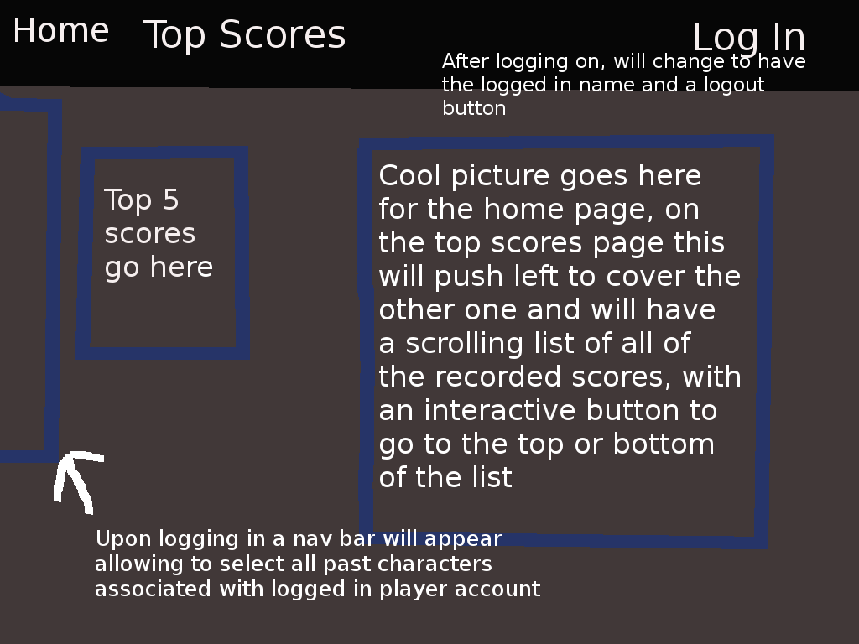

Basic GUI layout:
