Gavin Woodruff

SE 350-01

4/24/2024

Building an App using Streamlit

**Task 1**

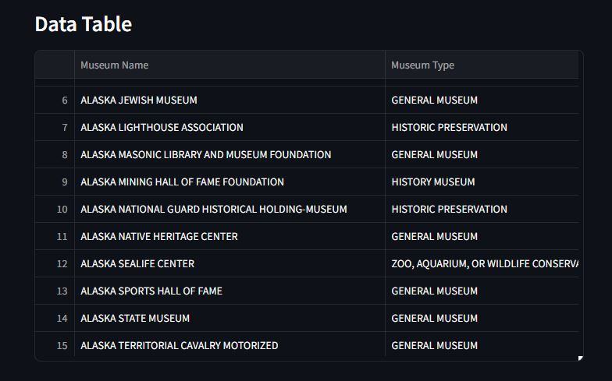

**Task 2**

**Task 3**

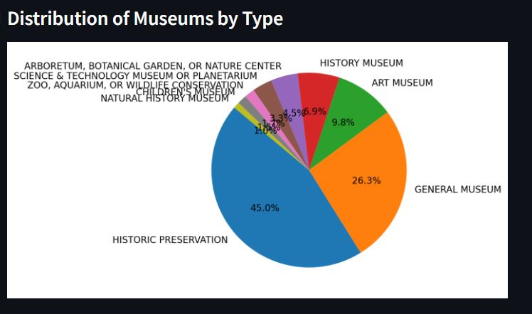

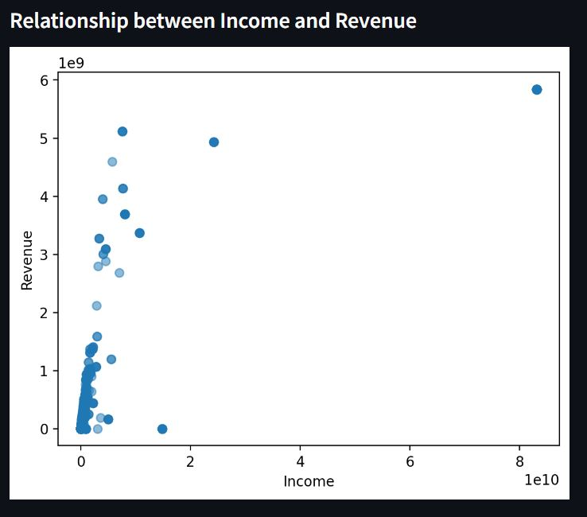

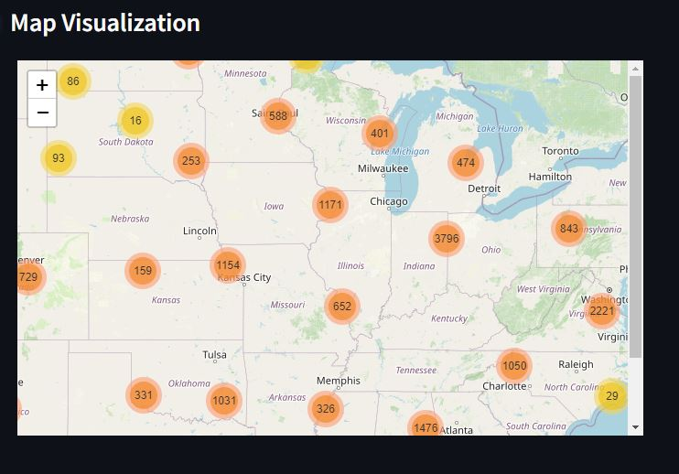

**Task 4**

For a better user experience, I would suggest adding a header that will allow me to quickly view each sub header. For example, I would be able to quickly view my data visualization section without having to scroll down to search for it. Also having various styling options would be beneficial. Currently all of my sub headers are close to the previous data, so having a larger top margin for each sub header would make it a bit easier to read.

For the map visualization in particular, having a input field somewhere where I can input an address and see what museums are around me could be fun rather than having to zoom in on the map to the area I live. Having a search feature outside of the default Ctrl+F that my browser supports could also benefit the users, so that the user can easily find the data they are looking for such as the total number of museums.