Portable Cell Initiative

Antenna Analysis for Microcells

By: Arpad Kovesdy

**Summary**

The antenna’s design, provided a 30 m elevation from a real ground, provides a directivity (gain) of 5.76 dB

**Basic Antenna Configuration**

The microcell’s base station for GSM communications consists of two antennas: one for uplink (handling radio communications the mobile user to the microcell) and one for downlink (microcell to the mobile users). For both antennae, there are two portions: a conducting and a grounding region. In a classic half-wave dipole that is pointing vertically and is thus vertically polarized, the feed point will be at the middle of two conductors pointing towards the ground and towards the sky. The vertical polarization is common in mobile systems because “vertical polarization has somewhat lower attenuation over terrain”[1].The radiation pattern of this type of antenna is a donut shape that projects most of the radiation perpendicular to the conductor. To lower the impedance to the characteristic impedance of the feed line (which is 50 Ω), from the antenna impedance of a dipole, the grounding portion is raised closer to be 30° below the horizontal. In total, there are three conductors that point out from the center to form the grounding portion to improve omnidirectionality. Here is an image of the projected geometry with wires in gray and axes in green:

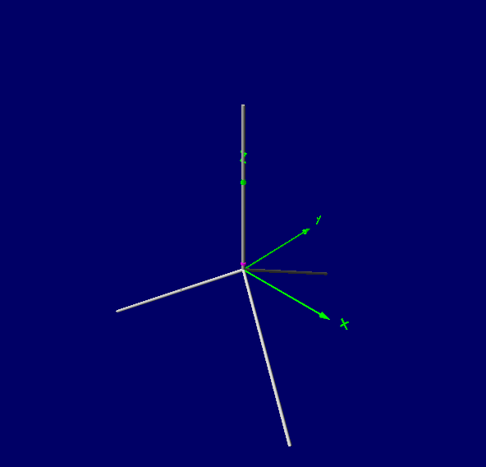

**Antenna Characteristics**The length of the antenna conductors (which is around a quarter of the wavelength of the transmitted or received radio wave since the complete system is based on a half-wave dipole design) is given by the following equation[2]:

The following characteristics of the antennae were calculated based on simulations in 4nec2, a program for showing how EM radiation is generated by different antenna geometries. The same simulations were also conducted over a 30 m real ground, which overs more realism than the simulation of the antennae in free space (an environment that does not practically exist). The diameter of the wires used in the antennae was

|  |  |
| --- | --- |
| Characteristic | Value |
| Transmission frequency range | 890 – 915 MHz |
| Average operating frequency | 902.5 MHz |
| Wavelength | 0.332 m |
| Monopole length | 0.07903 m |
| Number of monopoles | 4 |
| Isotropic Gain in Free Space | 1.76 dBi |
| Isotropic Gain above a 30 m real ground | 5.98 dBi |
| Impedance | 44.1 Ω |
| Radiated Efficiency (30 m above real ground) | 50.73 % |
| S.W.R. (50 Ω feed line) | 1.18 |

Table 1: **Uplink** Antenna Characteristics

|  |  |
| --- | --- |
| Characteristic | Value |
| Transmission frequency range | 930 – 960 MHz |
| Average operating frequency | 945 MHz |
| Wavelength |  |
| Monopole length | 0.0755 m |
| Number of monopoles | 4 |
| Isotropic Gain in Free Space |  |
| Isotropic Gain above a 30 m real ground |  |
| Impedance |  |
| Radiated Efficiency (30 m above real ground) |  |
| S.W.R. (50 Ω feed line) |  |

Table 1: **Downlink** Antenna Characteristics

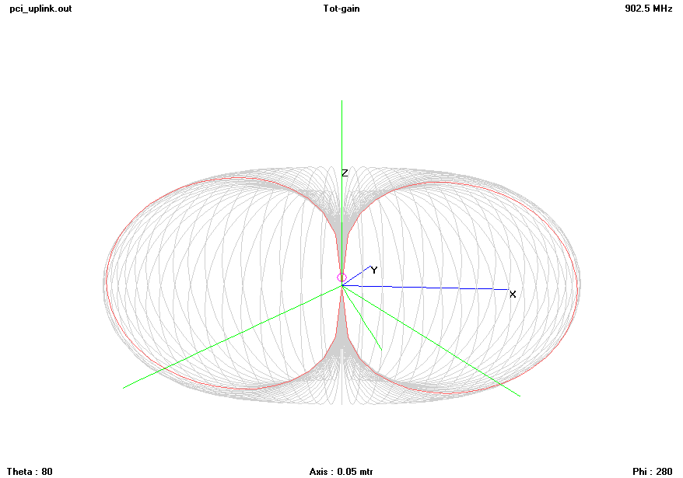

Image 2: Radiation Pattern (Uplink) in free space

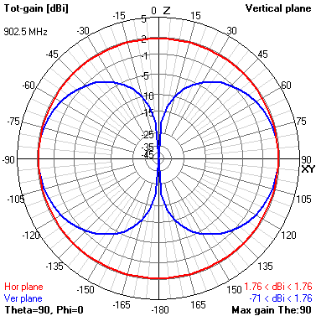

Image 3: Radiation pattern (uplink) from the vertical plane’s perspective in free space

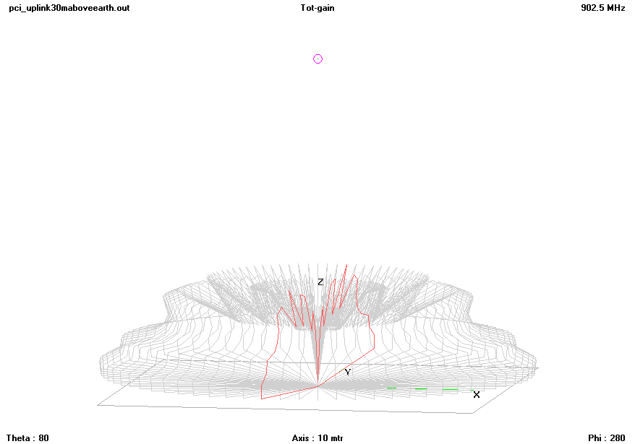

Image 4: Radiation pattern (uplink) when the antenna is 30 m above real ground

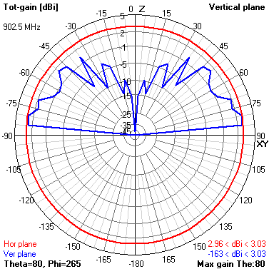

Image 4: Radiation pattern (uplink) from the vertical plane’s perspective when the antenna is 30 m above real ground

**Other Considerations**

When constructing the tower upon which to mount the uplink and downlink antennae, it is important that any conducting materials, like guy wires, extra cables, and metal supports, should be separated from the antennae to prevent electromagnetic interference. Additionally, the antennae should be separated by several wavelengths to reduce interference further, since the two antennae transmit or receive on similar frequencies.

1. http://people.csail.mit.edu/bkph/cellular_repeater_outside.shtml
2. Silver, H. W. (2007). The ARRL general class license manual. Newington, CT: ARRL.