Beamlink Prototype Evolution

Beamlink I

A power-efficient, yet powerful **single board computer** utilizes the newest mobile processors to create an independent cell tower.

The computer can assign phone numbers, store texts, link international calls, host a local web server, and even be remotely monitored and configured.

A picture containing wall, electronics

Description generated with high confidence

**Integrated** **battery** allows for 7 hours of operation before connecting to outside power.

A **water-proof case** allows the cell tower to survive even when fully immersed in water. Foam padding and the reinforced case mean that the tower can survive being dropped. And weighing in at 8 pounds, the tower can truly be taken anywhere.

A **software-defined radio** allows use of any radio protocol, including GSM, Wi-Fi, and even LTE. The system can be instantly configured to meet the regulatory requirements of any country.

Beamlink II

**Custom ports** allow ethernet and power connections from the outside while keeping out water, while a switch provides more control over the device.

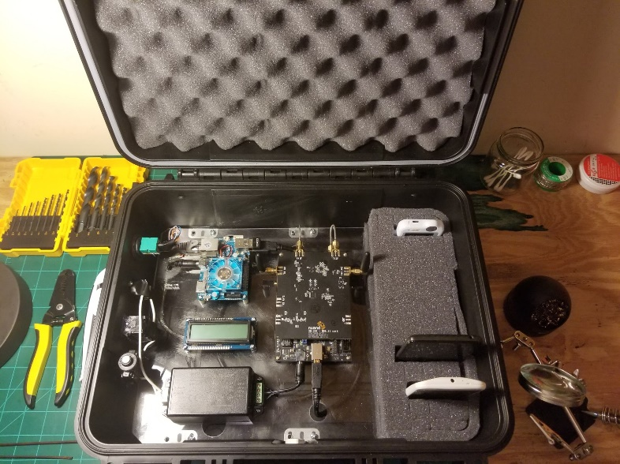

**Built-in antennas** and smaller coaxial cables allow for the case to operate while closed, even when an amplifier is attached.

The **larger case** has space for storing extra, pre-configured phones and medical devices. And the device is even lighter, at 7.5 pounds.

A **custom power supply** further reduces power consumption to 11.2-11.9 W during cell tower operation.

The **information display** reads out real-time information, such as the tower’s status, registered phones, and active connections.