SACRALINK - A CROSS PLATFORM SYSTEM FOR CHURCH MANAGEMENT: ONLINE DONATION MASS STREAMING, 360 VIEW, AND AN AI AGENT FOR SCHEDULING & RECORDS
A Thesis Proposal
Presented to the Faculty of the
Information and Communications Technology Program
STI College San Jose Del Monte

In Partial Fulfilment
of the Requirements for the Degree
Bachelor of Science in Computer Science
Arvee D.S Avida
Darwin Kiel D.V. Ipio
Denzel John N. Pulido
Jensim Kert E. Roque

November 2025

ENDORSEMENT FORM FOR PROPOSAL DEFENSE

TITLE OF RESEARCH: SACRALINKL – A CROSS PLATFORM SYSTEM FOR CHURCH MANAGEMENT: ONLINE DONATIONS, MASS STREAMING, 360 VIEW, AND AN AI AGENT FOR SCHEDULING & RECORDS

NAME OF PROPONENTS: Arvee D.S. Avida
Darwin Kiel D.V. Ipio
Denzel John N. Pulido
Jensim Kert E. Roque

In Partial Fulfilment of the Requirements
for the degree Bachelor of Science in Computer Science
has been examined and is recommended for Proposal Defense.

ENDORSED BY:

Jeffrey S. Coco
Thesis Adviser

APPROVED FOR PROPOSAL DEFENSE:

Enoch James C. Tayanguna
Thesis Coordinator

NOTED BY:

Deffrey Josh A. Austria
Program Head

November 2025

APPROVAL SHEET
This thesis proposal titled SACRALINK – A CROSS PLATFORM SYSTEM FOR CHURCH MANAGEMENT: ONLINE DONATIONS, MASS STREAMING, 360 VIEW, AND AN AI AGENT FOR SCHEDULING & RECORDS, prepared and submitted by Arvee D.S. Avida; Darwin Kiel D.V. Ipio; Denzel John N. Pulido; and Jensim Kert R. Roque, in partial fulfillment of the requirements for the degree of Bachelor of Science in Computer Science, has been examined and is recommended for acceptance and approval.
Jeffrey S. Coco
Thesis Adviser
Accepted and approved by the Thesis Review Panel
in partial fulfillment of the requirements for the degree of
Bachelor of Science in Computer Science

Janice R. Flores | Louis Matthew P. Sindao
Panel Member | Panel Member

Enoch James C. Tayanguna
Lead Panelist

Noted:
Enoch James C. Tayanguna | Deffrey Josh A. Austria
Thesis Coordinator | Program Head

November 2025

Table of Contents
 | Page
Title Page | i
Endorsement Form for Proposal Defense | ii
APPROVAL SHEET iii
Table of Contents iv
Introduction 6
Background of the problem 8
General Problem 9
Specific Problems 9
General Objectives 11
Specific Objectives 11
Overview of the current state of the technology 12
Scope and limitations of the study 14
Review of related literature/studies/systems 22
Local Literature 22
Local Studies 25
Foreign Studies 26
Local System 27
Foreign Systems 28
Synthesis 29
METHODOLOGY 31
Hardware/Software 34
Calendar of Activities 38
Budgetary Estimate 41
Human Resources 42
Survey for parishioners 48
Survey for parish admin 53
Transcript of Record 58
References 60

Introduction
In today’s world, being able to communicate easily is important for every group, including churches. Local churches are still a huge part of Filipino life, serving as places to pray and gather as a community. However, many churches are having a hard time keeping up with what modern members need. Most people now prefer using their phones and computers to stay in the loop, while old methods like posting on bulletin boards or passing word of mouth often don't reach everyone. Because of this, fewer people end up attending church activities.
From 2020 to 2025, there has been a growing change in how churches work, especially in the Philippines. Church members now rely on digital tools to talk, schedule events, and give money, while traditional announcements just aren't working as well anymore according to the Barna Group (2020). Locally, Pulumbarit (2025) noted that the Diocese of Malolos has started putting church records online, making it easier to get certificates. These changes show that members are ready for faster and easier services like donating without cash or booking schedules online which are the main features that led to the creation of SACRALINK.
The way churches handle money and collect donations has also changed. Since 2021, many churches in the Philippines have started using QR codes so people can give without needing physical cash. PayMaya (2021) worked with over 80 churches to allow e-wallet donations, and news reports show that churches like Our Lady of Unity and San Roque are using GCash and QR codes for offerings (Interaksyon, 2022). These examples prove that members, even those living abroad, are open to safe and cashless ways to support their church. To fit in with this trend, the proposed SACRALINK system allows donations via QR codes using banking and e-wallet apps.

This study introduces SACRALINK, a platform that combines scheduling, watching mass online, online donations, and office management all in one place. Church members can get updates, join online services, and donate safely, while the staff can handle records and events much faster. By using these modern tools, SACRALINK aims to build a stronger community in San Jose del Monte, keeping traditions alive while making the Church more connected, organized, and ready for the future.

Background of the problem
Church processes are central to the faith and community life of Church members, but many remain slow, repetitive, and time-consuming. In San Jose del Monte, some churches still depend on traditional, manual methods for scheduling, record-keeping, and communication. One significant challenge is church scheduling and coordination. Church members who wish to book weddings, baptisms, confirmations, or house blessings must often visit the church office in person. Survey results show that 83.6% of respondents find it inconvenient to visit the office personally.
The process of record-keeping itself is also problematic, as it is performed manually. Church staff must search through logbooks or piles of paper records when Church members request certificates. This process takes more than 30 minutes for 65.6% of Church members. This can result in long waiting times and inaccurate records, an issue experienced by 68.9% of respondents. Communication delays also challenge church life. Important announcements are primarily shared through bulletin boards or word-of-mouth. These methods have led 47.5% of respondents to miss events due to poor communication.
The donation process also presents challenges. Contributions are mostly collected in cash during Mass. However, 85.3% of Church members agree that online or cashless options would make it easier to support the church. Limited accessibility to Mass attendance is another challenge. Many Church members are unable to attend Mass in person. The importance of livestreaming is shown by 67.2% of respondents.
These problems show that the church really needs to update its system. If the church starts using digital tools, the work will be faster, easier, and more organized. It will also help people get the information they need without long waiting times. A modern system can make church services smoother, help members stay connected, and make things more convenient for everyone.

General Problem
Based on the challenges observed in church operations, several issues were identified that cause delays and inefficiencies in the delivery of services. These time-related problems prevent Church members from accessing faster and more convenient church processes. The absence of a centralized digital system and reliance on manual record-keeping contribute to these inefficiencies, limiting coordination among church administrators and slowing down service delivery.

Specific Problems
- Inefficient Scheduling and Records-Keeping for Church Record
The current system for scheduling ceremonies requires a physical visit to the church office, which 83.6% of members find inconvenient. Obtaining documents like baptismal certificates is also inefficient, taking over 30 minutes for 65.6% of members due to manual record searches. This process is error-prone, with 68.9% reporting delays or mistakes from lost or handwritten records.
- Delays in Communicating Church Announcements and Events
The church relies heavily on bulletin boards and word-of-mouth to share important information about Mass schedules and events. These methods are unreliable and fail to reach everyone on time. This failure has a direct consequence: 47.5% of church members have missed church events because the announcement was late, or they did not hear about it at all.
- Limited Options for Making Donations to the Church
The church's financial support relies almost entirely on cash donations during Mass. This method is not suitable for today's digital society and excludes those who cannot attend physically. The survey shows a clear demand for change, as 85.3% of church members agree that online or digital donation options would make it easier for them to support the church financially.

- Limited Access to Mass for Remote or Unable Church members.
Many church members, such as the elderly, the sick, overseas workers, and those with busy schedules, cannot physically attend Mass. Without a way to participate remotely, they are cut off from the community. The need for a solution is clear, as 67.2% of the community stated that video streaming of Masses is important for those who cannot attend in person.

General Objectives
To design and develop SACRALINK, a cross-platform application that streamlines church operations in CSJDM by digitalizing church scheduling, securing church records, enhancing real-time communication, enabling cashless donations, and providing accessible services, to facilitate a faster, more efficient, and more inclusive church experience for all Church members.

Specific Objectives
- To Create An AI Agent To Automate The Church Records And Requests
The developers aim to create an AI agent to help automate the process of keeping and accepting the church records. The AI agent also helps to automate the requests of the users by making a decision by looking first on the current status of the church or priest and then the AI agent will be able to either accept, decline, or reschedule the request of the user.
- To Develop An Integrated Communication System
The developers aim to design a system that integrates real-time announcements, notifications regarding requests updates, along with the accomplishment of the church.
- To Create A System Of Improving the Limited Donation Methods
The developers aim to create a secure and digitalized way of donation to the church by creating a module where the users can scan a QR code uploaded by the church administrators linked to the preferred e-wallets and bank transfers.
- To Create An Interactive Streaming Platform
The developers aim to create a streaming module where the church members can conduct a live stream of Mass or upload a recorded video of Mass. Along with this, the user can also watch the newest and past streams of the Mass, making sure that everyone, especially those far away or unable to attend physically, can still join in worship and community life.

Overview of the current state of the technology
YouTube – Digital Media Sharing and Faith Broadcasting
YouTube serves as a major platform for video content, widely used by churches to livestream Masses, post homilies, and share faith-based reflections. Its accessibility allows Church members, especially those who cannot attend in person, to participate virtually in liturgical celebrations. YouTube functions primarily as a broadcasting tool and lacks interactive features tailored to church administration. SACRALINK takes inspiration from YouTube’s accessibility and media-sharing capability while integrating church-specific tools that allow both engagement and participation beyond watching content.
GoFundMe – Crowdfunding and Transparent Giving
GoFundMe is a global crowdfunding platform that enables individuals and organizations to raise financial support for various needs. Its strength lies in transparency, allowing donors to monitor the progress of campaigns and directly observe the impact of their contributions. However, GoFundMe primarily serves personal or charitable projects and does not address the unique requirements of church communities, such as church scheduling or spiritual engagement. SACRALINK adapts this concept of transparent digital giving by providing Church members with a secure method to contribute directly to their church.
Facebook – Social Media Connection and Community Building
Facebook is one of the most popular platforms for sharing updates, livestreaming Masses, and connecting Church members. It helps build community and keeps people informed, but it cannot handle church-specific needs like church records or private communication. SACRALINK takes Facebook’s strength in connection and adapts it into a secure, church-focused system that blends communication with church administration.

YouVersion App – Digital Bible Engagement
YouVersion is a widely used mobile application for Scripture reading and devotionals, offering free access to Bible translations, reading plans, and sharing features. Its key strength is accessibility, which allows users worldwide to engage with Scripture individually and as a community. YouVersion focuses mainly on personal faith practices rather than integrated church operations. SACRALINK draws inspiration from YouVersion’s accessibility by incorporating daily Bible verses while simultaneously addressing administrative and community engagement needs within the church.
Calendar Systems – Digital Scheduling and Coordination
Digital calendar applications allow users to schedule events, receive reminders, and coordinate activities efficiently, reducing conflicts, and improving participation. While these tools are effective for general scheduling, they lack church-specific functionalities, such as managing multiple sacraments across different churches. SACRALINK incorporates a scheduling system directly within its platform, enabling Church members to request and track sacraments while administrators prevent conflicts in real time.

Scope and limitations of the study
Super Admin Module
- Login module
The super admin will be logged in with their account and will be redirected to the dashboard.
- Dashboard
In this page, the super admin will land on the Dashboard after they login with their account. This is where the super admin manages the central database and the system.
- Church Page
Allows super admin to create, update, or manage church profiles across the system.
- 360 view module
To upload and manage 360° church images for use on church pages.
- Account Management
Reviews and approves requests (registrations of accounts and churches) with an AI agent to assist them for automated verification.
  - Search Module
Enables the super admin to search across all churches, users, documents, and system features.

Church Module
- Account Management
The church will be the one responsible for choosing their administrators, priests, and other staff. This module is where the church will manage the creation of accounts of these church members.
Admin Module
- Registration module
The admin will submit the required documents for them to be accepted and have an account created in the church module.
- Login
The admin will be logged in with their account and will be redirected to the respective home page.
- Home Page
In this page, the admin will land on the Home Page after they login their account. Through here, the admin will be able to see and manage the requests for the scheduling (or the AI agent will do the job), can conduct the live stream of the Mass or upload a recorded video of the Mass, and post announcements through the dashboard which can be done also by the AI agent.
- Dashboard
Allows the admin to post church announcements and updates and will be visible to priests, volunteers, and users.
- Donation
This is where the admin can view donation history, managing donation channels, and monitoring contributions. The admin can upload a QR code of the preferred online bank or e-payment.
- Streaming module
Provides tools to manage and conduct church live streams or upload recorded Mass.
- Messaging module
Allows admin to communicate with other admin, priests, volunteers, and users through chat. The module has options of video and audio conference.
- Management module
Enables managing church or office appointments by approve, reschedule, or cancel appointments with the assistance of an AI agent.
  - Request approval module with AI
Processes user requests with AI suggestions to assist in evaluating and approving.
- Profile
Lets admin update their information, security settings, and availability.
- File Management
This is where the admin keeps the documents and records of data submitted by the users.
- Account Management
This is where the admin will create and distribute the accounts of priests, volunteers, and other staff.
  - Account Action module
The admin can suspend or ban user accounts if the user violates church policies.
- Task Assignment module
This is a module where the admin gives and assigns tasks to the volunteers and staff.
- 360 view
The admin will be able to upload images of the church in 360-view.

Priest Module
- Login module
The priest will be logged in with their account and will be redirected to the respective home page. The account will be created by the admin.
- Home page
Displays the priest’s dashboard with upcoming masses, appointments, requests, tasks, and important updates.
  - Search module
Allows priests to quickly find user records, scheduled sacraments, church documents, and past requests.
- Schedule module
Enables priests to manage their mass schedules, confession schedules, sacraments, and availability, including edits and updates.
- Church Page
Allows the priests to view the full church information managed by them.
- Bulletin board module
Allows priests to view the announcements, schedules, updates, and church events.
- Messaging module
Provides a communication channel for priests to message with users regarding counseling, inquiries, appointments, and requests. The priest can also choose between video and audio conference.
- Profile Management
Allows priests to update personal information, contact details, security settings, and account preferences.
- Task Assigning module
This is a module where the priest gives and assigns tasks to the volunteers and staff.
Volunteer Module
- Registration module
Allows volunteers to register under a church, subject to approval by the admin
- Login module
The volunteers will be logged in with their account and will be redirected to the respective home page.
- Home page
Shows an overview of volunteer tasks, assigned activities, schedules, announcements, and updates.
- Search Module
Enables volunteers to look up church information, events, user queries, and activity records.
- Streaming management module
Allows volunteers to set up, manage, or assist in running church live streams for masses, events, or special services. But before they can conduct a live stream or upload a recorded video or to use exclusive features, they need access from the admin.
- Messaging module
Provides a messaging tool for volunteers to communicate with users and assist with inquiries or support tasks.
- Profile Management
Allows volunteers to update their personal information, skills, availability, and security

User Module
- Registration module
To register as a user, they will register through the registration page. This requires a username, phone number or email, and password.
- Login module
Allows users to login with their account.
- Home page
In this page, the user will be able to see the latest announcements, the church conducting a live broadcast of mass, notification inbox, profile icon, calendar, status of request, and menu bar containing the church module, donation module, and appointment module.
  - Search module
Enables users to search for churches, schedules, sacraments, documents, and services.
- Bulletin board module
This is where the users view the church announcements, events, and updates posted by the admin & volunteer.
- Announcement module
Delivers important notices such as mass schedules, church events, and reminders.
- Notification module
Sends notification about appointment approvals, live streams, announcements, and donation confirmations.
- Calendar module
Displays scheduled church events, user appointments, and reminders.

- Church page
Shows detailed information about a church including overview, schedules, locations, and priests.
- 360-view of church
The users can view the images of the church either in view or in 360-view.
- Maps module
Provides navigation and directions to nearby churches and church event locations within the map of San Jose del Monte Bulacan.
- Donation
Allows users to donate through QR code by scanning the QR code uploaded by the admin. And the users are able to view donation history.
- Streaming page
Lets users watch live streams of masses.
- Messaging module
Enables users to message church admin, priest, and volunteers for questions or support. The module has options of video and audio conference.
- Appointment page
Lets users book appointments for church record, counseling, and office transactions.
  - Request module with AI
The AI agent helps the user to know the availability of the priest or church for their request. In case the chosen priest or church is not available, it automatically will give suggestions or recommendations about other priests or churches that have the same capability and availability for the user’s request.

- Daily bible verse module
Users can view daily bible verses, chapters, and prayers posted by AI.
- Profile page
Lets users update basic information, preferences, and contact details.

Limitations
- Android Accessibility
The mobile application will be available only for Android devices, supporting Android 10 (API 29) up to the latest Android version.

- iOS Accessibility
iOS users can only access the system through its web version, which provides the same features and functionality as the Android app. The proponents limited iOS accessibility to the web version due to the restrictions of Apple-exclusive development tools and paid developer access.

- Third Party Communication
The discussions or plans between the church and the user are outside the super admin's control and they will not be part of this.

Review of related literature/studies/systems

Local Literature
Pulumbarit (2025), in the Journal of Information Systems Engineering & Management, discusses the Diocese of Malolos’s “Digitalization of Church Records” project. This study describes the development of a web-based church information system (PIMS) that integrates church registers such as baptisms, confirmations, and marriages across 120 churches. Key features include encrypted data storage, online church certificate requests, and third-party payment options like GCash to streamline record access and management (researchgate.net). This study validates the local demand and technical feasibility for the type of digital record-keeping SACRALINK aims to implement.
Sambile et al. (2025), in ResearchPublish (IJCSITR), studied “Indang Faith Connect: A Web-Based Online Community Platform for St. Gregory the Great Church, Indang.” This capstone project built a digital portal to strengthen the church community’s engagement and service delivery. It focuses on using web and mobile interfaces (HTML/JS/PHP/MySQL) to disseminate announcements, enable online community discussions, and involve Church members in faith activities. All testers rated the system highly according to ISO-25010 standards (“Highly Acceptable”), indicating success in improving church outreach and communication (zenodo.org). This local work illustrates how a web-based church platform can foster community involvement, a key aim of SACRALINK.

Barlis et al. (2020) presented a paper at an IEEE conference titled “Development of Centralized Church Record and Information Management System (PRIMS)” for the Diocese of Cubao in Metro Manila. The authors documented the design and prototyping of a centralized information system to replace manual church record-keeping. PRIMS consolidates member profiles and church data across churches to speed up reporting, reduce record loss, and improve communication between clergy (researchgate.net). The prototype improved workflow by simulating a unified database for all churches, establishing a foundational model that SACRALINK seeks to adapt and expand upon for the CSJDM context.
Foreign Literature
ChurchesAdmin (2025), a Kenya-based professional blog, describes “How Catholic Churches Can Use a Church Management System for Better Engagement.” It defines Church Management Systems and lists features relevant to church use, noting that a ChMS stores member contact information, church history, and family links; tracks attendance; manages online giving; schedules events and Masses; and enables email and SMS communications with Church members (churchesadmin.com). Such descriptions reinforce that modern church platforms should include member databases, event scheduling, financial modules, and notification tools which are all components planned for SACRALINK.
Barna Group (2025), in the survey report “Christians Say Churches Could Benefit from Digital Tools,” shows that a strong majority of U.S. Christians support digital ministry tools. The survey found that 75% of respondents endorsed online giving and 74% endorsed a “digital resource hub” for outreach and learning (barna.com). The report concludes that congregations expect more technology from their churches, such as streaming, apps, online donations, and social outreach. These findings confirm that features like secure online donations and digital communications, as planned in SACRALINK, align with Church members’ expectations.
The ChurchSOFT blog (2024) provides an overview titled “8 Faith-Based Church Technology Tools for Churches.” It highlights key digital tools such as Church Management Software, online giving, mobile apps, and livestreaming that churches use. It emphasizes integrated solutions for member databases, liturgy scheduling, communication, and donations tailored to church needs (churchsoft.com). For example, ChMS platforms combine attendance tracking, communication, and volunteer management in one system to simplify operations, which is exactly the kind of functionality SACRALINK aims to provide.

Local Studies
The Malolos Diocese DCRMS study (Pulumbarit 2025), as part of the Phase I report on “Church Records Digitalization,” indicates that moving church registers to a web and mobile system greatly reduced time spent retrieving records. By automating certificate requests and tracking, the church cut down paper bottlenecks and improved data security (researchgate.net). This case study highlights the challenges of manual archives and the efficiency gains from digital record-keeping, paralleling SACRALINK’s objectives in the local context.
E-Church (Bernardino et al., 2024) reports on a “Web and Mobile-based Church Management System for Holy Rosary Church” in Angeles City, Philippines. The system allows Church members to schedule Mass intentions and Eucharist services online and generate consolidated reports. The platform provides a centralized hub for church requests, enabling Church members to book appointments and services online while consolidating them in one place (ieomsociety.org). Testing showed time saved on administrative tasks and better information tracking, demonstrating successful implementation of online event scheduling and request handling like SACRALINK’s church scheduling and communication features.
St. Nicolas de Tolentino PMS (Kipkomboi, 2020) is a student thesis project for a church in Bais City, Philippines. The paper outlines developing a web-based Church Management System to computerize records, automate common tasks, and improve usability for church staff. Objectives included efficient record-keeping, rapid report and certificate generation, and online dissemination of information. While not an official publication, this capstone illustrates typical Philippine church needs, such as manual register issues and the desire for web automation, which inform SACRALINK’s design for web portals, SMS notifications, and QR code check-in.

Foreign Studies
The virtual church in Ghana (2025). The study highlights that as churches digitize communication and records, risks such as unauthorized access, identity theft, and misuse of personal data emerge. This parallels SACRALINK’s goal by emphasizing that digitization must not only streamline services but also incorporate strong data protection and privacy measures.
Vincent (2024) conducted a study on the Assemblies of God Church that identified key challenges in records management such as unavailable, incomplete, inaccurate, and dishonest records, as well as difficulties in retrieval and the absence of electronic record-keeping. The research suggests adopting electronic records management systems, providing training, and establishing organizational structures to improve administrative effectiveness. This directly supports SACRALINK’s mission to digitize church records for efficiency and reliability.
A study in Uganda by RSIS International (2022) investigated how accountability, transparency, and integrity of church leaders influence fraud prevention in the management of church funds. While focusing mainly on financial records, the study emphasizes the importance of accurate and reliable record-keeping as a mechanism for transparency and accountability. This supports SACRALINK’s initiative of adopting structured, digitalized systems that ensure trustworthy and traceable records.

Local System
The Diocese of Malolos DCRMS, described in Pulumbarit (2025), is a web and mobile app that allows clergy and staff to access baptismal and marriage records online while enabling laypeople to request certificates electronically. Notably, it integrates with GCash for online payment of fees (researchgate.net). This system exemplifies the type of cross-platform church scheduling, record access, and e-payment system that SACRALINK envisions for San Jose del Monte’s churches.
The Indang Faith Connect Platform (2025), a prototype local church app in Indang, Cavite, was built to connect Church members with church services and each other. It offers online portals for announcements, prayer requests, and faith formation resources, meeting ISO software quality standards (zenodo.org). While not a finished product, it shows how even small churches use simple web tools to enhance communication and outreach. SACRALINK can draw on ideas like these for its community engagement and information sharing features.
Barlis et al. (2020) developed the Church Record and Information Management System (PRIMS) for the Diocese of Cubao. This academic prototype serves as a significant precursor to SACRALINK, demonstrating a working model for a centralized, multi-church database designed to streamline church record-keeping and reporting. The PRIMS project provides a validated architectural blueprint that SACRALINK can build upon, extending its concept with a stronger focus on community engagement, mobile accessibility, and integrated financial tools.

Foreign Systems
Pushpay ChurchStaq (2025) in the USA is a leading Catholic church software suite combining a giving platform, ChMS, custom apps, and data insights into one comprehensive church platform. According to Pushpay, ChurchStaq helps churches manage operations, drive donations, monitor community health, and engage their congregation (pushpay.com). It includes mobile apps for Church members and staff, donor-management dashboards, and church-wide metrics. This global example demonstrates how integrated church systems work in practice, informing SACRALINK’s feature set for donations, apps, and analytics.
FellowshipOne ChMS (2022) in the USA highlights a system implemented at Park Valley Church. Staff praised the integrated event-registration and forms engine, which allowed them to build multi-page signup forms with drag-and-drop fields, capture digital waivers, and offer recurring giving through the same platform (fellowshipone.com). This all-in-one church software model is directly analogous to SACRALINK’s design, which unifies scheduling and giving.
WS ChMS by Web Synergies (2020) in Singapore was customized for Emmanuel Assembly of God’s Church. The cloud-based ChMS centralized member profiles, including newcomer tracking and baptism data, managed ministries and service schedules, and automated notifications. The system allows leaders to filter and email members by criteria such as volunteers by role (websynergies.com). This illustrates a comprehensive ChMS in an Asian context that parallels SACRALINK’s planned scope for member databases, service scheduling, sacrament tracking, and communications.

Synthesis
The reviewed literature, studies, and systems show a clear global move to digitize church operations. International platforms like Pushpay's ChurchStaq and FellowshipOne demonstrate the technical feasibility of integrated church management systems, while the Barna Group survey confirms that congregants now expect these digital tools in their worship communities. However, important foreign studies reveal critical challenges in this digital transition. Adjin-Tetteya and Kwofieb highlight serious data security risks that could damage church trust, while RSIS International and Vincent identify problems in financial transparency and record reliability that undermine church administration. These studies show that technology must address both opportunity and risk in equal measure.
In the Philippine context, local systems demonstrate active engagement with these challenges. The work of Barlis et al. (2020) on the PRIMS system for the Diocese of Cubao, along with the Diocese of Malolos DCRMS, provides concrete evidence of a local shift towards centralized, digital record-keeping. Platforms like Indang Faith Connect and E-Church successfully improve community engagement. Yet as these examples demonstrate, existing solutions remain fragmented across different functional areas.
This analysis reveals a gap for a fully integrated solution. While foundational systems like PRIMS and Malolos DCRMS provide a crucial model for record management, their primary focus is on digitizing existing archives. SACRALINK aims to build upon this foundation by integrating these record-keeping strengths with the community engagement focus of platforms like Indang Faith Connect. Foreign systems, though robust, are often misaligned with local church structures and lack support for payment methods like GCash that are essential in the Philippine context.The SACRALINK system directly responds to this comprehensive analysis. It is designed not to replace but to synthesize and enhance existing concepts.

It integrates the record-management principles of systems like PRIMS and Malolos DCRMS with a stronger focus on community building, while specifically addressing the risks identified by Adjin-Tetteya and Kwofieb through strong data security. By incorporating the financial transparency called for by RSIS International and addressing the administrative challenges documented by Vincent, SACRALINK aims to provide a complete, secure, and community-centric solution for church administration in San Jose del Monte.

METHODOLOGY
According to Microsoft (2022), "Agile is a term that describes approaches to software development that emphasize incremental delivery, team collaboration, continual planning, and continual learning."
The developers of this project have decided to use the Agile model approach to software development in completing the SACRALINK system. This model includes different phases, namely, Requirement Gathering, Design of the Requirements, Development and Iteration, Testing, Deployment, and Review and Feedback.

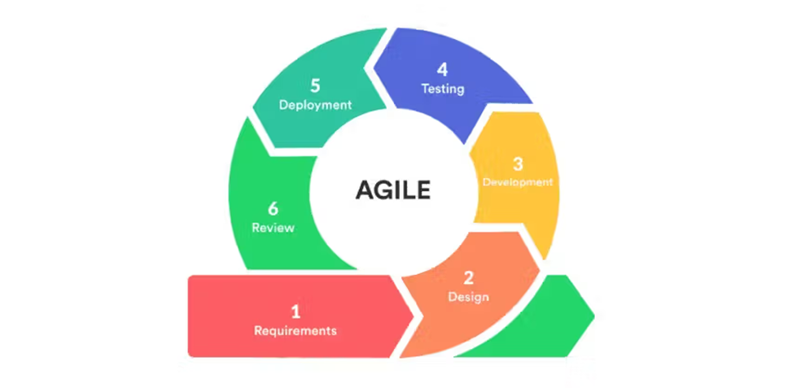
Image 1: Agile development

Requirement Gathering
This phase is where the criteria are defined, user needs are identified, and the time and resources required for development are estimated. For the SACRALINK system, the developers gathered requirements by conducting interviews and surveys with Church members and church staff of CSJDM churches to identify common problems in scheduling, donations, streaming, and records management. They also reviewed existing systems such as ChurchSOFT, Rolee PIMS, and other church management tools for inspiration. From there, they defined the core features needed to address inefficiencies in communication, church scheduling, and donation methods.
Design of the Requirement
In this phase, the system blueprint and workflows are created to serve as guides during development. For this project, user flow diagrams and UML diagrams were designed to demonstrate how Church members, administrators, and super administrators will interact with the system. Wireframes and mockups were prepared using design tools to visualize the mobile and web interfaces. Database schemas were also drafted to define how church records, announcements, donations, and user accounts will be stored and secured.
Development and Iteration
This is the most time-intensive phase, where developers build the system in smaller, functional increments. For SACRALINK, the project is divided into modules such as church scheduling, donations, streaming, and announcements, each developed in cycles. Every iteration produces a working prototype of a feature, which is refined in subsequent cycles. Collaboration and version control tools are utilized to manage progress and track updates efficiently.

Testing
This phase ensures that the system is secure, functions correctly, and meets user expectations. The proponents follow the ISO 25000 (SQuaRE) standard to verify software quality through various tests. Unit testing checks that individual components, such as donations and scheduling, function properly. Integration testing then verifies that all components work together smoothly. A pilot test with selected church staff and members gathers feedback on system usability. Security testing is conducted to protect user data. Any issues or errors identified during testing are addressed in the next development cycle, ensuring continuous system improvement.
Deployment
This phase delivers the working version of the SACRALINK system to its intended users. For the project, the mobile application will be deployed on Android devices for Church members and administrators, while the web application will be deployed for super administrators to oversee multiple churches. Deployment ensures that the system runs smoothly in the actual environment of CSJDM churches.
Review and Feedback
In this final phase, the system is reviewed, and user feedback is collected to guide maintenance and future improvements. For this project, Church members, church staff, and administrators will be surveyed about their experience using the SACRALINK system. The feedback will focus on ease of use, accessibility, accuracy, and reliability of the features. Developers will then address feedback and perform maintenance to ensure the long-term sustainability of the system.

Hardware/Software
Table I. Hardware
Computer’s Hardware | Recommended Specifications
CPU | Intel(R) Core (TM) i5-4460 CPU@ 3.20GHz
RAM | 16.0 GB DDR3
STORAGE | ESGAMING 128GB, ST3500414CS 500GB, Patriot P210 128GB
GPU | AMD Radeon RX 580 2048SP

Table II. Software
IDE / Editor | Visual Studio Code - A versatile code editor used for development. Its extensions, debugging tools, and integrated terminal streamline the coding process, allowing for faster development and easier maintenance.
Design Tool | Figma - A design tool used to create user interfaces (UI) and user experiences (UX). It helps teams visualize screen layouts, create prototypes, and ensure consistent design across applications.

Frontend (Web) | React (with Vite) - A library for building interactive and responsive web interfaces. Vite is used as a build tool to ensure fast loading and efficient development.  Tailwind CSS - A utility-first CSS framework that enables rapid creation of clean and modern designs for components like dashboards, forms, and data tables.
Mobile Development | React Native (Expo) - A framework used to build cross-platform mobile applications. It allows for real-time updates, fast development cycles, and consistent performance across different mobile devices.
Backend / Database | Supabase (PostgreSQL) - A backend-as-a-service platform that provides database management, authentication, and real-time functionalities. It uses PostgreSQL for secure, structured, and reliable data storage.
API Testing | Postman - A collaboration platform for API development used to test server endpoints. It ensures that all API requests and responses work correctly before integration.

Version Control | Git - is used for tracking all changes in the project source code, enabling multiple developers to collaborate.  GitHub - hosts the central repository, manages code branches, and serves as a backup.
Hosting | Vercel (Web) - A cloud platform for hosting web applications with a focus on frontend frameworks, providing fast global performance and continuous deployment.  Render (Backend) - A cloud service provider used for hosting backend APIs and services, ensuring stable and reliable server performance.
Cloud Storage | Supabase Storage - A cloud storage solution integrated with the backend platform, used for managing user-uploaded files such as images, documents, and other media.
Push Notifications | Firebase Cloud Messaging (FCM) - A cross-platform messaging solution that reliably delivers notifications and messages to mobile devices and web applications.
Mobile Emulator | Android Studio - An integrated development environment for Android, which includes an emulator to test mobile applications on various virtual devices, screen sizes, and OS versions.
Project Management | Notion - A productivity and note-taking web application used for project organization. It helps manage tasks, timelines, documentation, and development progress.

Calendar of Activities
The thesis project, initially conceptualized as “SacraLink: Smart Church Application with Services, Streaming, Online Giving, Stewardship, and Sacrament Chatbot Support,” received approval during the third week of classes on August 12, 2025. The proponents then began the documentation process in the last week of August, focusing on foundational components such as the Introduction, Background of the Problem, Specific Problem, Overview of the Current State of Technology, and Objectives of the Study. During this period, the group ensured that all objectives aligned with the project title, that no unnecessary information was included in the introductory sections, and that the technology overview incorporated relevant and updated applications.
By the second week, a preliminary survey was conducted to gather data in support of the study. The group also revised the project title, applied the required formatting guidelines, and refined the Introduction and Background of the Problem to ensure clarity and relevance. The Specific Problem and Objectives were rewritten into concise and coherent statements, while the Scope and Limitation section was developed to identify the primary issues the system aims to address. The proponents likewise began planning the system flow using Figma to conceptualize the structure and functionality of the application.
During the third week, additional revisions were made to the project title and improvements were applied to the documentation structure, particularly the Overview of the Current State of Technology. The Specific Problem, Objectives, and Scope and Limitation sections were further refined for accuracy and coherence. In Figma, the proponents began developing user interface designs for login and registration modules for both administrators and end users. Early designs for the homepage, dashboard, and initial system features for super admin, admin, and user were also created. The system concept and proposed features were formally approved during this period, enabling the proponents to proceed with more detailed interface development and content planning.

In the fourth week, now under the updated project title “SACRALINK: A Cross-Platform Web and Mobile Strategy for CSJDM Church Growth and Community Building,” the group continued improving both documentation and system prototype. The title, introduction, and background sections were further refined, while the Figma designs for the dashboard, content platform, and login pages were enhanced. Development of the Review of Related Literature (RRL) and Methodology sections advanced, with emphasis on establishing a clear system development process and research design.
By the fifth week, the proponents finalized the revised title, introduction, and background to ensure consistency across the documentation. Survey data were analyzed, and further development of the Review of Related Literature and Methodology continued. Figma designs for the login and registration interfaces for both admin and user were improved, and the research team ensured that the key problems of the study were clearly defined to emphasize the need for addressing issues inherent in the current manual church processes.
During the sixth week, the proponents strengthened the Review of Related Literature by incorporating updated sources related to church management systems and cross-platform applications. Revisions were also made to ensure accurate citations and alignment with the study’s objectives. The Methodology section was expanded to include detailed descriptions of the development model, research tools, and data-gathering procedures. Additionally, the Figma prototype was refined to improve interface consistency, layout organization, and visual elements for both admin and user dashboards.
In the seventh week, further enhancements were made to the documentation, particularly the RRL, Methodology, and Scope and Limitation sections, based on adviser feedback. The proponents developed the System Architecture and Use Case Diagrams to illustrate the operational structure of the application. The Figma prototype progressed to a mid-fidelity stage with interactive navigation, and additional user interface components—such as online giving previews and appointment request screens—were integrated.

Week eight focused on validating the documentation and prototype through initial adviser consultations. Revisions were applied to formatting, chapter structure, and title consistency. The system flowchart was refined for clarity and accuracy. Interface elements in the Figma design—such as icons, button interactions, and layout refinements—were added to enhance usability. Preparations for the prototype demonstration also commenced during this period.
By the ninth week, the proponents completed the first full draft of the documentation, ensuring that all revisions from Chapters 1 to 3 were thoroughly integrated. The system prototype reached a near-final version, featuring polished interfaces for login, dashboards, online giving, appointments, and content-management screens. An internal review was conducted to ensure consistency between the documentation and the prototype. Final adjustments were implemented in preparation for formal submission and adviser evaluation.

Budgetary Estimate
Table III. Budgetary Estimate
Quantity | Specifics | Approximate Cost

Human Resources
Name: Jeffrey S. Coco
Position: Thesis Adviser
Name: Enoch James C. Tayanguna
Position: Thesis Coordinator
Name: Deffrey Josh A. Austria
Position: Program Head

Curriculum Vitae of
Arvee DS. Avida
Barangay Kaypian, Carissa 5C San Jose Del Monte Bulacan
avida.365513@sjdelmonte.sti.edu.ph
09602570775

EDUCATIONAL BACKGROUND
Level | Inclusive Dates | Name of school/ Institution
Tertiary | August 2023 | STI College San Jose Del Monte
Vocational/Technical | month year
High School | 2017-2023 | Lagro High School
Elementary | 2011-2017 | Cielito Zamora Memorial Sc

SKILLS
SKILLS | Level of Competency | Date Acquired
Figma | Intermediate | May 2025
 |  | month year
 |  | month year

TRAININGS, SEMINARS OR WORKSHOP ATTENDED
Inclusive Dates | Title of Training, Seminar or Workshop
2023-2024 | National Service Training Program
Listed in reverse chronological order (most recent first).

Curriculum Vitae of
Darwin Kiel D.V. Ipio
1841 Partida, Muzon East, San Jose Del Monte, Bulacan
ipio.374987@sjdelmonte.sti.edu.ph
09602570775

EDUCATIONAL BACKGROUND
Level | Inclusive Dates | Name of school/ Institution
Tertiary | August 2023  August 2020-2021 | STI College San Jose Del Monte  FEU Institute of Technology
Vocational/Technical
High School | 2018-2020  2014-2018 | Far Eastern University High School  School of Our Lady of La Salette
Elementary | 2008-2014 | School of Our Lady of La Salette

PROFESSIONAL OR VOLUNTEER EXPERIENCE
Inclusive Dates | Nature of Experience/  Job Title | Name and Address of Company or Organization
2025 | Registrar at Medical Mission | CJMS at Santa Maria Bulacan
Listed in reverse chronological order (most recent first).

AFFILIATIONS
Inclusive Dates | Name of Organization | Position
month year
month year
month year
month year
Listed in reverse chronological order (most recent first).

SKILLS
SKILLS | Level of Competency | Date Acquired
MIT App Inventor | Intermediate | September 2025
Figma | Intermediate | February 2025
MS Office  MS Word | Intermediate  Intermediate | October 2014  July 2010

TRAININGS, SEMINARS OR WORKSHOP ATTENDED
Inclusive Dates | Title of Training, Seminar or Workshop
August 2023-2024 | National Service Training Program
Listed in reverse chronological order (most recent first).

Curriculum Vitae of
Denzel John N. Pulido
Block 15 Lot 8, North Fairway Homes, Barangay Muzon, City of San Jose Del Monte Bulacan
pulido.253501@sjdelmonte.sti.edu.ph
09086325080

EDUCATIONAL BACKGROUND
Level | Inclusive Dates | Name of school/ Institution
Tertiary | August 2023 | STI College San Jose Del Monte
Senior High School | August 2021-2023 | STI College San Jose Del Monte
Junior High School | June 2017-2021 | Bulacan Standard Academy
Elementary | June 2013-2017  June 2011-2012 | City of San Jose Del Monte Central School  College of Saint Adela Inc.

AFFILIATIONS
Inclusive Dates | Name of Organization | Position
2022-2023 | STIletes | Member
2021-2022 | COOL GENES | Member
2019-2020 | Citizenship Advancement Training (CAT) | Member
Listed in reverse chronological order (most recent first).

SKILLS
SKILLS | Level of Competency | Date Acquired
Mobile development | Beginner | 2025
Figma | Intermediate | 2025
Programming (Java, Python, C#) | Beginner | 2024

TRAININGS, SEMINARS OR WORKSHOP ATTENDED
Inclusive Dates | Title of Training, Seminar or Workshop
month year
month year
month year
month year
Listed in reverse chronological order (most recent first).

Curriculum Vitae of
Jensim Kert E. Roque
#2248 Kaypian Proper, CJSDM Bulacan
roque.361036@sjdelmonte.sti.edu.ph
09956615522

EDUCATIONAL BACKGROUND
Level | Inclusive Dates | Name of school/ Institution
Tertiary | August 2023 | STI College San Jose Del Monte
Vocational/Technical | May 2021-2023 | First City Providential College
High School | May 2017-2020 | Kaypian National High School
Elementary | June 2011-2017 | Kaypian Elementary School

SKILLS
SKILLS | Level of Competency | Date Acquired
Computer System Servicing NC II | Intermediate | May 2023

ADVISER’S ACCEPTANCE FORM

NAME OF PROPONENTS: Arvee D.S. Avida
Darwin Kiel D.V. Ipio
Denzel John N. Pulido
Jensim Kert E. Roque

APPROVED RESEARCH TITLE: SACRALINK – A CROSS PLATFORM SYSTEM FOR CHURCH MANAGEMENT: ONLINE DONATIONS, MASS STREAMING, 360 VIEW, AND AN AI AGENT FOR SCHEDULLING & RECORDS

AREA OF STUDY: Web and Mobile Application, Intelligent Process Automation (IPA), Real-Time Data Synchronization, Online Donation, Streaming

CONFORME:

Jeffrey S. Coco
Thesis Adviser

APPROVED BY:

Enoch James C. Tayanguna Date: <day Month, year>
Thesis Coordinator

NOTED BY:

Deffrey Josh A. Austria
Program Head

Survey for parishioners
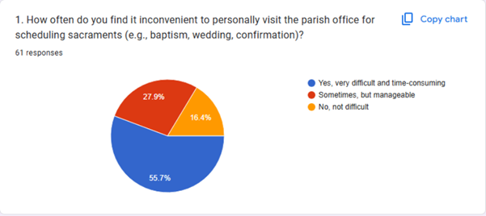
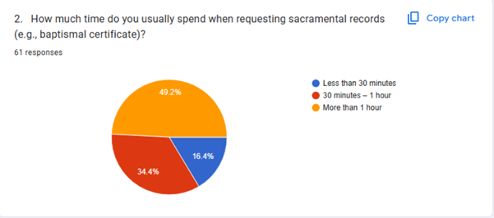
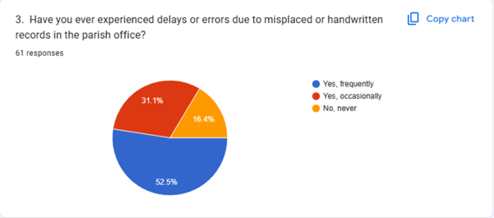12
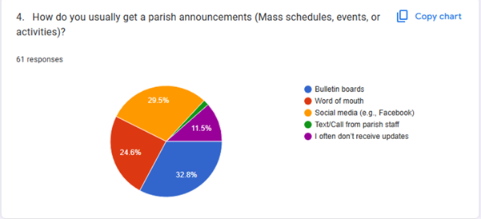
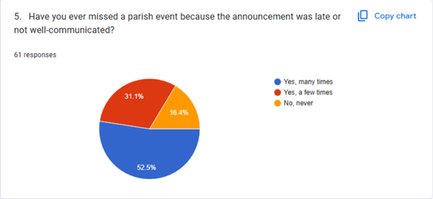
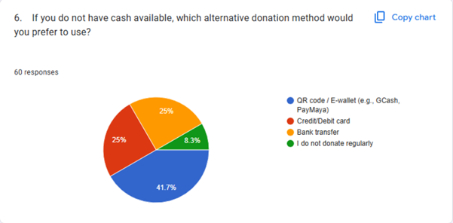
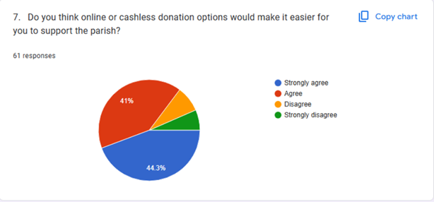
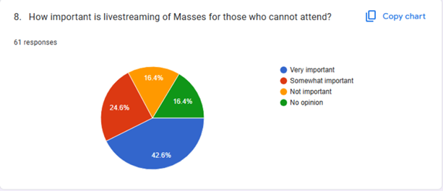
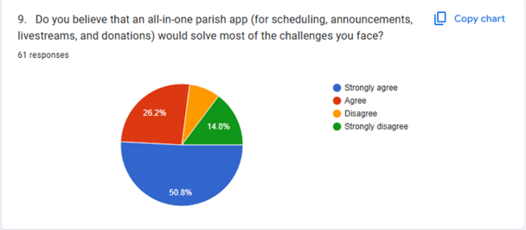
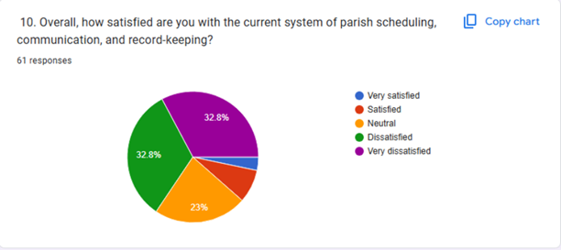

Survey for parish admin
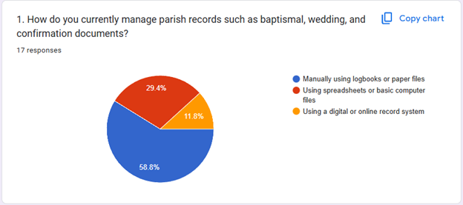
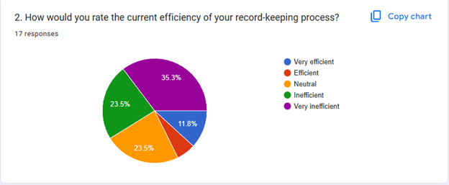

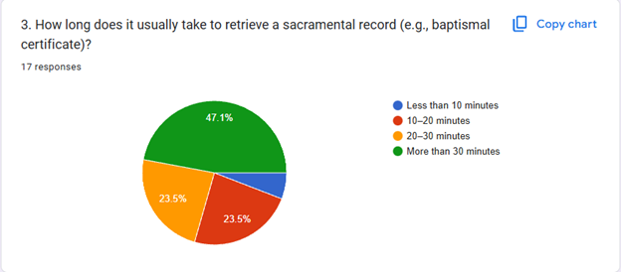
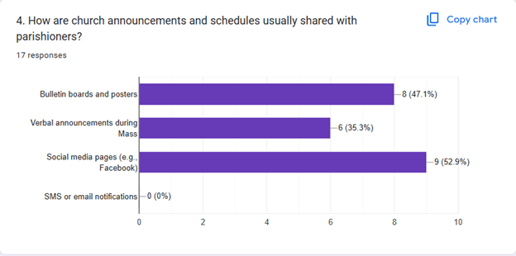

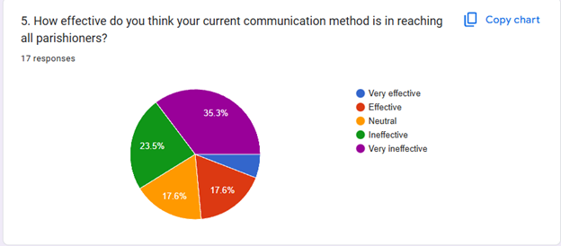
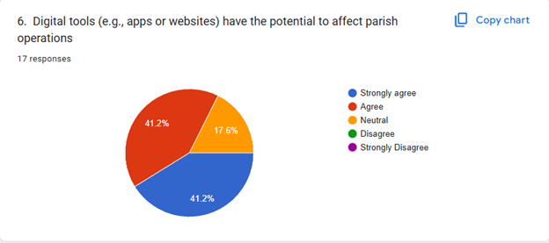

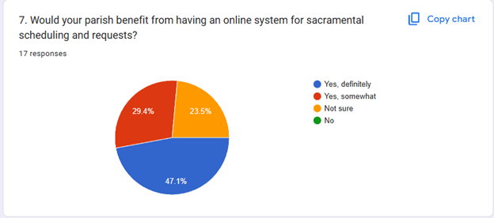
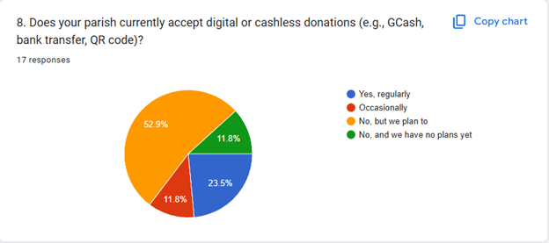

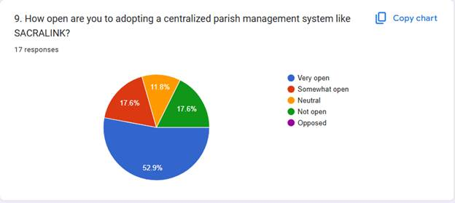
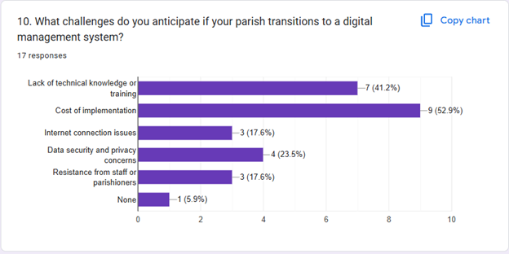

Transcript of Record
Date of Interview: November 23, 2025
Place of Interview: St. Joseph parking lot
Time Started: 1:00 pm
Time Ended: 1:20 pm
Total Duration: 20 minutes
Proponent: Good day, Father. We are students from STI College San Jose del Monte, and we are here to request permission to develop our thesis project titled “SACRALINK – A Cross-Platform Church Application with Services, Streaming, Online Giving, 360 View, and AI Scheduling & Appointment Assistance.”
SACRALINK is a digital platform designed to help parishioners stay connected with the church. It provides access to livestreaming, parish services, online giving, announcements, and scheduling assistance using AI. It will also include a 360-view feature so users can explore the parish virtually. The system aims to make communication and church engagement easier and more accessible for everyone.
Head Priest: Thank you for the explanation. What specific concerns would you like to clarify?
Proponent: Father, we would like to ask about including digital donations in the system. Would it be acceptable to implement this feature?
Head Priest: Yes, digital giving is allowed. However, I do not approve showing internal or detailed financial records within the application. Only authorized church staff should have access to financial information for safety and security. Public visibility of financial records will not be included.
Proponent: Understood, Father. We will only implement the allowed features and ensure financial data remains restricted.
Proponent: Father, since SACRALINK also includes a 360-view of the church and an AI-assisted scheduling and appointment module, do you think these features would benefit parishioners?
Head Priest: Yes. Digital tools like these are very helpful today. They allow the parish to reach more people, improve communication, and make church services easier to access, especially for those who cannot visit frequently. These features support modernization while still respecting church processes.
Proponent: Thank you, Father. With all the clarifications settled, may we have your official approval to continue developing and implementing SACRALINK for your parish?
Head Priest: I approve your request. You may proceed with the development of SACRALINK, as long as all guidelines discussed—especially regarding financial information and proper system management—are followed.
Proponent: Thank you, Father. May we also include this interview in our thesis documentation?
Head Priest: Yes, you may include it. Make sure everything you present reflects the discussion accurately.
Proponent: Thank you for your time and guidance, Father.
Head Priest: You’re welcome. I hope your project helps strengthen the church’s service to the community. God bless your work.
Proponents: Thank you, Father. God bless you too.

References
PayMaya. (2021, March 31). More than 80 churches now accept contactless donations via PayMaya QR [Press release]. PayMaya.
https://www.paymaya.com/press/More-than-80-churches-now-accept-contactless-donations-via-PayMaya-QR
Philstar.com (n.d.). GCash, PHINMA Foundation partner for QR on Wheels to modernize church donations. Philstar.com. https://interaksyon.philstar.com/posts/191175/gcash-phinma-foundation-partner-for-qr-on-wheels-to-modernize-church-donations
Adjin-Tettey, R., & Kwofie, C. (2024). Digital sanctuary: Exploring security and privacy concerns of congregants in the virtual church. Atlantic Journal of Communication, 33(2), 341–356. https://doi.org/10.1080/15456870.2024.2397965
Barlis, L., De Guia, J. M., Francisco, J. P., & Tolentino, K. (2020, October). Development of centralized church record and information management system (PRIMS) for the Diocese of Cubao. In 2020, IEEE 12th International Conference on Humanoid, Nanotechnology, Information Technology, Communication and Control, Environment, and Management (HNICEM) (p. 1–6). IEEE.
https://www.researchgate.net/publication/346694295_Development_of_Centralized_Church_Record_and_Information_Management_System_PRIMS_for_the_Diocese_of_Cubao
Barna Group. (2025). Christians say churches could benefit from digital tools. Barna Group. https://www.barna.com/research/christians-digital-tools/
Barna Group. (2025). Christians say churches could benefit from digital tools. Barna Group. https://www.barna.com/research/christians-digital-tools/
Bernardino, J., De Leon, J., & Garcia, K. (2024). E-church: A web and mobile-based church management system for Holy Rosary Church. In Proceedings of the International Conference on Industrial Engineering and Operations Management (pp. 200–207). IEOM Society International. https://ieomsociety.org/proceedings/2024manila/201.pdf
ChurchesAdmin. (2025, January 15). How Catholic churches can use a church management system for better engagement. ChurchesAdmin.
https://www.churchesadmin.com/how-catholic-churches-can-use-a-church-management-system-for-better-engagement/
ChurchesAdmin. (2025, January 15). How Catholic churches can use a church management system for better engagement. ChurchesAdmin.
https://www.churchesadmin.com/how-catholic-churches-can-use-a-church-management-system-for-better-engagement/
Diocese of Malolos. (n.d.). Digital Church Records Management System (DCRMS). Diocese of Malolos. https://malolosciology.org/digital-church-records-management-system-dcrms/
Kipkomboi, J. (2020). Church management system for St. Nicolas de Tolentino Church, Bais City [Unpublished undergraduate thesis].
https://www.scribd.com/document/488328697/Church-Management-System-Final-
ChurchSOFT. (2024, May 28). 8 faith-based church technology tools for churches. ChurchSOFT. https://www.churchsoft.com/8-faith-based-church-technology-tools-for-churches/
Pulumbarit, J. (2025). Digitalization of church records: A web-based church information system for the Diocese of Malolos. Journal of Information Systems Engineering & Management, 10(1). https://www.researchgate.net/publication/385031366_Digitalization_of_Church_Records_A_Web-based_Church_Information_System_for_the_Diocese_of_Malolos
Pulumbarit, J. (2025). Phase I report on church records digitalization: Diocese of Malolos. ResearchGate.
https://www.researchgate.net/publication/385031366_Digitalization_of_Church_Records_A_Web-based_Church_Information_System_for_the_Diocese_of_Malolos
Pushpay. (n.d.). ChurchStaq: The complete Catholic church management solution. Pushpay. https://pushpay.com/catholic
Rolee Business Solutions. (n.d.). Church Information Management System (PIMS). Rolee Business Solutions. https://www.roleepims.com/
RSIS International. (2022). The effect of accountability, transparency, and integrity of church leaders on fraud prevention in the management of church funds. International Journal of Research and Innovation in Social Science, 6(9), 166–173.
https://rsisinternational.org/journals/ijriss/articles/the-effect-of-accountability-transparency-and-integrity-of-church-leaders-on-fraud-prevention-in-the-management-of-church-funds/
Sambile, A. J., De Sagun, J. P., & Ilagan, J. P. (2025). Indang faith connect platform [Software prototype]. Zenodo. https://zenodo.org/records/13837661
Vincent, C. I. (2024). The challenges of records management and the way forward for the administrative effectiveness of the Assemblies of God Church. Spring Journals of Arts and Humanities, 8(2), 1–9. https://springjournals.net/articles/208201082024
Web Synergies. (n.d.). Church management system: Case study—Emmanuel Assembly of God. Web Synergies. https://www.websynergies.com/case-studies/church-management-system
PayMaya. (2021, March 31). More than 80 churches now accept contactless donations via PayMaya QR [Press release]. PayMaya.
https://www.paymaya.com/press/More-than-80-churches-now-accept-contactless-donations-via-PayMaya-QR
Philstar.com (n.d.). GCash, PHINMA Foundation partner for QR on Wheels to modernize church donations. Philstar.com. https://interaksyon.philstar.com/posts/191175/gcash-phinma-foundation-partner-for-qr-on-wheels-to-modernize-church-donations
Adjin-Tettey, R., & Kwofie, C. (2024). Digital sanctuary: Exploring security and privacy concerns of congregants in the virtual church. Atlantic Journal of Communication, 33(2), 341–356. https://doi.org/10.1080/15456870.2024.2397965
Barlis, L., De Guia, J. M., Francisco, J. P., & Tolentino, K. (2020, October). Development of centralized church record and information management system (PRIMS) for the Diocese of Cubao. In 2020, IEEE 12th International Conference on Humanoid, Nanotechnology, Information Technology, Communication and Control, Environment, and Management (HNICEM) (p. 1–6). IEEE.
https://www.researchgate.net/publication/346694295_Development_of_Centralized_Church_Record_and_Information_Management_System_PRIMS_for_the_Diocese_of_Cubao
Barna Group. (2025). Christians say churches could benefit from digital tools. Barna Group. https://www.barna.com/research/christians-digital-tools/
Barna Group. (2025). Christians say churches could benefit from digital tools. Barna Group. https://www.barna.com/research/christians-digital-tools/
Bernardino, J., De Leon, J., & Garcia, K. (2024). E-church: A web and mobile-based church management system for Holy Rosary Church. In Proceedings of the International Conference on Industrial Engineering and Operations Management (pp. 200–207). IEOM Society International. https://ieomsociety.org/proceedings/2024manila/201.pdf
ChurchesAdmin. (2025, January 15). How Catholic churches can use a church management system for better engagement. ChurchesAdmin.
https://www.churchesadmin.com/how-catholic-churches-can-use-a-church-management-system-for-better-engagement/
ChurchesAdmin. (2025, January 15). How Catholic churches can use a church management system for better engagement. ChurchesAdmin.
https://www.churchesadmin.com/how-catholic-churches-can-use-a-church-management-system-for-better-engagement/
Diocese of Malolos. (n.d.). Digital Church Records Management System (DCRMS). Diocese of Malolos. https://malolosciology.org/digital-church-records-management-system-dcrms/
Kipkomboi, J. (2020). Church management system for St. Nicolas de Tolentino Church, Bais City [Unpublished undergraduate thesis].
https://www.scribd.com/document/488328697/Church-Management-System-Final-
ChurchSOFT. (2024, May 28). 8 faith-based church technology tools for churches. ChurchSOFT. https://www.churchsoft.com/8-faith-based-church-technology-tools-for-churches/
Pulumbarit, J. (2025). Digitalization of church records: A web-based church information system for the Diocese of Malolos. Journal of Information Systems Engineering & Management, 10(1). https://www.researchgate.net/publication/385031366_Digitalization_of_Church_Records_A_Web-based_Church_Information_System_for_the_Diocese_of_Malolos
Pulumbarit, J. (2025). Phase I report on church records digitalization: Diocese of Malolos. ResearchGate.
https://www.researchgate.net/publication/385031366_Digitalization_of_Church_Records_A_Web-based_Church_Information_System_for_the_Diocese_of_Malolos
Pushpay. (2025). ChurchStaq: The complete Catholic church management solution. Pushpay. https://pushpay.com/catholic
Rolee Business Solutions. (n.d.). Church Information Management System (PIMS). Rolee Business Solutions. https://www.roleepims.com/
RSIS International. (2022). The effect of accountability, transparency, and integrity of church leaders on fraud prevention in the management of church funds. International Journal of Research and Innovation in Social Science, 6(9), 166–173.
https://rsisinternational.org/journals/ijriss/articles/the-effect-of-accountability-transparency-and-integrity-of-church-leaders-on-fraud-prevention-in-the-management-of-church-funds/
Sambile, A. J., De Sagun, J. P., & Ilagan, J. P. (2025). Indang faith connect platform [Software prototype]. Zenodo. https://zenodo.org/records/13837661
Vincent, C. I. (2024). The challenges of records management and the way forward for the administrative effectiveness of the Assemblies of God Church. Spring Journals of Arts and Humanities, 8(2), 1–9. https://springjournals.net/articles/208201082024
Web Synergies. (n.d.). Church management system: Case study—Emmanuel Assembly of God. Web Synergies. https://www.websynergies.com/case-studies/church-management-system/

