SandEE: AN EDUCATIONAL MULTI-PLATFORM 2D OPEN WORLD SURVIVAL CRAFTING GAME FOR LUA AND PYTHON FOR ICT AND STEM STUDENTS OF YVERDON DE PESTALLOZI SCHOOL INC.

Systems Analysis and Design
System Proposal Documentation

Presented to the Faculty of the
Information and Communications Technology Program
STI College San Jose Del Monte

In Partial Fulfilment
of the Requirements for the Degree
Bachelor of Science in Computer Science
Glenn Marco B. Accad
Adrian V. Gallano
Jefferson G. Mamauag
Jose Mari Christian V. Tayag

December 2025

INTRODUCTION
In recent times, especially in information communication technology, programming has been the focus of computing education. The recent advent of several tools has made coding more accessible than ever (Becker, 2023). Programming has been a challenge for learners. The proliferation of digital technologies has made programming skills increasingly important across various disciplines. This shift extends beyond traditional computer science domains (Lin, et.al., 2025). According to industry reports, the demand for Lua developers has been steadily increasing in recent years. As more companies turn to Lua for its speed, simplicity, and versatility, the need for skilled Lua developers has never been higher. In particular, the gaming industry has seen a rise in Lua-related job openings, with many companies looking for developers proficient in Lua scripting (Crudu, 2024). The Lua scripting language is a fast, procedural programming language it was designed to be highly customizable with simple API in the C programming language so that programmers could easily make changes to fit their needs. Python has a simple syntax that allows developers to write programs with fewer lines compared to other programming languages Additionally, Python as a scripting language has been steadily gaining traction since its inception. Its simplified syntax allows learners to easily learn and grasp the coding structure of the scripting language (Python, 2021).
Yverdon De Pestalozzi, Inc. is a private senior high school offering STEM and ICT strands, dedicated to developing students’ technical skills, academic competence, and readiness for future careers through a supportive and well-structured learning environment.
According to Lampropoulos (2023), Game-based learning emerged as a useful education approach that can be facilitated and enrich the learning process especially in students. This approach creates a motivational virtual learning environment that consciously engages and encourages students to actively participate in educational activities. This approach has also been used extensively in the field of programming, allowing an alternative approach to learning various programming concepts.
In a survey conducted to ICT and STEM Senior High School students of Yverdon De Pestallozi School Inc., a total of 104 respondents participated, consisting of 22 students from Grade 11 ICT (21.2%), 32 from Grade 11 STEM (30.8%), 16 from Grade 12 ICT (15.4%), and 34 from Grade 12 STEM (32.7%). The results revealed that most students demonstrated avergae familiarity with the Lua programming language, suggesting that it is relatively new to many respondents. In addition to this, the majority expressed positive attitudes toward learning Lua through supplementary game-based activities, with 81 (78.9%) agreeing that such an approach would improve their understanding of programming concepts and 76 (73%) showing motivation to explore Lua using an interactive approach. On the other hand, Python received generally favorable feedback, with 84 (80.8%) of participants finding its syntax and structure easy to understand and applicable to programming tasks. Overall, the findings indicate that while students are less experienced with Lua compared to Python, they show strong enthusiasm and willingness to learn it through interactive and game-oriented methods that enhance engagement and learning outcomes. As a result, introducing a gamified approach of learning Lua and Python is applicable to the students at the school.
SandEE is an educational 2D open world survival crafting game for Lua and Python. It introduces several programming concepts related to Lua and Python. Furthermore, SandEE also includes gameplay that can serve as an exercise to advanced users of Lua and Python. The proposed study offers a supplementary learning approach for Lua and Python by slowly introducing its syntax and structure. The game embeds interpreters for Lua and Python in which code that is run impacts the game environment to show visual feedback, as well as to provide a realistic basis to the player as the interpreters will give information accurate to its real use-case. Progression is achieved through the mission system, which guides the player to progress in learning. These missions will eventually lead to rewards to further gratify the player and give them feedback on their progress.

Problem Statement and Proposed Solution
The rapid advancement of technology has significantly transformed educational methodologies. Traditional learning, which often emphasizes theoretical concepts and static exercises, struggles to fully engage students or prepare them for real-world problem-solving. In contrast, educational games have emerged as an innovative approach to learning, combining interactivity and engagement with skill development.
To better understand the learning preferences of ICT and STEMS students, a survey was conducted among the grade 11 and 12 ICT and STEM students of Yverdon De Pestallozi School Inc. The results revealed that most respondents had average familiarity with the Lua programming language, with the majority rating their understanding between 2 and 4 on a 4-point scale. However, despite this lack of experience, 82 (78.9%) of respondents rated 2, 3, and 4 when asked how helpful and motivating it would be to learn Lua through game programming. For comparison, students showed higher familiarity with Python, averaging between 2, 3 and 4 in both ease of use and coding level. Yet even those comfortable with Python expressed strong interest in learning programming concepts through interactive, game-based methods. These findings indicate that students are more receptive and motivated when learning involves playing, which shows what happens inside the game, experimentation, and engagement rather than passive listening and reading books.
To address these findings, the proposed game introduces an immersive, game-based platform that integrates survival and crafting mechanics within an open-world sandbox-type environment. Through hands-on coding challenges embedded in gameplay, it aims to foster critical thinking, logical reasoning, and practical programming skills. This approach seeks to make programming educational, creative, experiential, contextual, and enjoyable.

Project Planning

System Development Life Cycle Methodology
Waterfall Development Life Cycle
Waterfall methodology is a well-established project management workflow. Each process phase cascades downward sequentially through five stages, requirements, design, implementation, verification, and maintenance.
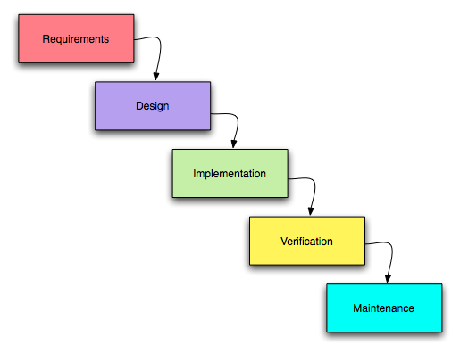
Figure I. Waterfall Methodology

Requirements
The requirement phase states what the system should do. At this stage the project of the scope is determined alongside the resources for the project, allocation of work for each member, timeline of the project, and the details of each stage.
Design
After gathering all the requirements, the developer develops solutions that meet the requirements. This phase focuses on the overall blueprint of the software including its user interface and architecture.
Implementation
Once the design is finalized and approved, the developers build from the specifications of design and collect research needed for the development.
Verification
The verification stage is dedicated to quality assurance and testing of the game alongside fixing the possible errors and bugs that may appear during development.
Maintenance
After the initial release, the developers address the additional bugs that may appear and continue to provide fixes that have not appeared during the initial verification stage. This includes fixing incompatibility issues provided within the limitations of the software and fixing bugs that occurs inside the game.

Gantt Chart
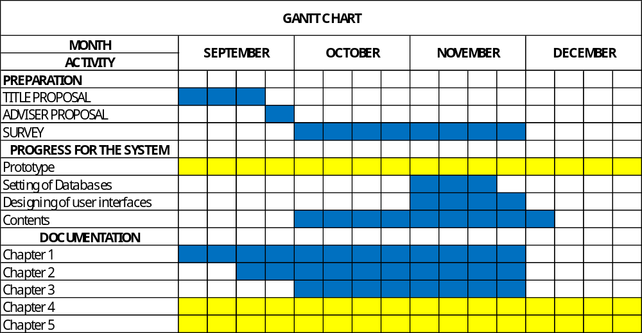

Work Breakdown Structure
Research and Planning
This activity is shared between all members of the group; discussions are held to ensure same ideas are on the same page before proceeding to later stages of the planning. Research is done by everyone.
Document Handling, Formatting and Management.
This activity is handled mostly by the project manager, to ensure proper documentation of the research and to ensure software requirements are present and testing is adequate.
Development and Art
The majority of the direction in development and the procurement of art and art styles is handled by the lead developer.
Testing, Quality Assurance and Analysis.
The final testing and quality assurance is done by the system analyst and system analyst ensuring all functions are proper and there are no inconsistencies within the papers and the software itself.

Feasibility Study
The proposed project is a game-based learning platform designed to teach programming concepts, particularly Lua, to Grade 11–12 ICT and STEM students. The game will combine survival and crafting mechanics in an open-world sandbox environment, with embedded coding challenges to develop logical reasoning, problem-solving, and practical programming skills.

Technical Feasibility
- Software Requirements:
  - Game engine: Unity or Godot (supports Lua scripting or C# for logic)
  - Database: For storing student progress and scores (e.g., SQLite or Firebase)
  - IDE/Editor: Visual Studio Code or built-in game editor
- Hardware Requirements:
  - Development PCs with sufficient processing power for game design
  - Students’ PCs capable of running the game
- Skills & Expertise:
  - Developers must have knowledge in game development, programming (Lua/Python), and UI/UX design
- Assessment:
  - The project is technically feasible because the required tools and skills are available, and the project scope is manageable for a school-level implementation.

Economic Feasibility
Estimated Cost
Game Server Hosting – 250 Pesos Per Month
Other Software Costs – 1000 to 2000 PHP
The project is economically feasible because costs are moderate for the expected educational benefits, and school resources can cover them.

Organizational Feasibility
The proposed game-based programming project is well-aligned with the goals and priorities of Yverdon De Pestallozi School Inc., as it promotes STEM education and encourages innovative, interactive teaching methods. The survey results indicate strong interest and motivation among students for learning programming through games, suggesting high receptiveness to the platform. Overall, the project is organizationally feasible because it aligns with institutional objectives, enjoys stakeholder support, and can be successfully integrated into the school’s educational framework.

System Analysis
Systems Analysis involves collecting and interpreting facts, identifying problems, and decomposing the system into its components. It focuses on what the system should do, based on the scope of the study.

Functional Requirements
- User Accounts: The system allows each user to create a unique account with a username and password for personalized progress tracking.
- Cloud Saves: The system uploads save files to the cloud whenever changes occur and ensures cross-platform accessibility.
- Main Menu Functions:
  - Start Game: Opens save menu for selecting or creating a save.
  - Settings: Opens the settings panel to adjust audio levels.
  - Quit: Closes the application.
- Settings Panel: Users can control background music and sound effects volumes via sliders.
- Saves Menu: Users can manage save states, including continuing or deleting save files.
- Game Mechanics:
  - Procedural Map Generation: Creates unique game maps automatically.
  - Missions: Guides the player through learning objectives (Easy, Medium, Hard).
  - Ranking and Leaderboards: Tracks player progress and ranks based on mission completion.
  - Crafting and Items: Allows crafting of materials, interactive objects, weapons, and consumables, with advanced items programmable via Lua or Python.
  - Challenge Areas: Unlockable areas for learning and testing programming skills, including puzzles and boss battles.
  - Enemies: Spawn dynamically in overworld and challenge areas.
  - Day/Night Cycle: Modifies enemy spawn rates and difficulty.
  - Live Interpreter: Built-in code editor interprets Lua and Python code in real time.
  - Automatica and Algorithmica: Programmable entities that automate tasks and interactions.
  - Special NPCs: LUA and Py-san assist beginners in Lua and Python challenges.
  - Autosave: Saves progress automatically at key points and on exit.
- Interface and Controls:
  - HUD: Displays health, missions, hotbar, inventory, and crafting panels.
  - Code Editor: Prompts users to code in Lua or Python.
  - Mobile Controls: On-screen joystick and dynamic interact button for mobile users.

Non-Functional Requirements
- Platform Compatibility: Runs on Windows 10–11 and Android 8.0+, ensuring consistent performance.
- Usability: Interface is intuitive for Grade 11–12 students.
- Reliability: Cloud saves and autosave features ensure progress is secure and retrievable.
- Security: User accounts and data are protected.
- Performance: Smooth gameplay even with procedural map generation and multiple challenges.
- Scalability: Supports multiple save files and future expansion of missions or content.

Activity Diagram (Description)
- User logs in or creates a new account.
- User accesses the main menu (Start Game, Settings, Quit).
- If Start Game is selected, the system opens the saves menu to continue or create a save.
- User navigates the game world, completing missions, crafting items, interacting with NPCs, or entering challenge areas.
- System interprets code submitted by the user through the live interpreter.
- Progress and achievements are updated in cloud saves.
- User quits or pauses the game; autosave ensures progress is recorded.

System Design

Analysis and Design Model
The system is modularized into the following components:
- User Account Module: Handles registration, login, and authentication.
- Save Management Module: Cloud saves, autosave, and multi-platform access.
- Game Engine Module: Procedural map generation, missions, day/night cycles, enemies, and challenge areas.
- Crafting and Items Module: Manages crafting mechanics, item categories, and programmable enhancements via Lua and Python.
- Coding Modules: Live Interpreter, Automatica, Algorithmica, and NPC assistance systems.
- UI Module: HUD, code editor panel, inventory, hotbar, crafting panel, and mobile controls.

Entity Relationship (Description)
Key entities include:
- User: Unique account with progress and save files.
- Mission: Objectives categorized by difficulty (Easy, Medium, Hard).
- Item: Materials, interactive objects, weapons, consumables.
- Automatica / Algorithmica: Programmable craftables tied to coding challenges.
- NPCs: LUA and Py-san for guidance in early challenges.
Relationships: Users complete missions, craft items, interact with NPCs, and program Automatica/Algorithmica to progress.

Interface Design (Description)
The interface includes:
- Main Menu: Access to game start, settings, and quit functions.
- In-Game HUD: Displays health, missions, hotbar, inventory, and crafting options.
- Code Editor Panel: Allows live coding in Lua and Python.
- Pause Menu: Resume, access settings, or quit.
- Mobile Controls: On-screen joystick and interact button for movement and object interaction.

