SandEE: AN EDUCATIONAL MULTI-PLATFORM 2D OPEN WORLD SURVIVAL CRAFTING GAME FOR LUA AND PYTHON FOR ICT AND STEM STUDENTS OF YVERDON DE PESTALLOZI SCHOOL INC.
Game Design Document

Contents
Scope 3
User Interface 3
Gameplay Scope 4
Core Gameplay Mechanics 5
Gameplay 7
Storyboard 8

Scope
SandEE is a video game designed as a supplementary learning game. The game is designed primarily to be played single player with a leaderboard system to encourage progress among players.
The scope of the game is listed below.

User Interface
- Main Menu
The interface where the player interacts at the start of the game, the player can choose to load a previous save file or create a new game. In the main menu the players can also change volume settings for sound effects and music.
- Hotbar
The hotbar indicates what item is currently selected for the player to use.
- Mission Panel
The mission panel currently lists the available objectives for the player to achieve.
- Inventory
The inventory system stores the current held items by the player available to use for crafting and hotbar usage.
- Code Editor Panel
A panel for editing code in Lua and Python respectively with a built-in compiler.
- Crafting Panel
An interface designed to let the player combine their current held items.

Gameplay Scope
- Environment
Interactable Objects <NAMES TO BE CHANGED>
Includes procedurally generated objects and player induced interactable objects.
Crafting Station
Smelting Station
Cooking Station
Trees
The player would be able to chop down the trees and gather them as resources for crafting.
Bodies of water
This area is interactable by the player and serves as a dedicated source of water.
Underground Areas
These areas are meant as separated environments denoted by cave entrances. The underground areas include:
Naturally Spawning Enemies
Inside the caves, enemies will naturally spawn regardless of daytime.
Naturally Generated Ores
Ores are interactable objects generated inside the game and can be smelted into materials using an appropriate station.
Biomes
Plains Biomes
The default plains biome where the player will spawn.
Desert Biomes
A different biome with a different set of materials and enemies available.
Snow Biomes
A different biome with a different set of materials and enemies available.
Challenge Areas
The challenge areas serve as a progression for the player to verify their learning regarding Lua and Python. The entrance to these challenge areas will appear as the player progresses through the missions.

Core Gameplay Mechanics
- Procedural Map Generation
The map will be randomly generated by a random seed at the start of a new game.
- Procedural Structure Generation
The structures and interactable objects are also generated on top of the randomly generated maps.
- Autosaving
The game autosaves at crucial moments and periodically.
- Automatica
Robot-like craftables that allow the user to automate certain processes by programming it through Lua, unlockable through the Lua-focused challenge areas.
Automaticas can be used to automate interaction with objects and aid the player in combat.
- Algorithmica
Allows the user to imbue regular items with automation by programming it through Python, unlockable through the Python-focused challenge areas.
- Missions
Missons will be listed and given automatically to the player. As the player progresses the difficulty of the missions will scale accordingly.
Missions are based on the literature of the current version of Lua and Python binaries specified on the version of the game.
- Ranks
Ranks can be raised by completing missions accordingly. The player’s ranks will be tied to their accounts and will be displayed in the game leaderboards for the players to compare their progress in-game.
- In-Game Compiler
The game features a code editor panel for in game code compiling for the player to test their input codes.
Lua
Lua programming language is used for programming Automatica within the game.
Python
Python programming language is used for programming automation for Algorithmica within the game.

- Daytime Cycle
The game cycles through daytime and nighttime to determine enemy spawn rate on the overworld.
Daytime
A cycle wherein enemy spawn rates are lower than usual.
Nighttime
A cycle wherein enemy spawn rates are increased.
- Combat
The player can engage in combat by utilizing crafted weapon in the game. Combat involves the player with the goal of depleting an enemy health pool to zero. When the enemy health pool is depleted, the enemy drops an item within its designated item pool.
- Progression
Progression can be measured by coding knowledge of the player, the more coding he can do the more utility he can add to the Automatica and Algorithmica. Adding code to Automatica allows it to be automated and adding code to Algorithmica allows items to have more damage and inflict additional effects.

Gameplay
- Player spawns in a natural world.
- Players gather resources to craft items and place objects on the world.
- Players add utility by coding.
- Player tackle missions by utilizing the items they have imbued with coding.
- Players unlock more challenges by completing previous missions.

Storyboard
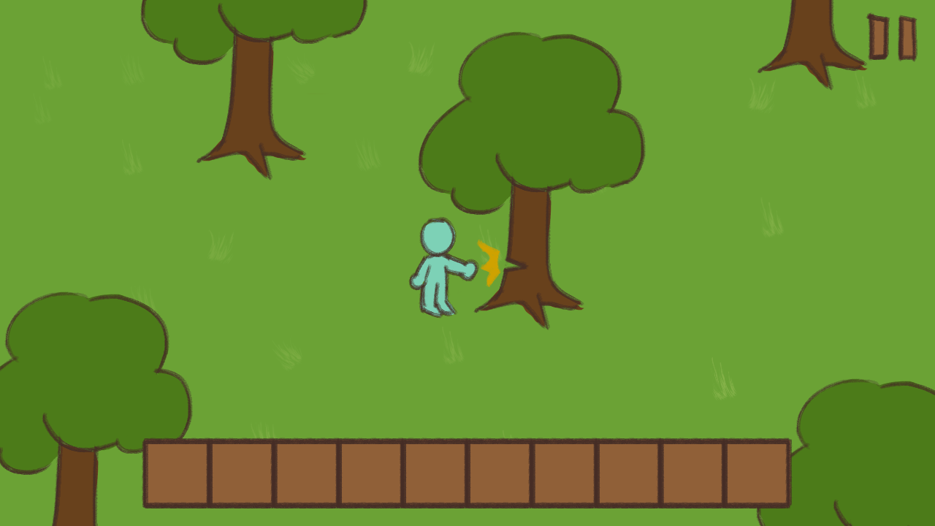
Player interacting with a tree.
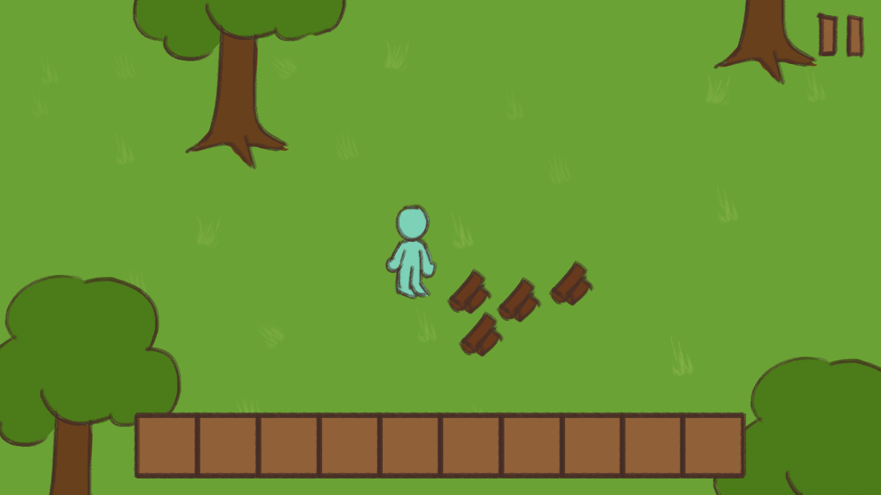
Player collecting resources from a tree.

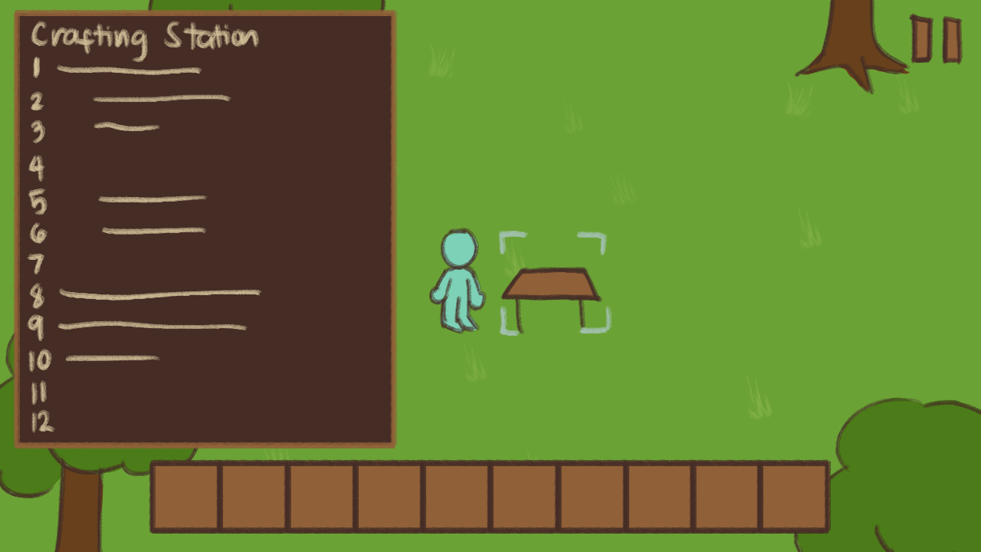
Player interacting with a crafting station
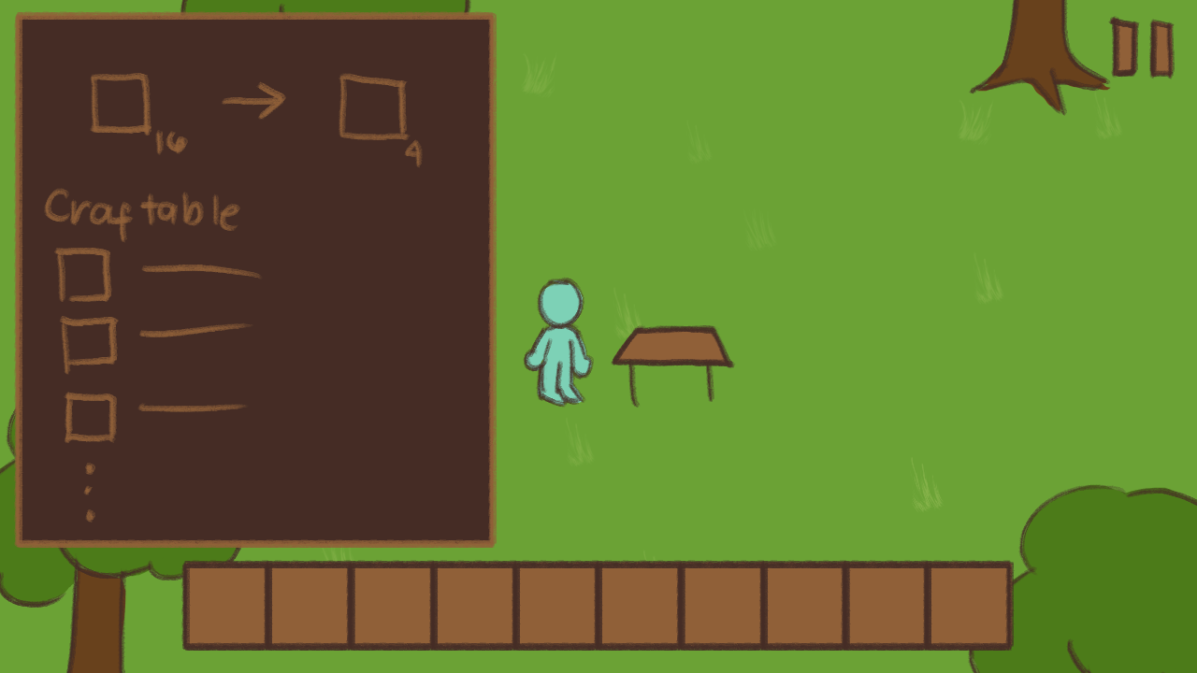
Player crafting items

