SandEE: AN EDUCATIONAL MULTI-PLATFORM 2D OPEN WORLD SURVIVAL CRAFTING GAME FOR LUA AND PYTHON FOR ICT AND STEM STUDENTS OF YVERDON DE PESTALOZZI SCHOOL INC.
A Thesis
Presented to the Faculty of the
Information and Communications Technology Program
STI College San Jose Del Monte

In Partial Fulfilment
of the Requirements for the Degree
Bachelor of Science in Computer Science
Glenn Marco B. Accad
Adrian V. Gallano
Jefferson G. Mamauag
Jose Mari Christian V. Tayag

November 2026

ENDORSEMENT FORM FOR ORAL DEFENSE

TITLE OF RESEARCH: SandEE: An Educational Multi-Platform 2D Open World Survival Crafting Game for Lua and Python for ICT and STEM Students of Yverdon de Pestalozzi School Inc.

NAME OF PROPONENTS: Glenn Marco B. Accad
Adrian V. Gallano
Jefferson G. Mamauag
Jose Mari Christian V. Tayag

In Partial Fulfilment of the Requirements
for the degree Bachelor of Science in Computer Science
has been examined and is recommended for Oral Defense.

ENDORSED BY:

Norvin Shaq F. Lintag
Thesis Adviser

APPROVED FOR ORAL DEFENSE:

Enoch James C. Tayanguna
Thesis Coordinator

NOTED BY:

Shiela Marie B. Llesol
Program Head

November 2026
APPROVAL SHEET

This thesis titled SandEE: An Educational Multi-Platform 2D Open World Survival Crafting Game for Lua and Python for ICT and STEM Students of Yverdon de Pestalozzi School Inc., prepared and submitted by Glenn Marco B. Accad; Adrian V. Gallano; Jefferson G. Mamauag; and Jose Mari Christian V. Tayag, in partial fulfillment of the requirements for the degree of Bachelor of Science in Computer Science, has been examined and is recommended for acceptance and approval.
Norvin Shaq F. Lintag
Thesis Adviser
Accepted and approved by the Thesis Review Panel
in partial fulfillment of the requirements for the degree of
Bachelor of Science in Computer Science

Louis Matthew P. Sindao | Lianoel Vergante
Panel Member | Panel Member

Enoch James C. Tayanguna
Lead Panelist

APPROVED:
Enoch James C. Tayanguna | Shiela Marie B. Llesol
Thesis Coordinator | Program Head

November 2026

Acknowledgements
The researchers would like to express their sincere gratitude to the individuals and institutions who made this study possible.
To their thesis adviser, Mr. Norvin Shaq F. Lintag, for his guidance, patience, and constructive feedback throughout the planning, development, and writing of this study;
To the thesis coordinator, Mr. Enoch James C. Tayanguna, for his support in the coordination, review, and defense process of the study;
To the members of the Thesis Review Panel, Mr. Louis Matthew P. Sindao and Mr. Lianoel Vergante, for their valuable comments and suggestions that helped improve the quality of this work;
To the faculty and staff of the Information and Communications Technology Program of STI College San Jose del Monte, for providing the academic environment and resources needed to complete this study;
To the Grade 11 and 12 ICT and STEM students of Yverdon de Pestalozzi School Inc., for their participation in the needs assessment and evaluation of SandEE;
To their parents, guardians, and families, for their unwavering love, patience, and moral support; and
To their friends, classmates, and everyone who contributed in one way or another to the completion of this study, the researchers offer their heartfelt thanks.

Abstract
Title of Research: SandEE: An Educational Multi-Platform 2D Open World Survival Crafting Game for Lua and Python for ICT and STEM Students of Yverdon de Pestalozzi School Inc.
Researchers: Glenn Marco B. Accad, Adrian V. Gallano, Jefferson G. Mamauag, and Jose Mari Christian V. Tayag
Degree: Bachelor of Science in Computer Science
Date of Completion: November 2026
Keywords: game-based learning, Lua, Python, educational game, programming education, survival crafting, open-world game
This study developed SandEE, an educational multi-platform 2D open-world survival crafting game designed to supplement the learning of Lua and Python among Grade 11 and 12 ICT and STEM students of Yverdon de Pestalozzi School Inc. The study was motivated by a needs assessment survey of 104 students, which showed limited familiarity with Lua but strong interest in learning it through interactive, game-based methods. Using the Waterfall development model, the researchers designed and developed a single-player game that combines procedural world generation, survival and crafting mechanics, mission-based progression, and embedded Lua and Python interpreters. Player-written programs control LUA robots and Algorithmica stations, allowing code to affect the game world in real time; syntax and runtime errors are reported in the in-game editor so debugging becomes part of the learning process. The game also includes themed Lua and Python dungeons, knowledge and quiz altars, a programming encyclopedia, and optional online accounts, cloud saves, and leaderboards. The system was evaluated through user testing and expert review using selected ISO 25010 software quality characteristics. The evaluation produced an overall weighted mean of [insert overall weighted mean], interpreted as [insert interpretation]. The results indicated that the game met its functional requirements and was rated favorably in terms of functional suitability, usability, reliability, and performance efficiency. The study concludes that SandEE can serve as a supplementary learning tool that makes programming practice more interactive, contextual, and engaging for beginner learners. Recommendations for further development include additional missions, classroom integration, accessibility improvements, and a longer-term study of learning outcomes.

List of Tables
Table | Title | Page
1 | Functional Modules and Descriptions | 49
2 | Hardware | 58
3 | Software | 59
4 | Budgetary Estimate | 63
5 | Mean Range Interpretation Legend | 67
6 | Profile of Respondents | 67
7 | Summary of Needs Assessment Findings | 68
8 | Summary of System Evaluation Results | 71
9 | Actual Thesis Expenses | 80
10 | SandEE Controls | 82

List of Figures
Figure | Title | Page
1 | Waterfall Methodology | 45
2 | Conceptual Framework | 48
3 | System Architecture | 50
4 | Data Flow Diagram Level 0 | 53
5 | Data Flow Diagram Level 1 | 54
6 | Entity Relationship Diagram | 55
7 | Hierarchical Chart | 56
8 | Overworld Gameplay Flowchart | 57
9 | Dungeon Gameplay Flowchart | 58
10 | SandEE Gameplay Screenshots | 65
11 | Lua Familiarity and Learning Perceptions | 68
12 | Lua Feedback and Interest | 69
13 | Python Familiarity and Learning Perceptions | 69
14 | Python Feedback and Interest | 70
15 | Project Gantt Chart | 79

List of Appendices
Appendix | Title | Page
A | Gantt Chart | 79
B | Actual Thesis Expenses | 80
C | User's Manual | 81
D | Curriculum Vitae of Researchers | 84
E | Adviser's Acceptance Form (Proposal Stage) | 88
Table of Contents
Acknowledgements iv
Abstract v
List of Tables vii
List of Figures viii
List of Appendices ix
Introduction 12
Background of the problem 14
General Problem 15
Specific Problem 15
Overview of the current state of the technology 17
Objectives of the study 20
General Objectives 20
Specific Objectives 20
Scope and limitations of the study 22
Review of related literature/studies/systems 36
Foreign Literature 36
Local Literature 37
Foreign Studies 38
Local Studies 40
Foreign Systems 41
Local Systems 42
Synthesis 43
METHODOLOGY 45
Conceptual Framework 47
System Design Specification 48
Diagrams 52
Hardware/Software 58
Calendar of Activities 61
Budgetary Estimate 63
Human Resources 64
Results and Discussions 65
Overview of the Results 65
System Implementation 65
Data Gathering Procedure 66
Statistical Treatment of Data 66
Needs Assessment Survey Results 67
System Evaluation Results 70
Expert Feedback 71
Conclusion 73
Summary 73
Conclusions 73
Recommendations 74
References 76
Appendices 79
Appendix A. Gantt Chart 79
Appendix B. Actual Thesis Expenses 80
Appendix C. User's Manual 81
Appendix D. Curriculum Vitae of Researchers 84
Appendix E. Adviser's Acceptance Form (Proposal Stage) 88

Introduction
In recent times, especially in information communication technology, programming has been the focus of computing education. The recent advent of several tools has made coding more accessible than ever (Becker, 2023). Programming has been a challenge for learners. The proliferation of digital technologies has made programming skills increasingly important across various disciplines. This shift extends beyond traditional computer science domains (Lin, et.al., 2025). According to industry reports, the demand for Lua developers has been steadily increasing in recent years. As more companies turn to Lua for its speed, simplicity, and versatility, the need for skilled Lua developers has never been higher. In particular, the gaming industry has seen a rise in Lua-related job openings, with many companies looking for developers proficient in Lua scripting (Crudu, 2024). The Lua scripting language is a fast, procedural programming language it was designed to be highly customizable with simple API in the C programming language so that programmers could easily make changes to fit their needs. Python has a simple syntax that allows developers to write programs with fewer lines compared to other programming languages Additionally, Python as a scripting language has been steadily gaining traction since its inception. Its simplified syntax allows learners to easily learn and grasp the coding structure of the scripting language (Python, 2021).
Yverdon De Pestalozzi School Inc. is a private senior high school offering STEM and ICT strands, dedicated to developing students’ technical skills, academic competence, and readiness for future careers through a supportive and well-structured learning environment.
According to Lampropoulos (2023), Game-based learning emerged as a useful education approach that can be facilitated and enrich the learning process especially in students. This approach creates a motivational virtual learning environment that consciously engages and encourages students to actively participate in educational activities. This approach has also been used extensively in the field of programming, allowing an alternative approach to learning various programming concepts.
In a survey conducted to ICT and STEM Senior High School students of Yverdon De Pestalozzi School Inc., a total of 104 respondents participated, consisting of 22 students from Grade 11 ICT (21.2%), 32 from Grade 11 STEM (30.8%), 16 from Grade 12 ICT (15.4%), and 34 from Grade 12 STEM (32.7%). The results revealed that most students demonstrated avergae familiarity with the Lua programming language, suggesting that it is relatively new to many respondents. In addition to this, the majority expressed positive attitudes toward learning Lua through supplementary game-based activities, with 81 (78.9%) agreeing that such an approach would improve their understanding of programming concepts and 76 (73%) showing motivation to explore Lua using an interactive approach. On the other hand, Python received generally favorable feedback, with 84 (80.8%) of participants finding its syntax and structure easy to understand and applicable to programming tasks. Overall, the findings indicate that while students are less experienced with Lua compared to Python, they show strong enthusiasm and willingness to learn it through interactive and game-oriented methods that enhance engagement and learning outcomes. As a result, introducing a gamified approach of learning Lua and Python is applicable to the students at the school.
SandEE is an educational 2D open world survival crafting game for Lua and Python. It introduces several programming concepts related to Lua and Python. Furthermore, SandEE also includes gameplay that can serve as an exercise to advanced users of Lua and Python. The proposed study offers a supplementary learning approach for Lua and Python by slowly introducing its syntax and structure. The game embeds interpreters for Lua and Python in which code that is run impacts the game environment to show visual feedback, as well as to provide a realistic basis to the player as the interpreters will give information accurate to its real use-case. Progression is achieved through the mission system, which guides the player to progress in learning. These missions will eventually lead to rewards to further gratify the player and give them feedback on their progress.

Background of the problem
The rapid advancement of technology has significantly transformed educational methodologies. Traditional learning, which often emphasizes theoretical concepts and static exercises, struggles to fully engage students or prepare them for real-world problem-solving. In contrast, educational games have emerged as an innovative approach to learning, combining interactivity and engagement with skill development. Popular examples like Duolingo demonstrate how gamified systems can make learning both effective and enjoyable. Game-based learning in programming has shown the potential to enhance logical reasoning, problem-solving, and creativity through active participation.
To better understand the learning preferences of ICT and STEMS students, a survey was conducted among the grade 11 and 12 ICT and STEM students of Yverdon De Pestalozzi School Inc. The results revealed that most respondents had average familiarity with the Lua programming language, with the majority rating their understanding between 2 and 4 on a 4-point scale. However, despite this lack of experience, 82 (78.9%) of respondents rated 2, 3, and 4 when asked how helpful and motivating it would be to learn Lua through game programming. For comparison, students showed higher familiarity with Python, averaging between 2, 3 and 4 in both ease of use and coding level. Yet even those comfortable with Python expressed strong interest in learning programming concepts through interactive, game-based methods. These findings indicate that students are more receptive and motivated when learning involves playing, which shows what happens inside the game, experimentation, and engagement rather than passive listening and reading books.
To address these findings, the proposed game introduces an immersive, game-based platform that integrates survival and crafting mechanics within an open-world sandbox-type environment. Through hands-on coding challenges embedded in gameplay, it aims to foster critical thinking, logical reasoning, and practical programming skills. This approach seeks to make programming educational, creative, experiential, contextual, and enjoyable.

General Problem
How to develop a game to supplement the high interest in learning Lua and Python through a game?
Despite low familiarity with ICT and STEM students, survey results have shown that interest in learning Lua and Python is high. Furthermore, the results have also shown an increasing interest in learning these languages using a more interactive and engaging approach through a game.

Specific Problem
- How to develop a game that enhances programming skills by providing hands-on learning where concepts are learned through experience?
Many ICT and STEM students have shown a strong interest in learning programming languages such as Lua and Python, particularly through interactive and engaging methods. Based on the survey conducted, there is a clear inclination toward learning through game-based experiences that allow the practical use of programming concepts. Therefore, this study focuses on developing a game that enhances programming skills by providing hands-on learning where concepts are learned through experience, serving as an innovative approach to support growing interest in programming.

- How to develop a game that provides direct visual feedback as players learn and apply programming concepts?
Students often show greater engagement and understanding when they can immediately see the results of their actions while learning. In programming education, providing direct visual feedback allows learners to observe how their inputs affect outcomes in real time, creating a more interactive and immersive experience. Therefore, this study aims to develop a game that provides direct visual feedback as players learn and apply programming concepts, promoting better comprehension and active participation through visual interaction.
- How to develop a game that realistically responds to player errors by embedding Lua and Python interpreters within the system?
To create a more authentic and educational programming experience, it is important for a game to respond realistically to player inputs, including coding errors. Embedding Lua and Python interpreters within the system enables real- time evaluation of player code, allowing the game to simulate how actual programming environments handle mistakes.
- How to develop a game that introduces the programming structure and syntax of Lua and Python?
Learning programming languages such as Lua and Python requires a clear understanding of their syntax and structural rules. Introducing these foundational concepts through an interactive approach can make learning more engaging and effective.

Overview of the current state of the technology
In recent years, advancements in teaching coding through educational and engaging means have been accomplished. There are ways, including game-based learning and digital courses, that provide plenty of valuable knowledge on how to code to solve problems and perform tasks.
Philippine Coding Camp (2023)
Such examples include the Philippine Coding Camp. These are digital learning bootcamps that primarily focus on teaching students of any age by making the courses simpler, welcoming, and open to beginners and experienced learners alike. Both provide structured courses that teach the fundamentals and concepts of programming, which they can later apply to what they have learned through exercises and challenges. They use platforms such as Roblox as a supplement and make learning more engaging. As learners progress through the courses, new concepts are slowly and simply introduced for them to better understand and retain what they are learning.
While these courses are structured, there are limitations that can be addressed. Such as the focus is only centered on the topics of the course. By making the process more hands-on, it removes the restriction of complying with the structure of the course and letting the learners learn in their own way with similar guidance.

Logiscool (2025)
Logiscool is a similar coding camp established worldwide and has a digital platform where they also teach digital courses. They provide programs where in each, they teach digital literacy, AI, and coding. They integrate gaming platforms such as Roblox and Minecraft into their learning curriculums to make learning more interesting. In addition, they also use artificial intelligence to support teaching. Part of the programs they teach are emerging languages such as Python and Lua. Python is taught within topics such machine learning, and Lua is primarily used in Roblox to create games and experiences. Logiscool’s main target is younger users but are still open to everyone.
Logiscool’s programs thoroughly teach its learners about the topics, provide and hones skills such as critical thinking and creativity. But by creating a more engaging way to teach, similarly to how they use games, learners can better learn and apply their skills into practical applications.
Hello World (2024)
Hello World is a game that primarily teaches Java and C#. It teaches fundamental concepts of these two-programming languages and integrates them into gameplay. Throughout Hello World, introductory lessons are provided, then the player must use what they have learned to progress. The game then adds the challenge of using different concepts to solve a given problem. It teaches through direct engagement with languages since it is incorporated into the gameplay. The strength of the system comes from the interactive process of learning languages.
This study provides aims to recreate the process of learning through interaction with languages, but uses two emerging languages, Lua and Python. Java and C# are already commonly taught in the field, but there is a growing need in the industry that seeks developers with knowledge of Lua and Python.

Code Combat (2025)
CodeCombat is a digital gaming platform that primarily focuses on teaching fundamentals of programming and applying it into game scenarios. Ozaria is built from CodeCombat, where Python is one of the main focuses. They have a custom built-in engine and interpreter that helps beginners in learning how to code. This platform can be integrated in school settings, allowing students to share their projects with others and teachers to grade their work. CodeCombat works by teaching students first, then placing them in game scenarios where their knowledge is put to the test. Ozaria expands this by creating a storyline that progresses with the learner’s skill and knowledge on the subject.
There are limitations to this, however. While this type of learning is more engaging, it lacks the structured format that courses provide. They teach first then send the learners into performing tasks. The study aims to bridge the gap between digital courses and gamified learning by blending the two ways of learning into a consolidated process. By merging the structured format of courses and the hands-on engagement that games provide, this creates a foundation for students to learn programming concepts in a unified form.
CodinGame (2025)
CodinGame is an online gaming platform that uses coding as its main method of playing. It challenges developers to use their skills in competing against others across different types of games. It encourages the application of what the user knows about programming. It features several programming languages such as Lua and Python, and developers must utilize their skills of the language throughout CodinGame’s challenges and competitions. This type of learning helps developers see what they can still learn and improve to solve future challenges and tasks they may face.
CodinGame is limited since it primarily focuses on competition against other players. It doesn’t provide an exact way to teach; it only points out what is lacking when it comes to knowledge. This type of learning is limited, hence creating a game that teaches, and rewards players gives a sense of accomplishment and progress that provides a better experience compared to the competitive nature of CodinGame.

Objectives of the study

General Objectives
To develop a game to supplement the high interest in learning Lua and Python through a game.
The proponents of the projects aim to develop a game with the goal of supplementing the high interest of learning the Lua and Python programming language through a game approach by integrating engaging gameplay with learning activities.

Specific Objectives
- To develop a game that enhances programming skills by providing hands-on learning where concepts are learned through experience.
The proponents of the project aim to create an interactive learning environment where students can apply programming concepts directly within gameplay. Specifically, the game will encourage learners to solve coding challenges that simulate real-world scenarios, promote active problem-solving, and experiential learning rather than passive observation.
- To develop a game that provides direct visual feedback as players learn and apply programming concepts.
The proponents of the project plan to use the game’s environment to display visual feedback based on the user’s coding input. Specifically, the player’s actions and written code will directly affect the environment, allowing them to see how Lua and Python interpret their logic in real time. This feedback helps learners understand programming flow and identify errors through immediate, intuitive results.
- To develop a game that realistically responds to player errors by embedding Lua and Python interpreters within the system.
The proponents of the project aim to ensure that the game reacts authentically to user errors by integrating Lua and Python interpreters. Specifically, this enables the application to detect and display syntax or runtime errors accurately, providing a realistic debugging experience. This approach helps students learn from their mistakes and develop stronger problem-solving and error-handling skills.
- To develop a game that introduces the programming structure and syntax of Lua and Python.
The proponents of the project intend to integrate Lua and Python learning modules within the game. Specifically, the application will include coding activities that demonstrate syntax rules, control structures, and logical operations in both languages. This allows users to understand and practice programming concepts naturally while progressing through the game.

Scope and limitations of the study
- User Account
  - Each user can create a unique account using their own username and password.
- Cloud Saves
  - The save file of each user will be uploaded to the internet every time the game saves.
  - The save file of each user is accessible multi-platform.
  - Cloud saves prioritize the save with the highest amount of stars to prevent conflict.
- Offline Mode
  - Allow the player to play the game offline.
  - Players can switch to online mode from offline mode.
- Online Mode
  - Allows the player to access the leaderboard and cloud saves.
- Main Menu
  - Continue
    - This allows the player to continue from their recently saved world.
  - Worlds
    - This will redirect the user to the saves menu to select their desired save or start a new save.
  - Leaderboards (Online Mode Only)
    - List the rankings of player’s acquired blue and yellow stars.
  - Cloud Save Management (Online Mode Only)
    - Allow the player to manage cloud saves.
  - Account (Online Mode Only)
    - Allow overview of the account and allow logging out.
  - Settings
    - This will redirect the user to the settings panel to adjust the game’s sound volume.
  - Quit
    - This will close the game.
- Settings Panel
  - Volume Sliders
    - BGM Volume
      - Adjusts the volume for the background music of the game.
    - Effects Volume
      - Adjust the volume for the sound effects of the game.
  - Fullscreen
    - Sets the game to full screen window.
  - Credits
    - Lists the developers and individuals who are part of the game development along with references to the materials and software used.
- Worlds Menu
  - World Creation
    - Lets the player name the world before creation.
  - Delete
    - Deletes the chosen save file upon confirmation.
  - Rename
    - Allows the player to rename their worlds.
  - Save Slot
    - Loads the chosen save file to continue its progress.
- Game Mechanics
  - Procedural Map Generation
    - Single player maps are automatically created using algorithms instead of being manually designed which allows each environment to be unique.

  - Missions
    - A list of gameplay objectives that gradually guides the player throughout the entire game.
    - Dungeon missions are separated into distinct levels of difficulties which encompasses a gradual flow of progression into learning programming.
      - Easy mission introduces basic concepts.
      - Medium missions combine concepts.
      - Hard missions teaches advanced concepts.
    - Completing missions will give the player stars and the stars they have will determine their rank.
  - Ranks
    - Ranking system will allow players to display their programming capabilities in the game.
    - Ranks can be increased by completing dungeons and earning blue stars.
  - Completion Badge
    - Granted to the player upon completing extra dungeon missions. Only given once.
  - Leaderboards
    - Sort available players by their rank.
    - Rankings are based on the blue stars the player has.
  - Crafting
    - The user will be crafting various items that improve their current state or progress the missions provided.
    - The user can craft multiple categories of items which include materials, interactive objects, weapons, and foods. Some of which can have additional functionality using programming.
    - The users can craft items to build and progress.
  - Fishing
    - Players can use fishing rods to catch fishes in bodies of water.
  - Farming
    - Players can use tools to collect seeds and build farmland near water.
  - Items
    - Materials
      - It can be used to craft materials and other craftable items.
    - Interactive Objects
      - Crafting Stations
        - Where the user can craft items.
      - Furnace
        - Allows the player to smelt ores and cook food using either wood or charcoal as fuel.

      - Chest
        - Allows the player to store items in a limited capacity.
      - Color Crafter
        - Allows the player to craft items with custom RGB colors.
        - Displays the hex number for the selected block.
        - Player can select between hex or RGB.
    - Weapons
      - Swords can be used to deal damage to enemies.
    - Tools
      - Tools such as the pickaxe, axe, and fishing rod can be used for specific purposes.
    - Food
      - Can be used to heal health.
  - Dungeons
    - Randomly generated areas that serve to give major progress for the user, challenging their skills in Lua or Python programming to unlock more mechanics.
    - Rewards the player with blue stars upon completion.
    - Serves as a guide to player’s progress.

    - Randomly spawns successively throughout the world and serve as the dungeon mechanic of the game. The next dungeon spawns after the last one are completed.
    - Includes quizzes that can be solved openly depending on the user.
    - Features Mini-Boss Battle in the last stage.
  - Caves
    - Large Caves
      - Generates in the overworld. Provides finite source of stone and ores.
    - Pixie Caves
      - Special caves with resources that regenerate after a period of time.
    - Friendly Mobs
      - Passive mobs like sheeps and wolves wander the overworld.
  - Enemies
    - Spawns randomly on the overworld and in dungeons.
    - Enemies that spawn on dungeons do not adhere to the day and night cycle.
    - Headless Fish
      - Spawns in the overworld during the night and attacks by homing and dashing into the player.

    - Desert Worm
      - Spawns in the overworld regardless of daylight. Spawns and hides in the desert and attack the player when approached.
    - Hitman
      - Spawns in the dungeon. Fires projectiles and can charge straight into the player to deal damage.
    - Pixie
      - Spawns in the Pixie Caves and attacks the player on sight.

  - Day and Night Cycle
    - Determines enemy spawning rate and difficulty.
    - Enemies deal less damage during daytime and do normal damage at night.
  - Live Interpreter
    - Serves as a built in IDE for the coding function in the game for both Algorithmica and Automatica.
    - Syntax Highlighting which will highlight the errors in programming syntax.
    - Interprets the code that is written by the player.
  - Automatica
    - Robot-like craftables that allow the user to automate certain processes by programming it through Lua, through the Lua-focused dungeons.
    - Automaticas can be used to automate interaction with objects and aid the player in combat.
    - Automaticas required placed wires to interact with stations.
    - Automaticas have the option to be renamed.
  - Algorithmica
    - Allows the user to automate actions in crafting stations, furnaces, and color crafters.

  - LUA (Live Unit Application)
    - An advanced Automatica non-player character that introduces the user to the Lua language.
  - Py-san
    - An advanced Algorithmica non-player character that introduces the user to the Python language.
  - Autosave
    - The game will automatically save the player’s progress periodically and during state changes such as entering caves and dungeons, as well as when the player quits the game.
  - Build Mode
    - Can be toggled on or off to place down blocks.

- Desktop and Mobile Application
  - HUD (Heads-Up Display)
    - Pause
      - Allow the user to temporarily pause the game, showing the Pause Menu Panel.
    - Pause Menu Panel
      - Resume
        - Resumes the current game.
      - Settings
        - Shows the settings panel.
      - Lua Management
        - Allows the player to manage the LUA robots.
      - Quit
        - Saves the game and directs the user to the Start Page.
    - Mission Panel
      - Shows the user the current missions they can do to progress.
    - Health Bar
      - Shows the user their current health.
    - Stamina Bar
      - Shows the current stamina, which drains when running.
    - Hotbar
      - Show the user their current held items.
    - Inventory
      - Shows the user their extra space and a smaller crafting area.
    - Programming Encyclopedia
      - Contain details about programming concepts for Lua and Python learned through dungeons and custom functions for Algorithmica and Automatica.
    - Code Editor Panel
      - A panel that prompts the user to code in Lua or Python to either progress in a dungeon or customize their Automatica and Algorithmica.
    - Crafting Panel
      - A panel for more advanced crafting, unlockable when the user crafts the crafting station.
    - Map
      - A representation of the world that shows the overworld, cave, and dungeons.

    - On-screen Joystick
      - Allows movement for mobile users.
    - Interact Button
      - A general button that changes depending on the items near the player's character.
    - Build Mode Button
      - Can be toggled on or off if the player wants to build.
Limitations
- The game only runs on Windows 10 – 11 and Android 8.0 and above.
Ensures the game performs consistently across devices with modern hardware and software support. Older systems may lack the necessary performance, security updates, or engine compatibility required by Godot.
- The game only supports Lua and Python for its languages.
This limitation is based on both practicality and accessibility. Lua and Python are in high demand across education, game development, and general programming, making them valuable languages for learners to practice. By restricting the system to these two languages, the game maintains a focused learning environment that is accessible to new programmers while still relevant to real-world applications.
- The game only supports single player.
This limitation ensures that each student’s learning experience remains individualized and self-paced. By focusing on single-player gameplay the game allows students to develop their skills independently and maintain consistent progress without distractions from multiplayer interactions.
- The game only references the 2025 version of official documentation for Lua 5.1 and Python 3.11.
This limitation ensures that all learning materials are consistent, stable, and aligned with a single verified source. Lua 5.1 and Python 3.11 have well- established, mature, and consistent syntax, making them reliable for teaching without frequent changes or breaking updates. By locking the game’s references to the 2025 documentation versions, students receive clear and uniform guidance.

Review of related literature/studies/systems

Foreign Literature
According to Crudu (2024), Lua developers are in high demand because it is currently widely used in the programming industry. Lua is efficient, flexible, scalable, and cost effective to apply in any programming field. According to the TIOBE Index, Lua is currently ranked as the 32nd most popular programming language. Furthermore, in a survey conducted by Stack Overflow in 2024 it is among the top 10 most loved programming languages.
According to Becker (2022), Generating high-quality learning resources is very time consuming and typically requires a high level of expertise therefore, games have been used as a learning tool for centuries; they have become more prominent in educational settings. When it comes to learning, being focused and immersed can massively improve a student’s experience.
According to Viduka (2021), Python is preferred by students and professionals alike due to its ease of use, availability, efficiency, portability, and extensibility. It is a common choice suitable for education. Many schools starting from primary to secondary, all the way to universities prefers teaching Python as primary programming languages.

Local Literature
Computer science software development evolves rapidly; innovative learning platforms transform how instructors teach and how aspiring developers learn programming. Several other solutions integrate interactive web based on learning programming languages. However, these methods of studying are not applicable to everyone. This is where a game-based solution can complement the traditional way of learning (Horlador, et., 2024)
The rapid development of computer science education signifies that traditional methods of learning are being challenged. Conventional approaches often are lacking when it comes to engaging students or providing practical application of programming concepts (Horlador, et., 2024). Traditionally, a beginner developer sits inside a classroom, listening to an instructor as they explain related programming concepts. However, there are instances wherein the beginner developer cannot follow along with the instructor’s sample codes (Horlador, et., 2024).
The current education system is outdated in the sense that it cannot keep up with the demands of a fast-paced and information-rich world outside of the classroom. In response to these challenges, innovative learning platforms can be applied to transform the way beginner developers usually learn (Horlador, et., 2024).
In today’s rapidly evolving landscape, mastering the concepts of Information Technology is crucial for the students aspiring to enter the technology industry (Abat, et al., 2024). Software development is fundamental to the innovation and efficiency of the applications and solutions tailored to specific needs and demands (Abat, et al., 2024). This caused the current curriculum to include programming languages such as Lua and Python (Abat, et al., 2024).Despite the abundance of academic materials and tutorials regarding different types of programming languages, most of the students still face difficulties in learning the fundamentals of programming and how to apply them. By implementing interactive game-based learning, it allows students to learn using an alternative method of learning that is both fun and educational. (Abat et al., 2024).

Foreign Studies
According to Eltomi (2025), the use of Lua programming language allows the game developers to easily implement core gameplay mechanics such as character movements, physics, and collision detection. This study also identified the problems that game developers encountered such as no prior knowledge in Lua programming language, Game size and complexity, and bad game designs. In relation to the study, it explains the use of Lua programming language in game development. However, the proposed study lacks the idea of showing how the actual Lua language is used in game development.
In a study done by Verbovetsksvi (2025), The authors identified the basic requirements for a game application, such as relevance to educational objectives, incorporation of game mechanics, the ability to write and debug code in the application, individualized passing of the game, and the ability to report and rate learning outcomes of students. The paper contains some fragments of the game workspace and code of a gaming application.
Several studies compare the use of Python and Lua in game development, highlighting their distinct advantages. Python, with libraries like Pygame, is favored for its simplicity and extensive community support, making it ideal for rapid prototyping and educational game development (Oleksiuk et al., 2024). However, it tends to have slower performance compared to Lua. Lua is widely used in professional game engines due to its lightweight nature, fast execution, and seamless integration with C/C++ code, making it suitable for performance-critical game scripting (MoldStud, 2025).

Tyagi’s study (2021) compares developing a 2D Flappy Bird game in both Python (Pygame) and Lua (LOVE engine), showing that while Python is easier for beginners, Lua provides better performance and embedding capabilities for commercial projects. Other research agrees that Lua excels in embedded scripting and resource-sensitive environments, whereas Python is often used for game prototyping, tooling, and educational purposes.
In conclusion, these studies demonstrate that the choice between Python and Lua depends on the project goals, with Lua being preferred for efficiency and embedding, and Python for ease of use and broad application.

Local Studies
According to a study done in the University of Mindanao-PALMA Cluster Campus Philippines aimed to determine the effectiveness of game-based learning, based on the findings it can be affirmed that implementing game-based learning strategies is highly effective, resulting in a notable enhancement of learners’ academic performance compared to conventional teaching methods. Moreover, the results encourage teachers to revisit their instructional materials and integrate game-based learning materials aligned with specific learning objectives. Additionally, the study provides substantial evidence that game-based learning significantly enhances academic performance compared to traditional instructional resources (Cezar, 2024).
According to Cezar (2022), a study was done to measure the effect of digital game-based learning. Educators and authors argued that video games are constructed on well-developed theories to engage players. The gathered data were interpreted and analyzed; the results revealed that the experimental group achieved higher scores in their academic performance test. The findings showed a significant difference in the performance for students engaging in digital game-based learning.
According to Justo et al. (2022), a study was done to analyze students’ perspectives of game-based learning. The results have been proven the game-based learning has a more significant influence on retention and class interaction when this technique is used. As a result, the findings say that game-based learning aids information acquisition and boosts student engagement through increased class interaction.

Foreign Systems
CodeCombat (2024) is a game-based learning platform that teaches languages such as Python through interactive, role-playing gameplay. Its custom-built coding engine and interpreter make it beginner friendly. The platform includes project-sharing features and teacher grading systems, making it usable in both personal and educational contexts. According to Ahlstrom (2025), the system not only simplifies coding, but they execute it in a method that emphasizes having fun. CodeCombat demonstrates how games can effectively serve as a medium for learning programming concepts.
OmegaCrafter (2025) is an open-world survival craft game set in an underdevelopment game world that is being attacked by a mysterious program. Grammi, the players’ programmable sidekick can be programmed with various actions and tasks to help with mining, logging, moving materials, and crafting items (Preferred Networks, 2025)
The Farmer Was Replaced (2023) is a game for Python-like language to fully automate various farming tasks that would otherwise be time consuming. (Herzog, 2023). Unlike most programming games, it is not divided into distinct levels that players have to complete but instead features continuous progression. Programming is done in a simple language similar to Python. The game is designed to provide basic programming concepts to the player (Herzog, 2023).

Local Systems
Philippine Coding Camp (2023) is a digital learning center that teaches Filipino students how to code through structured, hands-on programs. The system provides learning courses which teach Lua as one of the foundations for beginner and younger students while also introducing Python later as a part of the game. In relation to the study, the system highlights accessibility in programming education while sustaining engagement and interactivity that traditional digital courses may not fully achieve.
Logiscool (2025) is a digital learning platform that focuses on coding and digital literacy education. Its courses integrate popular platforms to provide engaging environments to enhance coding concepts. The system demonstrates the effectiveness of combining fun and interactivity with education.
Hello World (2024) is a game that teaches the fundamentals of Java and C#. Players apply their skills into gameplay where challenges are introduced. The game progresses based on what the players have learned so far, from introduction to more advanced topics. It is a practical application of game-based learning in the growing industry of programming.

Synthesis
The reviewed foreign and local literature, studies, and systems collectively emphasize the growing importance of game-based learning in programming education. Foreign authors (Becker, 2022; Crudu, 2024; Viduka, 2021) highlighted how games foster immersion and focus, while also pointing to the industry relevance of programming languages such as Lua and Python. Local studies (Horlador et al., 2024; Abat et al., 2024) reinforced these ideas by showing how interactive, game-based methods can complement or even surpass traditional classroom instruction, especially in engaging students who struggle with conventional approaches. Moreover, both foreign and local systems (e.g., CodeCombat, 2024; Philippine Coding Camp, 2023) demonstrated practical applications of integrating coding into interactive platforms, providing evidence that game-based solutions are not only feasible but effective in real-world educational settings.
However, despite these advances, the reviewed literature also reveals a gap: while many systems teach Python or Lua through games, few explicitly focus on bridging the fundamentals of programming with practical coding immersion tailored for beginners in the Philippine context. This gap underscores the significance of the present study, which seeks to design a game-based solution that leverages the strengths of Lua and Python while addressing the challenges faced by novice developers in traditional learning environments. In the context of learning, both data gathered from foreign and local literature are that gaming tools have been used as a powerful supplementary tool for learning and can be applicable into learning complex topics such as concepts of programming (Becker, 2022; Horlador, et al., 2024).
The difference between the gathered information from foreign and local literatures are that in foreign literature, it has been found that games have been increasingly prominent in educational settings since when it comes to learning, students can be more focused and immersed (Becker, 2022). Local literature on the other hand has found that traditional methods are becoming outdated and are challenged by more innovative means of learning, especially considering the context of teaching complex topics in Computer Science (Horlador, et al., 2024).
Foreign studies done by authors (Eltomi, 2025; MoldStud, 2025; Tiyagi, 2021) gathered that Lua and Python are applicable in implementing features much easier due to each of the advantages that the two languages have. Lua is a lightweight language and integrates with C and C++ code while Python is more beginner-friendly and applicable for prototyping and tooling.
Local studies proven by authors (Cezar, 2022; Justo, et al., 2022) found that gamified learning is an effective method of learning as it has been gathered that the group that was engaged in gamified learning scored better in comparison to the group that did not. Based on what the study has gathered from the local and foreign studies, the goal is to implement gamified learning into teaching students the concepts of Lua and Python as these two languages have been shown to be appealing for beginners to learn (Oleksiuk, et al., 2024; MoldStud, 2025).
The proposed game aims to be unique by implementing the methods of gamified learning into teaching the concepts of Lua and Python in such a way that it acts as a supplement alongside traditional learning methods. It acts to teach students in a more engaging way. It does so by applying concepts and ideas that the foreign and local literature and studies have gathered and combine them in such a way that it introduces a specialized method of teaching students various programming concepts. Lua and Python were chosen as the two programming languages to teach because of their simplicity and utility, making them appealing to teach.

METHODOLOGY
Waterfall Development Life Cycle
Waterfall methodology is a well-established project management workflow. Each process phase cascades downward sequentially through five stages, requirements, design, implementation, verification, and maintenance.
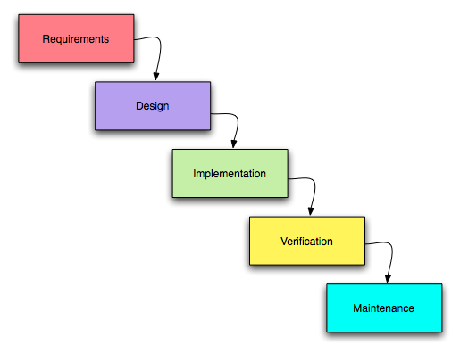
Figure 1. Waterfall methodology

Requirements
The requirement phase states what the system should do. At this stage the project of the scope is determined alongside the resources for the project, allocation of work for each member, timeline of the project, and the details of each stage.
Design
After gathering all the requirements, the developer develops solutions that meet the requirements. This phase focuses on the overall blueprint of the software including its user interface and architecture.
Implementation
Once the design is finalized and approved, the developers build from the specifications of design and collect research needed for the development.
Verification
The verification stage is dedicated to quality assurance and testing of the game alongside fixing the possible errors and bugs that may appear during development.
Maintenance
After the initial release, the developers address the additional bugs that may appear and continue to provide fixes that have not appeared during the initial verification stage. This includes fixing incompatibility issues provided within the limitations of the software and fixing bugs that occurs inside the game.

Conceptual Framework
The study is guided by the input-process-output (IPO) model, a widely used framework for describing how a system transforms identified needs into a working solution and measurable results. The model is appropriate for SandEE because the game is both a software product and a learning intervention: its design must respond to the learners' needs, its development must follow a structured process, and its output must be evaluated in terms of both software quality and educational value.
The input component consists of the learning needs and technical requirements gathered during the planning phase. These include the limited familiarity of ICT and STEM students with Lua, their strong interest in game-based learning, the programming concepts required by the curriculum, and the platform requirements of the target users. The process component consists of the Waterfall development phases and the game systems that operationalize the requirements: procedural world generation, survival and crafting mechanics, mission-based progression, Lua and Python code execution, and the supporting user interface. The output component consists of the SandEE game, the learning experiences it provides, and the results of user and expert evaluation. Feedback from the evaluation is returned to the input and process stages so that future iterations can address weaknesses and extend the game's educational coverage.
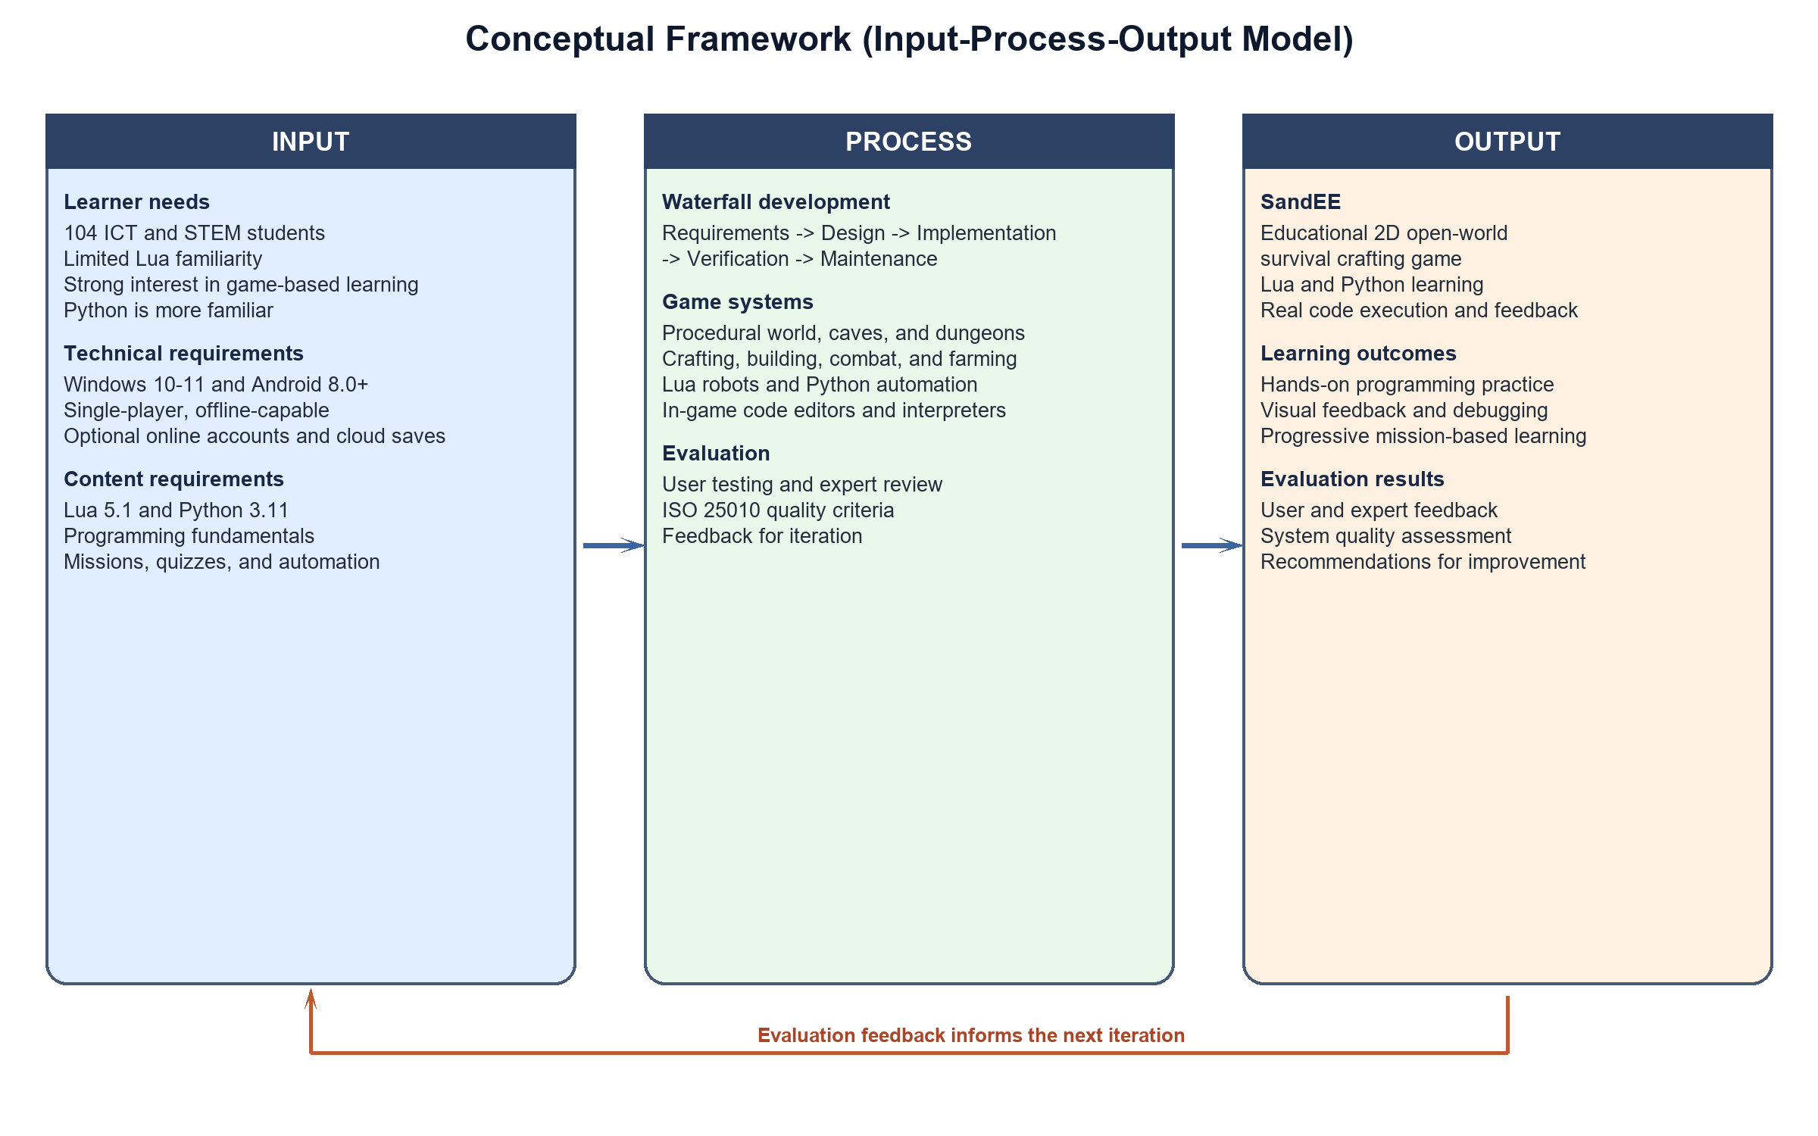
Figure 2. Conceptual framework

System Design Specification
SandEE is implemented in Godot 4.6 using GDScript for the game logic and scene composition. The project follows a modular, scene-based architecture in which the overworld, cave interiors, dungeon interiors, player, user interface, and programming tools are separate scenes or scripts coordinated by a central game instance. Four autoloads support the runtime: CrashLogger records unexpected errors, Global stores persistent state and shared services, Supabase provides optional online authentication and data access, and CloudSync manages two-way cloud-save synchronization. The main entry point is the startup mode scene, which restores a session when available and leads to the main menu.
The game uses a client-side architecture. All core gameplay, world generation, saving, and code execution run on the player's device, which allows the game to remain playable offline. Online features are optional and are accessed only when the player signs in. The language runtime is implemented as a Rust GDExtension: Lua is executed through the mlua library, while Python source is parsed with ruff_python_parser and transpiled to GDScript before execution. This design keeps the game engine independent of the language implementations while still providing real parsing, execution, and error reporting.
Functional Modules
Table 1. Functional modules and descriptions
Module | Description
World generation | Seeded terrain generation with plains, desert, snowy, and water areas; chunk-based structures, caves, and dungeon entrances.
Caves and dungeons | Cellular-automata caves, room-and-corridor pixie caves, and themed Lua/Python dungeons with knowledge and quiz altars.
Survival and crafting | Resource gathering, mining, smelting, crafting, building, farming, fishing, combat, and day/night survival.
Programming tools | In-game Lua and Python editors, syntax highlighting, code execution, error reporting, snippets, and the Programming Encyclopedia.
Automation | LUA robot stations that mine, chop, build, deposit, and fight; Algorithmica stations that automate furnaces, crafting stations, and color crafters.
Missions and progression | Mission tracker, blue and yellow stars, ranks, completion badges, dungeon rewards, and leaderboards.
Accounts and saves | Optional username/password accounts, local JSON saves, autosave, cloud saves, conflict handling, and star totals through Supabase.
User interface | Main menu, HUD, inventory, hotbar, crafting and smelting panels, minimap, pause menu, settings, and mobile touch controls.
System Architecture
The system is organized into five layers. The presentation layer contains the startup, menu, HUD, inventory, crafting, code-editor, and mobile-control interfaces. The game layer contains the overworld, caves, dungeons, player, combat, missions, and day/night cycle. The systems layer contains world generation, crafting and recipes, save/load, cloud sync, LUA robots, automation hosts, waypoints, and the minimap. The language runtime layer contains the Rust GDExtension, the Lua runtime, the Python parser and transpiler, error reporting, and the code sandbox. The data layer contains Godot resource files, local JSON saves, and the Supabase services used for accounts, cloud storage, and leaderboards.
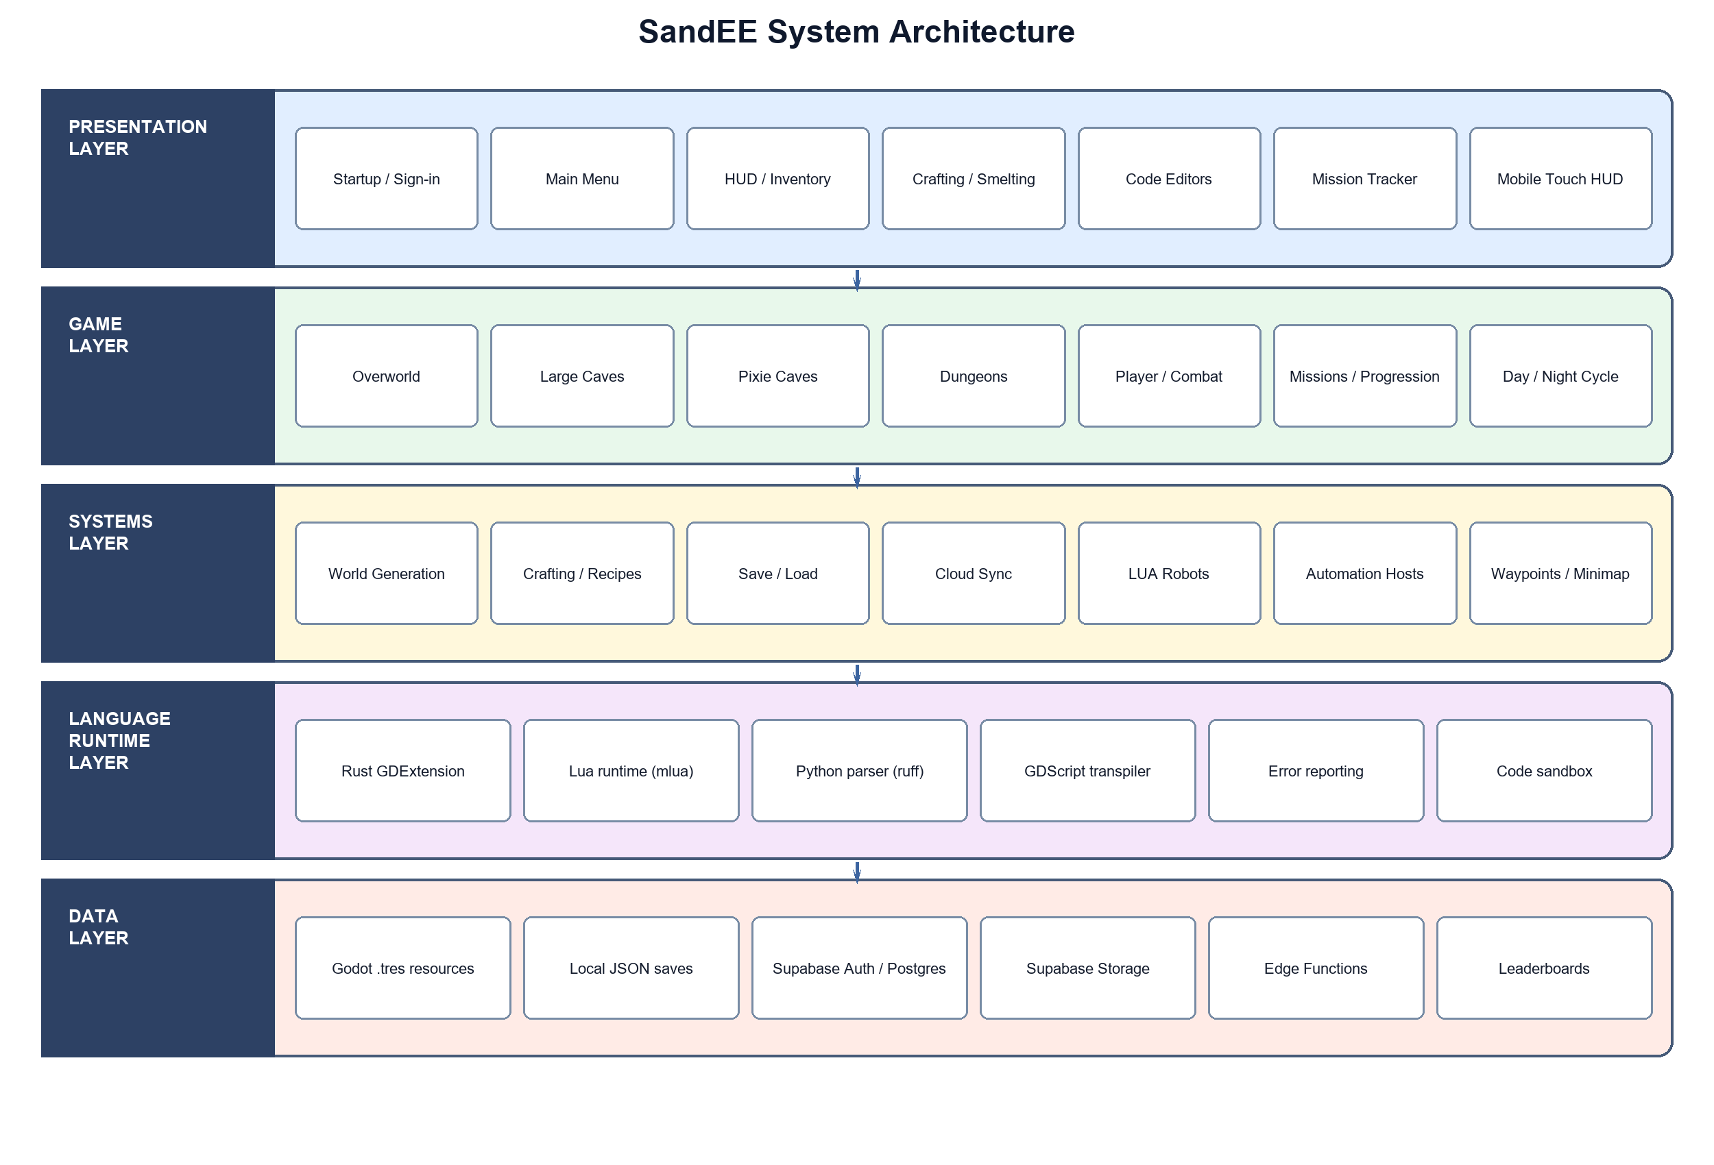
Figure 3. System architecture
World Generation and Environment
The overworld is generated from a random seed and divided into 25 by 25-tile chunks. Terrain is classified into water, plain, desert, and snowy biomes, and each chunk is populated with trees, grass, rocks, structures, mobs, and cave entrances according to seeded rules. Large caves use cellular-automata carving to produce organic caverns with stone and ore deposits. Pixie caves use room-and-corridor layouts with crystal ores and regenerating resources. Dungeons use a separate room-and-corridor generator that guarantees a knowledge room, a quiz room, an entrance room, and additional rooms for altars and chests. The world also includes a day/night cycle, ambient mob spawning, waypoints, and a minimap.
The world generator is deterministic: the same seed produces the same terrain, structures, cave entrances, and dungeon layouts. This is important for reproducibility, debugging, and fair play. The game also separates natural terrain from player-placed blocks, so the original world can be regenerated while player changes are restored from the save file.
Programming and Automation Module
The programming module is the educational core of SandEE. Players write Lua or Python in an in-game code editor that provides line numbers, syntax highlighting, snippets, and an output panel. Lua programs run through the embedded Lua runtime and can control LUA robots. Python programs are parsed and transpiled to GDScript before execution, and can control Algorithmica stations such as furnaces and crafting stations. The editors report syntax and runtime errors back to the player, and a successful run produces visible changes in the game world. This creates a direct link between code, feedback, and gameplay.
LUA robots can be renamed, given tools, assigned build materials, and switched into combat mode. They can chop trees, mine blocks, place blocks, deposit items, and fight nearby enemies. Algorithmica stations expose a Python API for loading inputs, adding fuel, smelting, crafting, and taking outputs. The Programming Encyclopedia and the Knowledge Altar provide reference material and unlockable explanations of programming concepts, while the Quiz Altar checks the player's understanding before a dungeon is cleared.
Save, Account, and Cloud System
Each world is stored in a local JSON save file associated with an account and a save slot. The game autosaves periodically and at important state changes such as entering a cave or dungeon, and it also saves when the player quits. Saves are written atomically to avoid corruption, and a sidecar file records ownership so that saves cannot be mixed between accounts. When the player is signed in and online, CloudSync uploads the local save to Supabase Storage and records its metadata in the database. Cloud-only worlds can be downloaded into free local slots, and conflicts are resolved by revision, world identity, or manual selection. The online layer also supports profiles, star totals, and leaderboards, with row-level security enforced in the database.
The account and cloud features are optional. A player can create a local account and play offline, then switch to online mode later. This supports classrooms and devices with unreliable internet access while still allowing progress to be synchronized across devices.
User Interface and Cross-Platform Layer
The user interface is designed for both Windows and Android. On desktop, the player uses the keyboard and mouse for movement, interaction, building, and combat. On mobile, a virtual joystick, contextual action buttons, and tap-to-interact controls replace the mouse and keyboard. The HUD includes the hotbar, health and stamina bars, mission tracker, minimap, inventory, crafting panel, code editors, and pause menu. All interface elements respect the global UI scale setting, which can be set to small, medium, or large. The game also uses a pixel-art visual style, responsive canvas scaling, and a consistent color palette across menus and in-game panels.

Diagrams
The following diagrams describe the flow of data, the structure of the data, the functional hierarchy, and the main gameplay loops of SandEE. The data flow diagrams show how the player, the game system, local saves, and the optional cloud services exchange information. The entity relationship diagram shows the main data entities used by the save, mission, dungeon, and automation systems. The hierarchical chart shows the major modules of the game, and the flowcharts show the expected sequence of actions in the overworld and in a dungeon.
Data Flow Diagram Level 0
Figure 4 presents the context diagram of SandEE. The player interacts with the game by issuing commands, writing code, and making menu choices. The game returns visual feedback, error messages, game state, and progress information. The game reads and writes local save files, and it exchanges authentication, cloud-save, and leaderboard data with Supabase when online features are enabled.
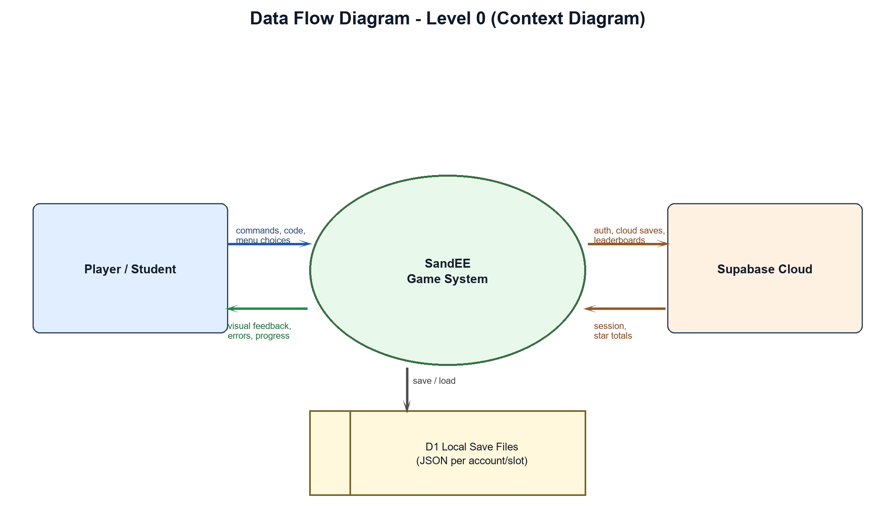
Figure 4. Data flow diagram level 0
Data Flow Diagram Level 1
Figure 5 decomposes the system into six processes. Account and save management handles sign-in, local saves, and cloud synchronization. World exploration manages terrain, caves, structures, and mobs. Gathering, crafting, and building manage resources, recipes, and placed blocks. Learning and code execution manage the editors, interpreters, and automation behavior. Mission and dungeon completion manage objectives, quizzes, rewards, and stars. Progress and leaderboard management maintain the player's profile, achievements, and ranking. The data stores hold the player profile, world save, mission progress, code programs, and game content.
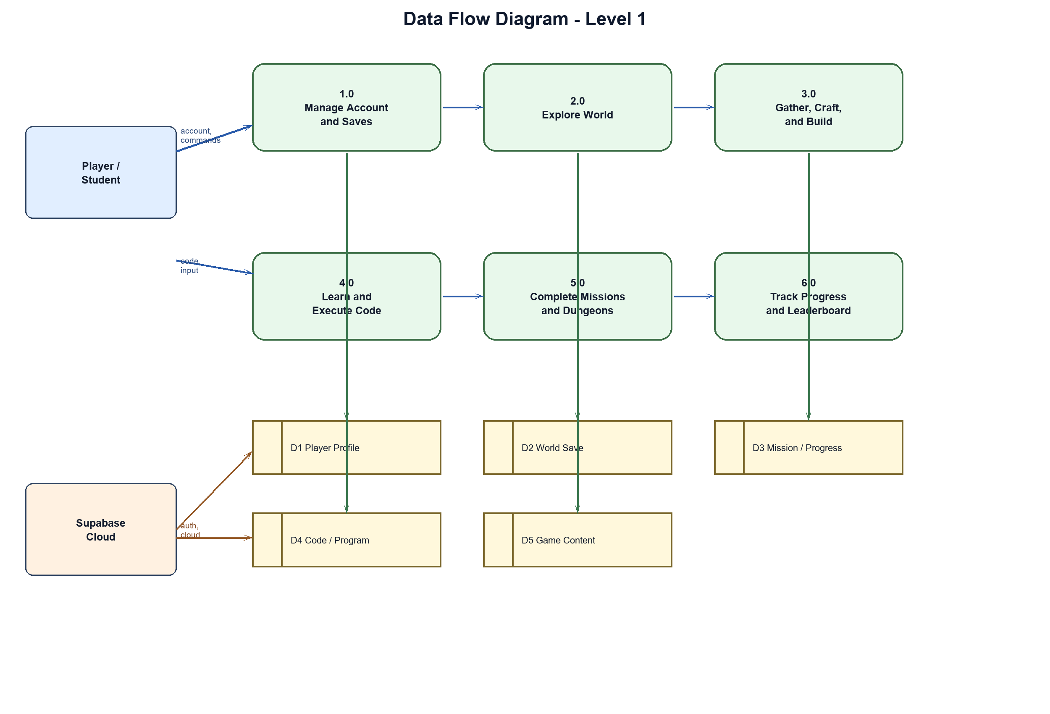
Figure 5. Data flow diagram level 1
Entity Relationship Diagram
Figure 6 shows the main entities used by the game. A player can own multiple world saves and can have progress records for multiple missions. Each mission can generate a dungeon, and each dungeon records the stars earned by the player. A world save can contain multiple LUA robots, and each robot can have an associated code program. Recipes reference the items they consume and produce. These relationships support the save system, the mission and dungeon system, and the automation system.
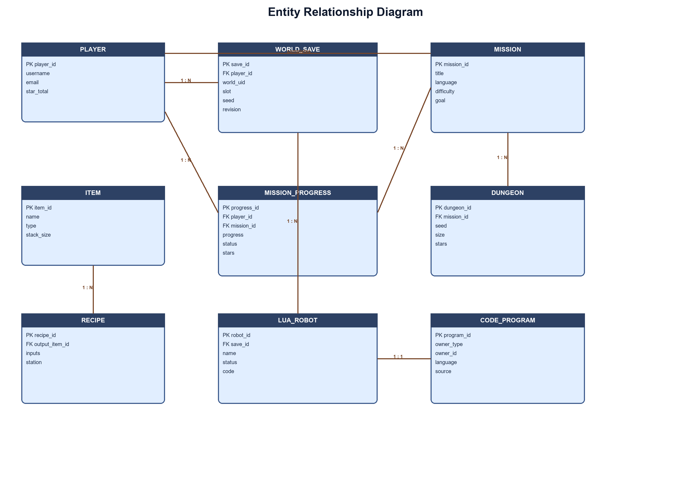
Figure 6. Entity relationship diagram
Hierarchical Chart
Figure 7 presents the functional hierarchy of SandEE. The main menu and account module provides access to worlds, leaderboards, cloud saves, and settings. The overworld module contains biomes, trees, water, caves, structures, and mobs. The cave module contains large caves, pixie caves, ores, and mining. The dungeon module contains the Lua and Python dungeons, knowledge and quiz altars, and the miniboss encounter. The programming module contains the Lua and Python editors, LUA robots, Algorithmica, and the encyclopedia. The interface module contains the inventory, crafting, mission tracker, minimap, and mobile HUD. The online module contains authentication, cloud saves, leaderboards, and profiles.
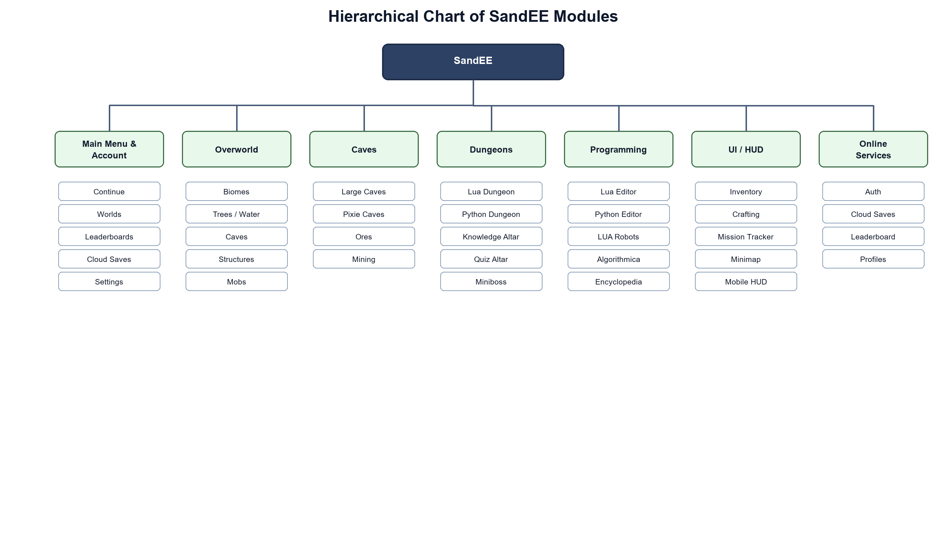
Figure 7. Hierarchical chart
Overworld Gameplay Flowchart
Figure 8 shows the main gameplay loop in the overworld. The player starts the game, signs in or chooses offline mode, and loads or creates a world. The player then explores, gathers resources, crafts items, builds structures, and programs LUA robots or Algorithmica stations. Missions provide objectives and rewards. The loop continues until the player saves and exits.
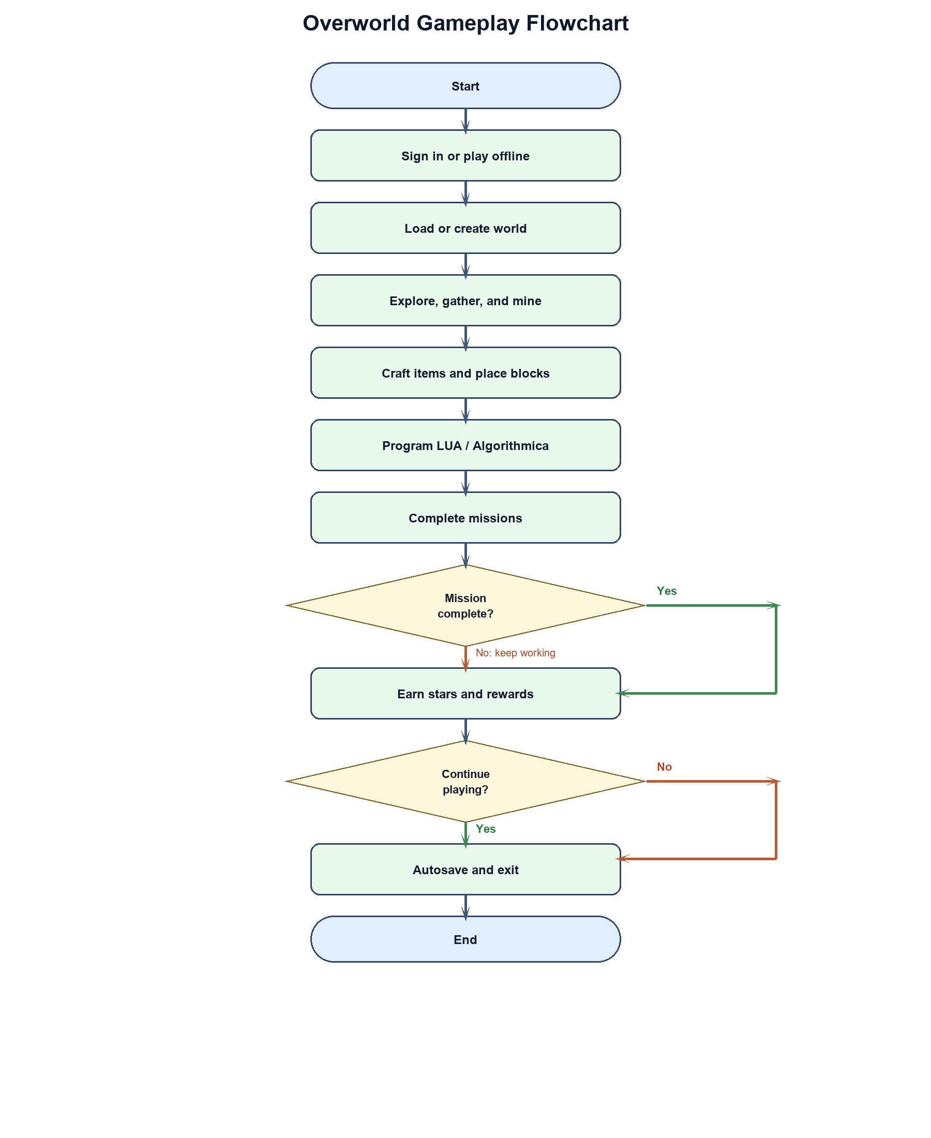
Figure 8. Overworld gameplay flowchart
Dungeon Gameplay Flowchart
Figure 9 shows the flow inside a dungeon. The player enters the dungeon, explores its rooms, reads the Knowledge Altar, answers the Quiz Altar questions, and writes and runs Lua or Python code. Correct answers and working code earn up to three stars. The final stage includes a miniboss encounter. Completing the dungeon rewards the player and returns them to the overworld.
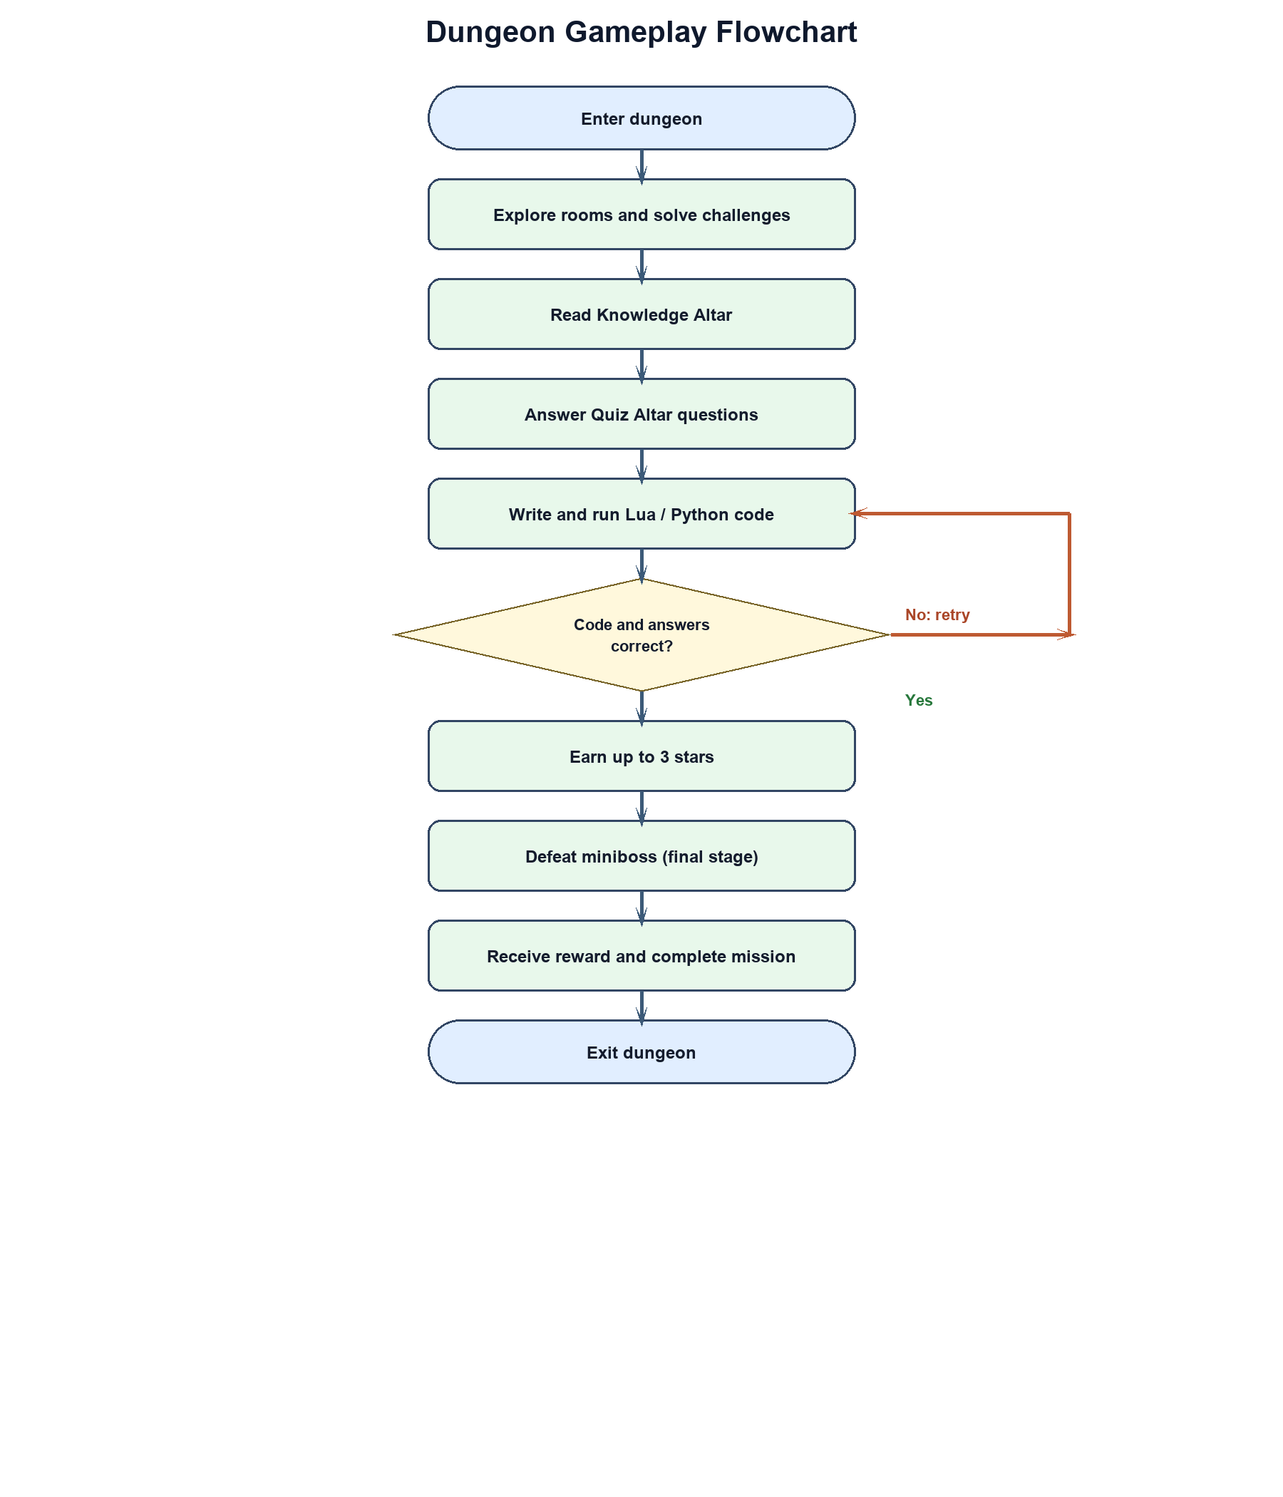
Figure 9. Dungeon gameplay flowchart
The diagrams show that SandEE is not a single linear program but a set of interacting systems. The player's actions in one system, such as mining an ore or writing a program, affect the state of other systems, such as crafting, missions, and saves. This interdependence is what makes the game a coherent open-world experience rather than a collection of separate mini-games.

Hardware/Software
Table 2. Hardware
Devices | Specifications
Desktop | CPU: AMD Ryzen 5 5600G  Motherboard: MSI PRO B550M-P GEN3  GPU: Radeon Vega 7 Integrated Graphics  RAM: 16 GB  Operating System: CachyOS (Arch Linux)
Laptop | CPU: i5-12500h  Motherboard:AN515-58-50YE  GPU: RTX 3050M  Ram: 8x2 DDR4 2400mhz sodimm  Operating System: Windows 10 Pro

Table 3. Software

Software | Purpose
Godot Engine | Game Engine
GDScript | Game Logic
Supabase | Game Database
Aseprite | Art Editing Software
Rust | Performance critical implementation
Lua | Main Scripting Language
Python | Sub Scripting Language
VS Codium | Chosen IDE.
GitHub | Version Control Software, Logger, File Storage

Calendar of Activities
During the first week of September, the developers began working on the initial draft of the study’s introduction and finalized the research title. This phase focuses on identifying the study’s purpose, significance, and scope while aligning the objectives with the project’s intended outcome. The week concluded with the team reviewing the overall direction of the research to ensure that it addressed relevant academic and industry needs.
In the second week of September, the team revised the introduction to improve clarity and alignment with the research objectives. They also began drafting Chapter I, which detailed the background of the problem, statement of the problem, and significance of the study. The group collaborated closely to ensure that the content presented a strong foundation for the succeeding chapters.
The third week of September was dedicated to additional revisions and refinements of Chapter I. The developers reviewed the document to ensure consistency, coherence, and adherence to academic standards. Feedback from peers and advisers was considered to enhance the quality and flow of the content, preparing the chapter for final review.
During the fourth week of September, the developers conducted the survey to gather data from the target respondents. The collected information served as the basis for understanding user preferences and needs. In the same week, the team began drafting Chapter II, which included the review of related literature, studies, and systems relevant to the proposed project.
The first week of October was devoted to extensive research on literature, existing studies, and software systems related to game-based learning. The developers consolidated and analyzed this information to strengthen Chapter II. By the end of the week, Chapter II was completed and prepared for initial revision.

In the second week of October, the proponents focused on drafting the hardware and software selection section. This included identifying the tools, technologies, and development environments necessary for system implementation. The week also involved outlining the technical specifications and requirements for the proposed application.
During the third week of October, the team concentrated on revising and improving Chapter III, which presented the project’s methodology. The developers refined the research design, data collection methods, and system development framework to ensure accuracy and alignment with research objectives. In the fourth week of October, the proponents carried out final revisions and grammar checks across all chapters to ensure consistency and correctness. The team also completed the initial design of the software user interface, marking the transition from the documentation phase to the beginning of system development.

Budgetary Estimate
Table 4. Budgetary Estimate
Quantity | Specifics | Approximate Cost
1 | Acer Nitro 5 AN515-50YE | PHP 49,000
1 | Ryzen 5 5600G processor | PHP 22,295
1 | Asus Prime B550 motherboard | Included above
1 | 16 GB RAM | Included above
1 | 1 TB SSD | Included above
1 | 650 W power supply | Included above
 | Total | PHP 71,295

Human Resources
Name: Norvin Shaq F. Lintag
Position: Thesis Adviser
Name: Enoch James C. Tayanguna
Position: Thesis Coordinator
Name: Deffrey Josh A. Austria
Position: Program Head

Results and Discussions

Overview of the Results
This chapter presents the results of the study in two parts. The first part reports the needs assessment survey conducted among Grade 11 and 12 ICT and STEM students of Yverdon de Pestalozzi School Inc. The second part reports the evaluation of the developed SandEE game by users and IT experts. The needs assessment established the learners' profile, their familiarity with Lua and Python, and their preferences for learning programming. The system evaluation assessed the game's functional suitability, usability, reliability, performance efficiency, and other software quality characteristics based on selected ISO 25010 criteria.
The results are presented using tables and figures. Frequency and percentage distributions are used for the respondents' profile and for the needs assessment findings. Weighted means and standard deviations are used for the system evaluation. The interpretation of the weighted means follows the four-point Likert scale legend presented in Table 5.

System Implementation
Figure 10 shows actual screenshots of SandEE during gameplay. The screenshots document the Lua Ancient Rune Sanctum, a dungeon exploration area, and the Python Stonegate Foundry. These images provide evidence that the game was implemented and that the visual style, dungeon themes, and player interface are consistent with the design described in the methodology.
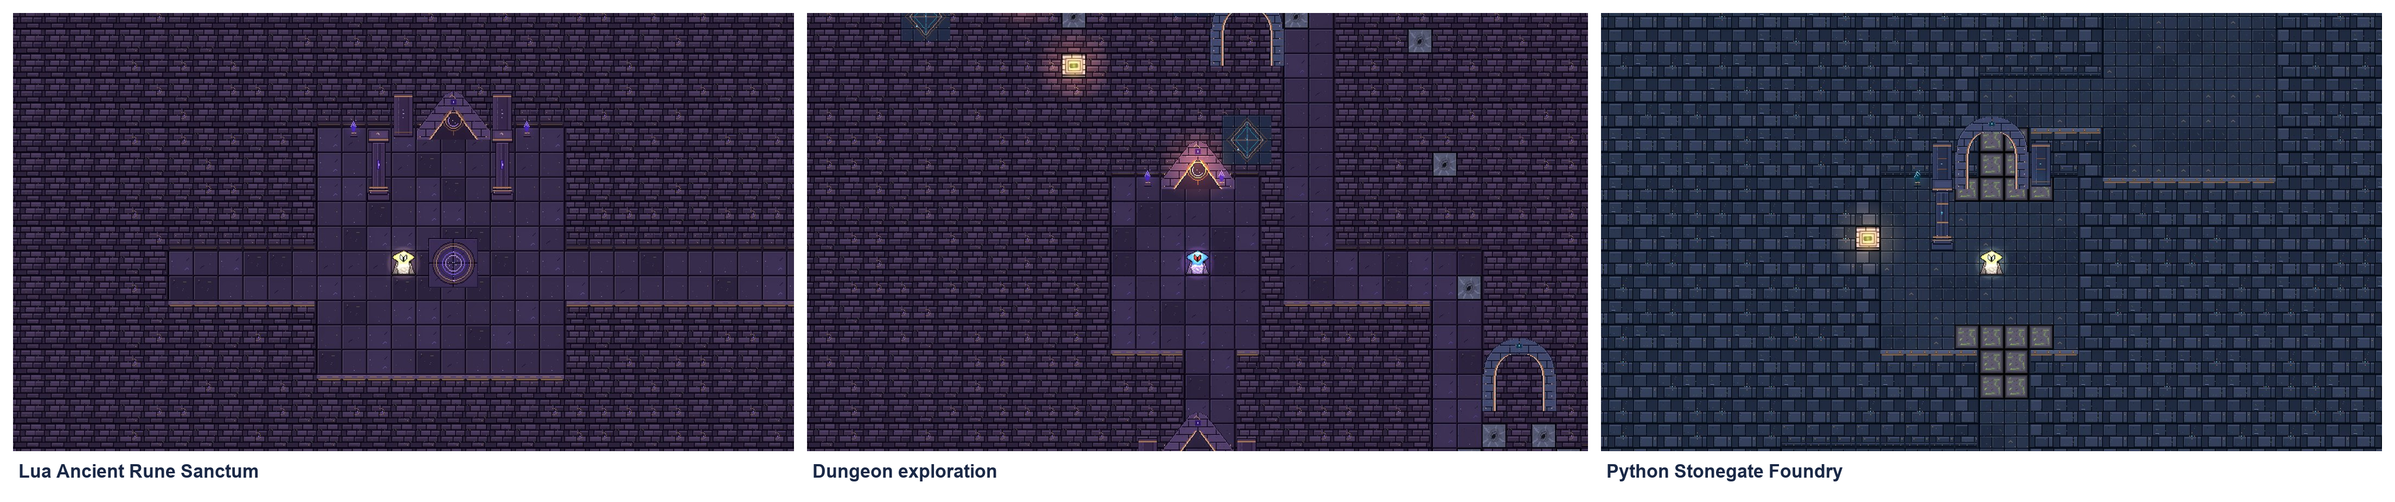
Figure 10. SandEE gameplay screenshots

Data Gathering Procedure
The study used a descriptive survey method. The needs assessment was conducted through Google Forms and was distributed to Grade 11 and 12 ICT and STEM students of Yverdon de Pestalozzi School Inc. A total of 104 students participated: 22 from Grade 11 ICT, 32 from Grade 11 STEM, 16 from Grade 12 ICT, and 34 from Grade 12 STEM. Purposive sampling was used to ensure that the respondents were enrolled in the strands and grade levels targeted by the study. Before answering, the respondents were informed of the purpose of the survey and were assured that their responses would be used only for academic purposes.
The system evaluation was conducted after the game was developed. The respondents were given a short demonstration of the game's main features, including the main menu, world exploration, crafting, building, the Lua and Python editors, LUA robots, Algorithmica stations, and the dungeon challenges. They were then asked to evaluate the game using a four-point Likert scale questionnaire based on selected ISO 25010 software quality characteristics. The evaluation involved [insert number] student users and [insert number] IT experts. The experts were selected based on their background in software development, programming education, or game development.
The evaluation instrument covered functional suitability, usability, reliability, performance efficiency, maintainability, portability, security, and compatibility. Each criterion was represented by several statements, and the respondents rated each statement from 1 (Strongly Disagree) to 4 (Strongly Agree). The responses were tallied, and the weighted mean and standard deviation were computed for each criterion.

Statistical Treatment of Data
The data were analyzed using frequency, percentage, weighted mean, and standard deviation. Frequency refers to the number of respondents who selected a particular response, while percentage is the frequency divided by the total number of respondents multiplied by 100. The weighted mean is computed by multiplying each response value by its frequency, summing the products, and dividing the sum by the total number of responses. The standard deviation measures the spread of the responses around the mean; a small standard deviation indicates that the respondents' ratings were consistent.
The weighted mean is interpreted using the four-point Likert scale in Table 5. A mean within 3.26 to 4.00 is interpreted as Strongly Agree or Very High; 2.51 to 3.25 as Agree or High; 1.76 to 2.50 as Disagree or Low; and 1.00 to 1.75 as Strongly Disagree or Very Low. The same legend is used for the needs assessment and for the system evaluation so that the results can be compared consistently.
Table 5. Mean range interpretation legend
Mean Range | Interpretation
3.26 - 4.00 | Strongly Agree / Very High
2.51 - 3.25 | Agree / High
1.76 - 2.50 | Disagree / Low
1.00 - 1.75 | Strongly Disagree / Very Low

Needs Assessment Survey Results
Table 6 presents the profile of the 104 respondents. The largest group was Grade 12 STEM with 34 respondents (32.7%), followed by Grade 11 STEM with 32 respondents (30.8%), Grade 11 ICT with 22 respondents (21.2%), and Grade 12 ICT with 16 respondents (15.4%). The distribution shows that the study gathered responses from both grade levels and both strands, which is important because the game is intended for ICT and STEM students.
Table 6. Profile of respondents
Grade Level and Strand | Frequency | Percentage
Grade 11 ICT | 22 | 21.2%
Grade 11 STEM | 32 | 30.8%
Grade 12 ICT | 16 | 15.4%
Grade 12 STEM | 34 | 32.7%
Total | 104 | 100.0%
Table 7 summarizes the key findings of the needs assessment. Most respondents had average familiarity with Lua, which confirms that Lua is relatively new to many ICT and STEM students. Despite this, 81 respondents (78.9%) agreed that a game-based approach would improve their understanding of programming concepts, and 76 respondents (73.0%) were motivated to explore Lua through an interactive approach. Python received more favorable feedback: 84 respondents (80.8%) found its syntax and structure easy to understand and applicable to programming tasks. These findings support the decision to develop a game that introduces Lua and Python through interactive, hands-on activities.
Table 7. Summary of needs assessment findings
Indicator | Result | Interpretation
Familiarity with Lua | Average familiarity (ratings of 2 to 4 on a 4-point scale) | Lua is relatively new to many respondents
Game-based approach improves understanding | 81 respondents (78.9%) | Agree
Motivation to explore Lua interactively | 76 respondents (73.0%) | Agree
Python syntax and structure are easy | 84 respondents (80.8%) | Agree
Figures 11 to 14 present the response charts for the Lua and Python items. The charts are grouped by language and by theme. Figures 11 and 12 cover Lua, while Figures 13 and 14 cover Python. The first figure in each pair focuses on familiarity and learning, and the second focuses on feedback and interest.
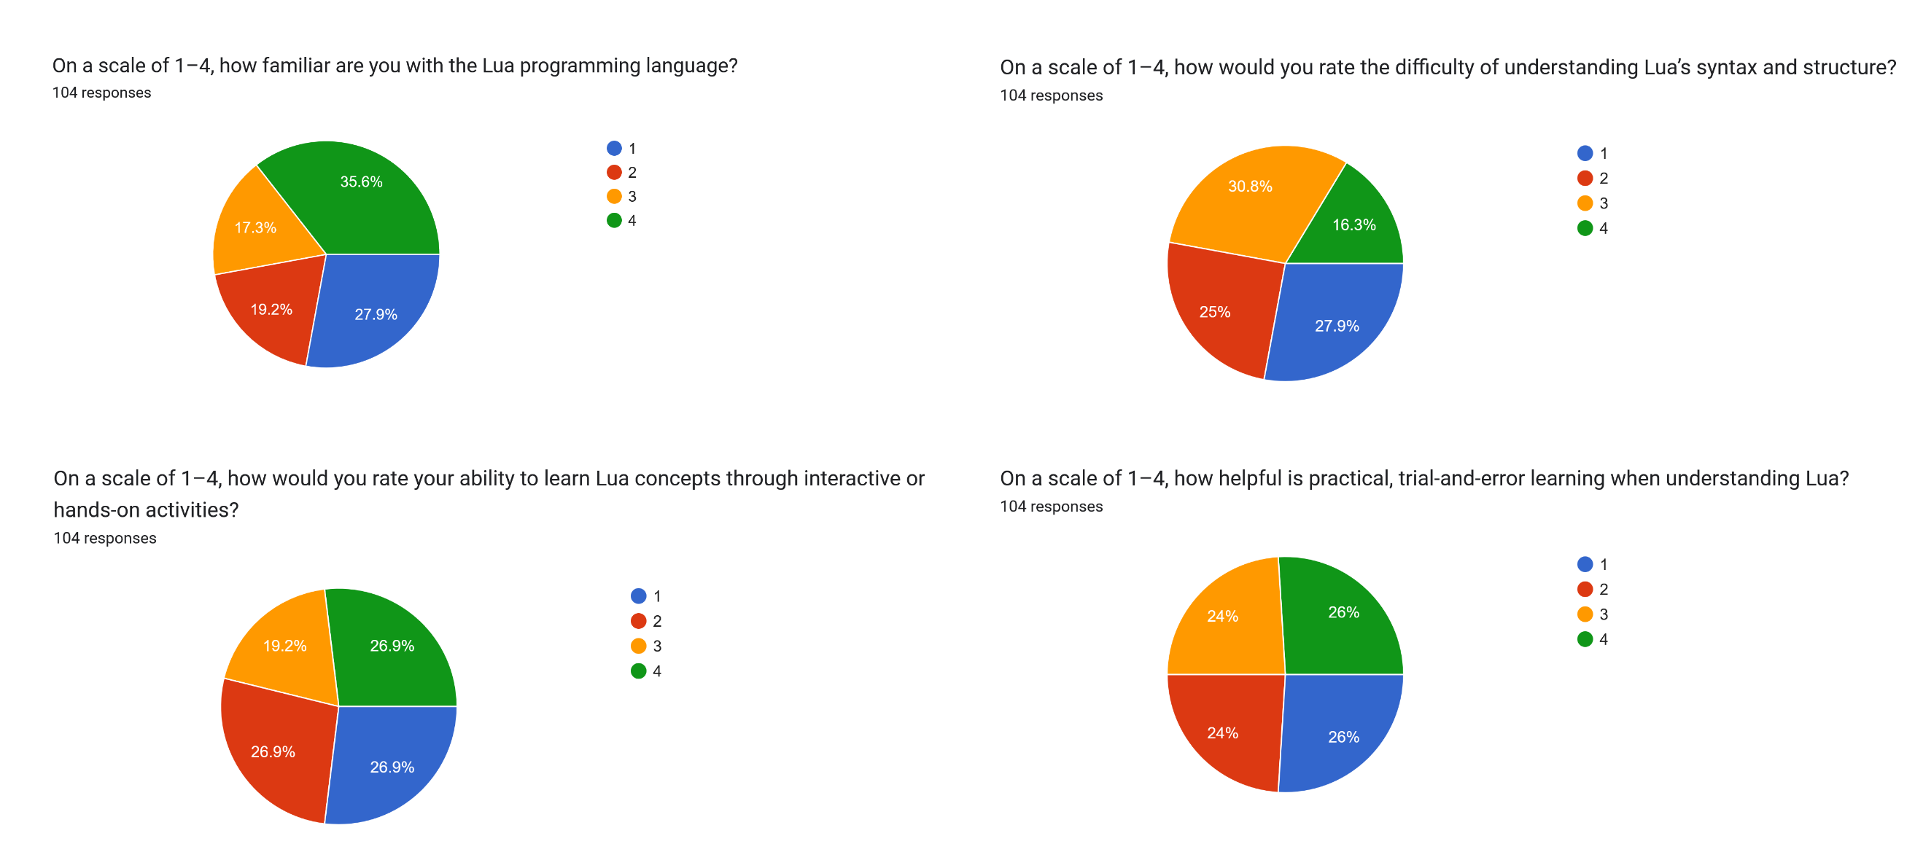
Figure 11. Lua familiarity and learning perceptions
Figure 11 shows the respondents' familiarity with Lua and their perceptions of learning it through interactive activities. The responses indicate that most respondents were not yet highly familiar with Lua, but they considered hands-on and trial-and-error activities helpful. This supports the game's approach of letting players learn by doing rather than by reading explanations alone.
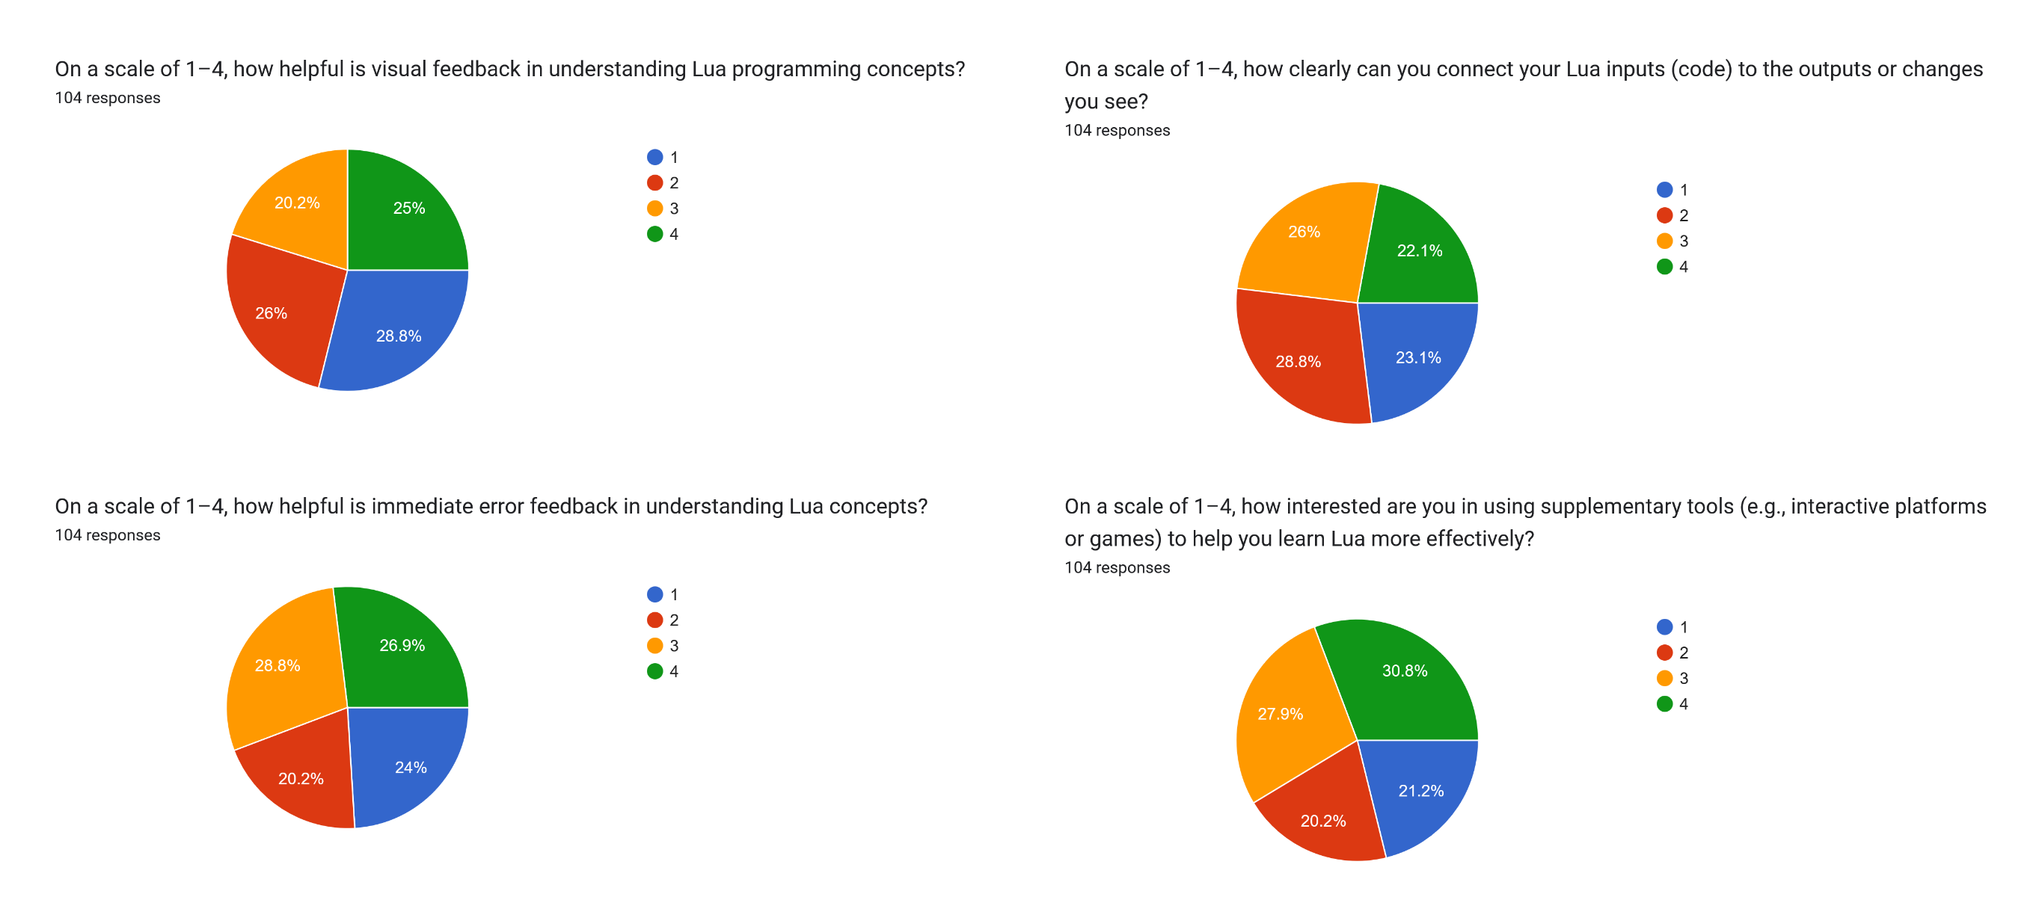
Figure 12. Lua feedback and interest
Figure 12 shows the respondents' views on visual feedback, error feedback, and supplementary tools for Lua. The responses lean toward agreement, which supports the inclusion of an in-game editor that shows the results of code immediately and reports syntax and runtime errors. The interest in supplementary tools also supports the use of a game as an additional learning resource rather than a replacement for classroom instruction.
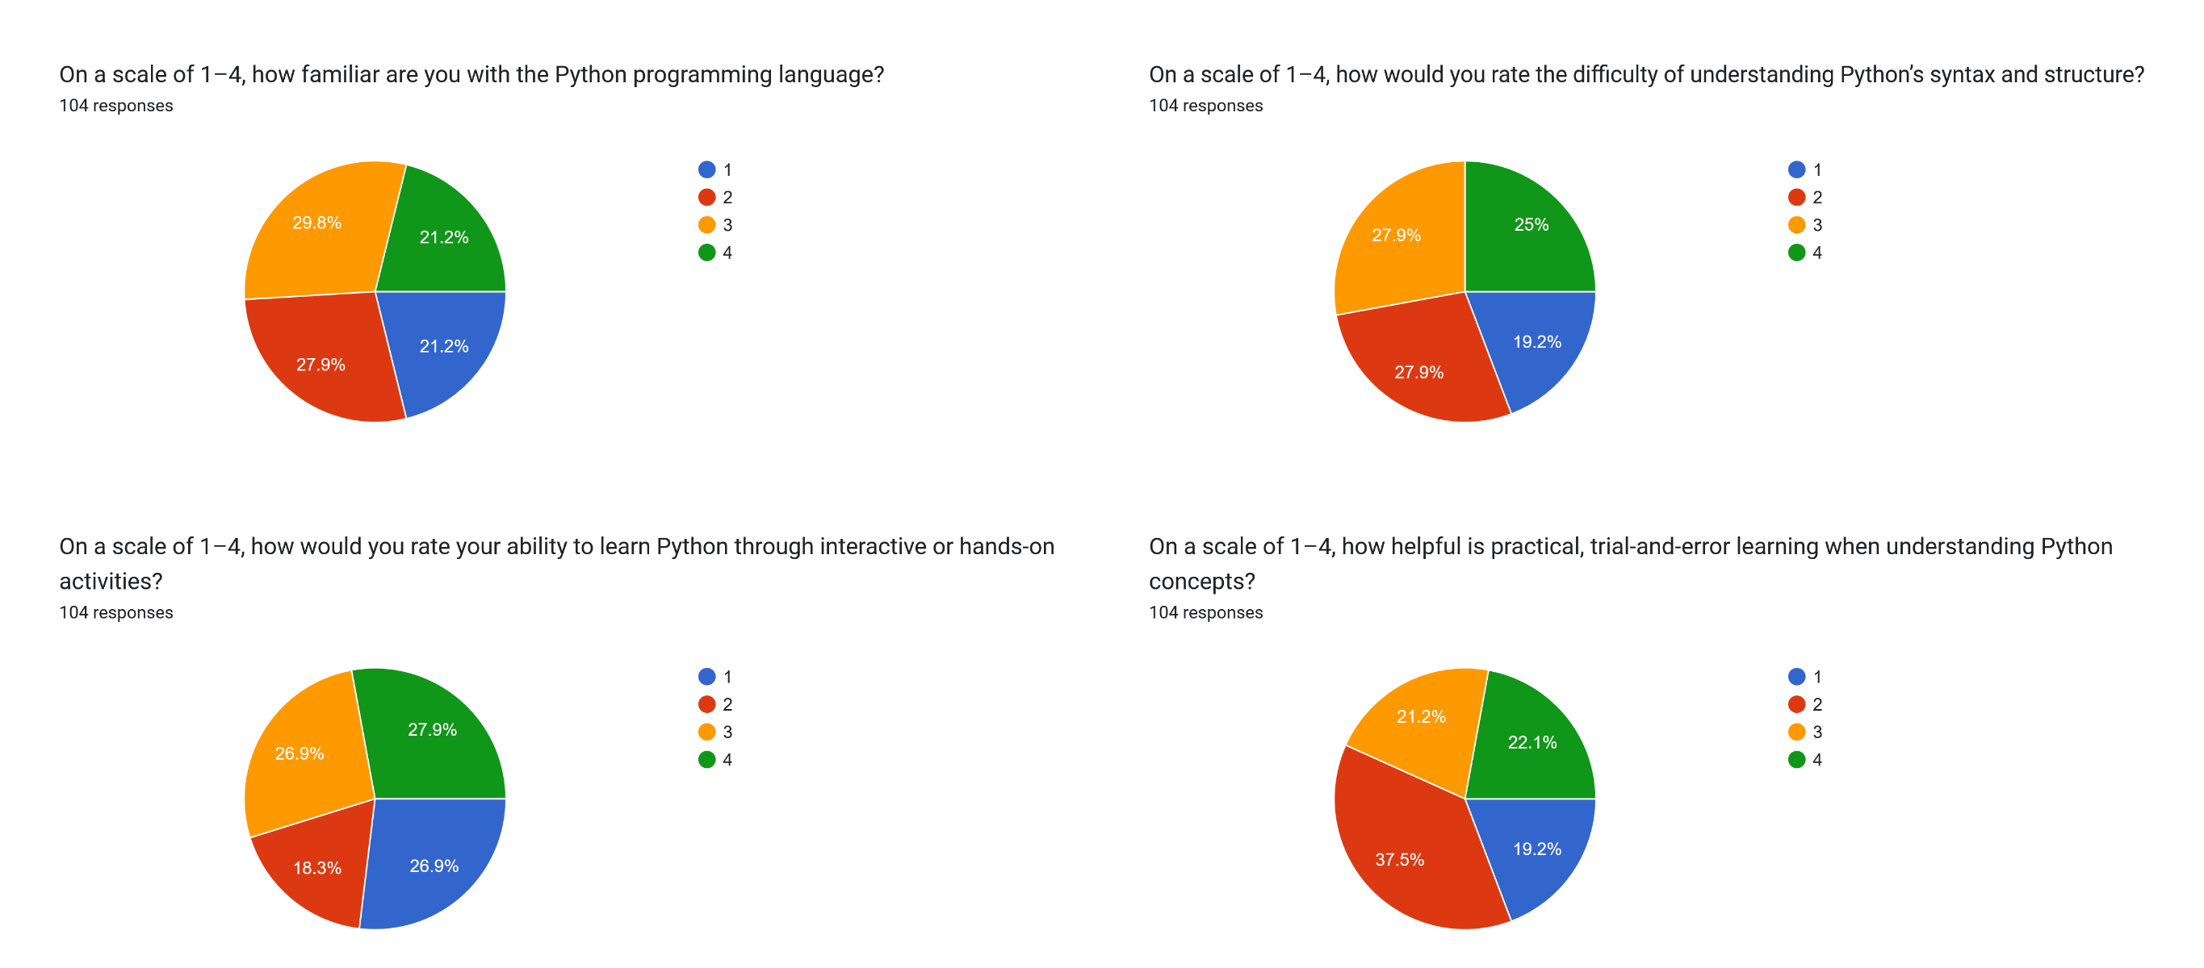
Figure 13. Python familiarity and learning perceptions
Figure 13 shows that the respondents were more familiar with Python than with Lua. They also regarded Python as easier to understand and considered interactive activities helpful. This is consistent with the needs assessment, which found that Python's syntax and structure were easier for the respondents. The game therefore introduces Python through automation and dungeon challenges that build on this prior familiarity.
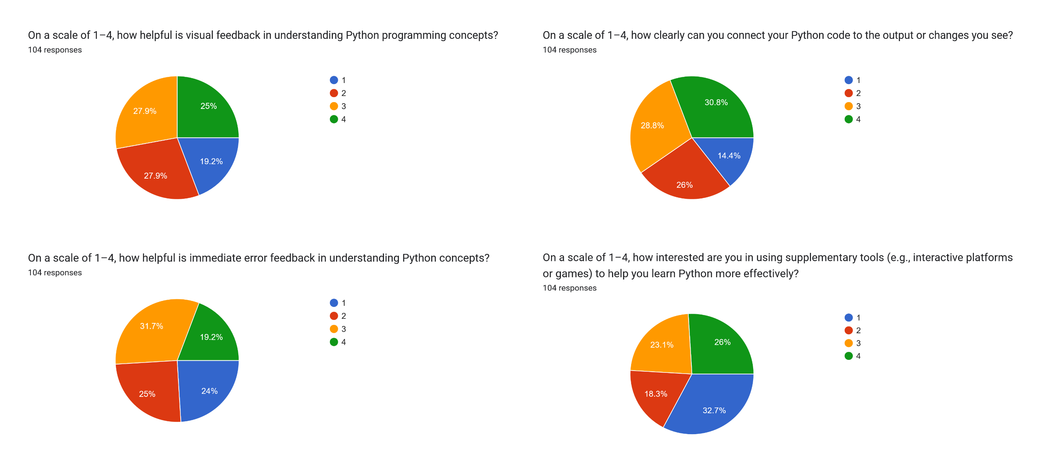
Figure 14. Python feedback and interest
Figure 14 shows the respondents' views on visual feedback, error feedback, and supplementary tools for Python. The responses again lean toward agreement, indicating that the respondents value immediate feedback and interactive tools. This supports the design of the Algorithmica stations and the Python editor, where players can see the results of their code in the game world.
Overall, the needs assessment shows a clear gap between the students' limited exposure to Lua and their strong willingness to learn it through games. It also shows that the students value visual feedback, immediate error feedback, and hands-on practice. These findings directly informed the design of SandEE's missions, dungeons, code editors, and automation systems.

System Evaluation Results
Table 8 summarizes the evaluation of SandEE based on selected ISO 25010 software quality characteristics. The table presents the weighted mean, standard deviation, and interpretation for each criterion. The values in the table are to be filled in from the final evaluation data.
Table 8. Summary of system evaluation results
Criterion | Weighted Mean | Standard Deviation | Interpretation
Functional Suitability | [ ] | [ ] | [ ]
Usability | [ ] | [ ] | [ ]
Reliability | [ ] | [ ] | [ ]
Performance Efficiency | [ ] | [ ] | [ ]
Maintainability | [ ] | [ ] | [ ]
Portability | [ ] | [ ] | [ ]
Security | [ ] | [ ] | [ ]
Compatibility | [ ] | [ ] | [ ]
Overall | [ ] | [ ] | [ ]
Functional suitability. The game obtained a weighted mean of [ ], interpreted as [ ]. This criterion measured whether the game's features performed their intended functions, including world exploration, crafting, building, coding, automation, missions, and saving.
Usability. The game obtained a weighted mean of [ ], interpreted as [ ]. This criterion measured the clarity of the interface, the ease of navigation, the readability of the text, and the overall user experience on desktop and mobile.
Reliability. The game obtained a weighted mean of [ ], interpreted as [ ]. This criterion measured the stability of the game, the consistency of saves, and the ability of the system to recover from errors without losing progress.
Performance efficiency. The game obtained a weighted mean of [ ], interpreted as [ ]. This criterion measured loading time, frame rate, responsiveness, and resource usage on the target Windows and Android devices.
The remaining criteria, namely maintainability, portability, security, and compatibility, were also evaluated. The results for these criteria are summarized in Table 8. The overall weighted mean of [ ] is interpreted as [ ], which indicates that the game met the expected software quality standards for an educational game prototype.

Expert Feedback
The IT experts who evaluated the game provided qualitative feedback on its design, functionality, and educational value. They commended the modular structure of the system, the use of real Lua and Python execution, and the consistency of the pixel-art interface. They also noted that the game provides a clear progression from simple exploration to programming-based automation, which makes it suitable for beginner learners.
The experts recommended [insert expert recommendation 1], [insert expert recommendation 2], and [insert expert recommendation 3]. These recommendations were considered in the final revisions of the game and are reflected in the recommendations section of this study.

Conclusion

Summary
This study developed SandEE, an educational multi-platform 2D open-world survival crafting game for Lua and Python. The game was designed for Grade 11 and 12 ICT and STEM students of Yverdon de Pestalozzi School Inc. as a supplementary learning tool. It combines procedural world generation, survival and crafting mechanics, mission-based progression, themed dungeons, and embedded Lua and Python interpreters. Players can explore a generated world, gather resources, craft items, build structures, farm, fish, fight enemies, and program LUA robots and Algorithmica stations. The game runs on Windows and Android and supports both offline play and optional online accounts, cloud saves, and leaderboards.
The development followed the Waterfall model. The requirements phase established the learning needs and technical requirements through a survey of 104 students. The design phase produced the conceptual framework, system architecture, data flow diagrams, entity relationship diagram, hierarchical chart, and flowcharts. The implementation phase built the game systems, user interface, programming tools, and online features. The verification phase tested the game's functionality, stability, and usability. The maintenance phase addressed bugs and prepared the game for final evaluation.
The needs assessment showed that the respondents had limited familiarity with Lua but were highly interested in learning it through games. They also valued visual feedback, immediate error feedback, and hands-on practice. The system evaluation used selected ISO 25010 criteria to assess the game's functional suitability, usability, reliability, performance efficiency, maintainability, portability, security, and compatibility. The results of the evaluation are presented in Table 8.

Conclusions
Based on the findings, the following conclusions were drawn:
1. The game provides hands-on learning because players apply programming concepts directly in the game world. They gather resources, craft items, build structures, and program robots and stations rather than memorizing syntax in isolation.
2. The game provides direct visual feedback because player-written code produces immediate changes in the game environment. The Lua and Python editors show output and errors, and the results of a program are visible in the behavior of LUA robots and Algorithmica stations.
3. The game responds realistically to player errors because it embeds real Lua and Python interpreters. Syntax and runtime errors are reported in the editor, which allows players to debug their programs and learn from mistakes.
4. The game introduces the structure and syntax of Lua and Python through missions, dungeons, knowledge altars, quizzes, and the Programming Encyclopedia. The progression from easy to hard missions gradually introduces concepts and gives players repeated practice.
5. The game was successfully developed as a multi-platform educational tool. It meets the functional requirements identified during planning and provides a coherent open-world experience that integrates survival, crafting, exploration, and programming.
Overall, the study supports the use of game-based learning as a supplementary approach to programming education. SandEE does not replace the teacher or the formal curriculum; instead, it provides an interactive environment where students can practice Lua and Python, see the results of their code, and develop problem-solving skills through play.

Recommendations
Based on the conclusions, the following recommendations are proposed:
1. Expand the mission and dungeon content to cover more programming concepts, including functions, loops, conditions, data structures, file handling, and object-oriented programming.
2. Add more Lua and Python examples, hints, and guided tutorials so that beginners can recover from errors without becoming frustrated.
3. Develop a teacher or facilitator mode that allows instructors to assign missions, monitor student progress, and export learning reports.
4. Improve accessibility by adding remappable controls, colorblind-friendly palettes, adjustable text sizes, and additional language options.
5. Optimize the Android build for lower-end devices by reducing memory usage, improving load times, and adding battery-friendly settings.
6. Conduct a longitudinal study that measures learning outcomes over a longer period and compares game-based practice with traditional exercises.
7. Explore additional platforms, such as iOS and web browsers, to reach more students and schools.
8. Consider future multiplayer or cooperative features that would allow students to collaborate on programming tasks and share their creations.
9. Continue collecting user and expert feedback after release so that the game can be updated based on real classroom use.
These recommendations are intended to guide future developers, educators, and researchers who wish to extend SandEE or build similar educational games. The study demonstrates that a well-designed game can make programming practice more engaging, but its long-term impact depends on thoughtful integration with teaching, clear learning objectives, and continuous evaluation.

References
Pohl, M., Rester, M., Judmaier, P. (2009). Interactive Game Based Learning: Advantages and Disadvantages. In: Stephanidis, C. (eds) Universal Access in Human-Computer Interaction. Applications and Services. UAHCI 2009. Lecture Notes in Computer Science, vol 5616. Springer, Berlin, Heidelberg. https://doi.org/10.1007/978-3-642-02713-0_10
D. Zhao, C. H. Muntean, A. E. Chis, G. Rozinaj and G. -M. Muntean, "Game-Based Learning: Enhancing Student Experience, Knowledge Gain, and Usability in Higher Education Programming Courses," in IEEE Transactions on Education, vol. 65, no. 4, pp. 502-513, Nov. 2022, doi: 10.1109/TE.2021.3136914.
Lampropoulos, G. (2023). Educational benefits of digital game-based learning: K-12 teachers’ perspectives and attitudes. Advances in Mobile Learning Educational Research, 3(2), 805-817. https://doi.org/10.25082/AMLER.2023.02.008
Becker, B. A., Denny, P., Finnie-Ansley, J., Luxton-Reilly, A., Prather, J., & Santos, E. A. (2023). Programming is hard—or at least it used to be: Educational opportunities and challenges of AI code generation. In Proceedings of the 54th ACM Technical Symposium on Computer Science Education V. 1 (SIGCSE 2023) (pp. 500–506). Association for Computing Machinery. https://doi.org/10.1145/3545945.3569759
Brumbaugh, Z., & Leithner, M. (2023). The Lua programming language. In Programming languages: Concepts and implementations (pp. 45–60). Springer. https://doi.org/10.1007/979-8-8688-0060-3_3
Crudu, V., & MoldStud Research Team. (2024, September 27). Are Lua developers in high demand in the job market? MoldStud. https://moldstud.com/articles/p-are-lua-developers-in-high-demand-in-the-job-market

Ierusalimschy, R., Figueiredo, L. H. de, & Celes, W. (2025). The evolution of Lua, continued. Journal of Computer Languages, 83, 101326. https://doi.org/10.1016/j.cola.2025.101326
Lin, H.-C. K., Tseng, C.-H., & Chen, N.-S. (2025). Enhancing programming education: The impact of AI-based pedagogical agents on student self-efficacy, engagement, and learning outcomes. Educational Technology & Society, 28(2), 279–294. https://www.jstor.org/stable/48827987
Python, W. (2021). Python: Python releases for Windows. Python Software Foundation. https://www.python.org/downloads/windows/
Viduka, D., Kraguljac, V., & Ličina, B. (2021). A comparative analysis of the benefits of Python and Java for beginners. Quaestus, (19), 318–327.
Abat, J., et al. (2024). [Complete title of study]. [Journal/Publisher]. [Details to be verified].
Ahlstrom, [Initial]. (2025). [Title of article or resource]. [Publisher/URL]. [Details to be verified].
Becker, B. A., Denny, P., Finnie-Ansley, J., Luxton-Reilly, A., Prather, J., & Santos, E. A. (2022). Programming is hard - or at least it used to be: Educational opportunities and challenges of AI code generation. arXiv. https://arxiv.org/abs/2212.01020
Cezar, [Initial]. (2022). [Title of study]. [Journal/Publisher]. [Details to be verified].
Cezar, [Initial]. (2024). [Title of study]. [Journal/Publisher]. [Details to be verified].
CodeCombat. (2024). CodeCombat: Learn to code by playing a game. https://codecombat.com
CodinGame. (2025). CodinGame: Programming games and competitions. https://www.codingame.com
Eltomi, [Initial]. (2025). [Title of study]. [Journal/Publisher]. [Details to be verified].
Herzog, [Initial]. (2023). The Farmer Was Replaced. [Steam/Publisher/URL]. [Details to be verified].
Horlador, [Initial]., et al. (2024). [Title of study]. [Journal/Publisher]. [Details to be verified].
Justo, [Initial]., et al. (2022). [Title of study]. [Journal/Publisher]. [Details to be verified].
Logiscool. (2025). Logiscool: Coding and digital literacy. https://www.logiscool.com
MoldStud. (2025). [Title of article]. MoldStud. [URL]. [Details to be verified].
Oleksiuk, [Initial]., et al. (2024). [Title of study]. [Journal/Publisher]. [Details to be verified].
OmegaCrafter. (2025). OmegaCrafter. [Steam/Publisher/URL]. [Details to be verified].
Philippine Coding Camp. (2023). Philippine Coding Camp. [URL]. [Details to be verified].
Tyagi, [Initial]. (2021). [Title of study]. [Journal/Publisher]. [Details to be verified].
Verbovetskyi, [Initial]. (2025). [Title of study]. [Journal/Publisher]. [Details to be verified].
Hello World. (2024). Hello World. [Steam/Publisher/URL]. [Details to be verified].

Appendices

Appendix A. Gantt Chart
The Gantt chart below shows the planned schedule of the study from the proposal stage to the final defense. The schedule covers the documentation of Chapters 1 to 3, the needs assessment, system design, development of the game systems, testing, evaluation, and the preparation of the final manuscript.
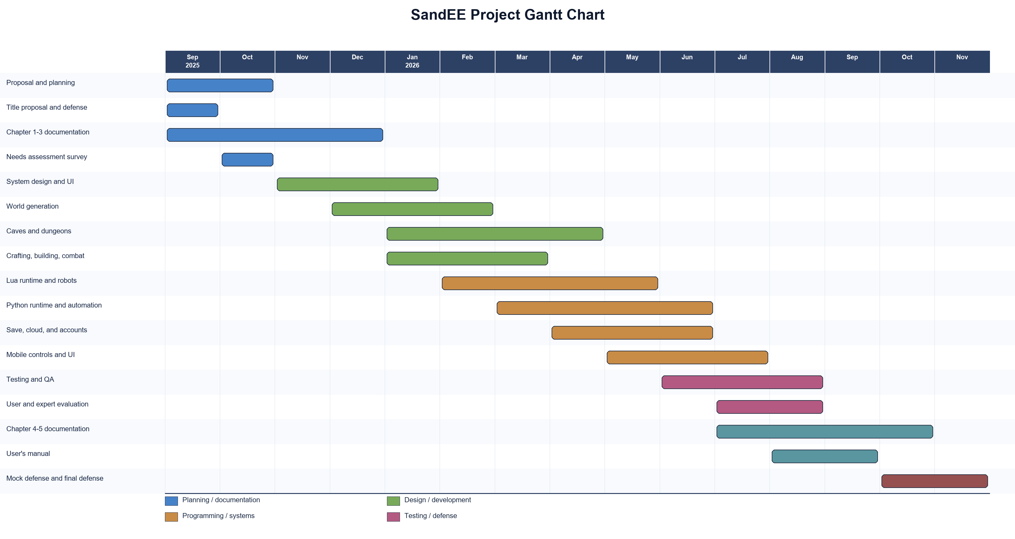
Figure 15. Project Gantt chart

Appendix B. Actual Thesis Expenses
Table 9 presents the actual expenses incurred during the development and documentation of the study. The approximate costs were based on the budgetary estimate, while the actual costs reflect the final expenditures.
Table 9. Actual thesis expenses
Quantity | Specifics | Approximate Cost | Actual Cost
1 | Acer Nitro 5 AN515-50YE | PHP 49,000 | [ ]
1 | Ryzen 5 5600G processor | PHP 22,295 | [ ]
1 | Asus Prime B550 motherboard | Included above | [ ]
1 | 16 GB RAM | Included above | [ ]
1 | 1 TB SSD | Included above | [ ]
1 | 650 W power supply | Included above | [ ]
1 | Internet connection | [ ] | [ ]
1 | Printing and binding | [ ] | [ ]
1 | Other expenses | [ ] | [ ]
 | Total | [ ] | [ ]
Prepared by:
Glenn Marco B. Accad Adrian V. Gallano
Jefferson G. Mamauag Jose Mari Christian V. Tayag
Noted by:
[Name of Parent/Guardian] [Name of Parent/Guardian]
Approved by:
Norvin Shaq F. Lintag Enoch James C. Tayaguna

Appendix C. User's Manual
This user's manual provides the basic instructions for installing, launching, and playing SandEE. It covers the system requirements, controls, main menu, gameplay basics, programming tools, dungeons, saving, and troubleshooting.
System Requirements
• Windows 10 or Windows 11 (64-bit)
• Android 8.0 or later
• At least 4 GB of RAM
• At least 500 MB of free storage
• Keyboard and mouse for Windows, or touch screen for Android
• Optional internet connection for online accounts and cloud saves
Installation
1. Download the SandEE installer or Android package from the official distribution page.
2. On Windows, run the installer and follow the on-screen instructions. On Android, allow installation from the chosen source if prompted, then install the package.
3. Launch SandEE from the Start menu or the Android app drawer.
Starting the Game
When the game starts, the player can sign in with an existing account, create a new account, or choose offline mode. Online mode enables cloud saves and leaderboards. Offline mode allows the player to play without an internet connection, and the player can switch to online mode later from the main menu.
Main Menu
The main menu provides Continue, Worlds, Leaderboards, Cloud Saves, Account, Settings, and Quit. Continue loads the most recent save. Worlds opens the save-slot menu where the player can create, rename, delete, or load a world. Settings allows the player to adjust the volume, fullscreen mode, UI scale, and other options.
Controls
Table 10. SandEE controls
Action | Windows | Android
Move | WASD / arrow keys | Virtual joystick
Look / aim / point and click | Mouse | Tap
Interact / mine / place / attack | Left click | Contextual action buttons
Build mode | Ctrl | BUILD button
Sprint | Shift | SPRINT button
Inventory | E | Inventory button
Hotbar | 1-9 | Tap hotbar slots
Pause / back | Esc | Pause / back button
Toggle control guide | F1 | On-screen controls
Gameplay Basics
The player begins in a procedurally generated world. Trees, rocks, grass, water, and ores can be interacted with to gather resources. The hotbar shows the currently selected item, and the inventory stores additional items. Resources can be crafted into tools, weapons, food, and building blocks. The player can place blocks in build mode to create shelters, bridges, and other structures. The day and night cycle affects enemy spawning and difficulty.
Programming Tools
The Lua editor is used to program LUA robots. The player can write code, run it, stop it, and view the output. The Python editor is used to program Algorithmica stations such as furnaces and crafting stations. Both editors provide syntax highlighting, snippets, and error messages. The Programming Encyclopedia contains explanations of programming concepts, and the Knowledge Altar provides additional references inside dungeons.
Dungeons and Missions
Dungeons are special challenge areas that test the player's programming knowledge. Each dungeon contains a Knowledge Altar, a Quiz Altar, and a final challenge. The Quiz Altar asks questions about Lua or Python, and the player must answer them correctly to earn stars. The final stage includes a miniboss. Missions guide the player through the game and reward stars that determine the player's rank.
Saving and Cloud Saves
The game saves automatically at regular intervals and at important state changes. The player can also save manually from the pause menu. When online, the save is uploaded to the cloud. If a conflict occurs, the game compares the local and cloud revisions and asks the player to choose which save to keep. Cloud saves can be managed from the main menu.
Troubleshooting
• If the game does not start, verify that the device meets the system requirements and that the latest version is installed.
• If the Lua or Python editor reports that the language runtime is unavailable, reinstall the game or check that the extension files are present.
• If cloud saves do not sync, check the internet connection and sign in again.
• If the game runs slowly on Android, lower the UI scale and close other applications.
• If progress is lost, check the save slot and the cloud-save menu before creating a new world.

Appendix D. Curriculum Vitae of Researchers
Curriculum Vitae of
MAMAUAG, JEFFERSON G.
<Block 66 Lot 24 Nuvista Subdivision Barangay Santo Cristo City of San Jose Del Monte Bulacan>
mamauag.248577@sjdelmonte.sti.edu.ph
0931096819

EDUCATIONAL BACKGROUND
Level | Inclusive Dates | Name of school/ Institution
Tertiary | August 2023 | STI College San Jose Del Monte
Vocational/Technical
High School | May 2016-2023 | Yverdon De Pestalozzi School
Elementary | June 2010-2016 | Placido Del Mundo Elementary School

PROFESSIONAL OR VOLUNTEER EXPERIENCE
Inclusive Dates | Nature of Experience  Job Title | Name and Address of Company or Organization

AFFILIATIONS
Inclusive Dates | Name of Organization | Position
July 2021-2023 | Code Camp Society | Member
August 2023-2024 | Intellitech | Member
August 2024-2025 | Intellitech | CS 2nd Year representative
August 2025-2026 | Intellitech | Member

SKILLS
SKILLS | Level of Competency | Date Acquired
MS Word | Intermediate | September 2016
Java Programming | Intermediate | December 2023
Python Programming | Intermediate | April 2025

TRAININGS, SEMINARS OR WORKSHOP ATTENDED
Inclusive Dates | Title of Training, Seminar or Workshop
August 2023 | National Service Training Program
February 2024 | GitGud

Curriculum Vitae of
Tayag, Jose Mari Christian V.
Block 34, Lot 5, Saint Therese Phase, Deca Homes Subdivision, Barangay Loma de Gato, Marilao, Bulacan
tayag.334839@sjdelmonte.sti.edu.ph
+639166248648

EDUCATIONAL BACKGROUND
Level | Inclusive Dates | Name of school/ Institution
Tertiary | August 2023 | STI College San Jose Del Monte
Vocational/Technical
High School | May 2014-2020 | Caloocan National Science and Technology Highschool
Elementary | June 2008-2014 | ST. Anne Power Academy-Marilao, inc.

AFFILIATIONS
Inclusive Dates | Name of Organization | Position
August 2023-2024 | Intellitech | Member
August 2024-2025 | Intellitech | Member
August 2025-2026 | Intellitech | Member

SKILLS
SKILLS | Level of Competency | Date Acquired
Ux/Ui Design | Intermediate | September 2020
Python Programming | Intermediate | March 2018
Rust Programming | Intermediate | December 2024

TRAININGS, SEMINARS OR WORKSHOP ATTENDED
Inclusive Dates | Title of Training, Seminar or Workshop
August 2023 | National Service Training Program
February 2024 | GitGud
 | CodeFest

Curriculum Vitae of
Accad, Glenn Marco B.
Block 32, Lot 17 Phase 6C Towerville, Barangay Gaya - Gaya, Towerville, San Jose Del Monte Bulacan
Accad.355761@sjdelmonte.sti.edu.ph
+639981847987

EDUCATIONAL BACKGROUND
Level | Inclusive Dates | Name of school/ Institution
Tertiary | August 2023 | STI College San Jose Del Monte
Vocational/Technical
High School | May 2017-2023 | Graceville National High school
Elementary | June 2011-2017 | Marangal Elementary School

PROFESSIONAL OR VOLUNTEER EXPERIENCE
Inclusive Dates | Nature of Experience  Job Title | Name and Address of Company or Organization
February 2023 – May 2023 | Student Assistant | San Jose Academy of Bulacan

AFFILIATIONS
Inclusive Dates | Name of Organization | Position
August 2023-2024 | Intellitech | Member
August 2024-2025 | Intellitech | Member
August 2025-2026 | Intellitech | Member

SKILLS
SKILLS | Level of Competency | Date Acquired
MS Office | Intermediate | June 2011
Java Programming | Intermediate | October 2023
C# Programming | Intermediate | May 2024

TRAININGS, SEMINARS OR WORKSHOP ATTENDED
Inclusive Dates | Title of Training, Seminar or Workshop
August 2023 | National Service Training Program
February 2024 | GitGud
 | CodeFest

Curriculum Vitae of
Gallano, Adrian V.
1067 Malaya Street, Sapang Alat Road, Barangay 181, Pangarap Village, Caloocan City, NCR
gallano.360632@sjdelmonte.sti.edu.ph
+63927208694

EDUCATIONAL BACKGROUND
Level | Inclusive Dates | Name of school/ Institution
Tertiary | August 2023 | STI College San Jose Del Monte
Vocational/Technical
High School | July 2017-2023 | Immaculada Conception Colleges
Elementary | August 2011-2017 | Our Lady of Mercy School

PROFESSIONAL OR VOLUNTEER EXPERIENCE
Inclusive Dates | Nature of Experience  Job Title | Name and Address of Company or Organization

AFFILIATIONS
Inclusive Dates | Name of Organization | Position
August 2023-2024 | Intellitech | Member
August 2024-2025 | Intellitech | Member
August 2025-2026 | Intellitech | Member

SKILLS
SKILLS | Level of Competency | Date Acquired
MS Office | Intermediate | June 2018
Java Programming | Intermediate | October 2023
C# Programming | Intermediate | September 2024

TRAININGS, SEMINARS OR WORKSHOP ATTENDED
Inclusive Dates | Title of Training, Seminar or Workshop
August 2023 | National Service Training Program
February 2024 | GitGud

Appendix E. Adviser's Acceptance Form (Proposal Stage)

ADVISER’S ACCEPTANCE FORM

NAME OF PROPONENTS: Glenn Marco B. Accad, Adrian V. Gallano, Jefferson G. Mamauag, and Jose Mari Christian V. Tayag
Adrian V. Gallano
Jefferson G. Mamauag
Jose Mari Christian V. Tayag

APPROVED RESEARCH TITLE: SandEE: An Educational Multi-Platform 2D Open World Survival Crafting Game for Lua and Python for ICT and STEM Students of Yverdon de Pestalozzi School Inc.

AREA OF STUDY: Cross-Platform Application, Game-Based Learning, Programming

CONFORME:

Norvin Shaq F. Lintag
Thesis Adviser

APPROVED BY:

Enoch James C. Tayanguna Date: 13 September 2025
Thesis Coordinator

NOTED BY:

Deffrey Josh A. Austria
Program Head

