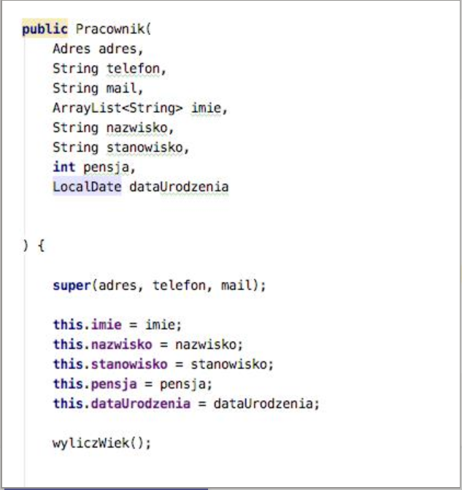

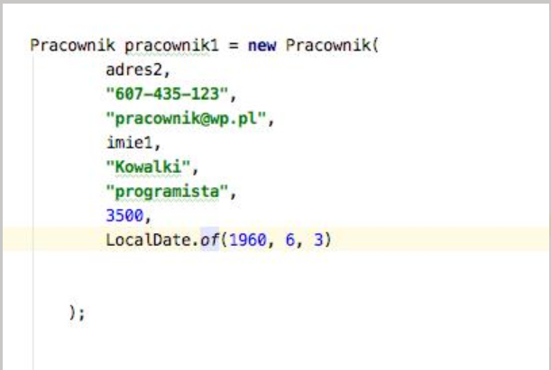

ArrayList<String> **imie** = **new** ArrayList<>();

ArrayList<String> imie1 = **new** ArrayList<>();

imie.add (**"Edmund"**);

imie.add (**"Zbigniew"**);

imie.add (**"Marian"**);