**Multiple Myeloma Treatment Algorithm**

Overview and Scope

In addition to tracking demographic and other characteristics of the simulants in our model, we will also assign and track multiple myeloma treatment regimens at each line of treatment for simulants who develop multiple myeloma and relapsed and refractory multiple myeloma. Simulants may receive a treatment regimen in one of the three categories below at each line of treatment:

* Isatuxamib-containing treatment
* Daratumumab-containing treatment
* All other treatments

A simulant’s assigned treatment category for a given line of treatment will affect both their progression-free and overall survival hazard rate for that stage of disease. Only a certain proportion of simulants who receive an isatuxamib- or daratumumab-containing regimen for a given line of treatment will be eligible for isatuxamib- or daratumumab-containing regimens at all other subsequent lines of treatment. Our simulation will examine the impact of increasing the proportion of newly diagnosed and newly relapsed MM/RRMM cases that are treated with an isatuxamib-containing treatment regimen.

Coverage Scale-Up

In our simulation, isatuxamib-containing regimens will increase in coverage linearly from 2021 to 2025 according to the maximum target coverage values listed in the table below (see the retreatment section for details on why these values are maximum target rather than absolute values):

Table 1. Percentage of newly diagnosed (or newly relapsed) patients receiving isatuxamib as part of their treatment regimen in 2021 (start of simulation) and 2025 (end of the simulation) in baseline and alternative scenarios.

|  |  |  |  |
| --- | --- | --- | --- |
| **Line of treatment** | **2021 coverage, % (Baseline and Alternative Scenarios)** | **2025 coverage, % (Baseline Scenario)** | **2025 coverage, % (Alternative Scenario)** |
| 1 | 0 | 0 | 10 |
| 2 | 0.8% | 10 | 10 |
| 3 | 1.3% | 10 | 10 |
| 4 | 1.5% | 10 | 10 |
| 5+ | 0.9% | 10 | 10 |

The coverage of isatuxamib-containing treatments in 2021 was estimated using IQVIA sales data and the respective costs of daratumumab and isatuxamib to derive a ratio of isatuxamib sales to daratumumab sales in 2021 (0.05:1), which was then paired with our estimated coverage of daratumumab by line of treatment in 2021 (described below). In the absence of data to the contrary, we assumed that this ratio applied equally to each line of treatment, except for the first line, which we set to zero due to lack of current FDA approval for use of isatuxamib in the first line of treatment.

The coverage of daratumumab-containing treatments in 2021 by line of treatment is informed by Braunlin et al. 2019, which reported the coverage of treatment regimens containing a monoclonal antibody, an immunomodulatory imide, and dexamethasone, which we assume is a proxy for daratumumab-containing regimens in the absence of more detailed data. Since coverage data for other daratumumab-containing regimens were not reported, we do not consider them in our treatment algorithm, which is a limitation of our analysis. We assume that daratumumab-containing treatments will increase at each line of treatment in proportion to the forecasted sales data obtained from IQVIA in our simulation from 2021 to 2025 in each scenario. IQVIA forecasts that daratumumab sales will increased 64 percent from 2019 to 2021 and 196 percent from 2019 to 2025. In the absence of data to inform otherwise, we assumed that these increases scaled equally across all lines of treatment. The table below reports the 2019 data informed by Braunlin et al. (2019) as well as our assumed coverage of daratumumab-containing treatments by line in 2021 and 2025; we assume a linear increase over this time period.

Table 2. Proportion of newly diagnosed (or newly relapsed) cases of MM/RRMM treated with daratumumab + lenalidomide + dexamethasone at each line of treatment.

|  |  |  |  |
| --- | --- | --- | --- |
| **Line of treatment** | **2019 (Braunlin et al. 2020)** | **2021** | **2025** |
| 1 | 1% | 1.6% | 2.9% |
| 2 | 10.3% | 16.9% | 30.6% |
| 3 | 15.6% | 25.6% | 46.3% |
| 4 | 18.1% | 29.7% | 53.7% |
| 5+ | 10.4% | 17.1% | 30.9% |

We will model all other treatment regimens as a single residual category. This residual category will be comprised of all treatment regimens that do not contain isatuxamib or daratumumab, including monotherapies/doublet therapies/triplet therapies/quartet therapies/etc. consisting of all other anti-myeloma drugs. We will assume that the proportion of newly diagnosed and newly relapsed cases of MM/RRMM that receive a treatment regimen in this residual category will decrease in proportion to the increases in isatuxamib-containing and daratumumab-containing treatment categories. The following diagrams represent the changes in the percent of newly diagnosed and newly relapsed MM/RRMM cases that receive each modeled treatment category by line of treatment in each scenario from 2021 to 2025.

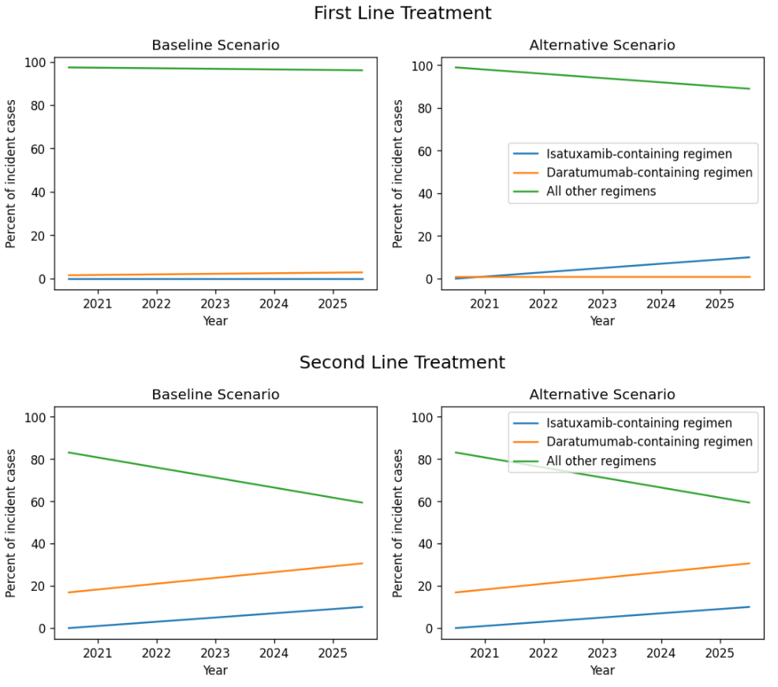



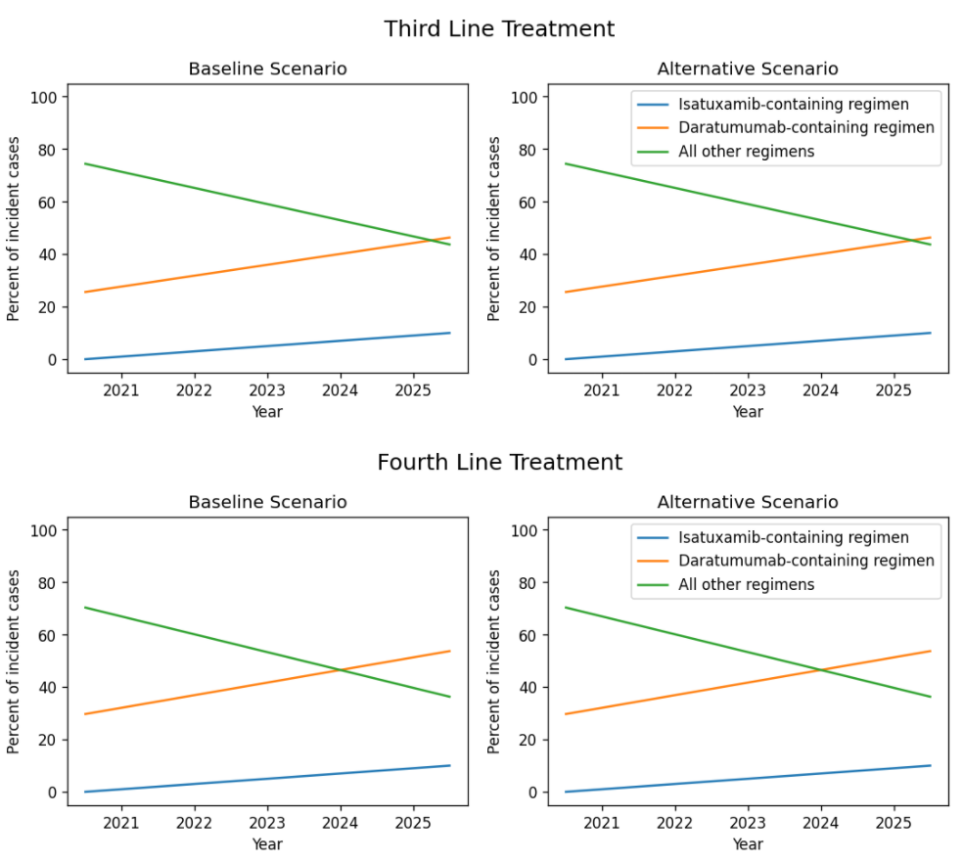



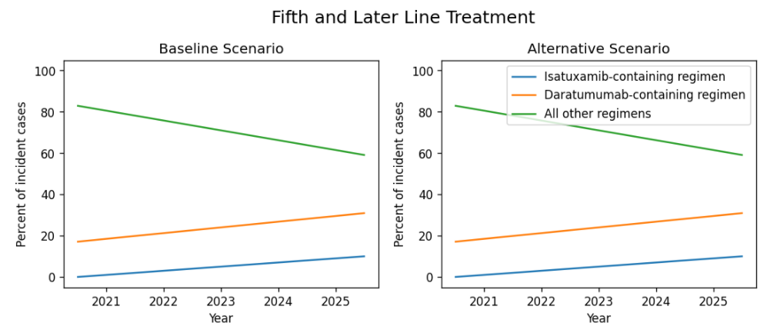

Retreatment

In our simulation, we will enforce that 15 percent of patients who receive an anti-CD38 monoclonal antibody treatment (isatuxamib or daratumumab) for a given line of treatment will be retreated with an anti-CD38 monoclonal antibody treatment at the next line of therapy. This assumption was informed by the reports that 10% and 20% of patients who received isatuxamib treatment and received subsequent treatment in the ICARIA and IKEMA trials, respectively, received daratumumab as a subsequent treatment. Notably, the enforcement of retreatment limits in our simulation results in the treatment coverage proportions listed in the above section to represent **maximum** *target* level coverage proportions, as less than the target proportion of patients (10%) in late-stage relapses may remain eligible for isatuxamib- or daratumumab-containing treatment regimens due to previous treatment in an earlier line. The exact proportion treatment coverage proportions used in the simulation will be recorded as a simulation output.

We will assume that isatuxamib and daratumumab are interchangeable as anti-CD38 monoclonal antibody treatments with respect to retreatment. In other words, the probability that a retreated simulant receives an isatuxamib-containing or daratumumab-containing re-treatment is equal to the relative treatment coverage rates of these two treatment categories for the relevant line of treatment at that time in the simulation and does not depend on whether their previous treatment was isatuxamib-containing or daratumumab-containing. Additionally, we assume the probability of whether a simulant is retreated with an anti-CD38 monoclonal antibody is independent of whether they were previously retreated, allowing for the possibility of multiple retreatments.

The clinical impact of retreatment with an anti-CD38 monoclonal antibody treatment in patients previously treated with an anti-CD38 monoclonal antibody treatment has not been rigorously studied and there is currently no consensus recommendation about retreatment (Radocha et al. 2021; Shah et al., 2020). However, small case series studies on the topic yielded “encouraging” results (Nooka et al., 2019; Becnel et al., 2020; Mikhael et al., 2021).

Therefore, in the absence of robust data, we will make the assumption that use of an anti-CD38 monoclonal antibody-containing regimen in patients who have been treated with an anti-CD38 monoclonal antibody at an earlier line of treatment will be half as effective as the use of an anti-CD38 monoclonal antibody-containing regimen in patients who have no prior treatment with an anti-CD38 monoclonal antibody. We will assume that this applies equally to progression free survival and overall survival and does not differ by the specific anti-CD38 monoclonal antibody drug(s).

This assumption was driven by observations from Nooka et al. (2019) that reported approximately half as many patients who were previously treated with daratumumab had achieved at least a partial response to daratumumab + pomalidomide + dexamehtasone treatment as those who were not previously treated with daratumumab. Notably, while the progression-free and overall survival rates among these two groups suggest that d daratumumab + pomalidomide + dexamethasone treatment is less than half as effective in those with previous daratumumab exposure than those without previous daratumumab exposure, these measures are confounded by the significantly greater number of previous lines of treatment among the patient group with previous exposure to daratumumab. Our analysis is limited due to the lack of robust data to inform the impact of retreatment with anti-CD38 monoclonal antibodies.

Treatment Effects

We will model differential progression free and overall survival rates among the different treatment categories modeled in our simulation. Because we are modeling a large residual treatment category composed of many differing treatment regimens, we will not use hazard ratios from double-armed clinical trials that directly compare two specific treatment regimens. Instead, we will use single-arm data from clinical trials for a specific treatment regimen (adjusted for relevant confounders) along with the coverage proportion for that treatment regimen to derive a hazard ratio for that treatment regimen relative to the residual category. We will do this by making the assumption that the overall survival function for a given line of treatment is a weighted average of the survival functions of each of the composite treatment groups, *tx* (see below equation).

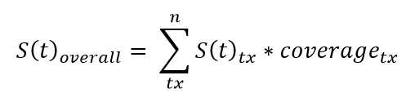

Notably, we will examine the first line of treatment for MM separately from later lines of treatment for RRMM and analyze progression-free survival and overall survival separately. Additionally, we not consider the effect of retreatment with anti-CD38 monoclonal antibodies in this portion of the analysis.

The overall survival function (*S(t)overall*) will be informed by Flatiron data published by Braulin et al. (2019). The survival functions for the remaining treatment categories will be informed by the sources described below. The coverage proportion for each treatment regimen will be informed by the 2021 values for a given line of treatment described in the Coverage Scale-Up section. The table below lists a summary of the data sources used to inform the survival outcomes for each treatment category in our simulation separately for newly diagnosed survival outcomes and for relapsed/refractory survival outcomes.

Table 3. Summary of data sources that will inform survival outcomes, by treatment category, in the simulation. Additional detail provided in text below.

|  |  |  |
| --- | --- | --- |
| **Treatment category** | **Data source for newly diagnosed survival outcomes** | **Data source for relapsed/refractory survival outcomes** |
| All treatment categories combined | Flatiron Health data (Braunlin et al. 2019) | Flatiron Health data (Braunlin et al., 2019) |
| Isatuxamib-containing treatment category | MAIA trial (Facon et al. 2020) | ICARIA trial (Attal et al., 2019) and IKEMA trial (Moreau et al. 2021) |
| Daratumumab-containing treatment category | MAIA trial (Facon et al. 2020) | POLLUX trial (Bahlis et al., 2020) |
| Residual treatment category (all treatments not containing isatuxamib or daratumumab) | Calculated using above sources | Calculated using above sources |

*Isatuxamib-Containing Treatment Category*

Isatuxamib is currently not approved for use in newly diagnosed multiple myeloma patients. Due to this absence of data, we assumed that the isatuxamib-containing treatment category will have the same effect on survival as the daratumumab-containing treatment category at the first line of treatment. See the daratumumab-containing treatment category description for more details.

In the relapsed and refractory setting, survival data specific to the isatuxamib-containing treatment category will be informed from the ICARIA trial (Attal et al. 2019), which reports on survival data among patients treated with isatuxamib + pomalidomide + dexamethasone, and the IKEMA trial (Moreau et al., 2021), which reports on survival data among patients treated with isatuxamib + carfilzomib + dexamethasone. Since the ICARIA and IKEMA study subjects differ from the Braunlin et al. (2019) study subjects we will perform standardization adjustment to the Braunlin et al. (2019) study (described in detail in the following section). We will assume that survival data from the ICARIA trial and the IKEMA trial contribute equally to inform the progression free survival rate of the isatuxamib-containing treatment category in the relapsed and refractory setting (an average of the two). However, since detailed data on overall survival was not reported in the IKEMA trial, the overall survival rate of the isatuxamib-containing treatment category will be informed by the ICARIA trial only.

*Daratumumab-Containing Treatment Category*

In addition to other daratumumab-containing regimens, daratumumab + bortezomib + lenalidomide + dexamethasone (dara-VRd) quartet regimen as well as the daratumumab + lenalidomide + dexamethasone (dara-Rd) triplet regimen are standard daratumumab-containing first line treatments, with dara-VRd more commonly administered to ASCT transplant eligible patients and daratumumab-Rd more commonly administered to ASCT patients. We chose to use survival data from patients treated with dara-Rd to inform the treatment effect of the daratumumab-containing treatment category in the first line of treatment. This is because, as reported in Braunlin et al. (2019), triplet regimens are significantly more common than quartet regimens in the first line of treatment and Braunlin et al. (2019) reports specifically on the coverage of first line treatment with a monoclonal antibody, an immunomodulatory imide, and dexamethasone, which is inclusive of dara-Rd. Therefore, the survival outcomes for the daratumumab-containing treatment category in the first line of treatment in our model is informed by survival data from the MAIA trial, which studied dara-Rd treatment among transplant ineligible patients. We will generalize the outcomes of this trial that is specific to transplant ineligible patients, which is a limitation of our analysis, although adjustment for confounding by age (as well as sex, cytogenetic risk, and renal function in the same manner described for the ICARIA trial) will partially address this limitation.

In the relapsed and refractory setting, survival data for the daratumumab-containing treatment category will be informed from the POLLUX trial (Bahlis et al., 2020), which reports survival data specific to daratumumab + lenalidomide + dexamethasone treatment regimen. Data from this study will be adjusted for relevant confounding factors in the same manner described for the ICARIA trial.

*Residual Treatment Category Survival Function*

We will solve for the survival function of the residual treatment category using the equation below for each modeled treatment category, *tx*.



*Hazard Ratios*

Using the survival functions for each treatment as described above and the following equations, we will solve for the hazard ratio (HR) of each treatment group relative to the residual treatment category.

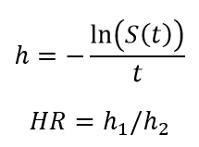

Notably, we will assume that the hazard ratios derived from third line of treatment data are the same across all lines of treatment in the relapsed/refractory setting. We will then use these estimated hazard ratios to inform the relative progression free survival and overall survival rates among simulants in the various treatment categories in our simulation.

**Estimation of Treatment Effects**

The following section walks through the specific methods and steps used to derive the hazard ratios for each treatment category, as briefly outlined in the previous section. We performed this process separately for the first line of treatment and for later lines of treatment.

First Line of Treatment

The data sources used to inform the survival rates at the first line of treatment in our model include Flatiron health data (Braunlin et al., 2020) and the dara-Rd arm of the MAIA trial (Moreau et al., 2021). The table below presents survival rates among the two populations.

Table 5. Survival data from Flatiron health study and the MAIA trail populations.

|  |  |  |
| --- | --- | --- |
| **Parameter** | **Flatiron Health (Braunlin et al. 2019)** | **MAIA Trial – Dara-Rd arm** |
| Median overall survival | 60 (95% CI: 57 – 62) | Not reached (83.2% of patients survived to 28 months) |
| Median progression free survival | Not reported | Not reached (70.6% of patients survived without progression to 30 months) |
| Median treatment duration | 9 (95% CI: 9 – 10) | 25.3 (Range: 0.1 to 40.4) |

The following table presents baseline patient characteristics for each of these studies. Notably, the patient characteristics vary substantially by age, cytogenetic risk, and renal insufficiency distributions, which confound the direct comparison of survival data between these two populations.

Table 5. Demographic comparison of Flatiron health study population and the MAIA trail population.

|  |  |  |
| --- | --- | --- |
| **Parameter** | **Flatiron Health (Braunlin et al. 2019)\*** | **MAIA Trial – Dara-Rd arm** |
| Sex, male | 53.9% | 51.4% |
| Age, years |  |  |
| 50-64 | 35.3%* | 1.1% |
| 65-74 | 32.5% | 55.4%* |
| 75+ | 32.2% | 43.5% |
| Race |  |  |
| White | 60.5% | 91.3% |
| Black | 15.9% | NR |
| Other/Missing | 23.6%* | 8.7% |
| High cytogenetic risk at diagnosis (at least one cytogenetic abnormality, including del17p, t[14;16], or t[4;14]) | 72.9%** | 15% |
| Renal insufficiency at diagnosis | 8.1% | 13.3% |
| Eastern Cooperative Oncology Group (ECOG) performance status score at diagnosis |  |  |
| 0 | 40.3%** | 34.5% |
| 1 | 38.9%** | 48.4% |
| 2+ | 20.8%*,** | 17.1% |
| International staging system (ISS) stage at diagnosis |  |  |
| I | 34.1%** | 26.6% |
| II | 33.3%** | 44.3% |
| III | 32.7%** | 17.1% |
| Previous lines of therapy | 0 | 0 |

NOTE: Values shown in this table were calculated from reported data in Braunlin et al. (2020) and Moreau et al. (2021) by aggregating across categories (indicated with *) or adjusting for missing data assuming complete lack of non-response bias (indicated with **) for ease of comparison when necessary. NR=not reported.

Therefore, we sought to standardized the survival rates of the MAIA trial to the population of the Flatiron health population with respect to the covariates presented in the above table. However, since the MAIA trial did not report survival rates stratified by each of these covariate values, we searched for hazard ratios for the covariates above, adjusted for treatment effects, from the literature to estimate stratified progression free and overall survival rates in the MAIA trial.

We performed a literature search to obtain estimates of hazard ratios for covariates of interest independent of treatment effects. The most relevant source we obtained was a large-scale prospective cohort study of newly diagnosed multiple myeloma patients from 90 different sites worldwide in the CoMMpass registry published by Derman et al. (2020). Derman et al. (2020) performed a multivariate analysis of the independent effects of age (+/- 65 years), gender, race (white/black), Eastern Cooperative Oncology Group (ECOG) performance score (+/- 2), International Staging System (ISS) score, estimated glomular filration rate (eGFR) (+/- 60 mL/min per 1.73 m2), high risk cytogenetic abnormalities, induction therapy (triplet/non-triplet), and autologous stem cell transplant (ASCT) on progression free survival and overall survival. The hazard ratios from this study for the covariates of interest are summarized in the table below. Notably, only non-treatment-related covariate in this analysis that was associated with progression free survival and/or overall survival at a statistically significant level was cytogenetic risk and the ISS. Notably, the authors did not report on collinearity between nor interactions among the variables in this analysis (Derman et al., 2020). Therefore, we are limited to the assumption that each of these variables have independent effects on progression free and overall survival rates. Notably, an independent analysis considering collinearity and interactions would be possible with access to Flatiron Health microdata.

Table 5. Hazard ratios of relevant covariates on progression free and overall survival from multivariate analysis adjusted for all variables shown and additional treatment-related variables obtained from Derman et al. (2020).

|  |  |  |  |  |
| --- | --- | --- | --- | --- |
| **Covariate** | **HR for progression free survival** | **HR for overall survival** | **Group of interest** | **Reference group** |
| Sex | 1.1 (0.9 – 1.5) | 1.5 (0.97 – 2.2) | Male | Female |
| Age | 1.2 (0.9 – 1.6) | 1.3 (0.9 – 2.0) | 65+ | Under 65 |
| Race | 1.2 (0.8 - 1.7) | 1.4 (0.9 - 2.3) | Black race | White race |
| Cytogenetic risk* | 1.3 (1.1 – 1.5) | 1.5 (1.2 – 1.9) | Increase in the number of cytogenetic abnormalities (including deletion 17p/TP53, 1q gain or amplification, t(4;14), t(14;16), and t(14;20) | |
| High risk by UAMS70 | 1.6 (1.2 – 2.4) | 1.9 (1.2 – 3.0) | High risk | Low risk |
| Renal function | 0.95 (0.7 – 1.3) | 1.1 (0.7 – 1.7) | <60 eGFR | >60 eGFR |
| ECOG performance score | 0.97 (0.7 – 1.4) | 1.0 (0.7 – 1.6) | ECOG performance status score of 2 or above | ECOG performance status score less than 2 |
| ISS status | 1.3 (1.04 – 1.5) | 1.5 (1.1 – 2.0) | Unit increase in ISS status score | |

*The authors found that this effect was modified by race such that it was present in white patients but not black.

The Flatiron health and the MAIA trail populations substantially varied with respect to age, race, cytogenetic risk, renal impairment, ECOG performance status score, and ISS stage at diagnosis. However, given that only the cytogenetic risk and ISS stage variables were found to be associated with progression free and overall survival at a statistically significant level and that the differences between the Flatiron health and MAIA trial populations were more substantial with regard to cytogenetic risk than ISS stage, we chose to standardized the MAIA trial population to the Flatiron Health population with regard to cytogenetic risk only. We chose not to additionally standardize to ISS stage due to the expected correlation between the two variables and the lack of a joint distribution with cytogenetic risk exposure reported in the MAIA trial participants.

While Derman et al. (2020) found that the effect of cytogenetic risk was modified by race, we do not currently consider this, which is a limitation of our analysis. Due to a lack of more detailed data from Flatiron Health and the MAIA trial, we assumed that of those with at least one high risk cytogenetic abnormality, 75% had one and 25% had two. This assumption was obtained based on data reported by Derman et al. (2020) that 243 patients had one high risk cytogenetic abnormality and 84 had at least two. Based on this assumption, we weighted the hazard ratio reported by Derman for an increase in the number of high risk cytogenetic abnormalities such that the summary hazard ratio for HRCA on PFS was 1.375 (95% CI: 1.125, 1.625) and OS was 1.625 (95% CI: 1.25, 2.125) relative to those with no high risk cytogenetic abnormalities.

The steps taken to perform this standardization and derive the hazard ratios for each treatment category at the first line of treatment for overall survival. Because Braunlin et al. (2020) did not report progression free survival for the Flatiron health cohort, we chose to repeat the process outlined below for overall survival using duration of treatment hazard rates, which we will ultimately use to inform progression free survival hazard ratios in our simulation.

**Step 1:** Calculate MAIA trial overall survival hazard rate using the overall survival rate of 83.2% at 28 months.

**Step 2:** Calculate MAIA trial overall survival hazard rates stratified by cytogenetic risk using the trial overall survival hazard rate (calculated in step 1), the cytogenetic risk hazard ratio for overall survival (1.5), and the prevalence of high risk cytogenetic patients (15%).

Given:

and

Then,

Where,

|  |  |
| --- | --- |
| Parameter | Definition |
|  | Overall hazard rate |
|  | Hazard rate for exposure category 1 |
|  | Hazard rate for exposure category 2 |
|  | Prevalence of exposure category 1 |
|  | Hazard ratio of exposure category 1 relative to exposure category 2 |

Given that we have the overall hazard rate and the prevalence of each exposure category (from the MAIA trial and the hazard ratio () from Derman et al. (2020), we can then solve for the hazard rate specific to each exposure category (shown below).

**Step 3:** Calculate the MAIA trial overall survival hazard rate standardized to the Flatiron health population on cytogenetic risk using the exposure distribution of high risk cytogenetics from that cohort (72.9%).

**Step 4:** Calculate the overall survival hazard rate for the Flatiron Health cohort using the median overall survival time of 60 months.

**Step 5:** Solve for the overall survival rate of the residual treatment category using the following equation, using the MAIA standardized hazard rate for both the daratumumab-containing and isatuxamib-containing treatment categories, the treatment coverage rates in 2019 from Braunlin et al. (2020), and first line of treatment Flatiron Health hazard rate.

**Step 6:** Calculate hazard ratios for each treatment category using respective overall survival rates by dividing the treatment category-specific hazard rate by the hazard rate specific to the all categories combined (Flatiron health hazard rate).

Table 6. Estimated overall survival hazard ratios at the first line of treatment for each modeled treatment category relative to all categories combined, without uncertainty.

|  |  |  |
| --- | --- | --- |
| **Exposure category** | **Hazard rate** | **Overall Survival Hazard ratio relative to all categories combined\*** |
| All categories combined | 0.01155 | 1 (reference) |
| Dara-containing category | 0.00874 | 0.760 |
| Isa-containing category | 0.00874 | 0.760 |
| Residual category | 0.01158 | 1.0024 |

*Note rounding differences

**Step 7**: Calculate uncertainty intervals.

We will calculate uncertainty intervals for the PFS HRs in the table above using Monte Carlo simulation methodology, propagating parameter uncertainty through each of the calculations shown in the steps above. We assumed a log-normal distribution of uncertainty within the reported confidence intervals for the hazard ratio of cytogenetic risk on survival outcomes. We assumed a normal distribution of uncertainty within the reported confidence intervals for median survival times from Braunlin et al. (2020). We performed 1,000 draws and used the 2.5th and 97.5th percentiles of the resulting distribution as lower and upper bounds.

**Step 8**: Repeat for treatment duration (details not shown).

**Final Values**

Table 7. Estimated progression free and overall survival hazard ratios at the first line of treatment for each modeled treatment category relative to all categories combined, with uncertainty.

|  |  |  |
| --- | --- | --- |
| **Treatment Category** | **Treatment Duration HR (95% UI)\*** | **Overall survival HR (95% UI)** |
| All categories combined | 1 (reference) | 1 (reference) |
| Daratumumab-containing treatment category | 0.429 (0.368, 0.495) | 0.760 (0.645, 0.895) |
| Isatuxamib-containing treatment category | 0.429 (0.368, 0.495) | 0.760 (0.645, 0.895) |
| Residual treatment category | 1.00581 (1.0051, 1.0064) | 1.0024 (1.0011, 1.0036) |

*To be used as a proxy for progression free survival

While we might expect to see a larger effect of daratumumab/isatuxamib-containing treatments on progression free survival than overall survival, the use of treatment duration as a proxy for progression free survival from the Braunlin et al. (2020) paper may have underestimated progression free survival rates among the Flatiron Health population (as briefly discussed by Braunlin et al.), may have exacerbated this difference. This potential overestimate of the impact of daratumumab/isatuxamib-containing treatments on progression free survival is a limitation of our analysis. We will assume a lognormal distribution of uncertainty within each uncertainty interval for use in Monte Carlo sampling of values in our simulation.

Relapsed and Refractory Treatment Effects

The data sources used to inform the treatment category-specific survival rates in the relapsed and refractory setting in our model include Flatiron health data (Braunlin et al., 2020), the ICARIA trial (Attal et al., 2019), the IKEMA trial (Moreau et al., 2021), and the POLLUX trial (Bahlis et al., 2020). The survival data for these trials is presented in the table below.

|  |  |  |  |
| --- | --- | --- | --- |
| **Parameter** | **ICARIA Isa-Pd arm** | **IKEMA Isa-Kd arm** | **POLLUX dara-Rd arm** |
| Median overall survival | Not reached (72% survived to 12 months) | Not reported | Not reached (65% survived to 42 months) |
| Median progression free survival | 11.5 (95% CI: 8.9 – 13.9) | Not reached (68.9% (95% CI: 60.7 – 75.8) survived without progression to 24 months) | 44.5 (upper bound confidence interval not estimate-able) |
| Median treatment durations | 9.43 (95% CI: 4.4 – 12.0)* | 18.4 (95% CI: 9.2 – 20.5)* | 34.3 (range: 0 – 05.8) |
| Median time to next treatment | Not reached (40% received subsequent treatment at median follow up of 11.7 months)** | Not reported | 50.6 |

*Converted from weeks to months by dividing by 4.345 weeks per month. **Visually estimated from figure

Notably, Braunlin et al. (2020) reports treatment line-specific survival data, but does not report treatment line-specific demographic data beyond baseline demographic data. Therefore, we do not have direct data to inform the covariate exposure distribution of Flatiron health data in the relapsed and refractory setting, which prevents us from directly standardizing the trial-specific data to the Flatiron population in the same manner as for the first line of treatment.

Rather, for the relapsed and refractory setting, the number of previous lines of treatment is an especially influential variable that influences survival rates. Therefore, rather than standardizing on cytogenetic risk as we did for the first line of treatment data sources, we will standardize each data source for the relapsed and refractory setting to the number of previous lines of treatment using similar methodology. The following table displays the distribution of number of previous lines of treatment across each trial; Flatiron health data included line-specific survival rates, so it is not included here.

Table X.

|  |  |  |  |
| --- | --- | --- | --- |
| **Parameter** | **ICARIA Isa-Pd arm** | **IKEMA Isa-Kd arm** | **POLLUX Dara-Rd arm** |
| Number of prior lines of therapy: median | 3 (IQR: 2-4) | 2 (IQR: 1-2) | 1 (Range: 1-11) |
| One | 0%* | 44% | 52.1% |
| Two | 33%** | 36% | 29.7% |
| Three | 33%** | 18% | 13.3% |
| Four+ | 34% | 2% | 4.9% |

*An inclusion criterion for the ICARIA trial was at least two prior lines of treatment.

**The ICARIA trial reported the number of study subjects with two to three prior lines of treatment as a single category; in the absence of more detailed data, we assumed equal distribution between two and three prior lines of treatment.

In order to compare to survival data for single line of treatment from the Flatiron Health data, we chose to standardize each trial to represent 100% two prior lines of treatment, as this was the category with the greatest combined density across all three trials. To achieve this standardization, we used line of treatment-specific survival data from Flatiron health to derive hazard ratios by line of treatment for progression free and overall survival (notably, we performed sensitivity analysis by standardizing to each line of treatment and results were robust).

*Duration of treatment*

|  |  |  |  |  |
| --- | --- | --- | --- | --- |
| Number of previous lines of treatment | Events/Total | Median duration of treatment in months (95% CI) | Hazard rate calculated from median survival | Hazard ratio relative to two previous lines of treatment |
| 1 | 4,885/5,124 | 8.0 (8.0 – 9.0) | 0.0866 | 0.875 (0.767 – 1.019) |
| 2 | 2,680/2,815 | 7.0 (6.0 – 7.0) | 0.0990 | 1 (reference) |
| 3 | 1,508/1,588 | 6.0 (NE – NE) | 0.1155 | 1.167 (1.036 – 1.309) |
| 4+ | 765/850 | 12.0 (11.0 – 15.0) | 0.0578 | 0.583 (0.454 – 0.786) |

*Overall Survival*

|  |  |  |  |  |
| --- | --- | --- | --- | --- |
| Number of previous lines of treatment | Events/Total | Median overall survival in months (95% CI) | Hazard rate calculated from median survival | Hazard ratio relative to two previous lines of treatment |
| 1 | 1,987/5,124 | 48.0 (45.0 – 50.0) | 0.0866 | 0.750 (0.681 – 0.812) |
| 2 | 1,213/2,815 | 36.0 (33.0 – 39.0) | 0.0990 | 1 (reference) |
| 3 | 731/1,558 | 29.0 (26.0 – 32.0) | 0.1155 | 1.241 (1.080 – 1.429) |
| 4+ | 423/850 | 23.0 (21.0 – 26.0) | 0.0578 | 1.565 (1.356 – 1.815) |

Since the line of treatment variable has four categories rather than the cytogenetic risk variable that had two, the standardization equations become a bit more complicated and are shown below.

So,

|  |  |  |
| --- | --- | --- |
| **Trial** | **PFS HR** | **OS HR** |
| ICARIA | 0.667 (0.537 – 0.836) | 1.159 (1.044 – 1.185) |
| IKEMA | 0.395 (0.349 – 0.447) | Not estimated |
| POLLUX | 0.217 (0.201 – 0.231) | 0.573 (0.550 – 0.595) |

For a given line of treatment:

**Final Values**

|  |  |  |  |  |
| --- | --- | --- | --- | --- |
| **Treatment category** | **PFS HR** | **OS HR** | **PFS HR (retreated)** | **OS HR (retreated)** |
| All categories combined | 1 (reference) | 1 (reference) | 1 (reference) | 1 (reference) |
| Isatuxamib-containing treatment category | 0.530 (0.356 – 0.803) | 1.159 (1.044 – 1.185) | 0.765 (0.678 – 0.902) | 1.318 (1.088 – 1.37) |
| Daratumumab-containing treatment category | 0.217 (0.203 – 0.231) | 0.572 (0.551 – 0.594) | 0.609 (0.601 – 0.616) | 0.786 (0.776 – 0.797) |
| Residual treatment category | 1.331 (1.324 – 1.337) | 1.181 (1.171 – 1.190) | NA | NA |

Will not plan to standardize to additional covariates as Braunlin does not report treatment line-specific exposure distributions; however, we may use data from Mohty et al. (2018), which tracks exposure distribution over treatment lines as a resource to inform how this may affect our model.

**Assumptions and Limitations**

1. We assume that the relative survival of those treated with daratumumab + lenalidomide + dexamethasone represents the relative survival of the entire daratumumab-containing treatment category both for the first line as well as relapsed/refractory settings. Notably, because the coverage of the daratumumab-containing coverage is informed by the coverage of a monoclonal antibody + immunomodulatory imide + dexamethasone triplet regimen, of which daratumumab + lenalidomide + dexamethasone is a part of, the bias introduced by this assumption is reduced, as other daratumumab-containing regimens will be effectively included in the residual treatment category. However, by not considering additional daratumumab-containing treatment regimens, we fail to capture the effect of potential retreatment and inherently assume that some daratumumab-containing regimens will be transitioned to isatuxamib-containing regimens as a result of the isatuxamib scale-up.
2. We assume that no patients are restricted from treatment with isatuxamib + pomalidomide + dexamethasone due to no prior treatment with lenalidomide and a proteasome inhibitor. Since lenalidomide and proteasome inhibitors are very common treatments, this is not a major limitation of our analysis.
3. We assume that all treatment regimens that do not contain isatuxamib or daratumumab will decrease in coverage at an equal rate proportionately to the increase in isatuxamib and daratumumab coverage. However, in reality, as isatuxamib and daratumumab coverage increases, it will likely be prescribed in preference over specific selected treatment regimens. Because this future provider practice is uncertain, it is unknown whether this will cause us to underestimate or overestimate the impact of isatuxamib scale-up.
4. We assume that 15 percent of patients treated with either an isatuxamib- or daratumumab-containing regimen who survive to the next line of treatment will be retreated with an anti-CD38 monoclonal antibody containing regimen at the next line of treatment, independent of the previous retreatment status. However, since there is no consensus recommendation for the retreatment with anti-CD38 monoclonal antibodies, this may not reflect true clinical practice.
5. We assume that isatuxamib-containing regimens and daratumumab-containing regimens are half as effective with respect to both progression free survival and overall survival among patients previously treated with a monoclonal antibody treatment relative to those without prior treatment with an anti-CD38 monoclonal antibody. This assumption is a limitation of our analysis caused by the lack of robust data to inform otherwise.
6. We assume that the isatuxamib-containing treatment category survival data in the relapsed and refractory setting is informed by an equal average between the survival data from the isa-Pd regimen in the ICARIA trial and the isa-Kd regimen from the IKEMA trial. The assumption of equal contribution of these two treatment regimens across all lines of treatment for relapsed/refractory MM is a limitation of our analysis that may be improved as more data on prescribing practices becomes available.
7. We assume that the (adjusted) survival outcomes of patients treated with daratumumab + lenalidomide + dexamethasone from the MAIA trial represent the survival outcomes of the entire isatuxamib-containing treatment category at the first line of treatment in our simulation. This is a limitation in the absence of isatuxamib-specific clinical data at the first line of treatment.
8. We assume that hazard ratios between treatment regimens do not differ by line of treatment in the relapsed/refractory setting.
9. We assume isatuxamib coverage does not vary by age, sex, race/ethnicity, cytogenetic risk, or ASCT eligibility. In reality, as triplet regimens are less likely to be prescribed to older and frail patients due to toxicity concerns, isatuxamib-containing triplet regimens may be prescribed at a higher rate among younger patients than older patients. Failing to consider this differential coverage by age may cause us to underestimate the impact of an isatuxamib scale-up on years of life lost among the total population.
10. We assume that, after standardization on cytogenetic risk exposure, differences in survival rates between the MAIA trial and the Flatiron Health data are entirely attributable to differences in treatment regimens and not confounded by other factors. Due to the non-randomized nature of these comparisons, it is possible that unmeasured confounding factors are present.
11. [Repeat above assumption for relapsed and refractory once completed]
12. We assume that the treatment regimen for a given line of treatment affects the progression free survival rate and overall survival rate for that stage of disease only. Once a patient relapses and progresses to the next stage of disease, their progression free survival and overall survival rates are exclusively affected by the treatment regimen for that disease stage and no treatment regimens from any prior lines of treatment.
13. We assume that the daratumumab-containing treatment category will increase in coverage over time according to IQVIA sales forecast data for each line of treatment equally. However, it may be likely that daratumumab-containing treatment category will increase in coverage for the first line of treatment at a faster rate than other lines of treatment given its relatively lower coverage in 2021.
14. We assume that the duration of treatment survival rate reported by Braunlin et al. (2020) is an acceptable proxy measure for the progression-free survival rate. However, the duration of treatment survival rate likely is an underestimate of the progression-free survival rate, which may cause an overestimation of the relative treatment effect of daratumumab/isatuxamib-containing treatments.

**References**

Attal M, Richardson PG, Rajkumar SV, et al. Isatuximab plus pomalidomide and low-dose dexamethasone versus pomalidomide and low-dose dexamethasone in patients with relapsed and refractory multiple myeloma (ICARIA-MM): a randomised, multicentre, open-label, phase 3 study. Lancet 2019; 394: 2096–107.

Bahlis, N. J., Dimopoulos, M. A., White, D. J., Benboubker, L., Cook, G., Leiba, M., ... & San-Miguel, J. (2020). Daratumumab plus lenalidomide and dexamethasone in relapsed/refractory multiple myeloma: extended follow-up of POLLUX, a randomized, open-label, phase 3 study. Leukemia, 34(7), 1875-1884.

Becnel, M.R.; Horowitz, S.B.; Thomas, S.K.; Iyer, S.P.; Patel, K.K.; Manasanch, E.E.; Weber, D.M.; Kaufman, G.P.; Lee, H.C.; Orlowski, R.Z. Descriptive Analysis of Isatuximab Use Following Prior Daratumumab in Patients with Relapsed/Refractory Multiple Myeloma. Blood 2020, 136, 20–21.

Braunlin, M., Belani, R., Buchanan, J., Wheeling, T., & Kim, C. (2021). Trends in the multiple myeloma treatment landscape and survival: A US analysis using 2011–2019 oncology clinic electronic health record data. Leukemia & Lymphoma, 62(2), 377-386.

Derman, B. A., Jasielec, J., Langerman, S. S., Zhang, W., Jakubowiak, A. J., & Chiu, B. C. H. (2020). Racial differences in treatment and outcomes in multiple myeloma: a multiple myeloma research foundation analysis. Blood cancer journal, 10(8), 1-7.

Facon, T., Kumar, S., Plesner, T., Orlowski, R. Z., Moreau, P., Bahlis, N., ... & Usmani, S. Z. (2019). Daratumumab plus lenalidomide and dexamethasone for untreated myeloma. New England Journal of Medicine, 380(22), 2104-2115.

Mikhael, J., Belhadj-Merzoug, K., Hulin, C., Vincent, L., Moreau, P., Gasparetto, C., ... & Leleu, X. (2021). A phase 2 study of isatuximab monotherapy in patients with multiple myeloma who are refractory to daratumumab. Blood cancer journal, 11(5), 1-5.

Mohty, M., Cavo, M., Fink, L., Gonzalez‐McQuire, S., Leleu, H., Mateos, M. V., ... & Yong, K. (2019). Understanding mortality in multiple myeloma: Findings of a European retrospective chart review. European journal of haematology, 103(2), 107-115.

Moreau, P., Dimopoulos, M. A., Mikhael, J., Yong, K., Capra, M., Facon, T., ... & Ozkalemkas, F. (2021). Isatuximab, carfilzomib, and dexamethasone in relapsed multiple myeloma (IKEMA): a multicentre, open-label, randomised phase 3 trial. The Lancet.

Nooka, A.K.; Joseph, N.S.; Kaufman, J.L.; Heffner, L.T.; Gupta, V.A.; Gleason, C.; Boise, L.H.; Lonial, S. Clinical Efficacy of Daratumumab, Pomalidomide, and Dexamethasone in Patients with Relapsed or Refractory Myeloma: Utility of Re-Treatment with Daratumumab among Refractory Patients. Cancer 2019, 125, 2991–3000.

Radocha, J., van de Donk, N. W., & Weisel, K. (2021). Monoclonal Antibodies and Antibody Drug Conjugates in Multiple Myeloma. Cancers, 13(7), 1571.

Shah, N.; Aiello, J.; Avigan, D.E.; Berdeja, J.G.; Borrello, I.M.; Chari, A.; Cohen, A.D.; Ganapathi, K.; Gray, L.; Green, D.; et al. The Society for Immunotherapy of Cancer Consensus Statement on Immunotherapy for the Treatment of Multiple Myeloma. J. Immunother. Cancer 2020, 8.