**Lung cancer screening coverage overview**

There have been several screening programs initiated in China; generally pilot or feasibility studies to investigate the effectiveness of LDCT. These programs are summarized by Cheng et al. (2019), Triphuridet & Henschke (2019), and Zhao & Wu (2015). Notably, as part of the Cancer Screening Project in Urban Areas of China, which aimed to provide free screenings to community based high-risk populations in 14 provincial-level regions in China, an estimated 210,000 (3,000 individuals/year/province for five years) received free baseline lung cancer screenings between 2012 and 2017 (Zhao & Wu, 2015).

However, lung cancer screening practices in China among the general population have not been extensively studied, as recognized by Yao et al. (2016). Yao et al. (2016) published a protocol for a study that will make use of linked cancer registries and insurance claim data to evaluate cancer screening practices, which they note is the first study of its kind in China. However, results from this study have not yet been published.

Notably, increased coverage in LDCT lung cancer screening has been hypothesized to contribute to a recent rise in lung cancer incidence among women in China, although no data on cancer screening rates was available to confirm this hypothesis (Liang et al., 2019).

Given the lack of data on lung cancer screening coverage in China, it is useful to consider lung cancer screening coverage by LDCT in other locations. As reported in the 2019 review by the American Cancer Society (Smith et al., 2019), 3.3% of the eligible population in the United States received a recent lung cancer screening in 2010 and 3.9% in 2015. Additionally, as discussed by Blom et al. (2019), a gradual increase in LDCT lung cancer screening coverage is necessary in order to not overwhelm the capacity of surgery wards to treat these newly identified lung cancers.

Yoshida et al. (2010) summarizes the lung cancer screening rate in Japan between 1990 and 2010, shown in the figure below. Notably, as discussed by Pinsky (2018) and Triphuridet & Henschke (2019), chest x-rays were used for lung cancer screenings before the early 1990s in Japan when LDCT screenings were introduced.

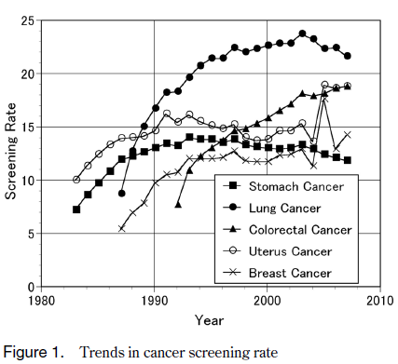

References

Blom, E. F., ten Haaf, K., Arenberg, D. A., & Koning, H. J. (2019). Treatment capacity required for full‐scale implementation of lung cancer screening in the United States. *Cancer*, *125*(12), 2039–2048. https://doi.org/10.1002/cncr.32026

Cheng, Y. I., Davies, M. P. A., Liu, D., Li, W., & Field, J. K. (2019). Implementation planning for lung cancer screening in China. *Precision Clinical Medicine*, *2*(1), 13–44. https://doi.org/10.1093/pcmedi/pbz002

Liang, F., Wu, C., Gu, H., Zhu, M., Xuan, Z., Jiang, Y., Chen, H., Fu, C., & Zheng, Y. (2019). Lung cancer incidence in female rises significantly in urban sprawl of Shanghai after introduction of LDCT screening. *Lung Cancer*, *132*, 114–118. https://doi.org/10.1016/j.lungcan.2019.04.020

Pinsky, P. F. (2018). Lung cancer screening with low-dose CT: A world-wide view. *Translational Lung Cancer Research*, *7*(3), 234–242. https://doi.org/10.21037/tlcr.2018.05.12

Smith, R. A., Andrews, K. S., Brooks, D., Fedewa, S. A., Manassaram‐Baptiste, D., Saslow, D., & Wender, R. C. (2019). Cancer screening in the United States, 2019: A review of current American Cancer Society guidelines and current issues in cancer screening. *CA: A Cancer Journal for Clinicians*, *69*(3), 184–210. https://doi.org/10.3322/caac.21557

Triphuridet, N., & Henschke, C. (2019). Landscape on CT screening for lung cancer in Asia. *Lung Cancer: Targets and Therapy*, *Volume 10*, 107–124. https://doi.org/10.2147/LCTT.S192643

Yao, N., Wang, J., Cai, Y., Yuan, J., Wang, H., Gong, J., Anderson, R., & Sun, X. (2016). Patterns of cancer screening, incidence and treatment disparities in China: Protocol for a population-based study. *BMJ Open*, *6*(8), e012028. https://doi.org/10.1136/bmjopen-2016-012028

Yoshida, M., Kondo, K., & Tada, T. (2010). The relation between the cancer screening rate and the cancer mortality rate in Japan. *The Journal of Medical Investigation*, *57*(3,4), 251–259. https://doi.org/10.2152/jmi.57.251

Zhao, S., & Wu, N. (2015). Early detection of lung cancer: Low‐dose computed tomography screening in C hina. *Thoracic Cancer*, *6*(4), 385–389. https://doi.org/10.1111/1759-7714.12253