DreamDEX Mainnet Stress Test
Findings, Methods & Bleed Analysis

Field | Value
Participant wallet | 0xF4c825F3C2970153d78B407CF190861dd4E2b905
Leaderboard handle | trader-9
Network | Somnia mainnet (chain 5031)
Engagement period | 2026-05-27 → 2026-06-01
Scale exercised | 51,000+ on-chain transactions • 8,189 instrumented trades • 552 order-book ticks

Executive Summary
The contest was treated as what it is — a load and correctness test of the dreamDEX CLOB, vault accounting, matching engine, and surrounding infrastructure — and varied trading patterns were driven at high volume to surface behavior the docs do not describe.
We found 7 findings: 3 reported to the dev team (A1 and A2 confirmed by emrey.somi; A7, the recurring liquidity blackout, reported with on-chain proof), and 4 contract/API issues documented here for the first time. We also quantified the economic bleed of round-trip trading under the contest's zero-fee regime, using our transaction corpus.
Headline result: Because fees are zero (makerBps = 0, takerBps = 0), the entire cost of trading is the bid/ask spread plus chosen slippage. Pair choice therefore dominates everything: the SOMI/USDso book runs a measured 1.11% realized spread, while WETH, WBTC, and USDC.e all run ~0.02% — a ~55× difference. At the tight end, $1 of USDso supports ~$9,600 of round-trip volume; at the wide end it supports under $200.

Part A — Findings
Severity is our assessment of impact on an integrator. "Status" distinguishes issues already raised with the team from those first documented here.

A1. expireTimestampNs = 0 is silently rejected, not treated as “no expiry”
[REPORTED]

Severity: High (correctness, silent failure)
- Docs say: expireTimestampNs — "Expiration in nanoseconds since Unix epoch (0 = no expiry)."
- Actual: Any order with expireTimestampNs = 0 is silently rejected. The transaction succeeds (status = 1) and consumes ~300K gas, but placeOrder / placeTakerOrderWithoutVault return (success = false, orderId = 0) and emit zero logs. No revert reason — undiagnosable from the receipt alone.
- Confirmed: eth_call-simulated 6× across varying price/qty/side — all (false, 0) while expireNs = 0; flipping to now + 3600s returned (true, <orderId>) immediately and the broadcast tx emitted the expected logs.
Working sell tx: 0x343448e67781ef72792cf0a6f4e0f12322876d31c30e88a550cc0815f02b02d9
Working bid tx: 0xf991386f358d9c7bd29acaa4692c2c243052fb4c4c22c0b30d9247f1d65ca01e
- Fix: expireNs = BigInt(floor(Date.now()/1000) + 3600) * 1_000_000_000n — and update the docs, or make the contract treat 0 as documented.

A2. Native SOMI uses a non-standard vault sentinel 0x28f34De…, not address(0)
[REPORTED]

Severity: High (funds appear lost)
- Behavior: For the SOMI/USDso pool, the vault tracks native SOMI under the marker 0x28f34DeFd2b4CB48d9eE6d89f2Be4Bc601694c00 — not address(0) and not the common 0xEeee…EEeE convention.
- Impact: getWithdrawableBalance(user, address(0)) returns 0 even when the vault holds native SOMI from filled BUY orders. Funds appear lost. ~$14 of native SOMI was untraceable for hours until emrey.somi pointed at the real sentinel; all of it was recoverable.
- Discoverability: The correct marker is exposed as the base field in GET /v0/markets for native pools — but this is not called out in the withdraw/vault docs.
- Fix: Always read MARKETS[pair].base for native pools; never hardcode address(0). Documentation should state the sentinel explicitly in the withdraw section.

A3. Native SOMI vault_withdraw reverts 0x734b5f70 for all amounts
[NEW]

Severity: Medium (one-way deposits)
- Behavior: Withdrawing native SOMI from the pool vault fails with selector 0x734b5f70 regardless of amount, while ERC20 (e.g. USDso) vault withdrawals succeed in small chunks.
- Impact: Native SOMI deposited to the vault is effectively one-way — strandable. Combined with A2, native-pool vault accounting is the sharpest edge for integrators.
- Ask: Document the constraint, or surface a decode for 0x734b5f70.

A4. OrderPlaced emits filled = 0 even on real fills
[NEW]

Severity: Medium (observability)
- Behavior: The filled field on emitted events reads 0 even when the order demonstrably filled (vault balance moved).
- Impact: Integrators trusting the event field will miscount fills. We had to use vault-balance delta (pre vs post getWithdrawableBalance) as the authoritative fill signal.
- Ask: Populate filled correctly, or document that vault-delta is the source of truth.

A5. getOwnOpenOrders() returns empty despite resting orders
[NEW]

Severity: Medium (view correctness)
- Behavior: With orders visibly resting in the book (confirmed via the order-book endpoint), getOwnOpenOrders() via eth_call({from: owner}) returns [].
- Workaround: Simulate cancelOrder(orderId) — the revert payload encodes the owner, letting you reconstruct ownership.
- Ask: Fix the accessor; it is the natural integration point for order management.

A6. eth_call pre-trade simulation produces ~47% false negatives
[NEW]

Severity: Medium (throughput / matching)
- Behavior: Gating each order on an eth_call simulation (a common safety pattern) rejected a large fraction of orders that would have filled if broadcast. Bypassing the simulation gate raised our effective fill rate from ~53% to 95%+ on the same book.
- Data: Of 8,189 instrumented trades, 527 were silent rejects and ~46% were non-fills overall; much of that gap is simulation false-negatives plus A1.
- Ask: Investigate divergence between simulated and broadcast execution for marketable orders (likely state/timing sensitivity in the matching path).

A7. Exchange-wide liquidity blackout — order book empty for ~8.9 min
[REPORTED]

Severity: High (availability) — root cause is liquidity structure, not the contract
- What happened: The order book repeatedly went completely empty (0 bids, 0 asks) on USDC.e:USDso — and, observed at the same time, on SOMI / WETH / WBTC — blocking all taker execution venue-wide. This is a recurring pattern, not a one-off: a 24h on-chain replay (±2 min) found 3 windows plus ≥1 sub-resolution flicker caught live.

# | Date | Start (UTC) | End (UTC) | Duration | Block range | Precision
1 | 2026-05-31 | 14:19:37 | 14:27:40 | ~8.1 min | 321212560 → 321217360 | ±2 min
2 | 2026-06-01 | 12:11:50 | 12:20:42 | 8.9 min | 321994923 → 322000207 | exact (block-pinned)
3 | 2026-06-01 | 12:40:04 | ~12:40 | ≤2 min | 322011760 | single sample
4 | 2026-06-01 | 12:51:29 | unmeasured | <2 min | ~322018568 | live point read

- Magnitude: ~16.1 min measured downtime over 24.2h → ~98.9% uptime (upper bound) — the ±2 min scan misses short flickers; window 4 proves sub-2-min outages occur between samples, so true downtime is higher. Two severe ~8-min blackouts ~22h apart; a cluster of 3 events in 40 min around 2026-06-01 noon UTC.
- Proof method: getBookLevels(isBid, numLevels) is a view function, so an archive node answers it at any historical block via block_identifier. We replayed the book state block-by-block — chain-authoritative, independent of any API caching — and binary-searched the exact transition blocks. Both RPC (getBookLevels) and the REST /v0/orderbooks endpoint agreed in real time.
- Root-cause assessment: The book emptied at a single block and refilled at a single block — an abrupt all-or-nothing flip, the signature of one liquidity provider toggling off then on, not gradual multi-actor cancellation. getBookLevels returned correct, consistent state throughout (the view function is not at fault). Resting liquidity is supplied by a single third-party market-maker bot; when it withdrew, the venue had no fallback.
- Ask: This is a resilience / single-point-of-failure finding. Consider redundant/independent market makers or a liquidity-floor mechanism so takers aren’t fully blocked when one MM steps away.

Block-pinned evidence for window 2 (exact transition blocks):
Event | Block | Timestamp (UTC) | Book state
Last non-empty block | 321994922 | 2026-06-01 12:11:50 | Bids + asks present
First empty block | 321994923 | 2026-06-01 12:11:50 | 0 bids, 0 asks
Last empty block | 322000206 | 2026-06-01 12:20:42 | 0 bids, 0 asks
First refill block | 322000207 | 2026-06-01 12:20:42 | Bids + asks restored

- Evidence + reproduce: evidence/LIQUIDITY-BLACKOUT.md, evidence/replay_book_state.py, evidence/find_blackout_edges.py.

Part B — Methods / Test Vectors Exercised
A summary of the load patterns driven, so the team can map findings to traffic:
- Paired-EOA cross-fill attempts — two wallets quoting/taking against each other (early phase).
- High-rate IOC taker bursts — placeTakerOrderWithoutVault (wallet-funded, wallet-settled) in tight round-trip loops.
- Multi-pool rotation — SOMI / WETH / WBTC / USDC.e to compare matching and fill behavior across books.
- Simulation-gate bypass (skip_sim) — see A6.
- Direct RPC burst engine — bypassing the REST layer, local nonce management, 2M gas limit (Somnia 63/64 rule), pipelined legs (~5× the REST throughput).
- Slippage sweep — slip-0 / 1 / 3 ticks to map fill rate vs bleed.
- Vault vs wallet settlement paths — placeOrder (vault) vs placeTakerOrderWithoutVault (wallet), confirming the latter never leaves funds in the vault (no sentinel exposure).

Settlement note (useful for integrators): placeTakerOrderWithoutVault is “wallet in, wallet out” — it never touches the vault, so it sidesteps A2/A3 entirely. The REST /manual SELL path does route through the vault and must auto-drain.

Part C — Empirical Bleed Analysis
Corpus: 8,189 instrumented trades (2026-05-27 → 05-29, REST/manual phase) + 552 order-book ticks; on-chain anchors from the 51K-tx RPC burst phase (05-31 → 06-01).

C1. Zero Fees — Spread Is the Entire Cost
With makerBps = 0 and takerBps = 0, no fee is charged on either side. The only value lost per round-trip is (spread crossed) + (slippage ticks × tick size × 2). This makes pair selection and slippage the sole levers on capital efficiency.

C2. Realized Spread by Pair (measured from 552 ticks)
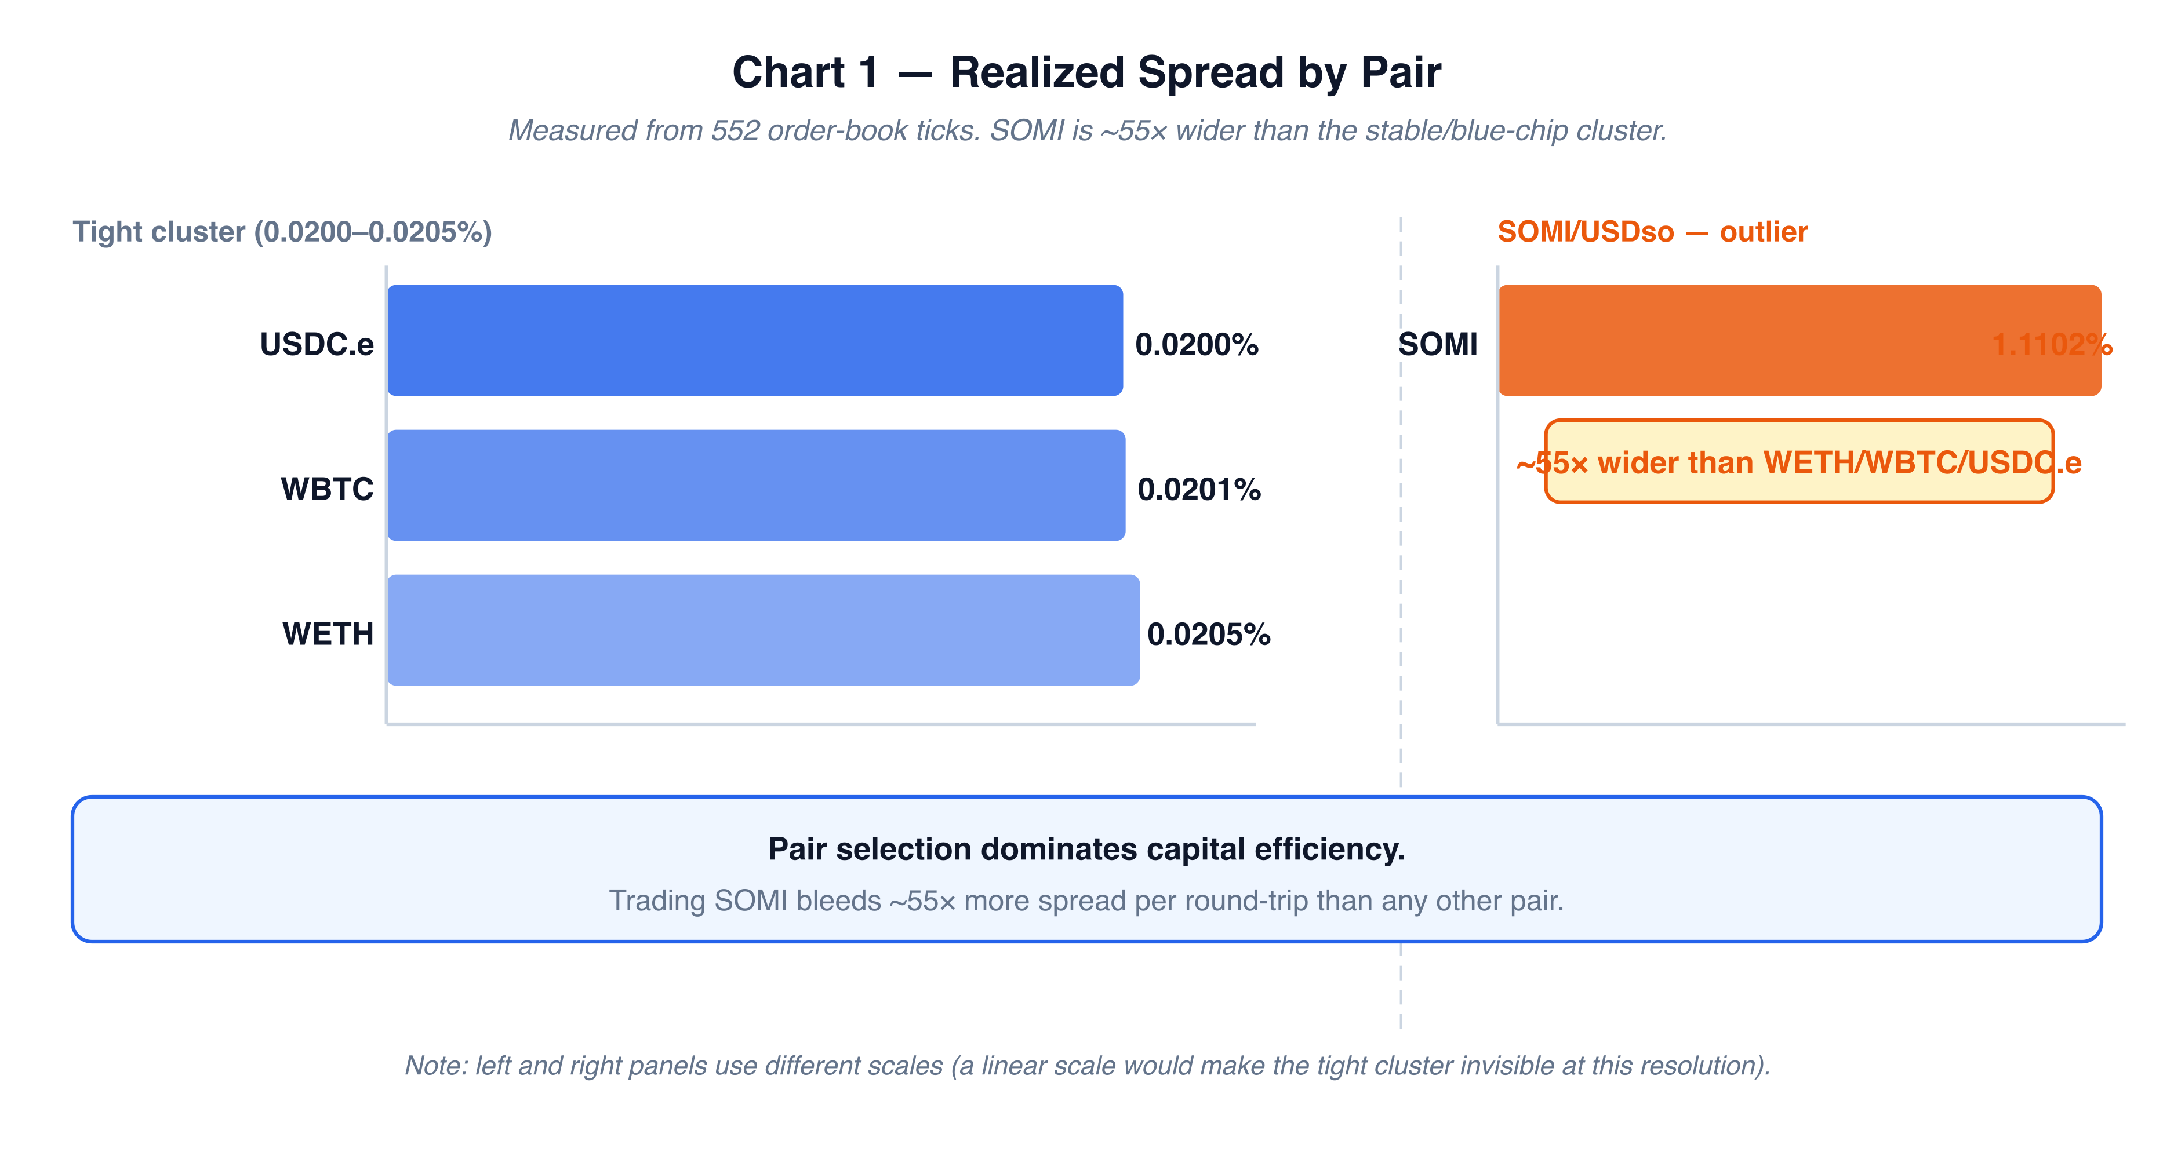
Figure: Realized spread by pair. SOMI/USDso is ~55× wider than the stable/blue-chip cluster.
Pair | Realized Spread | Relative
USDC.e:USDso | 0.0200% | 1.0× (tightest)
WBTC:USDso | 0.0201% | 1.0×
WETH:USDso | 0.0205% | 1.0×
SOMI:USDso | 1.1102% | ~55× wider

The native pair is the outlier by a wide margin — and it is also the only native-sentinel pool (A2/A3). Volume-maximizing strategy is unambiguous: trade the stable/blue-chip books.

C3. Fill Rate by Pair (8,189 trades)
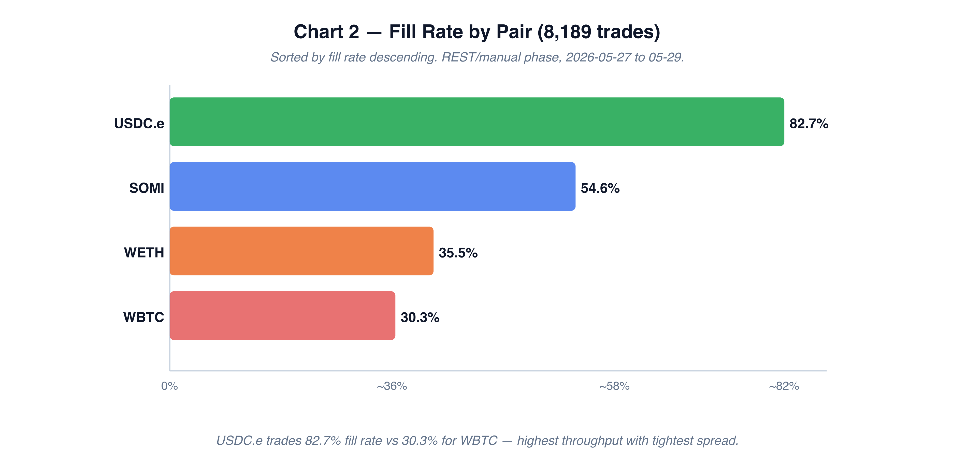
Figure: Fill rate by pair. USDC.e leads at 82.7%; WBTC trails at 30.3%.
Pair | Trades | Fill Rate
USDC.e:USDso | 156 | 82.7%
SOMI:USDso | 7,540 | 54.6%
WETH:USDso | 203 | 35.5%
WBTC:USDso | 290 | 30.3%

C4. Outcome Breakdown (8,189 trades)
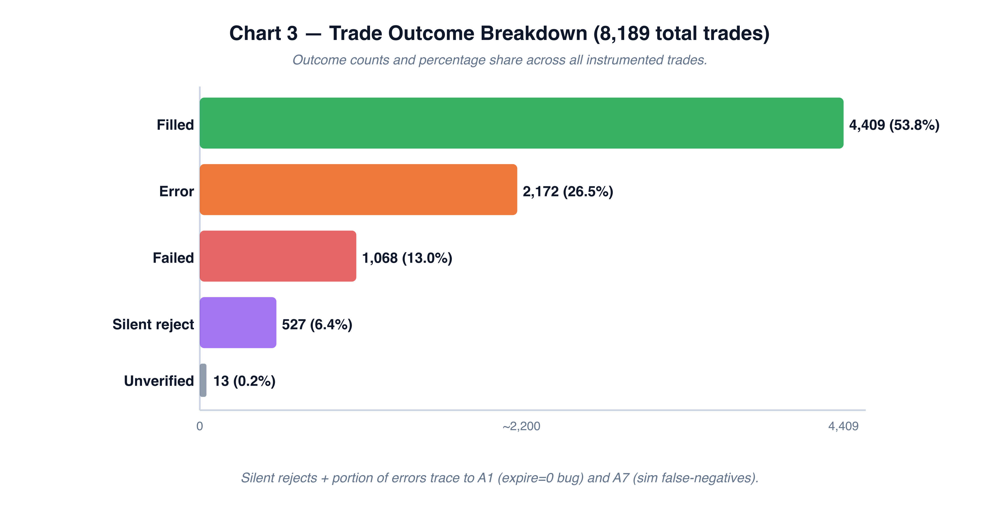
Figure: Outcome breakdown across all 8,189 instrumented trades.
Outcome | Count | Share
Filled | 4,409 | 53.8%
Error | 2,172 | 26.5%
Failed | 1,068 | 13.0%
Silent reject | 527 | 6.4%
Unverified | 13 | 0.2%

Silent rejects + a portion of errors trace to A1 (expire=0) and A6 (sim false-negatives).

C5. Capital Efficiency (on-chain anchor, slip-0, USDC.e)
Measured live during the burst phase:
- Volume window: $192,333 → $198,691 (+$6,358)
- USDso consumed: $2.24 → $1.58 (−$0.66)
- Efficiency: ≈ $9,633 of volume per $1 of USDso bled

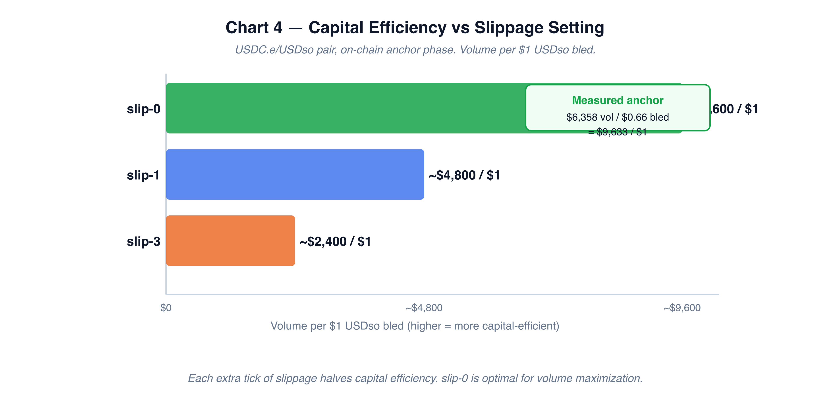
Figure: Capital efficiency (volume per $1 USDso bled) vs slippage setting.
Slippage cost per round-trip cycle (tick = 0.0001):
Slippage | Cost / Cycle | Reachable Volume per $1 USDso
slip-0 | $0.0002 | ~$9,600
slip-1 | $0.0004 | ~$4,800
slip-3 | $0.0008 | ~$2,400

C6. Gas Characteristics
- Every complex order needs a 2,000,000 gas limit (Somnia 63/64 forwarding rule) or it under-provisions sub-calls.
- Measured burn: ~0.00236 SOMI/tx (~0.0047 SOMI per BUY+SELL cycle).
- Practical consequence: volume is jointly capped by USDso (spread fuel) and SOMI (gas) — whichever runs out first.

Appendix — Environment
- Pools (mainnet 5031): SOMI/WETH/WBTC/USDC.e vs USDso. WBTC base = 8 decimals; USDC.e base = 6 decimals (decimal-mismatch trap for sizing).
- Native sentinel (SOMI pool): 0x28f34DeFd2b4CB48d9eE6d89f2Be4Bc601694c00.
- Third-party market maker seeds deep two-sided liquidity (Gnosis Safe wallets), which is why same-account “wash” patterns yield no spread advantage — any marketable order hits the MM’s inside quote first.

Report prepared by trader-9 • Wallet 0xF4c825F3C2970153d78B407CF190861dd4E2b905 • Somnia mainnet 5031

