DreamDEX Campaign
Complete On-Chain Trade Analysis

Full dataset analysis

Wallet: 0xF4c825F3C2970153d78B407CF190861dd4E2b905 (trader-9)
Network: Somnia mainnet · Chain 5031
Dataset: 63,569 txs · 2026-05-26 → 06-01

Dataset Provenance
Wallet: 0xF4c825F3C2970153d78B407CF190861dd4E2b905 (trader-9) · Network: Somnia mainnet (chain 5031)
Dataset: 63,569 transactions, 2026-05-26 → 2026-06-01. Scraped from chain (Blockscout v2). Source: analysis/onchain_trades.db; regenerate via analysis/scrape_trades.py, analyse via analysis/analyze_full.py.

The direct-burst engine fires raw RPC and never logged to the backend DB, so the chain is the only complete record. Computed filled notional (~204,475 USDso) matches the leaderboard (~205k) — confirming the dataset is complete.

1. Overview
Metric | Value
Transactions | 63,569
Order txs (buy/sell) | 62,118
Other (approvals/setup) | 1,451
First tx | 2026-05-26 10:02:42 UTC
Last tx | 2026-06-01 15:16:39 UTC
Calendar span | 149.2 h (6.2 days)
Trading sessions (gap >10 min) | 48
Active trading time | ~69.4 h

2. By Pair — Where Volume and Reverts Came From
Pair | Txs | Fills | Fill % | Reverts | Volume (USDso) | Gas (SOMI)
WETH:USDso | 39,703 | 28,751 | 72.4% | 4,635 | 124,789 | 82.93
SOMI:USDso | 8,419 | 7,041 | 83.6% | 815 | 64,406 | 18.55
USDC.e:USDso | 13,836 | 13,761 | 99.5% | 19 | 14,543 | 33.91
WBTC:USDso | 160 | 91 | 56.9% | 25 | 736 | 0.38
TOTAL | 62,118 | 49,644 | 79.9% | 5,494 | ~204,475 | 136.34

Key reads:
- WETH was the workhorse and the troublemaker — 61% of all volume, but 84% of all reverts (4,635) and 61% of gas.
- USDC.e was the cleanest engine — 99.5% fills, only 19 reverts (the slip-0 + skip-sim era).
- SOMI carried 64k volume off just 7k fills — early legs were large (~$9 notional vs ~$1 for USDC.e).

Chart: Volume by Pair (USDso)
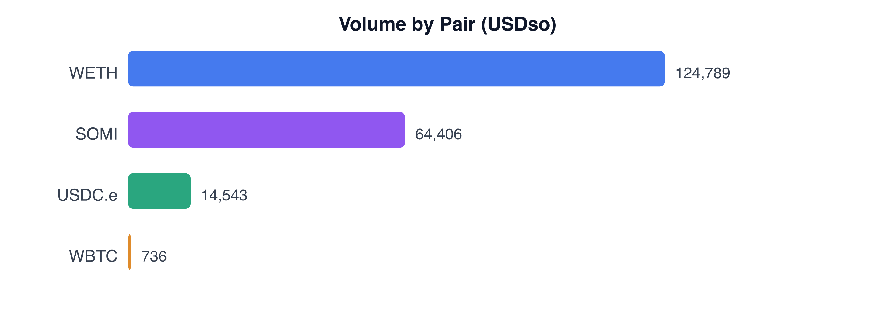
Chart: Gas Spent by Pair (SOMI)
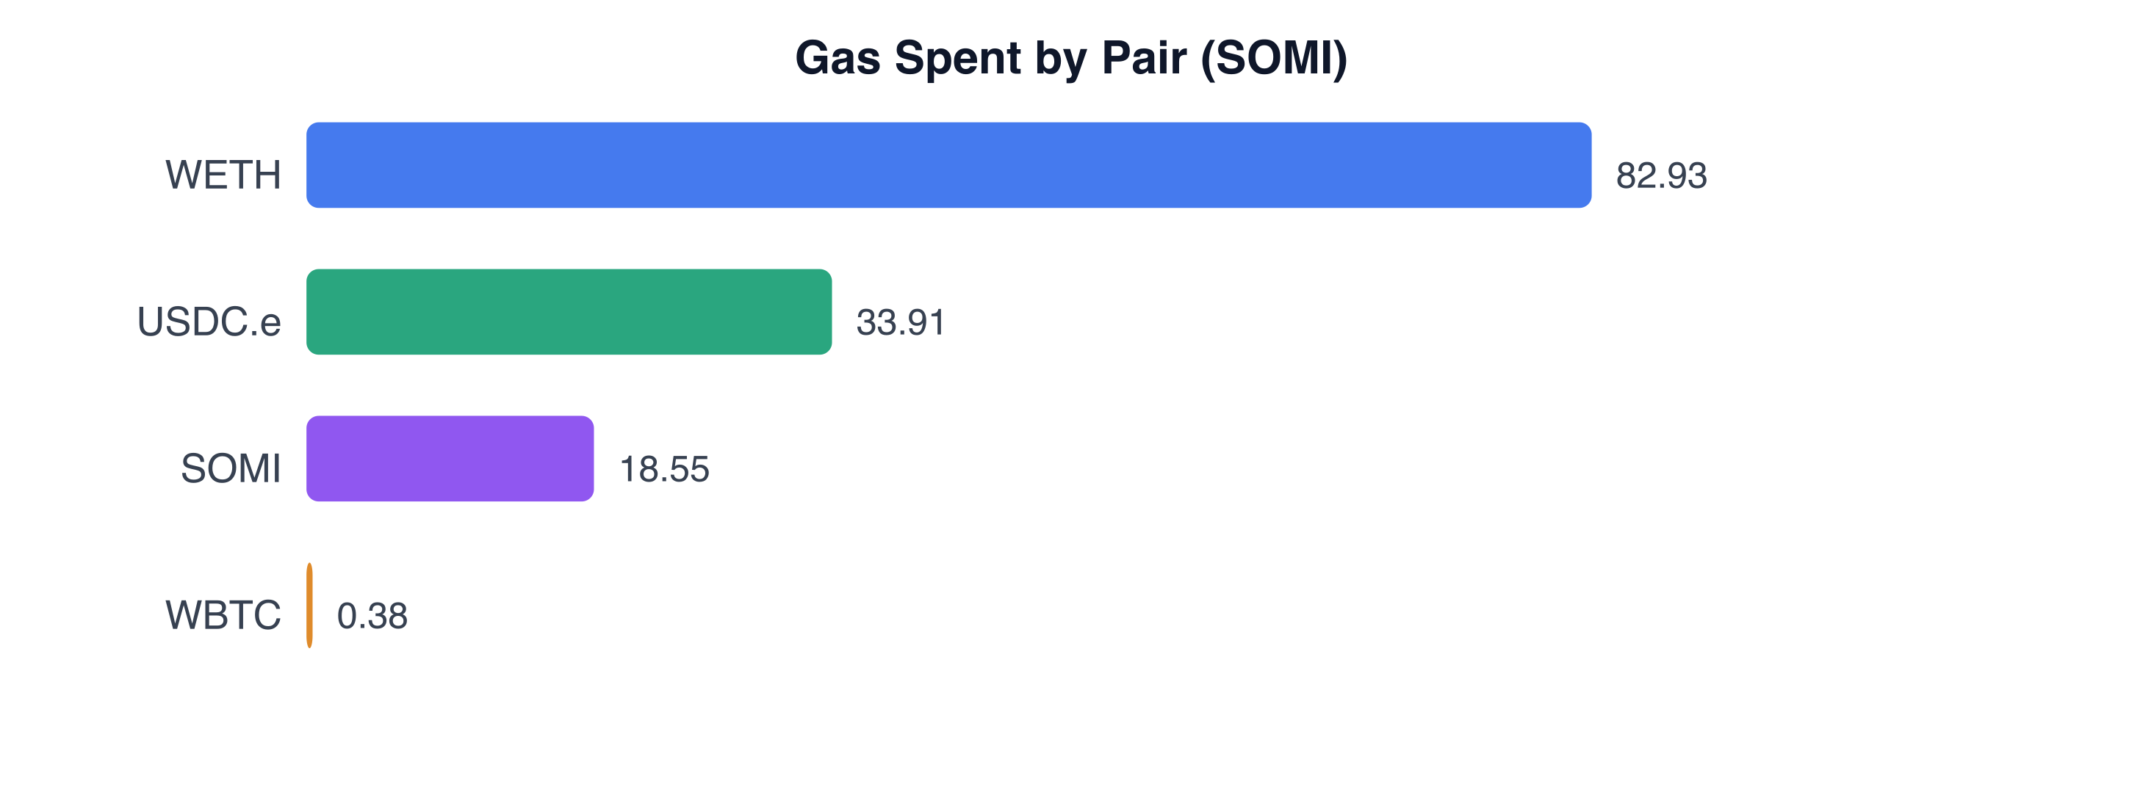
Chart: Reverts by Pair
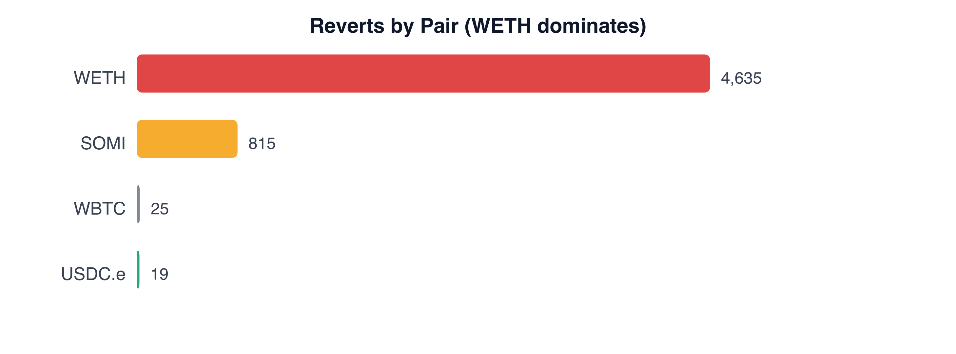

3. Buy/Sell Balance
Side | Txs | Fills | Fill %
Buy | 31,244 | 24,815 | 79.4%
Sell | 30,874 | 24,829 | 80.4%

Near-perfectly balanced — disciplined round-tripping, no lopsided inventory drift.

4. Status & Gas Economics
Outcome | Count | Avg Gas
Filled order | 49,644 | 419,222
No-fill order | 6,980 | 185,238
Reverted | 5,507 | 95,404
Status ok / reverted | 58,062 / 5,507 | Revert rate 8.7%

Total gas burned: 136.34 SOMI — the true cost of the campaign. The clean gas separation (fill ≈19k, no-fill ≈185k, revert ≈95k) is what makes the gas-based fill classifier reliable.

5. Traded Price Ranges (Filled)
Pair | Min | Max | Avg | Note
USDC.e:USDso | 0.9996 | 1.0006 | 1.000 | rock-stable peg → safe pair
SOMI:USDso | 0.1457 | 0.171 | 0.153 | ~17% range → volatile, wide spread
WETH:USDso | 1,975 | 2,089 | 2,020
WBTC:USDso | 73,347 | 73,618 | 73,505

6. Activity Over Time
Day | Order Txs | Fill %
2026-05-26 | 107 | 88%
2026-05-27 | 1,469 | 89%
2026-05-28 | 3,103 | 86%
2026-05-29 | 23,775 | 68%
2026-05-30 | 13,109 | 82%
2026-05-31 | 14,746 | 89%
2026-06-01 | 5,809 | 99%

Fill rate climbed over the campaign — from ~68% on the heaviest day to 99% at the end — as skip-sim + slip-0 + USDC.e were dialled in.

Hour-of-day (UTC): activity peaked 12:00–16:00 (afternoon), bottomed overnight (22:00–00:00). Peak hour 15:00 (~5,200 txs); quietest 23:00 (~0).

Chart: Daily Activity (Order Txs)
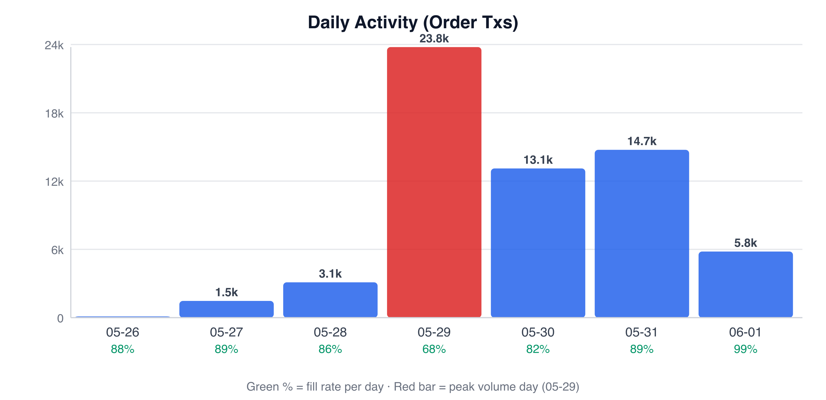

7. Bot-Tuning Takeaways (Post-Contest Profit Bot)
- USDC.e slip-0 is the engine — 99.5% fills, ~zero reverts, stable peg. Start here.
- WETH is a revert trap — 84% of all reverts; only use with skip-sim + a strict balance guard, or avoid for reliability.
- SOMI’s wide spread = high capital bleed; only for big-notional bursts, never for profit-making.
- Fill classifier is solid — 419k/185k/95k gas tiers cleanly separate fill/no-fill/revert, so the dataset’s ‘filled’ flag is trustworthy for modeling.
- 8.7% reverts concentrate in empty-book windows + WETH — a smarter bot should gate on live book depth before firing (see evidence/LIQUIDITY-BLACKOUT.md).

Chart: Fill Rate by Pair (%)
