DreamDEX
Event Contracts — Test Report
Hands-on test of docs, SDK, app UI, and the full on-chain trading path. Every tested feature listed as working / not working / issue. Tested 2026-08-11 · Somnia Shannon testnet · SDK 0.25.0.
Context: at the first look the app’s backend was down, so it couldn’t load event markets — the empty selector, “no liquidity”, the wrong chart price and the odd balance were symptoms of that outage, not UI defects. This report retests every feature with the backend back up. Separately, the SDK’s documented testnet indexer was unreachable during this test, so indexer-backed SDK calls fail here and discovery was done from chain logs (a distinct availability issue).
Test matrix — every feature we tested
# | Area | Feature tested | Status | Evidence
1 | App UI | Event market loads and is selectable | ✔ Working | working/RETEST-01
2 | App UI | Chart: correct asset + strike line + Up/Down zones | ✔ Working | working/RETEST-02
3 | App UI | Order book renders (spread 3¢, last 58¢) | ✔ Working | working/RETEST-02
4 | App UI | Max-stake, question/asset labels, balances | ✔ Working | working/RETEST-01
5 | App UI | “Recently published” results feed | ✔ Working | working/RETEST-01
6 | SDK read | Discovery from chain logs (no indexer) | ✔ Working | 12 events; BTC+ETH
7 | SDK read | Market status on-chain (getMarketOnchain) | ✔ Working | status/finalized/winner
8 | SDK read | Order book on-chain (getAllOpenOrdersOnchain) | ✔ Working | 3 bids + 3 asks
9 | SDK read | Outcome balances on-chain (getOutcomeBalance) | ✔ Working | ERC-6909 Up/Down
10 | SDK read | Own resting orders on-chain | ✔ Working | 1 resting
11 | SDK helper | probabilityToPrice / priceToProbability | ✔ Working | 0.62→620000→0.62
12 | Trade | faucet TestUSDC | ✔ Working | 0xeab04b…54b1
13 | Trade | mintSet — 1 collateral → 1 Up + 1 Down | ✔ Working | ΔUp+6 ΔDown+6
14 | Trade | burnSet — merge Up + Down → collateral | ✔ Working | ΔUp−2 ΔDown−2
15 | Trade | Maker order rests (PostOnly SELL Up) | ✔ Working | orderId returned
16 | Trade | Taker order fills (IOC BUY Up crosses) | ✔ Working | filled 1 @ 0.368
17 | Trade | cancelOrder (cancel resting maker) | ✔ Working | 0xf0e282…3afe
18 | Trade | Settle → redeem winner after resolution | ✔ Working | Down won; 10→10 USDC
19 | SDK | PostOnly crossing order rejected SILENTLY | ⚠ Issue | success + orderId undefined
20 | SDK | import under native Node (node bot.mjs) | ✘ Not working | ERR_MODULE_NOT_FOUND
21 | SDK | loadMarkets / unified createOrder | ✘ Not working | documented indexer HTTP 000
22 | SDK | listBinaryMarkets (indexer discovery) | ✘ Not working | documented indexer HTTP 000
Legend: ✔ working · ⚠ works but has an issue · ✘ not working during this test. The programmatic SDK/trade rows ran in one automated pass (methodology/matrix.mjs → matrix-result.json).
Working
- All app UI features. With the backend up, the market loads, the chart shows the correct asset with the strike line and Up/Down zones, the order book renders with a live spread and last-traded price, max-stake and balances compute, the question/asset are labelled, and the results feed populates. These were simply unavailable during the backend outage at the first look (compare evidence/outage/ with evidence/working/).
- The full trading path, on-chain. faucet → mintSet → burnSet/merge → maker rest → taker fill → cancel → settle → redeem, all verified with real transactions. A maker (0x789f…) quoted a two-sided book around 50/50 with a ~0.03 spread.
- Indexer-free SDK reads. Discovery from chain logs and getMarketOnchain / getAllOpenOrdersOnchain / getOutcomeBalance read directly from the RPC.
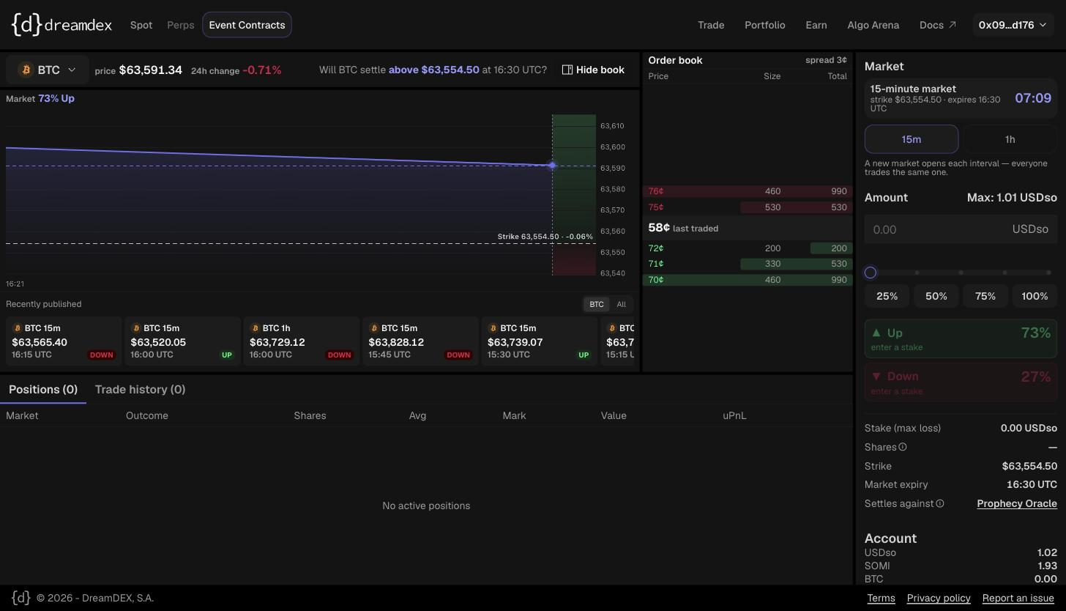
Backend up: order book (bids 70–72¢ / asks 75–76¢, spread 3¢), BTC chart with strike line and Up/Down zones, clear question.
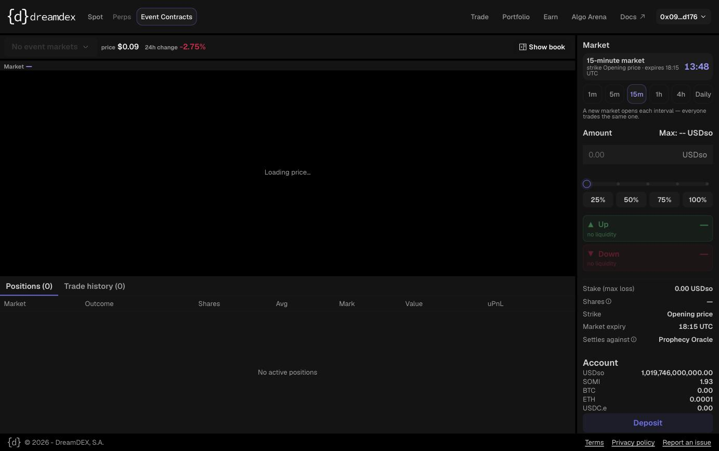
During the backend outage: the app could not load markets (“No event markets” / “no liquidity”).
Not working (during this test)
- SDK won’t import under native Node. “type”:”module” + extensionless relative imports → node bot.mjs fails with ERR_MODULE_NOT_FOUND. Runs only via a bundler or tsx.
- The SDK’s documented testnet indexer was down — HTTP 000 over many minutes while app + RPC were up; a raw-IP nip.io URL with no stable DNS. Breaks loadMarkets, listBinaryMarkets, unified createOrder, getOutcomeBalances. Chain-log discovery is a working fallback but isn’t the documented path.
Issues (works, but rough edges)
- PostOnly rejection is silent. A crossing PostOnly order returns success with orderId undefined, fills 0, and no error — detectable only by null-checking orderId.
- Docs mismatch on getOutcomeBalance. README shows positional (token, address, id); the real signature is an object { outcomeToken, account, id }. The plural getOutcomeBalances reads the (down) indexer; the singular reads on-chain.
- Carried over: getBinaryOrderBook wants a pool address (not marketId); the README binary example uses a fixed-strike symbol that finds nothing; tick/lot grid unpublished; window list says 15m/1h but 4h exists.
Credit: the raw trader.placeOrder correctly throws on revert (it replays to recover the reason) — the “reverts don’t throw” caveat applies only to the higher-level unified verbs.
Transactions from this test
Full trade re-run on BTC-60min (marketId 0x…3f04), RPC-only (indexer bypassed):
faucet 0xcfaddaa5de777bda5887a4089be15e6665c5940c02944108fef4b18d01f9a062
mintSet 0xa80c0949cc4498613aa5a69c553371dc8a5c90c6376c432b01448ff5f8fdb6ab
maker rest (SELL Up) 0xf211d5aad05af43a189210a62149de841fd5a594f1677eaa256940ef7d95153c
taker fill (BUY Up, 2) 0x9e5f9c286247af357ae8928e63bf8ca8f980285555ecf4cdba12f0472d1120b9
settle → redeem 0xbfd0c93c44bef14b36657e7194ada9225befc2b58d9e307561f257fa3d0a8c24 (Down won, 10→10 USDC)
Bottom line: with the backend up, the app and the full trading path work end to end. What remains is SDK-side — the native-Node packaging and an unreliable documented indexer — plus the smaller issues above.

