DreamDEX
Event Contracts — Builder Feedback
Findings from building and running a trading bot against the venue — docs, SDK, app UI, and the end-to-end trading path. Somnia Shannon testnet.
How I tested
I ran a disposable bot wallet (funded with 10 STT gas) through the full lifecycle with the SDK: faucet TestUSDC → mint a complete set → rest a maker order → cross as a taker for a real fill. Every step is a real on-chain transaction. I cross-checked the app UI against the on-chain order book at the same instant, and read the SDK source and docs in full.
1. The protocol works — proven with live transactions
The core mechanics behave correctly, one round-trip per write, receipts returned:
Step | Result | Tx
faucet() TestUSDC | success | 0x230f0d…baba
mintSet 10 → 10 Up + 10 Down | success | 0xf16cad…fe05
Maker: rest SELL Up @0.55 ×5 (PostOnly) | rested | 0x0b4fc3…a44bf
Taker: BUY Up IOC → matched a real maker | filled 3 Up @0.045 | 0xbef57a…6bd9
The taker order matched maker 0x7970…A460's resting ask at 0.045. The on-chain venue is healthy.
2. The app UI is the broken layer (highest priority)
A liquidity census across all six live markets — read straight from the pool contracts — shows every rolling market has a two-sided book from a market-maker, 3 bids + 3 asks each:
BTC 15min bids=3 asks=3 makers=1 ETH 15min bids=3 asks=3 makers=1
BTC 60min bids=3 asks=3 makers=1 ETH 60min bids=3 asks=3 makers=1
BTC 240min bids=3 asks=4 makers=2 (<-me) ETH 240min bids=3 asks=3 makers=1
Yet at that same moment the app shows “No event markets,” both sides “no liquidity,” and “Max: -- USDso”. So this is not a cold-start — it is a frontend / data-plumbing bug: the app is not rendering an on-chain order book that demonstrably exists (I placed and filled orders against it). Likely trigger: these rolling markets carry symbol: undefined, so the picker finds nothing while the trade panel keeps ticking. This is the #1 fix.
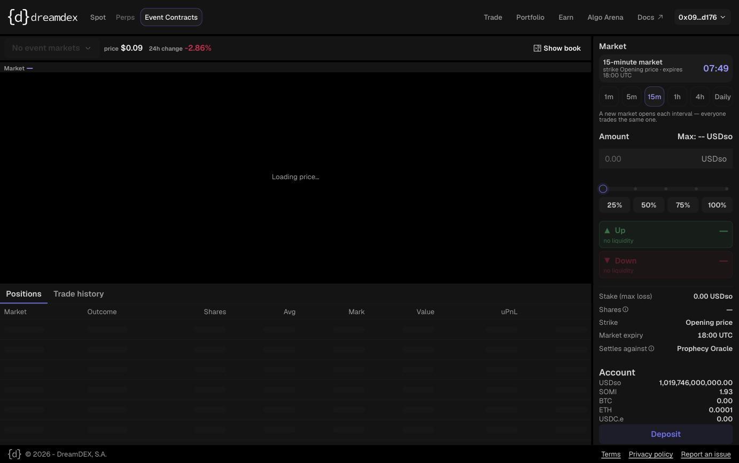
“No event markets” + both sides “no liquidity” + Max “--”, while a live window ticks down.
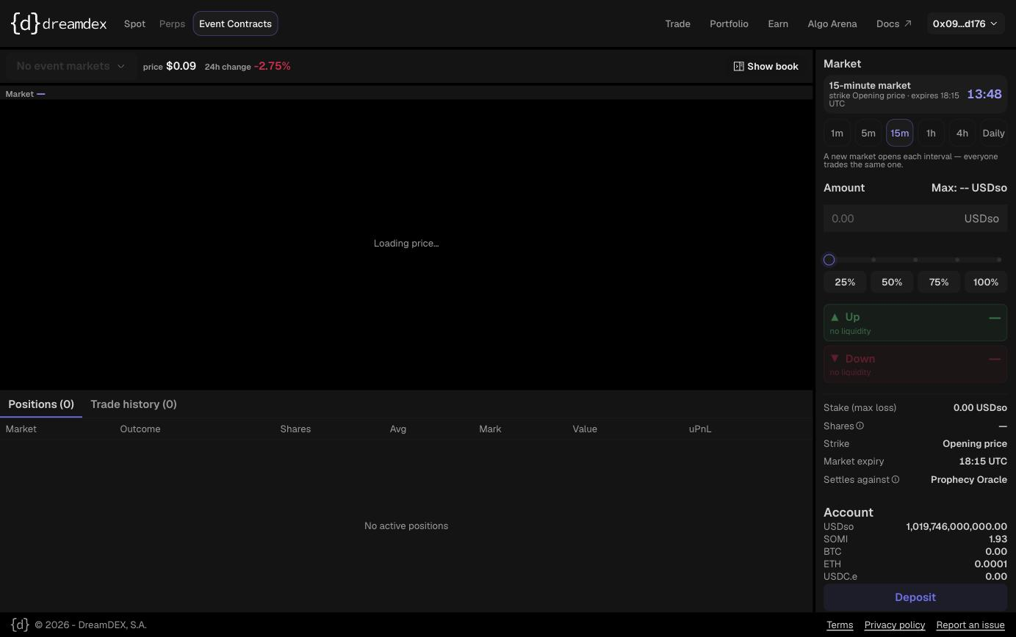
“no liquidity” shown at a moment the ETH 15-min market has 3 bids + 3 asks on-chain.
Two further confirmed UI issues
- The chart shows the wrong asset. On an ETH/BTC event page the chart plots SOMI/USDso (~$0.097) and the header reads “SOMI/USDso $0.09”. The underlying (ETH vs BTC) is never labelled in the trade UI — it only appears in the on-chain question field.
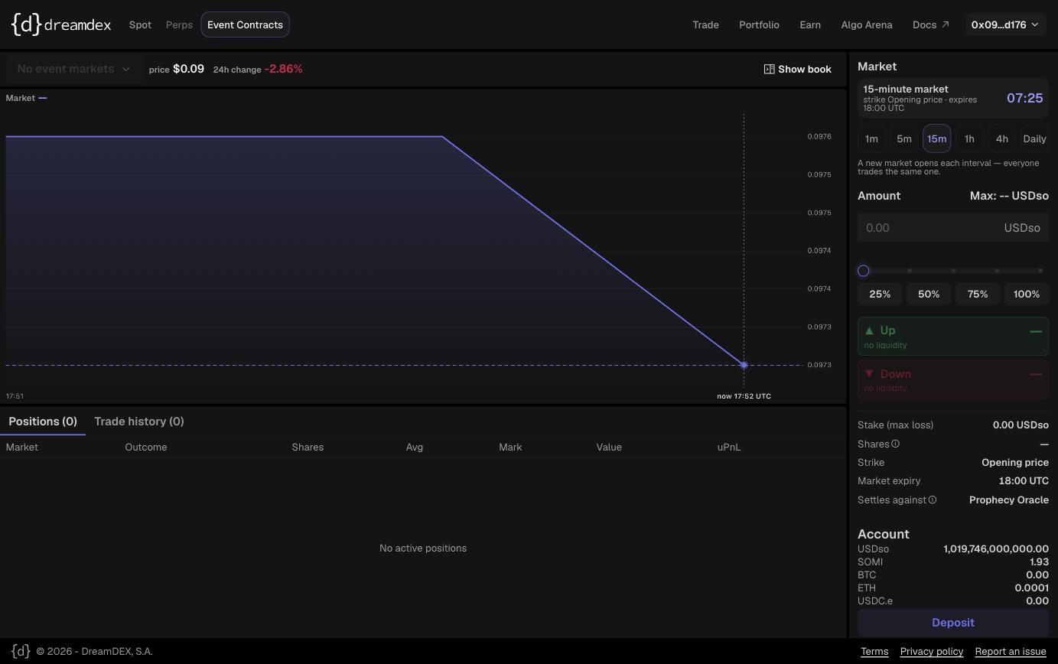
Chart plotting SOMI/USDso (0.0973–0.0976) on an ETH event-contracts page.
- Liquidity is real but thin and wide. A single maker quotes Up bid 0.024 / ask 0.045 on BTC with 120–280 tokens of depth (a ~2× spread). Even once the UI renders it, one maker at that spread won’t feel tradeable — worth seeding a second, tighter maker.
3. SDK — well designed, but the first-run path fights you
The SDK is genuinely good: ccxt-familiar surface, a typed discriminated-union Market type, a WebSocket live feed with no polling, React hooks, one-round-trip writes, and an OpenTelemetry-mappable debug sink. The problems are in packaging and a couple of sharp edges:
- Cannot import under native Node. package.json sets “type”:”module” but the published dist uses extensionless relative imports, so a plain node bot.mjs fails on the first import with ERR_MODULE_NOT_FOUND.
- Naive bundling also breaks. esbuild inlines viem and hits “Dynamic require of ‘events’ is not supported,” which then makes every read fail as a misleading “unknown RPC error.” I had to run via tsx. Since the README advertises a “Node bot” workflow, this out-of-the-box failure is worth fixing.
- PostOnly rejection is silent. A SELL Down @0.55 (= buy Up @0.45, which crosses) was correctly refused, but returned status: success, orderId: undefined, fills: 0, and no error. A caller can’t tell “rested” from “rejected-for-crossing” except by null-checking orderId.
- marketId vs poolAddress. Docs say “key by marketId, never pool address,” but getBinaryOrderBook(marketId) throws — it requires poolAddress. Pick one convention or accept both.
- Credit / correction: the raw trader.placeOrder does throw on revert (it replays to recover the reason). The “reverts don’t throw” gotcha applies only to the higher-level unified verbs — good design at the raw tier.
4. Docs
The gotchas page is excellent — real field notes. Gaps found:
- The tick/lot grid it tells you to respect is never published for binary markets (spot documents tickSize/lotSize/minQuantity; binary doesn’t).
- Stale window list. Docs say “15-minute and 1-hour”; on-chain there are 15m / 1h / 4h for both BTC and ETH.
- README example doesn’t match the live venue — a fixed-strike symbol that finds nothing against the rolling reference markets that actually exist.
- Raw-IP indexer URL hardcoded in the README (nip.io) — no stable DNS.
- Naming drift: “Prophecy Oracle” (UI) vs “Oracle Hub” (docs) vs oracleHub (SDK).
Bottom line
The primitive and the SDK design are strong, and the on-chain venue works — I confirmed it by trading on it. The distance between “looks dead” and “works” is almost entirely the frontend not rendering a live on-chain order book, plus the SDK’s import/packaging friction. Fix those two and Event Contracts is genuinely usable today.

