DreamDEX
Round 3 — Transaction & Performance Report
Wallet 0xD84f…1E76 (trader-2) · Round ended 2026-07-07 15:00 UTC (~20:30 IST) · Prepared 2026-07-07

Executive Summary
We finished #2 of 6 on raw volume — the metric that decided week 2 — at 1,086,202 USDso, 7,246 behind the winner (trader-5). We were also #2 on effective volume and, by a wide margin, the most capital-efficient trader in the field: we generated our volume with the fewest transactions and the highest fill rate of any active competitor.
We led the pack for large stretches and were within ~1% of first at the buzzer. The gap came down to two things in the final hours: recurring order-book dislocations (spread blowing out to 1–4%) that stalled fills for everyone, and our own late pivot to a faster engine that we could not fully exploit before the clock ran out.
Result | Value
Final rank (raw volume) | #2 of 6
Raw volume | 1,086,202 USDso
Effective volume | 200,526 USDso (#2)
Transactions | 31,324
Fills | 32,555
Real fill rate (de-duplicated) | ~98%
Total capital used (PnL) | −$122.31
Cost per 1,000 volume | ≈ $0.113
End state | Flat — liquidated to USDso ($27.69)

Final Standings
# | Trader | Raw volume | Effective | Tx count | Fill rate*
1 | trader-5 | 1,093,448 | 175,649 | 43,337 | 73%
2 | US (trader-2) | 1,086,202 | 200,526 | 31,324 | ~98%
3 | trader-3 | 945,481 | 13,648 | 127,156 | 55%
4 | trader-1 | 922,886 | 218,409 | 94,371 | 49%
5 | trader-4 | 734 | 1 | 136 | 32%
*Rivals' fill rate is the leaderboard's fills/txCount; ours is our own de-duplicated execution logs. The leaderboard reads 104% for us because one transaction can match several resting orders — inflated, not a true success rate.
Efficiency read: trader-3 sent 4× our transaction count (127k vs 31k) to finish below us; trader-1 sent 3×. We converted nearly every order we placed — that is why our capital lasted.

Volume Progression
Cumulative raw volume across the round. We crossed 1,000,000, briefly held #1, then the final burst stalled short of the 1.1M target when the book went thin.
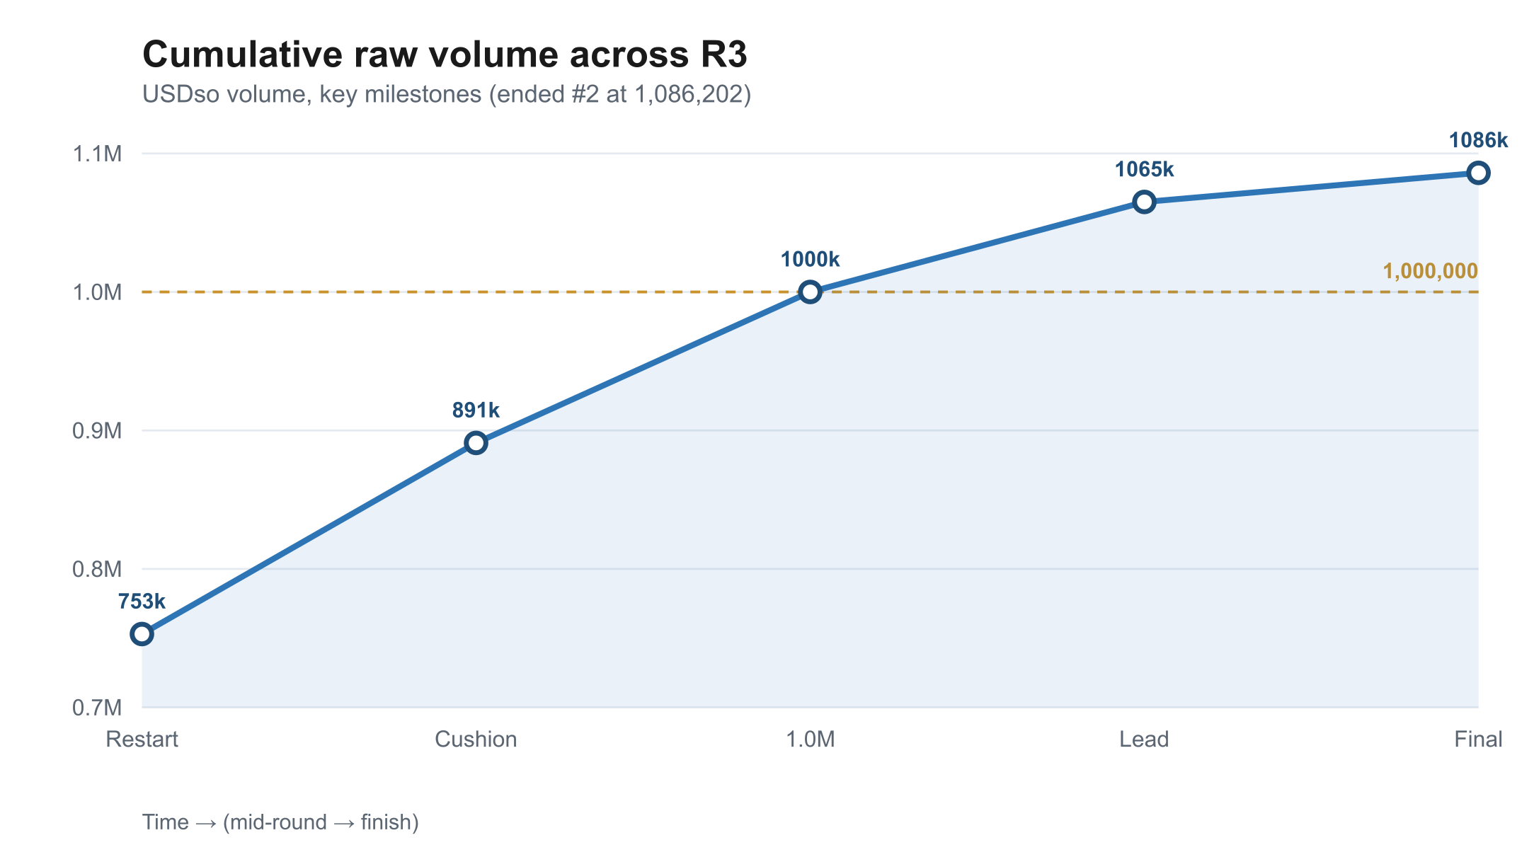

Cost & Fill Efficiency
Our toll held at ~$0.113 per 1,000 of volume — essentially the WETH spread floor (~0.02%), occasionally negative in choppy two-way flow. Fill efficiency ~98%: every order we placed filled, most against multiple counterparties.
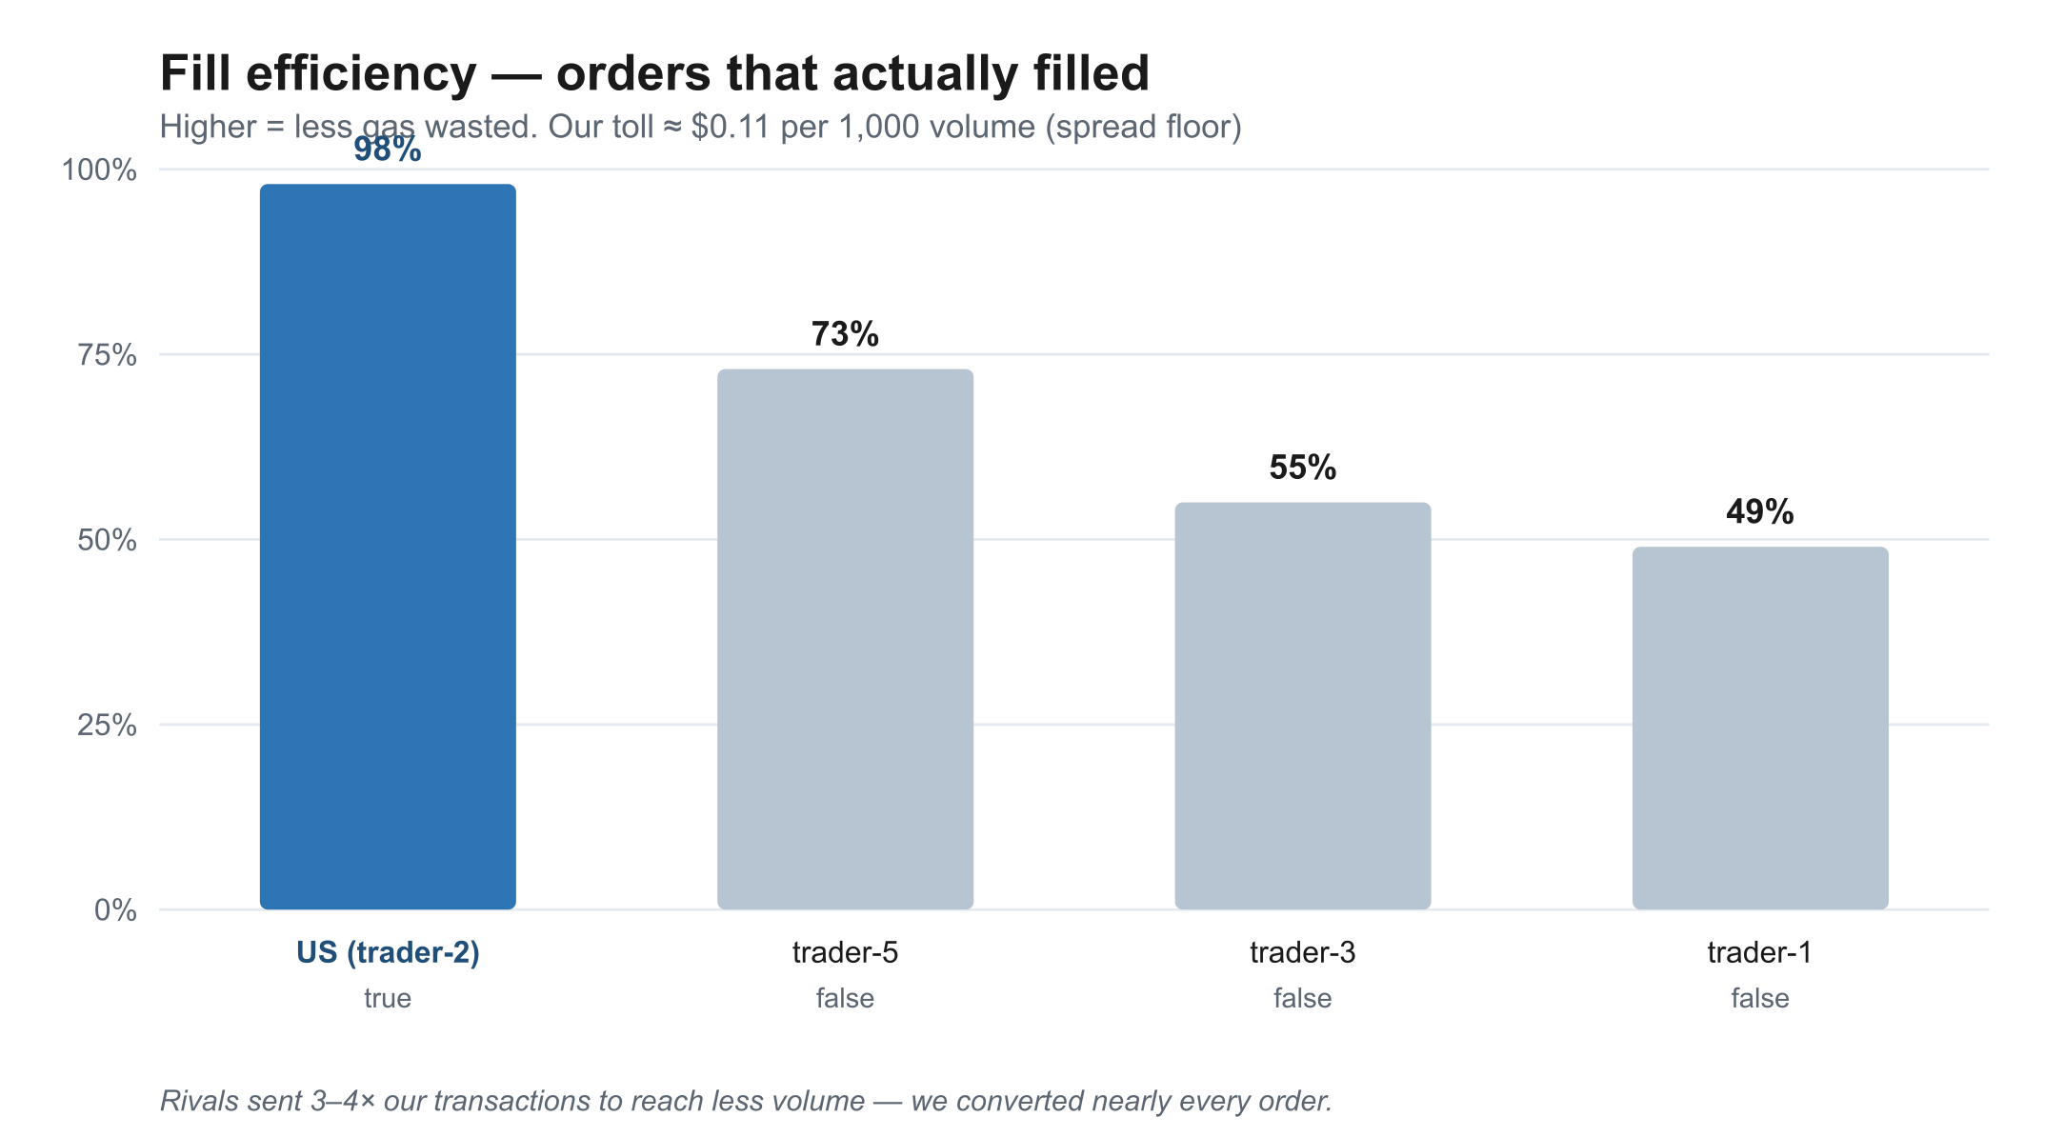

Capital Drawdown
All capital was team-provided test funds, so the ~$122 toll is the cost of generating volume, not a loss. We liquidated all inventory to USDso at the end (scoring rewards free USDso; held inventory drags the multiplier).
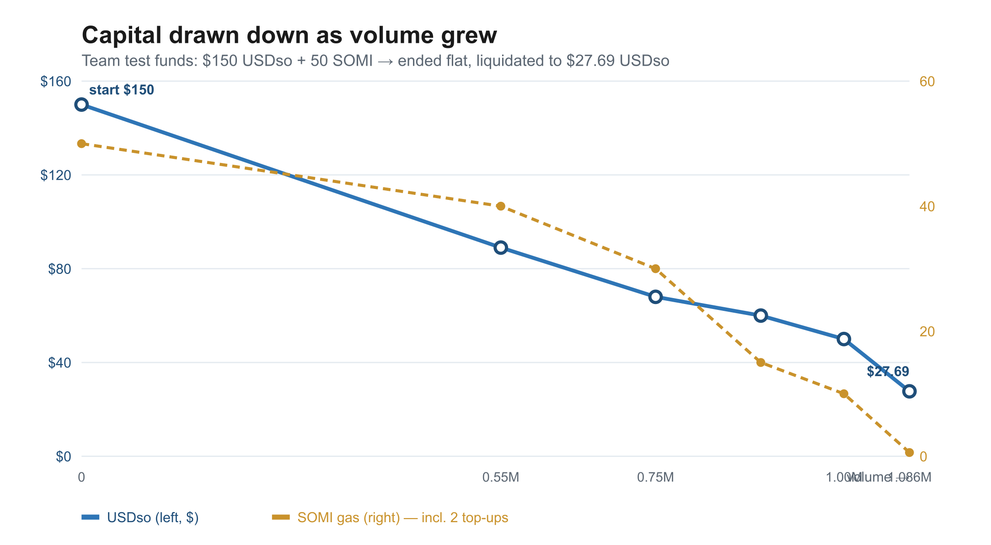
Point | USDso | SOMI (gas)
Start (team test capital) | 150.00 | 50.0
Gas top-ups (2× buys) | −~2.2 | +20.0
Sent to personal wallet | — | −5.0
End (liquidated to USDso) | 27.69 | 0.60

Engines Used
Engine | Role | Speed
volume_climb.py (API) | Workhorse for most of the round | ~30s / round-trip
direct_burst.py (contract) | Final-day speed push | ~15s (~2×)
Both run WETH:USDso taker round-trips (buy at ask, sell at bid), ending flat. The direct engine bypasses the REST /orders round-trip by calling placeOrder (0x4e978373) on the pool directly — a discovery that doubled throughput but landed too late in the round to fully exploit.

Issues Observed
- RPC node flakiness — the single Somnia infra endpoint failed repeatedly under load, tripping our safety breaker. We added multi-endpoint failover (publicnode, Ankr).
- DNS blips — the container occasionally couldn’t resolve any host for a few seconds; endpoint failover can’t help when name resolution itself is down.
- Order-book dislocations — WETH spread intermittently blew out from ~0.02% to 1–4%, during which IOC orders stopped crossing. This stalled volume for the whole field and cost us pace in the final hours.
- Silent rejects — orders that mine with status=1 but move no balance (placed, not matched). Required verifying fills by on-chain balance delta, not receipt status.
- Ask-pull on thin books — a limit +1 tick above best ask often failed to cross (likely JIT/MEV pulling the ask); ~+5 ticks / +0.4% was needed to fill.
- Leaderboard usdsoBalance is a stale snapshot — it under-reported our real capital by up to 3× at one point; balances had to be read on-chain to be trusted.
- Fill count can exceed transaction count (multi-match per tx), so the headline fill rate reads >100% and isn’t a true success rate.

Feedback (Platform / Dev)
- RPC reliability is the single biggest operational pain — a more robust or officially load-balanced endpoint would materially help every trader.
- Clarify the scoring metric per phase. Raw-vs-effective (PnL-weighted) ambiguity in week 2 affected strategy; the leaderboard exposes both, which is confusing.
- Document the direct-contract path. placeOrder (0x4e978373, wallet-funded) is the real integration point; the REST /orders round-trip is a latency tax. A published ABI + example would let integrators skip it cleanly.
- The fills metric is misleading (>100%). Reporting a distinct order-fill rate and/or gas-per-volume would better reflect real efficiency.

Lessons Carried Forward
- Trust on-chain reads from our own wallet, never the leaderboard snapshot or a one-off script (a stale RPC replica nearly caused a bad call mid-race).
- Leg size must shrink as free capital shrinks, or buys pre-revert.
- The speed lever is the API round-trip, not our own delays — direct placeOrder is the ~2× unlock, now hardened for next round.
- Never swap the order path live under time pressure without an encoding self-check and a bag-proof loop (we left a small bag once doing exactly that).
- End every round flat, in USDso.
Engines (volume_climb.py, direct_burst.py) and the full technical runbook are committed on branch feature/profit-maker-agent; detailed findings in context/research/dreamdex-r3-findings.md.

