CS271 Spring 2021 Computer Graphics II

HomeWork 2

**Name:**

**Student ID:**

**E-mail:**

**Acknowledgements:**

* Deadline: **2020-03-31 18:00:00**
* You can choose C++ or Python, and no restrictions on programming framework. You can freely use frameworks such as openGL.
* The full score of this HW2 is 100 points.
* The **report** submits as a PDF file, the **programming part** should package all the files include **code**, **input files**, **executable file**, **readme.txt**, and **report**. The package name is your_student_name+student_id.zip.
* You will get Zero if the code not passing the plagiarism check.

**2D Skeleton extraction by Chordal Axis Transform (CAT) [1]**

1. Implement 2D Delaunay Triangulation for any given sampling points. You are required to provide at least five examples (sample on the contours of some 2D shapes [2]) and corresponding DT visualization. (40 points)
2. Implement CAT and visualize the skeleton results of the above examples. (30 points)
3. Compare and analyze the skeleton generated by CAT and by the connected centers of circumcircles of DT triangles on different sampling densities on the contours of 2D shapes. (30 points)

Note: You can use C++ geometry libraries, like CGAL, to conduct Delaunay Triangulation but will get at most 10 points for question 1.

[1] Prasad L. Morphological analysis of shapes[J]. CNLS newsletter, 1997, 139(1): 1997-07.

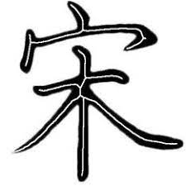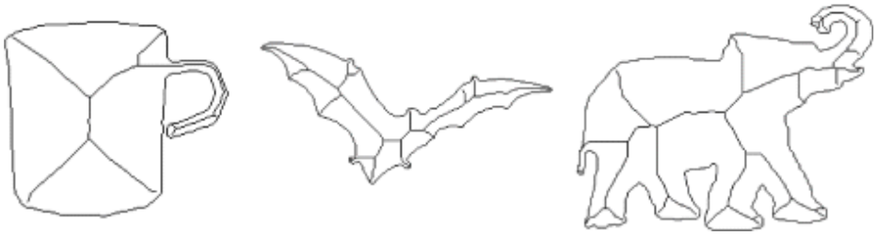[2] For example: