CS271 Spring 2021 Computer Graphics II

HomeWork 3

**Name:**

**Student ID:**

**E-mail:**

**Acknowledgements:**

* Deadline: **2022-04-21 23:59:00**
* You can choose C++ or Python, and no restrictions on programming framework. You can freely use frameworks such as openGL.
* The full score of this HW3 is 100 points.
* The **report** submits as a PDF file, the **programming part** should package all the files include **code**, **input files**, **executable file**, **readme.txt**, and **report**. The package name is your_student_name+student_id.zip.
* You will get Zero if the code not passing the plagiarism check.

Research topic: Image compression and vectorization by QEM.

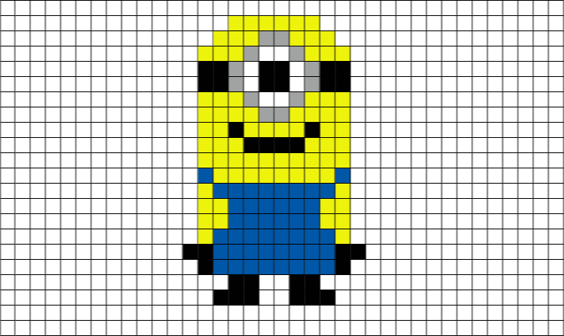

We learned the QEM [1] algorithm in lecture 6 and in this assignment we want to transfer it to Image compression and vectorization. The details of the assignment are explained in the end of lecture8 (about 01:29:00).

1. (15 points) Implement 2D mesh on the image you selected, describe the data structure of the meshed image.

2. (60 points) Write down the distance function you chose for the RGB image QEM algorithm, finish your own QEM algorithm and briefly describe the details of your algorithm implementation. Finally, show several results of mesh simplification on different target numbers.

3. (25 points) Select an appropriate QEM target number for the meshed image and implement image zoom-in. Compare the result with the original image.

[1] Michael Garland and Paul S. Heckbert. 1997. Surface simplification using quadric error metrics. In Proceedings of the 24th annual conference on Computer graphics and interactive techniques (SIGGRAPH '97). ACM Press/Addison-Wesley Publishing Co., USA, 209–216.