Imagine you are TyTitan and this is your repository. Your initial code commit (from last term) is in the lab1-master branch and the beta version of your code is in lab1-authentication.

1. Click on “New Pull Request”

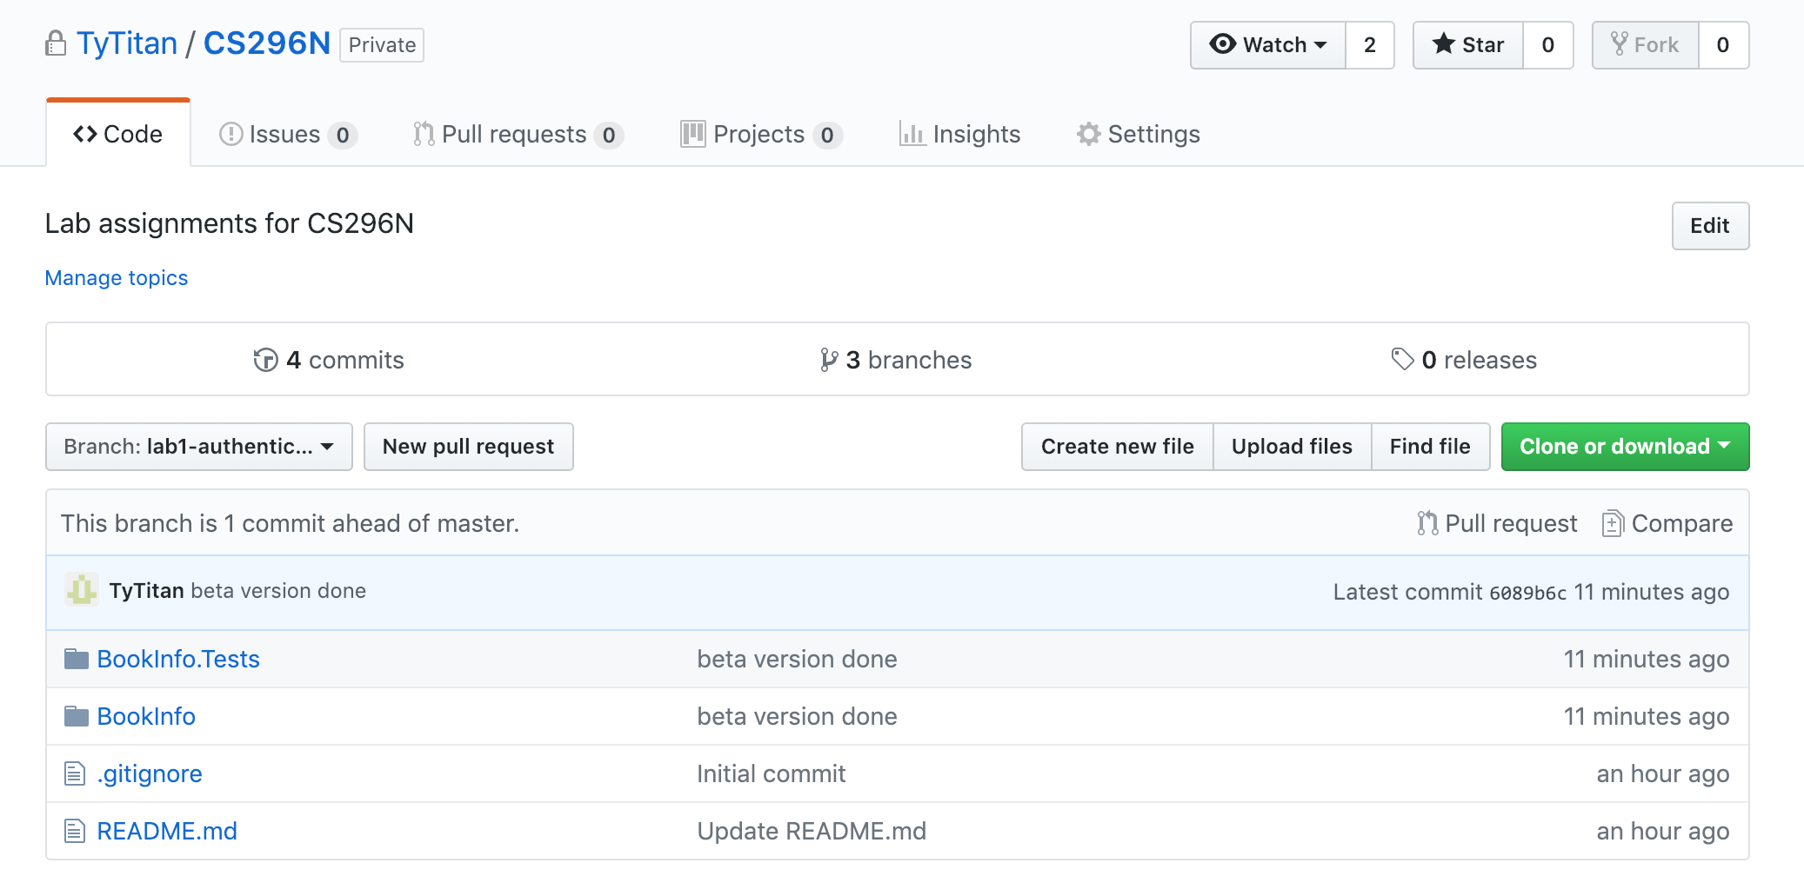

1. Choose the branch with your beta code as the “compare” branch  
   Note that the *base* and *compare* branches must have differences in code
2. Select reviewers: your lab partner and your instructor
3. Add a comment
4. Click on “Create Pull Request”

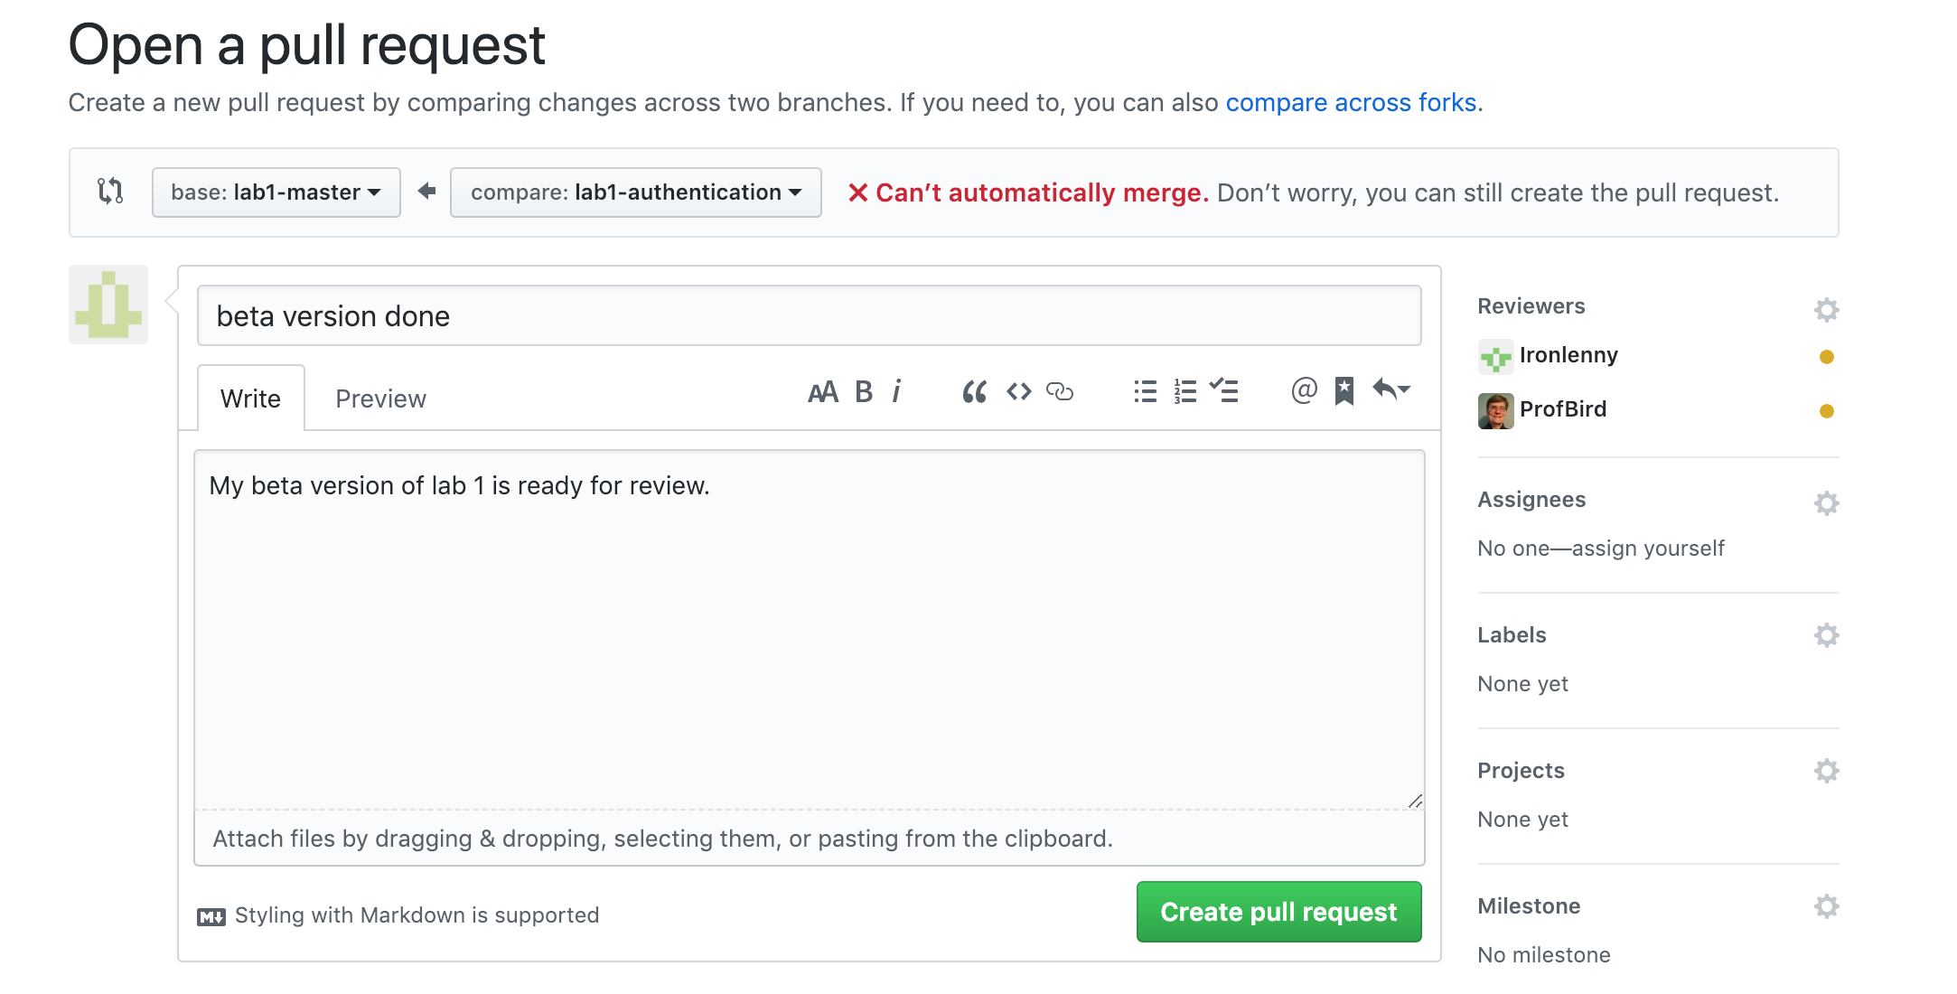The pull request is now sent to your reviewers, ProfBird and ironlenny.

Doing a Code Review

Now imagine you are TyTitan’s lab partner, ironlenny. You just got an e-mail with the PR, when you follow the link in the e-mail you will be taken to TyTitan’s repository and you’ll see this:

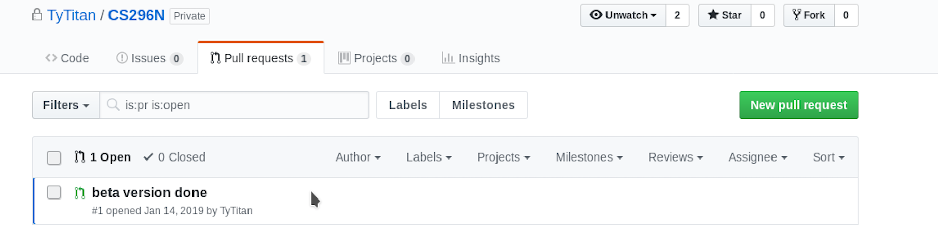

Now you can pull the branch, look at the code, run it, and make comments. Here’s an example of comments a lab partner might make:

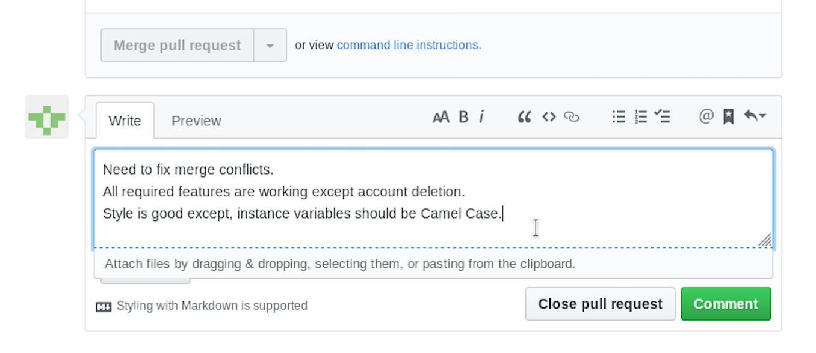

Reading the code review from your lab partner

Now imagine you are TyTitan again. After your lab partner has done the code review, you can read their comments by first clicking on “Pull requests”

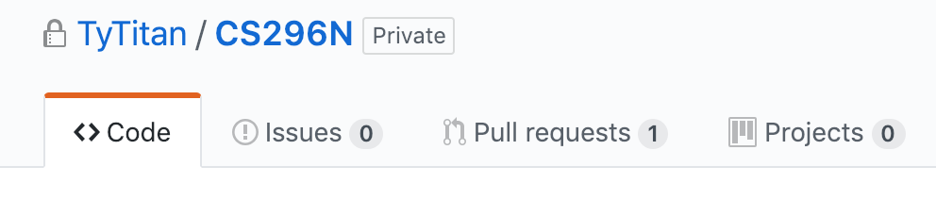

Then select the current pull request

(see next page)

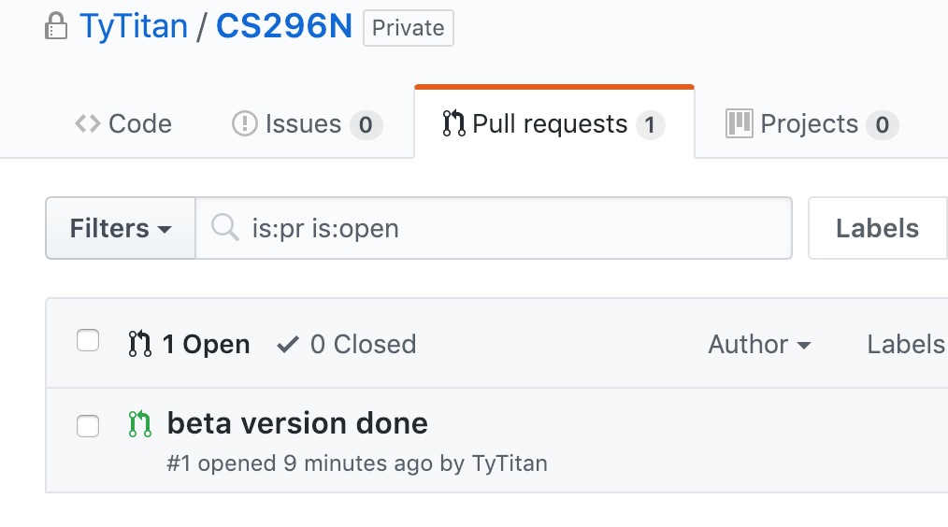

Then read your lab partner’s comments.

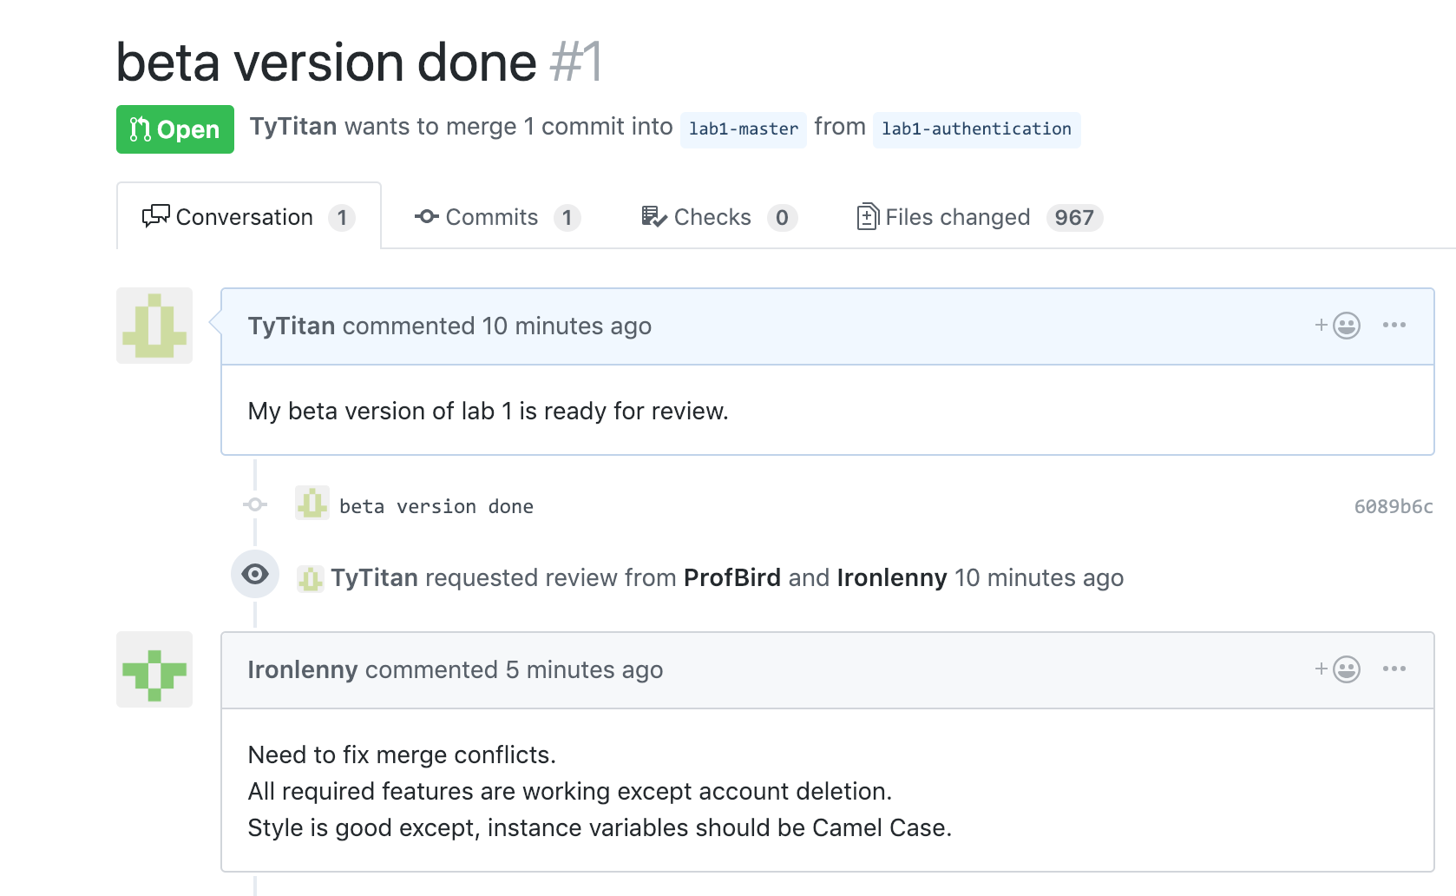

Your lab partner, ironlenny, doesn’t need to do the merge or close the PR, you can do that yourself once you are satisfied that the code is production-worthy. Your merge will end up back in Lab1-master

It’s fine to make multiple changes to the beta branch and get feedback from your lab partner multiple times if your lab partner is willing.