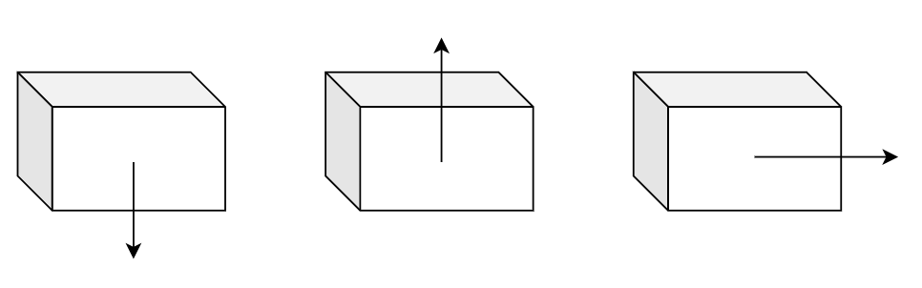 $F_{up}=9*9.8m/{s^{2}}*26.6kg=2346.12N$

$F_{down}=9*9.8m/{s^{2}}*26.6kg=2346.12N$ $F_{lateral}=9*9.8m/{s^{2}}*26.6kg=2346.12N$

Each robot is 60.5g.

$$F_{accel}=ma=0.0605*9*9.8m/{s^{2}}=5.3361N$$

The robot may unattached from the surface due to not enough magnetic force or static friction and hit the wall.

$$\frac{1}{2}at^{2}=L_{max}=\sqrt{L^{2}+W^{2}+H^{2}}=1.225m \left(a=9g\right)$$

$$v_{max}=at=14.7m/s (a=9g)$$

The kinectic energy that unattached robot has is:

$$\frac{1}{2}m{\left(v_{max}\right)}^{2}=6.53J$$

The wall is 1/8’’ thick Clear Impact-resistant Polycarbonate.

Then the impact $I={6.53J}/{1/{8''}=}2060.4J/m=38.6ft-lb/in$.

The impact strength of Polycarbonate is $12\sim 18ft-lb/in$ *.*

There are 4 M6 screws used for fixing the Steel plate. M6 screws stress area: $20.1{mm}^{2}=0.031in^{2}$. The shear strength is about 42,000psi, which give us: 42000\*0.031\*4=5,208lbs=23,166N.

${9*9.8m/s}^{2}*2.8kg=246.96N$. The safety factor is 23,166/246.96=93.8.