选择题20分
10题多选题
1, Let B={ø}, A =ρ(ρ(B)), find the correct ones in following statements:
(1) Ø∈A (2) {Ø,{ Ø }}∈A (3) {Ø,{{Ø}}∈A (4) {Ø,{{Ø}}A
2, Let R be a relation on A={1,2,3,…,10}, R={(x,y)|x+y = 10, x,y∈A}, then R is:
(1) reflexive (2) symmetric (3) transitive (4) antisymmetric
3, Let |A| = n, how many binary operations can we define on A:
(1) 2^{n} (2) n² (3) n (4) n
n²
2^{n}
4, operation defined as following, which ones can not make ({a,b},*) a monoid?

(1) 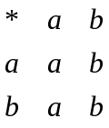 (2) (3)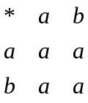 (4) 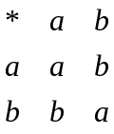

5, which ones are lattices in the following posets?

(1)
(2)
(3)
(4)

6，Let directed graph D = <V,E>, then:
(1), EV×V (2), EV×V (3) E=V×V (4) V×VE

7, In a connected undirected graph with n vertices, the number of edges is
(1) at least n-1 (2) at least n (3) at most n(n-1)/2 (4) at most n²/2

8, which one is tautology?
(1) (P∧(P→Q))→Q (2)P→(P∨Q) (3) P→(P∧Q) （4）(P→Q)→Q

9,In the following sentences, which one is true?
(1),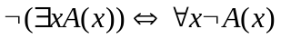 (2),
(3), (4),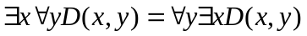
10,How many numbers must be chosen from 1 to 25 to ensure that one of them is a multiple of another?
(1)12 (2)13 (3)14 (4)15

计算题25分

1,Let p be the proposition “I will do every exercise in this book” and q be the proposition “I will get an ‘A’ in this course.” Express each of the following as a combination of p and q:
a), I will get an ‘A’ in this course only if I will do every exercise in this book.
b), I will get an ‘A’ in this course and I will do every exercise in this book.
c), Either I will not get an ‘A’ in this course or I will not do every exercise in this book.
d), For me to get an ‘A’ in this course it is necessary and sufficient that I do every exercise in this book.

2, What is the coefficient of x¹²y¹³ in the expansion of (2x-3y)²⁵?

3,compute the connectivity relation for R defined by the following matrix (detail steps needed):
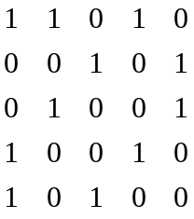

4, From point A, use Prim’s algorithm to find a minimum spanning tree in the following graph（detail steps needed）:
E
A
3
D
2
F
4
6
J
7
G
5
3
I
6
H
5
B
3
C
2
2
K
1
4
L
6
7
2
5,find a maximum flow in the following network by using the labeling algorithm.(Detail steps needed).
2
1
3
3
2
2
4
4
2
3
6
4
3
1

证明题：40分

5题证明题

(1), Let k be a positive integer. show that 1^{k}+2^{K}+…+n^{k} is O(n^{k+1}). Is it O(n^{k})? Why?

(2), Let n=p₁p₂…p_{k}, where the pi are distinct primes. Show that D_{n} is a Boolean algebra.

(3), Show that isomorphism relation is an equivalent relation. Is homomorphism an equivalent relation too? Why?

(4), Let A is a Boolean algebra. Define operation * as following:
a*b = (a∧~b)∨(~a∧b)
show that (A,*) is an Abelian group.

(5), The order of an elements g of a goup G is the least positive integer n such that g^{n} =1_{G}(or is ∞ if none exists).
(5.1) Prove that if f is an isomorphism from group G to G’, and g is an element in G, then g and f(g) in G’ must have the same order.
(5.2) Let G be the group of all real numbers under addition(+), and H be the group of all non-zero real numbers under multiplication(×). Show that G and H are not isomorphic.

