考试科目名称 计算系统基础（A卷）
考试方式：开卷 闭卷 考试日期 年 月 日 教师
系（专业） 软件工程 年级 班级
学号 姓名 成绩
题号 | 1 | 2 | 3 | 4 | 5 | 6 | 7 | 8 | 9 | 10
分数
题号 | 11 | 12 | 13 | 14 | 15 | 16 | 17 | 18 | 19 | 20
分数

1. (12%) Assuming the numbers are 2’s complement binary numbers. Compute:
得分
(a) 0111 + 0011, did the addition generate an overflow?
0111
0011
1010 (1%) overflow (1%)
(b) 01010101 AND 00001111 OR 11010111
01010101
AND 00001111
00000101 (1%)
OR 11010111
11010111 (1%)
(c) 1110 + 0101100, did the addition generate an overflow?
11111110
00101100
00101010 (1%) no (1%)
(d) Convert -225510 to hexidecimal?
16 |2255
|140 15
|8 12
0 8
225510=08CF16=0000 1000 1100 1111B (1%)
-225510=1111 0111 0011 0001B=F731 16 (1%)
(e) 64-33, Use 8-bit notation.
01000000
-00100001
01000000
+11011111 (1%)
00011111 (31) (1%)
(f) What is the binary encoding for the number 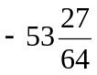? (IEEE 754 standard)
5310=0011 0101B, 27/64=0.0110 11 B
=-00110101.011011=-1.10101011011*2⁵ (1%)
E=5+127=132=1000 0100 B (0.5%)
1 10000100 10101011011000000000000 (0.5%)
2. (15%)
得分
(a) (7%) The transistor-level circuit below implements the logic equation given below. Label the inputs to all the transistors.

Y=NOT (A AND (B OR C))
A
A
B或C
C或B
Y
B或C
C或B
(b). (8%) Generate the truth table and the gate level logic design for the equation (Using the AND, OR, and NOT logic gates).
(4%)
A | B | C | Y
0 | 0 | 0 | 1
0 | 0 | 1 | 1
0 | 1 | 0 | 1
0 | 1 | 1 | 1
1 | 0 | 0 | 1
1 | 0 | 1 | 0
1 | 1 | 0 | 0
1 | 1 | 1 | 0
(1%)
(3%)
A
B
C
Y

3. (3%)
得分
(a) How many output lines will a 6-input decoder have? (1%)
2⁶=64 (1%)
(b) How many output lines will a 32-input multiplexer have? How many select lines will a 32-input multiplexer have?
1 (1%)
5 (1%)
4. (3%) If a computer has 24-bit addressable and needs 24 bits to access a location in memory,
得分
(a) What is the address space of this memory?
2²⁴ (1%) 或 2⁴*2²⁰=16M
(b) What is the total size of memory in bits?
2²⁴*24=384M bits (1%)
(c) What is the total size of memory in bytes?
2²⁴*24/8=48MB (1%)

5. (5%) What are the different components of the Von Neumann model?
得分
Memory, processing unit, control unit, input, output

6. (9%)
得分
(a) The six phases of the instruction cycle for the LC-3. (6%)
Fetch, decode, evaluate address, fetch operand, execute, store result.

(b) Which of the instruction cycle phases does the LC-3 “NOT” instruction not require? (1%)
evaluate address
(c)Write a single instruction that copies R2 to R3. (2%)
ADD R3, R2, #0 或 AND R3, R2, #-1

7. (5%) Suppose a machine has a 32-bit instruction with the following format:
得分
Opcode | SR | DR | IMM
If there are 100 opcodes and 64 registers, what is the maximum and minimum values of IMM? Assume IMM is a 2’s complement value.
2⁷=128 (1%) 2⁶=64 (1%)
32-7-6-6=13 (1%)
2¹²-1=4095 (1%) -2¹²= -4096 (1%)

8. (5%) Consider the following LC-3 assembly program:
得分
.ORIG x3000
AND R0, R0, #0
ADD R2, R0, #10
LD R1, MASK
LD R3, PTR1
LOOP LDR R4, R3, #0
AND R4, R4, R1
BRz NEXT
ADD R0, R0, #1
NEXT ADD R3, R3, #1
ADD R2, R2, #-1
BRp LOOP
STI R0, PTR2

HALT
MASK .FILL x8000
PTR1 .FILL x4000
PTR2 .FILL x5000
.END
(a) (3%) Create the symbol table.
symbol | address
LOOP | x3004
NEXT | x3008
MASK | x300D
PTR1 | x300E
PTR2 | x300F

(b) (2%) What does this program do?
将从x4000开始的10个数中负数的个数存于x5000中

9. (8%) The program below, when complete, should print the following to the monitor:
得分

ABCFGH
Insert instructions at (a)~(d) that will complete the program.
.ORIG x3000
LEA R1, TESTOUT
BACK_1 LDR R0, R1, #0
BRz NEXT_1
TRAP x21
ADD R1,R1,#1 (a)
BRnzp BACK_1
;
NEXT_1 LEA R1, TESTOUT
BACK_2 LDR R0, R1, #0
BRz NEXT_2
JSR SUB_1
ADD R1, R1, #1
BRnzp BACK_2
;
NEXT_2 HALT (b)
;
SUB_1 ADD R0, R0 #5 (c)
K LDI R2, DSR
BRzp K (d)
STI R0, DDR
RET
DSR .FILL xFE04
DDR .FILL xFE06
TESTOUT .STRINGZ “ABC”
.END

10. (10%) Circle all the parts of the datapath, including the connection lines where the data traverse, that are responsible for performing the instruction: LDI Rx, LABEL
得分

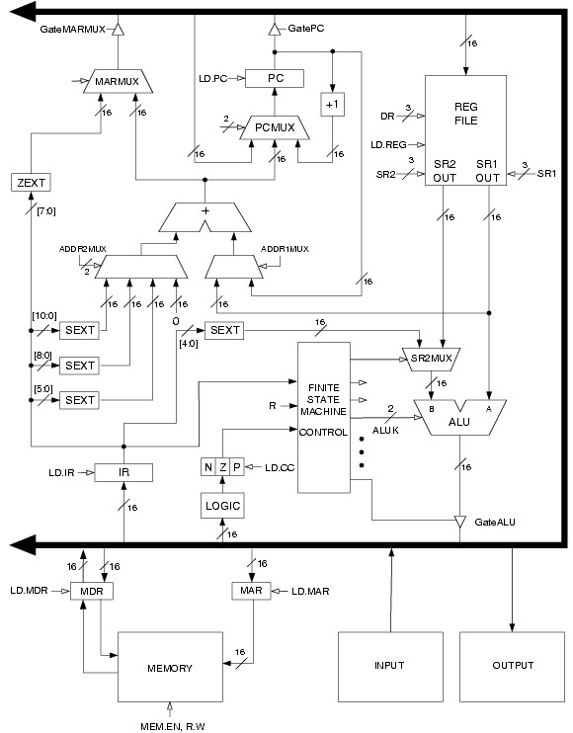
GateMDR
Fetch: PC, PC+1, BUS,MAR, MEMORY, MDR, IR (3%)
Decode: FSM (1%)
Evaluate address: [8:0]SEXT, PC, ADD, MARMUX (3%)
Fetch operand: BUS, MAR, MEMORY, MDR, BUS, MAR, MEMORY, MDR (1%)
Store result. BUS, REG FILE, LOGIC, NZP (2%)

11. (5%) What is the output of the following code?
得分

#include<stdio.h>
main()
{
int i,r;
char s1[80]="bus";
char s2[80]="book";
for(i=r=0; s1[i]!='\0' && s2[i]!='\0'; i++)
if(s1[i]==s2[i])
i++;
else{
r=s1[i]-s2[i];
break;
}
printf("%d",r);
}
's' –'o'= 4
12. (5%) The following function takes an integer height input and prints the letter ‘V’ using the asterisk character (‘*’). Fill in the missing code. Three example outputs are shown below. Assume that height > 1 and that the leftmost ‘*’ appears in the leftmost column on your monitor.
得分
PrintV(2); PrintV(3);PrintV(4);
* * * * * *
* * * * *
* * *
*
void PrintV(int height)
{
int i, j;
for(i = 0; i< height; i++)
{
for(j = height; j > (height - i); j--)
printf(" ");
printf("*");
for(j = 0; j < ___2*height-2*i-3___ ; j++) (3%)
printf(" ");
if (i < ___ height-1___ ) (2%)
printf("*");
printf("\n");
}
}
13. (10%) Translate the C function into LC-3 assembly code.
得分

int Init(int x)
{ int y=2;
return y+x;
}
Init ADD R6,R6,#-1 (0.5%*20)
ADD R6,R6,#-1
STR R7,R6,#0
ADD R6,R6,#-1
STR R5,R6,#0
ADD R5,R6,#-1
ADD R6,R6,#-1

AND R1,R1,#0
ADD R1,R1,#2
STR R1,R5,#0
LDR R2,R5,#4
ADD R2,R2,R1
STR R2,R5,#3

ADD R6,R5,#1
LDR R5,R6,#0
ADD R6,R6,#1
LDR R7,R6,#0
ADD R6,R6,#1
RET
14. (5%) What is the output of the following code?
得分

#include<stdio.h>
main()
{
int a,b;
int k=4;
int m=6;
int *p1=&k;
int *p2=&m;
a=p1==&m;
b=(-*p1)/(*p2)+7;
printf("a=%d\n",a);
printf("b=%d\n",b);
}
a=0 (2.5%)
b=7 (2.5%)

