Curriculum Vitae

# Personal Information

Name : Ricky Indra Djunawan

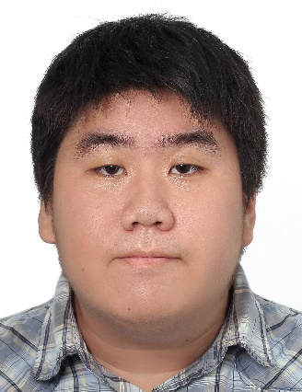Gender : Male

Permanent Address : Surya Utama IIN/8, 11520, Jakarta, Indonesia

Current Address : 43 Keelung Rd., Section 4, Da’an Dist., Taipei City, Taiwan (NTUST Dorm 2)

Contact Number : (+886) 986 400 088 / (+62) 851 324 000 88

E-mail : ricky.indra@hotmail.com

Nationality : Indonesian

Place / Date of Birth : Jakarta / December 6th 1992

Religion : Buddha

Marital Status : Single

# Educational Background

## Formal Education

|  |  |  |
| --- | --- | --- |
| **Level** | **Place** | **Year** |
| Kindergarden | TK Kemurnian II, Jakarta | 1996-1999 |
| Elementary School | SD Kemurnian II, Jakarta | 1999-2005 |
| Junior High School | SMP IPEKA Tomang II, Jakarta | 2005-2008 |
| Senior High School | SMA IPEKA Tomang II, Jakarta | 2008-2009 |
| Senior High School | SMA Ketapang II, Jakarta | 2009-2011 |
| Bachelor Degree | Universitas Indonesia, Depok | 2011-2016 |
| Master Degree | National Taiwan University of Science and Technology | 2018-Present |

## Informal Education

|  |  |  |
| --- | --- | --- |
| **Type** | **Place** | **Year** |
| English Language (IELTS Prep) | Private Teacher - Jakarta | 2016 |
| Chinese Language | Mandarin Study and Culture Center - MingChuan University - Taiwan | 2017-2018 |

# Personal Skill and Interest

## Language

1. Bahasa Indonesia – Bahasa Ibu
2. English – Intermediate
3. Chinese – 還好

## Engineering Field

## Mechanical Engineering

1. CAD/CAM (CFD and FEM)
2. Quality Control and Analysis
3. Production and Manufacturing Processes
4. Micro Fabrication
5. Basic Engineering Material
6. Fundamental of Mechanical Design

## Computer Science

1. AI, Machine Learning, Deep Learning and Neural Network
2. Basic Computer Graphic
3. Digital Image Processing
4. Mathematical Modeling and Evolutionary Algorithm
5. Social Media Analysis
6. Statistic and Data Analysis

## Computer Skill & Knowledge

1. Ms. Office – Ms. Word, Ms. Excel, Ms. Power Point, etc. – Great
2. Adobe – Acrobat, Photoshop, Illustrator, Indesign – Good
3. Autodesk – Inventor, AutoCAD – Not bad
4. Solidworks – Not bad
5. UG Siemens NX – Not bad
6. C and C++ – Familiar with syntax
7. Python – Good
8. AI and Machine Learning – Good
9. Basic Computer Graphic and Multimedia – Good
10. HTML, CSS, JS, Blender – Learn a little bit, wish to learn more on free time

## Hobby and Interest

1. Reading
2. Design and drawing
3. Coding
4. Gaming
5. Memes

# Organization Experience

## Organization

|  |  |  |
| --- | --- | --- |
| **Year** | **Organization** | **Position** |
| 2011 | MAKRAB KMBUI | Consumption Supervisor |
| 2012 | Children’s Day TIS | Staff of Supply and Equipment |
| 2012 | Kathina Day KMBUI | Staff of Publication |
| 2013 | Journalism Training | Supply and Equipment Supervisor |
| 2013 | Freshmen Admission | Publication and Documentation Supervisor |
| 2012-2014 | PARAMITA KMBUI | Head of Design |
| 2018-2019 | INDONESIAN CULTURE EXHIBITION | Head of Registration and Souvenir Division |

# Work Experience

|  |  |  |
| --- | --- | --- |
| **Year** | **Place** | **Position** |
| 2014 | PT. Sanwa Engineering Indonesia | Internship |
| 2015 | Micro Fabrication Laboratory | Student /Researcher |
| 2016 | PT. Sama Sukses Sadaya | QC Supervisor |
| 2018 | PT. Telin Taiwan | Part-timer |
| 2019 | Computer Graphic Laboratory | Student / Researcher |

This Curriculum Vitae is prepared in valid data by my good intention to be used by any party needed.

Sincerely

Ricky Indra Djunawan