Callisto APT Threat Intelligence Investigation
MISP-Based Threat Actor Profiling & IOC Correlation Project

Project Overview
This project documents a structured threat intelligence investigation into Callisto Group, a Russia-aligned cyber-espionage group targeting European government and critical infrastructure sectors.
Using MISP deployed via Docker, the investigation focused on:
- Collecting and enriching Indicators of Compromise (IOCs)
- Correlating threat infrastructure across events
- Profiling TTPs using MITRE ATT&CK
- Producing executive-level intelligence reporting
- Delivering actionable mitigation guidance
This project simulates a national CERT threat actor investigation scenario.

Objectives
- Identify Callisto-related IOCs using MISP feeds
- Analyze attack infrastructure (C2, phishing domains, VPS hosting)
- Map TTPs to MITRE ATT&CK
- Correlate overlapping events in MISP
- Deliver executive and technical reporting
- Provide detection & mitigation recommendations

Threat Actor Profile – Callisto
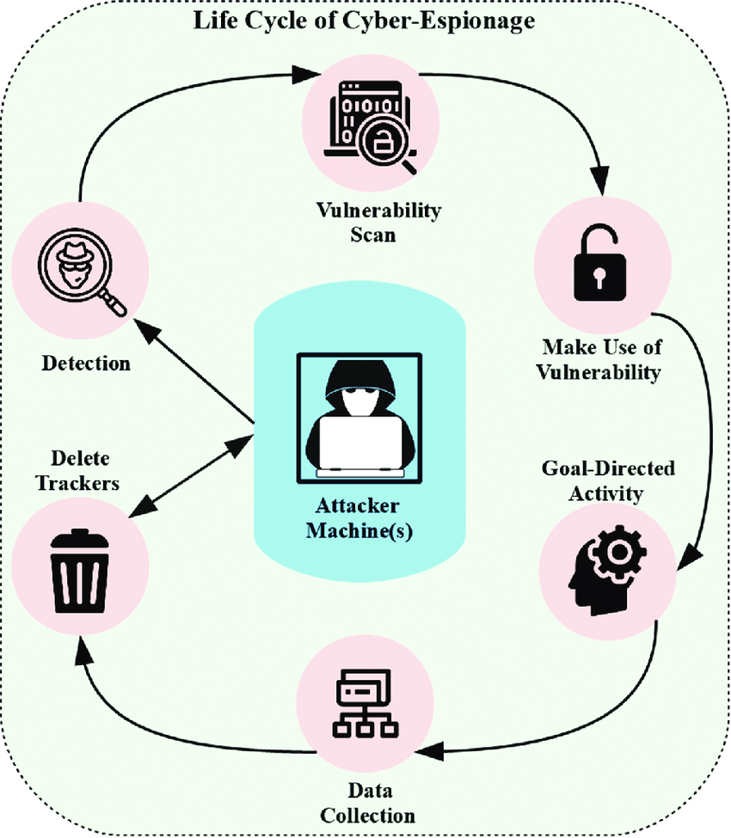
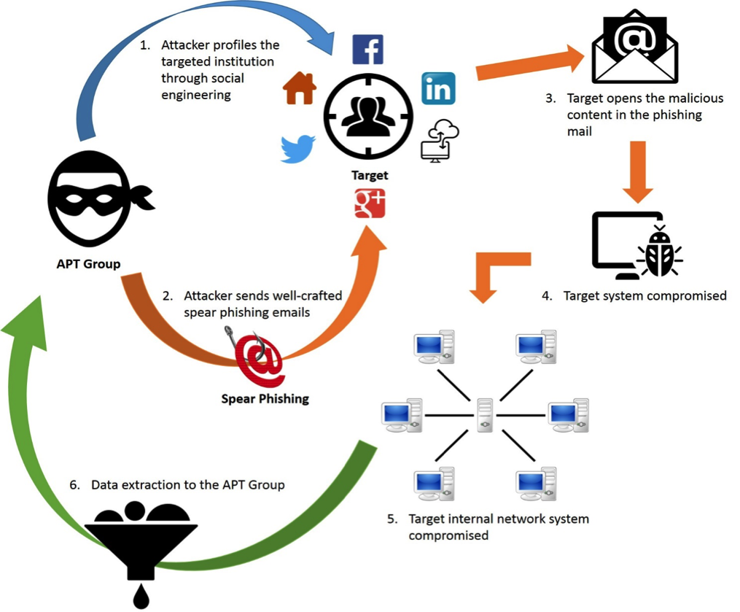
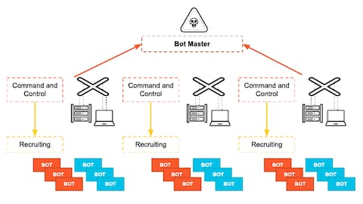
4
Known Aliases
- COLDRIVER
- SEABORGIUM
- TA446
Attribution
- Suspected origin: Russia
- Motivation: Strategic cyber espionage
- Target sectors:
  - Government
  - Defense
  - Energy
  - Think tanks
  - Critical infrastructure

TTP Analysis (MITRE ATT&CK Mapped)
ATT&CK Phase | Technique | ID
Initial Access | Spear-phishing Link | T1566.002
Credential Access | Web Credential Harvesting | T1556
Command & Control | Web-Based C2 over HTTPS | T1071.001
Collection | Email Data Exfiltration | T1114
Key Behavioral Patterns
- Fake Microsoft/Google login portals
- Lookalike domains (typosquatting)
- Rotating VPS infrastructure
- Minimal malware footprint
- Targeted social engineering campaigns

MISP Investigation Workflow
Environment
- Ubuntu / Kali Linux
- Dockerized MISP
- Default feeds enabled
- FireHOL malicious IP custom feed added
Investigation Steps
- Enabled default MISP feeds
- Loaded and fetched threat events
- Searched for “Callisto” tags & related events
- Extracted attributes:
  - Domains
  - IP addresses
  - Email indicators
  - SSL certificate metadata
- Used correlation view to identify shared infrastructure
- Tagged & exported relevant IOCs

IOC Categories Identified
Indicator Type | Observed Pattern
Domains | Lookalike Microsoft login portals
IP Addresses | VPS providers (frequent churn)
SSL Certs | Let’s Encrypt short validity
Email Lures | Policy briefings, defense invites
Infrastructure | HTTPS-based phishing servers

Attack Flow Model
Targeted Email
↓
Spoofed Domain
↓
Fake Login Portal
↓
Credential Capture
↓
Web C2 Panel
↓
Email Account Compromise
↓
Intelligence Collection

Correlation Findings
- IOC overlap across multiple MISP events
- Reuse of phishing kit infrastructure
- Shared SSL certificate patterns
- Common VPS ASN providers
Demonstrates campaign continuity and operational reuse.

Detection Engineering & SOC Value
This project supports:
SIEM Use Cases
- Suspicious domain detection
- Typosquatting domain monitoring
- Abnormal login activity detection
- Geo-location anomaly alerts
Sample Detection Logic (Splunk Example)
index=o365_logs
| stats count by user, src_ip, country
| where country!="UK" AND country!="US"
Domain Monitoring Example
index=dns_logs
| search query="*microsoft*login*"

Risk Assessment
High Risk To:
- Government entities
- Policy think tanks
- Defense contractors
- NATO-aligned organizations
Why It's Dangerous:
- Low malware signature detection
- Highly targeted spear-phishing
- Credential-focused attacks
- Strong operational security

Mitigation Recommendations
- Enforce phishing-resistant MFA (FIDO2 preferred)
- Monitor for lookalike domains
- Integrate MISP IOC feeds into SIEM
- Conduct executive phishing simulations
- Deploy email threat protection & sandboxing

Technology Stack
- MISP (Threat Intelligence Platform)
- Docker
- Ubuntu / Kali Linux
- OSINT Techniques
- MITRE ATT&CK Framework
- Splunk (Detection Use Case Simulation)

Skills Demonstrated
✔ Threat Intelligence Analysis
✔ SOC Monitoring & Detection Engineering
✔ IOC Lifecycle Management
✔ Threat Correlation
✔ Incident Analysis
✔ Executive Communication
✔ Infrastructure Pattern Analysis
✔ Intelligence Reporting

Optimized Keywords (ATS Friendly)
Threat Intelligence | SOC Analyst | APT Analysis | MISP | MITRE ATT&CK | IOC Correlation | Detection Engineering | SIEM | Splunk | Cyber Espionage | Phishing Campaigns | Threat Hunting | Incident Response | Security Operations | OSINT | C2 Infrastructure | Domain Monitoring

