Customer Personality & Conversion Rate Analysis
Predict Customer Personality to Boost Marketing Campaign using Machine Learning
Final Report

Author: Irsan Maulana Yusuf
Supported by: Rakamin Academy - Career Acceleration School

Executive Summary
This project analyzes customer transactions and demographic data to engineer a conversion rate metric, identify which customer attributes drive campaign conversion, segment customers into actionable groups via K-Means clustering, and translate the findings into a data-driven retargeting recommendation with estimated financial impact.
The key finding across the entire analysis is that household composition (number of children), not age, is the strongest and most consistent driver of campaign conversion. This pattern holds both in the direct statistical testing (Part 1) and in the resulting customer segments (Part 3) and directly informs the final retargeting recommendation (Part 4): only one of three customer segments is financially viable to retarget under the current campaign cost structure.
Part 1 - Conversion Rate Analysis
1.1 Business Understanding
This project engineers several features to support the conversion rate analysis, based on the project objective and established customer behavior frameworks:

- Age & Age Group - used to segment customers and test whether age has a significant relationship with conversion rate.

- Conversion Rate (Response / NumWebVisitsMonth) - measures how likely a customer is to respond to a campaign relative to how often they visit the website.

This is a custom, per-customer metric rather than the standard aggregate definition used in marketing analytics (total responders ÷ total visitors) and is better read as "response efficiency."

- Total_Spending and Total_Transactions - derived from the RFM model (Recency, Frequency, Monetary), a well-established framework in customer behavior analytics.

- Total_Children (Kidhome + Teenhome) - household composition as a demographic segmentation variable; direction of effect was not assumed upfront. It turned out to be the strongest predictor found in this analysis.

1.2 Data Cleaning
The dataset contains 2,240 customers and 29 attributes. Missing values were found only in Income (24 rows, ~1%), which were imputed using the median rather than the mean, since Income contained extreme outliers that would bias the mean upward.

Outlier detection using the IQR method flagged 3 rows in Year_Birth (1893, 1899, 1900 -biologically implausible for active customers) and 8 rows in Income. Of the Income outliers, 1 row (666,666,000) showed a clear data-entry error pattern, and 4 more had high income but spending far below average (inconsistent, likely bad data). All 8 problem rows were dropped, alongside the 3 Year_Birth rows, leaving a final dataset of 2,232 rows.
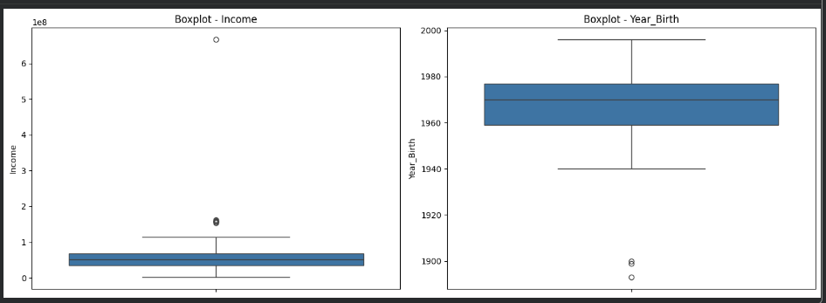

Boxplot — Income & Year_Birth outlier detection (IQR method)

1.3 Feature Engineering
Feature | Formula | Notes
Age | Year (Dt_Customer) -Year_Birth | Relative to each customer's registration date, not the current year
Age_Group | Binned into 5 categories | Youth (16–25), Young Adult (26–35), Adult (36–45), Middle Age (46–55), Senior (56+)
Total_Children | Kidhome + Teenhome | Household composition indicator
Total_Spending | Sum of all Mnt* columns | RFM Monetary proxy
Total_Transactions | Sum of all Num*Purchases columns | RFM Frequency proxy
Conversion_Rate | Response / NumWebVisitsMonth | Zero-visit customers assigned 0 to avoid division by zero (9 customers)

1.4 Exploratory Data Analysis
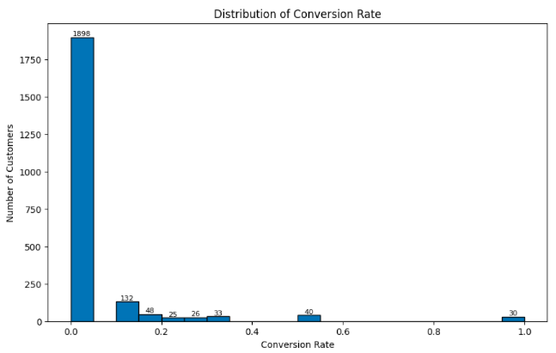
Conversion Rate Distribution

Distribution of Conversion Rate — heavily right-skewed and zero-inflated

Approximately 85% of customers (1,898 of 2,232) have a Conversion_Rate of 0.0, meaning they did not respond to the last campaign regardless of visit frequency. A smaller group converted with varying efficiency (0.1–0.5), and 30 customers converted on their very first visit (Conversion_Rate = 1.0).

Conversion Rate by Age Group
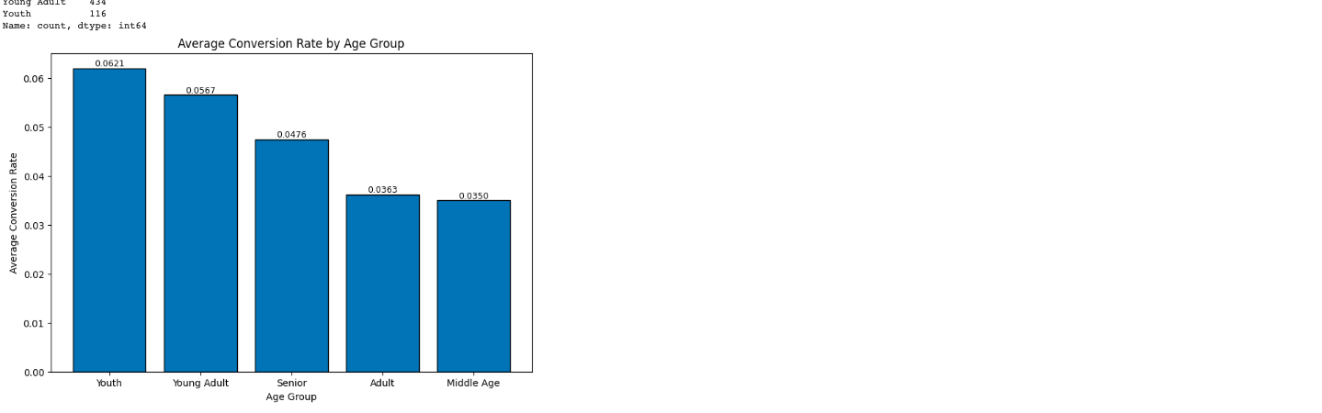

Average Conversion Rate by Age Group

Youth (16–25) appeared to have the highest average conversion rate (0.062) compared to Middle Age (0.035), but this difference was not statistically significant (Kruskal-Wallis, p = 0.317). The result is at least partly explained by Youth's small sample size (116 customers vs. 420–727 in other groups).

Conversion Rate by Total_Children
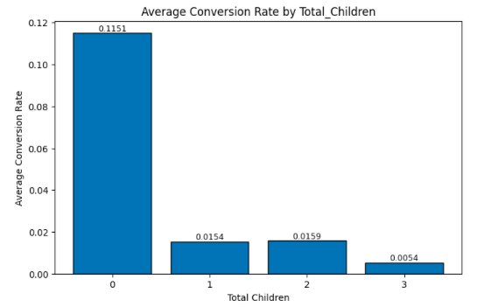

Average Conversion Rate by Total_Children

Customers with no children convert at 0.115 on average — 7 to 23x higher than customers with children (0.005–0.016). This is the strongest and most reliable relationship found in the entire analysis (Kruskal-Wallis, p ≈ 0.000000).

Conversion Rate vs. Total_Spending
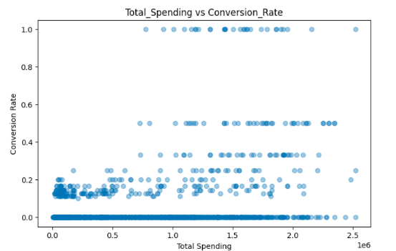

Total_Spending vs Conversion_Rate

Total_Spending shows a statistically significant but weak positive relationship with Conversion_Rate (Spearman rho = 0.26, p ≈ 0.000000).

Correlation Heatmap
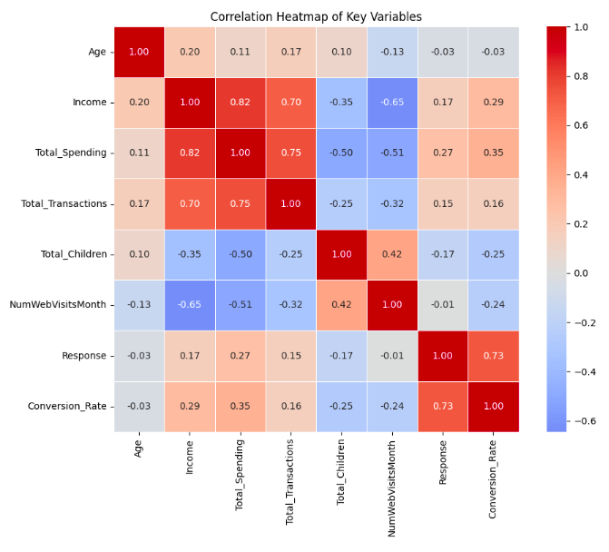

Correlation heatmap of key variables

Income strongly correlates with Total_Spending (0.82) and Total_Transactions (0.70).
Age shows almost no linear relationship with anything, including Conversion_Rate (-0.03).
Total_Children correlate negatively with Income, Spending, and Conversion_Rate.
Response (raw) vs. NumWebVisitsMonth shows almost no relationship (-0.01), unlike Conversion_Rate's built-in -0.24 correlation with visit count, which is partly a formula artifact.

1.5 Statistical Significance Testing
Since Conversion_Rate failed the Shapiro-Wilk normality test (p ≈ 0.000000 in every group), Kruskal-Wallis was used instead of ANOVA for categorical comparisons, and Spearman correlation instead of Pearson for the continuous relationship.

Variable | Test | p-value | Result | Strength
Age Group | Kruskal-Wallis | 0.317 | Not significant | -
Total_Children | Kruskal-Wallis | ≈0.000000 | Significant | Very strong (7–23x gap)
Total_Spending | Spearman | ≈0.000000 | Significant | Weak (rho = 0.26)

Part 2 - Data Cleaning & Preprocessing for Machine Learning
2.1 Null, Duplicate Re-verification & Column Removal
Null and duplicate checks were re-verified on the cleaned dataset (0 missing values across all columns, 0 duplicate rows). Five columns were dropped ahead of clustering:

Column | Reason
ID | Unique identifier, no behavioral signal
Z_CostContact, Z_Revenue | Constant values across all rows, zero variance
Dt_Customer, Year_Birth | Redundant — already captured in the Age feature
Result: 35 columns reduced to 30 columns (2,232 rows unchanged).

2.2 Feature Encoding
Clustering algorithms require numeric input, so text-based categorical columns were converted:
Column | Type | Method | Example
Education | Ordinal (has rank) | Label Encoding (0–4) | SMA=0, D3=1, S1=2, S2=3, S3=4
Age_Group | Ordinal (has rank) | Label Encoding (0–4) | Youth=0 … Senior=4
Marital_Status | Nominal (no rank) | One-Hot Encoding | 6 new columns, e.g. Marital_Menikah (True/False)
Marital_Status was one-hot encoded rather than label encoded because it has no natural order - forcing ranked numbers onto it would mislead the clustering algorithm's distance calculations.

2.3 Feature Standardization
All 20 continuous numeric columns (Income, Total_Spending, Age, Conversion_Rate, etc.) were standardized using z-score scaling (z = (x − mean) / std), so no single feature dominates distance calculations simply because its raw scale is larger. Binary and one-hot columns (Response, Complain, Marital_*, AcceptedCmp*) were left unscaled, already being on a comparable 0/1 scale.

Column | Before (raw) | After (standardized)
Income | 58,138,000 | 0.304
Total_Spending | high spender | 1.4 (well above average)
Conversion_Rate | 0.143 | 0.695
Verification: after scaling, all 20 columns show mean ≈ 0 and standard deviation ≈ 1.

Part 3 - Data Modeling: Customer Segmentation (K-Means)
3.1 Determining the Optimal Number of Clusters
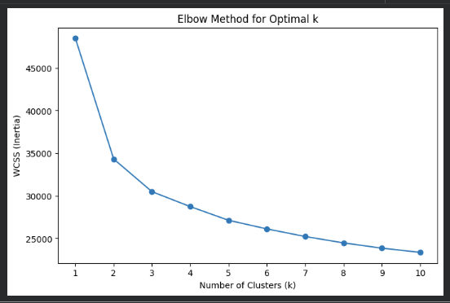

Elbow Method for Optimal k

The Elbow Method shows WCSS dropping sharply from k=1 to k=2, moderately to k=3, then flattening - the "elbow" appears around k=3, indicating diminishing returns beyond that point.

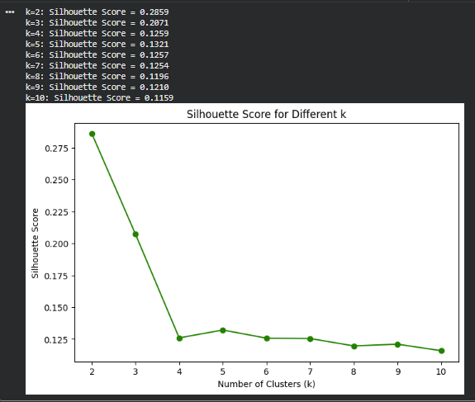

Silhouette Score for Different k

k | Silhouette Score
2 | 0.2859 (highest)
3 | 0.2071
4–10 | 0.11–0.13 (flat)
k=3 was selected over k=2 (the technically highest score) because the gap between them is small, the Elbow Method supports k=3, and 3 segments provide more actionable granularity for marketing than a simple 2-way split. All tested Silhouette Scores fall below the 0.5 threshold typically associated with strongly separated clusters, indicating a weak but present cluster structure - segments should be read as general tendencies rather than sharply distinct groups.

3.2 Final Model & Visualization
K-Means was fitted with k=3 (init='k-means++', random_state=42, n_init=10). Final Silhouette Score: 0.2071.
Cluster | Size | Proportion
0 | 1,034 | 46.3%
1 | 570 | 25.5%
2 | 628 | 28.1%
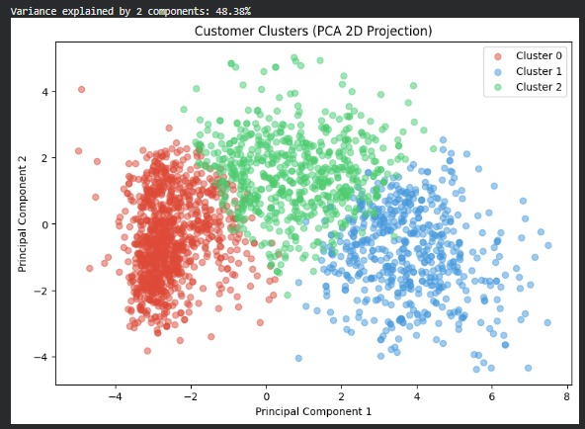

Customer Clusters — PCA 2D Projection

A 2D PCA projection was used to visualize the clusters. The three groups appear reasonably separated, with some overlap between Cluster 0 and Cluster 2. The 2 components shown explain only 48.38% of total variance in the original 30 features, so this plot should be read as a helpful intuition aid, not a precise representation of the true cluster structure — the Silhouette Score (computed in the original feature space) remains the more reliable metric.

3.3 Cluster Profiling
Metric | Cluster 0 | Cluster 1 | Cluster 2
Income (avg) | 34.7M | 76.0M | 57.8M
Total_Spending (avg) | 97.5K | 1.39M | 731K
Total_Transactions (avg) | 7.89 | 20.90 | 20.99
Total_Children (avg) | 1.23 | 0.20 | 1.17
Conversion_Rate (avg) | 0.01 | 0.13 | 0.02
NumWebVisitsMonth (avg) | 6.44 | 2.85 | 5.74
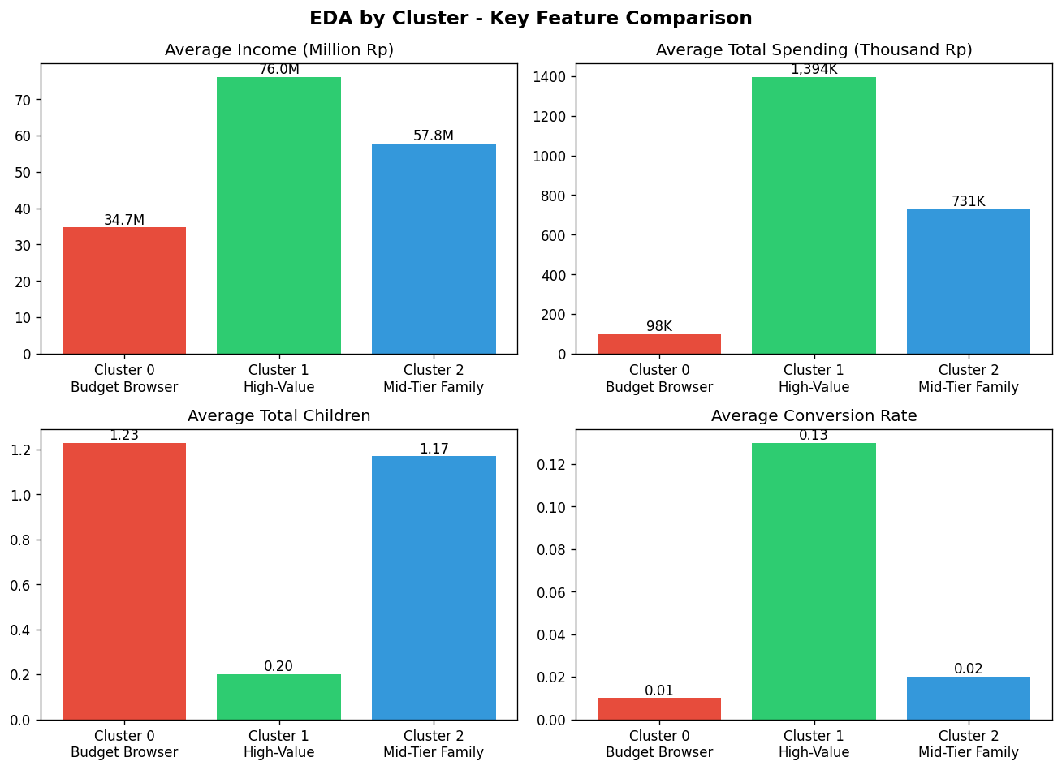

EDA by Cluster — key feature comparison

Cluster 0 - Budget-Conscious Browser (46.3%, largest segment)
Lowest income and spending, most children, most frequent web visits, but the lowest conversion rate. This group browses often but rarely converts — the least efficient segment despite being the largest.

Cluster 1 - High-Value, Low-Commitment (25.5%)
Highest income, spending, and transactions; fewest children; fewest web visits but by far the highest conversion rate and campaign response. The most valuable and most responsive segment.

Cluster 2 - Mid-Tier Family Spender (28.1%)
Mid-range income and spending, high transaction count (comparable to Cluster 1), many children, oldest average age, but low conversion rate. Likely loyal routine buyers who are less responsive to new campaigns specifically.

Part 4 - Retargeting Selection & Business Impact
4.1 Potential Impact Calculation
Cost and revenue assumptions were taken directly from the dataset's own columns: cost per contact = 3 (Z_CostContact), revenue per response = 11 (Z_Revenue). For each cluster, the retargeting pool (customers who have not yet responded) was multiplied by that cluster's historical response rate to estimate expected responders, cost, revenue, and net profit.

Cluster | Pool Size | Response Rate | Total Cost | Expected Revenue | Net Profit
0 - Budget-Conscious Browser | 942 | 8.90% | 2,826 | 922 | -1,904
1 - High-Value, Low-Commitment | 403 | 29.30% | 1,209 | 1,299 | +90
2 - Mid-Tier Family Spender | 553 | 11.94% | 1,659 | 726 | -933

Cluster 0 and Cluster 2 both result in a net loss if retargeted with a standard campaign - their response rates are too low to cover contact costs, despite larger pool sizes. Cluster 1 is the only segment that remains profitable, even though the margin is thin.

4.2 Final Business Recommendation
Decision: Retarget Cluster 1 only (403 non-responders) expected net profit of +90, the only financially viable segment under the current campaign model.

- Prioritize customers without children (Cluster 1) for future campaign targeting - the only segment with positive expected ROI.
- Avoid segmenting campaigns primarily by age - not found to be a statistically reliable differentiator (Kruskal-Wallis p = 0.317).
- Use spending level as a secondary, not primary, targeting signal, given its weak (though significant) relationship with conversion.
- For Cluster 0 and Cluster 2, explore lower-cost engagement channels (email, loyalty programs) instead of paid retargeting, since standard campaigns lose money for these segments.
- Investigate further why customers with children convert less often, to design more relevant campaigns for that segment going forward.

4.3 Limitations
- Conversion_Rate is a custom, per-customer metric defined by the project brief, and differs from the standard aggregate definition of conversion rate used in marketing analytics.
- The metric only captures web-channel activity — it cannot account for catalog, in-store, or word-of-mouth influence.
- Silhouette Scores across all tested k values are relatively low (max 0.29), indicating the underlying cluster structure is weak rather than sharply defined; the PCA visualization only captures 48.38% of total variance.
- Some subgroups have small sample sizes (e.g. Youth: 116 customers; Total_Children=3: 53 customers) and should be interpreted cautiously.
- All relationships reported here are correlational, not causal.

Source Code
Notebook: [link to Colab / notebook file]
GitHub: github.com/Irsan-DA/customer-personality-conversion-analysis

