AAT Code Test

Solution: AAT.File.Processor3

(.NET 5.0 Console App)

# Application Output

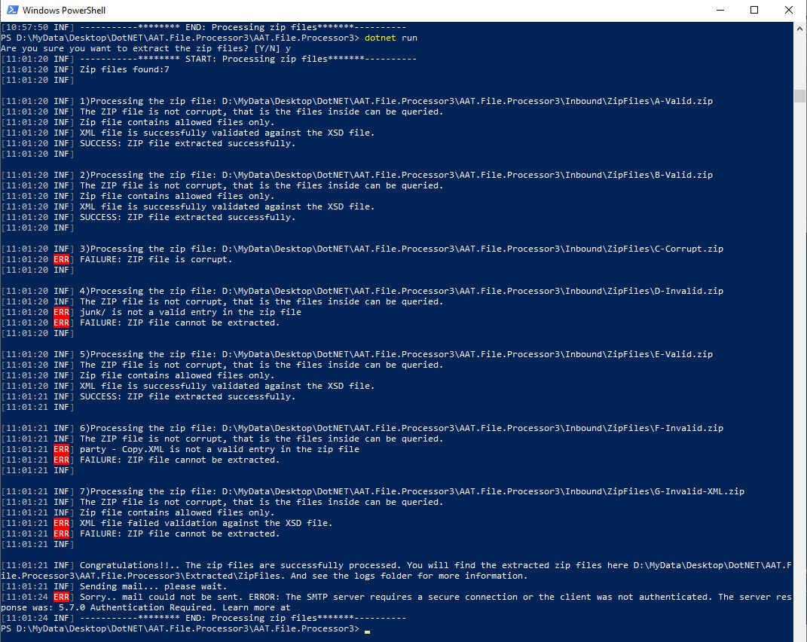

# Solution structure

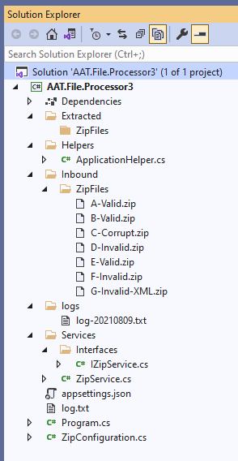

# Build and run

1. Use command ‘dotnet build’ in dotnet CLI to build the application or just build the solution in visual studio.

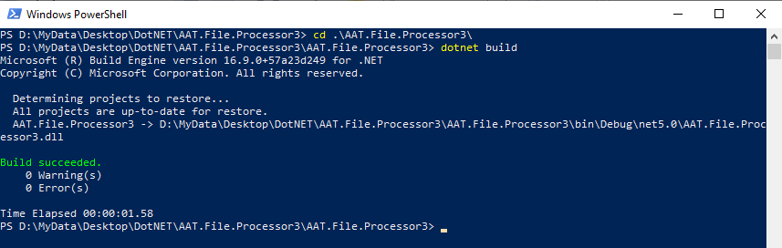

1. Use command ‘dotnet run’ from dotnet CLI or just run the application from Visual Studio



# Tools used

1. Visual Studio 2019.
2. Dotnet CLI.
3. .NET 5.0 Console application.
4. Serilog for writing the logs to file and console.

# Some useful Information

For convenience, I have included few inbound zip files along with this solution.

The system can be configured as per the need under ‘ZipSettings’ section in appsettings.json file.

See the below screenshot for the location of Inbound files, extracted files, logs and appsettings.

