Ans 1 - Print the sum of the first 5 decimal numbers from 1 to 5 in binary format.

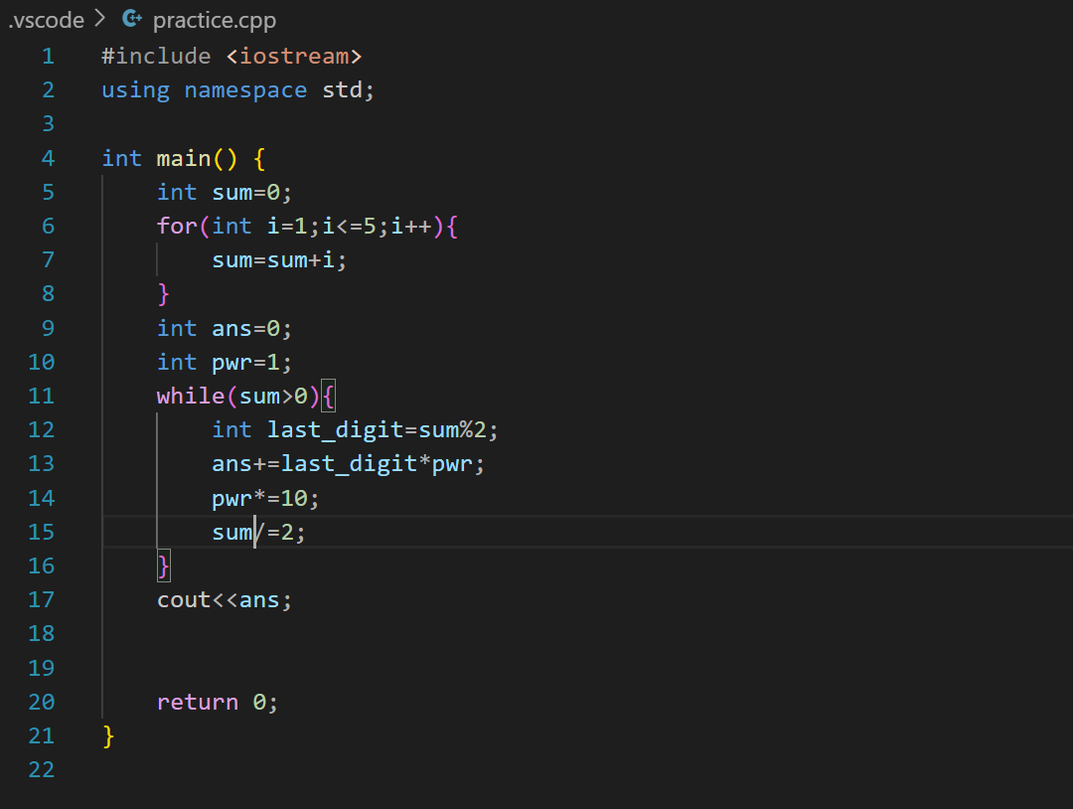

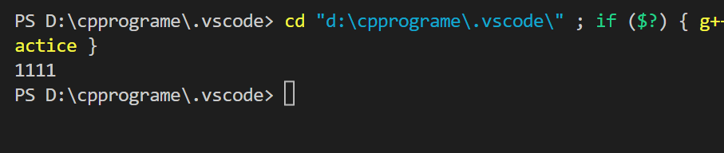

Ans 2 - Given a natural number, find the number of 0’s in the binary representation of that number.

Note: Don’t count the preceding zeros.

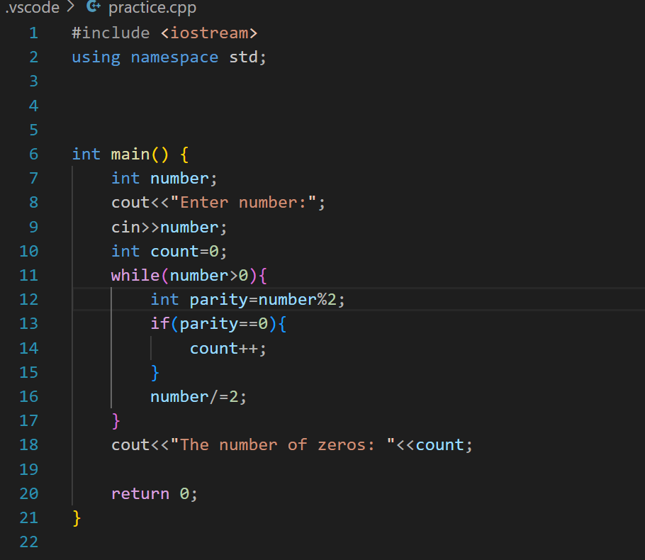

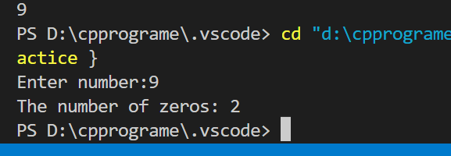

Ans 3 - Given two binary numbers, return the greatest of these numbers in decimal format.

