

**Department of Electrical and Computer Engineering**

**North South University**

**Spring 2019**

**CSE 299: Junior Design Course**

Section: 08

Group Number: 04

**Submitted To:**

**Shaikh Shawon Arefin Shimon**

Lecturer, ECE Department

North South University, Dhaka, Bangladesh

**Submitted By:**

**Irtifa Sarwath**

**ID:1610187042**

**Email:irtifa.sarwath@northsouh.edu**

**Github:** <https://github.com/Irtifa/SU19CSE299S01G04NSU>

**Date of submission: 26.08.2019**

|  |
| --- |
| Table of Contents   1. **Introduction …………………………………………… 3** 2. **Font-end plan …………………………………………… 3** 3. **Features ……………………………………………………… 3** 4. **Images ………………………………………………………… 4** 5. **Technology …………………………………………………. 5** 6. **Monetization …………………………………………….... 5** 7. **Business plan ……………………………………………….. 5** 8. **Future Plane …………………………………………………. 5** |

**Project Details**

Project name: Orphanage Management System

Introduction:

Orphanage management system is a website interconnecting our nation’s NGOs, civil society and orphanages to eradicate the hopeless conditions of the orphanages due to lack of proper communication between donors and receivers and seeking parents. There are a lot of orphanages existing at this current time and there are a lot of eager parents and donors to help these orphanages prosper. Orphans Hope is the platform were these two parties with a mutual interest meet and take conclusive decisions to reach their desired goals in an effective and authentic manner.

So this is a website where people can find their necessary information together.

This is website based project so that interested people about orphanage so that they do not need to browse dozens of websites. Sometimes they don’t even find the right information. For them this website is a very good option.

For this, we will collect data from real orphanage owner and update our information page. Interested parents will go through the information and policies about adoption and donation. So that they may get easily adaption details. Their information will all hide and only the orphanage owner will see this.

**Font-end plan**

1. Home

2. About

3. Log in

4. Adoption form

5. Donation form

6. Contact

Features

In this project we will use html, css, Php, MySQL for database. And this is a total web based project so that all the info that will provide the user will save on our database directly. User can not able to see any other person’s or user information. There are 2 types of register. One is admin another is orphanage owner. Orphanage owner can see the interested parents provided information. donation information can see the admin. The rest development need more advanced code and authorizations.

Images :

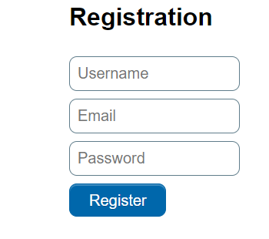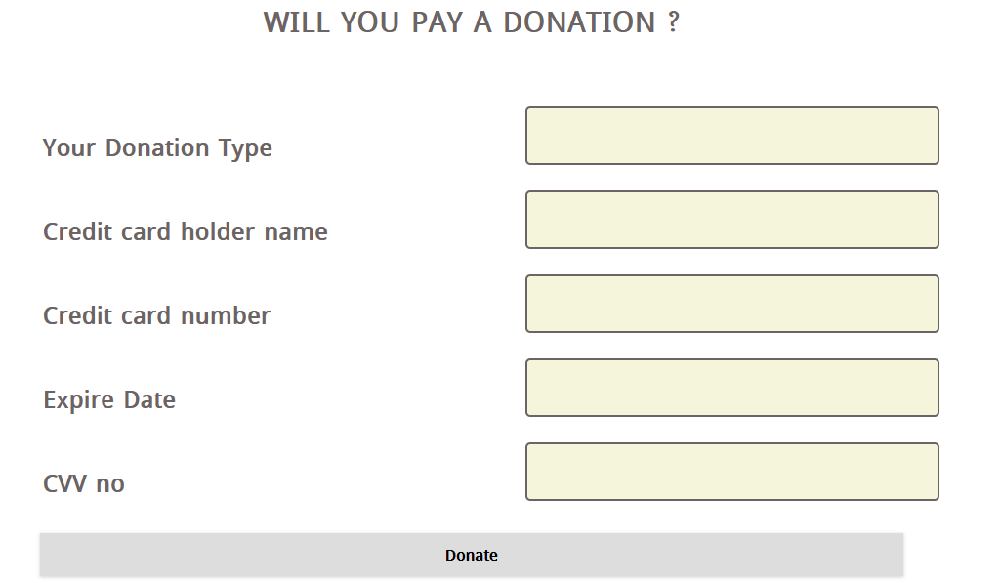

Donation records 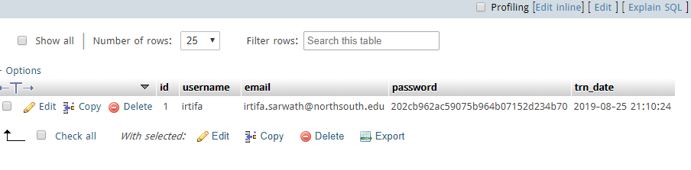

Home page

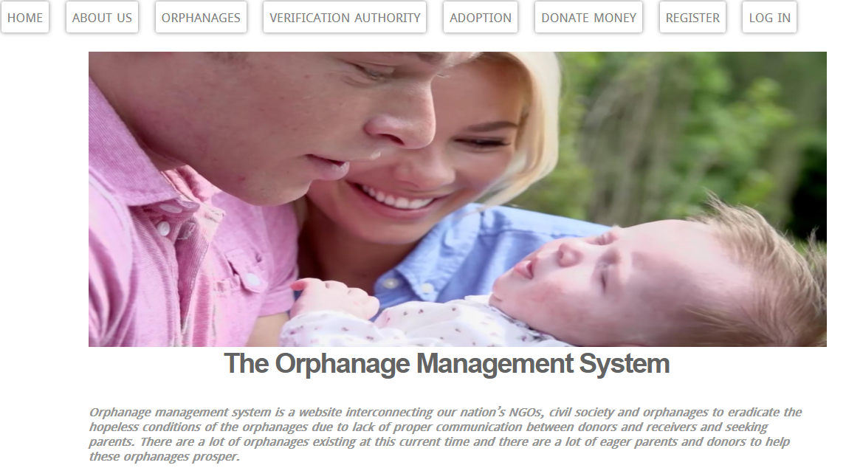

Technology

In this management system this is a complete website based project. All the system developed has predefined system requirement for a maximum performance. However, the system requirement is the minimum hardware and software to be designed. Below are the minimum and software are needed.

Monetization

In future, I will try to make a mobile application version of this project. Also will try to make sure to add more detail data of the orphanage houses. so that I can on the monetization on for Google add sense and many other sponsors. But that will take more time and good enough resources and a worthy team to grow this up.

Business plan

For business purpose, every application needs attention of users. On that case, we need marketing. The idea need to be presented in such way that the users feel the necessity of using this application. So we will be needed good advertising and solid marketing strategy

Release Plan

The requirements are divided into three releases based on the prioritization and their dependencies. The three different releases are assembled so that each would work as a fully functional application. In the first release the requirements that build up the foundation of the mobile application were included, together with the most highly prioritized requirements and their dependencies. The second release also includes important requirements. However, these requirements are not vital for a functional application. They are more suited to act as additional features that can contribute to making the software product more attractive. The third release includes the requirements that can be afforded to discard if the project gets delayed or overruns the budget.

Future plan

In future, we will try to make a mobile application version of this project. Also we will try to make sure to add more details data of the orphanages institutions all over our country. So that we can preset this project as an economic platform and also research on it. But that will take more time and also good enough resources and a worthy experienced team to grow this up.