Data Science &amp; Machine Learning: Lab Cycle 3

1.Sarah bought a new car in 2001 for $24,000. The dollar value of her car changed each year as shown in
the table below.
Value of Sarah&#39;s Car
Year Value
2001 $24,000
2002 $22,500
2003 $19,700
2004 $17,500
2005 $14,500
2006 $10,000
2007 $ 5,800
Represent the following information using a line graph with following style properties
• X- axis - Year
Y –axis - Car Value
• title –Value Depreciation (left Aligned)
• Line Style dashdot and Line-color should be red
• point using * symbol with green color and size 20

PROGRAM

import matplotlib.pyplot as plt
import numpy as np
x = np.array([2001,2002,2003,2004,2005,2006,2007])
y = np.array([24000,22500,19700,17500,14500,10000,5800])

plt.plot(x, y,marker='*',ms=20,mfc='g',ls='-.',color='red')
plt.xlabel("Year")
plt.ylabel("Car Value")
plt.title("Value Depreciation",loc="left") # add title
plt.show()

OUTPUT

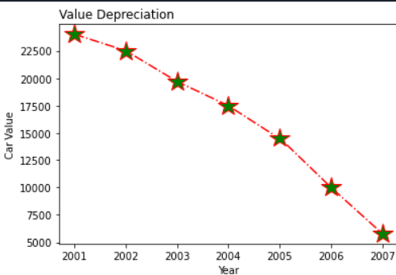

2.Following table gives the daily sales of the following items in a shop
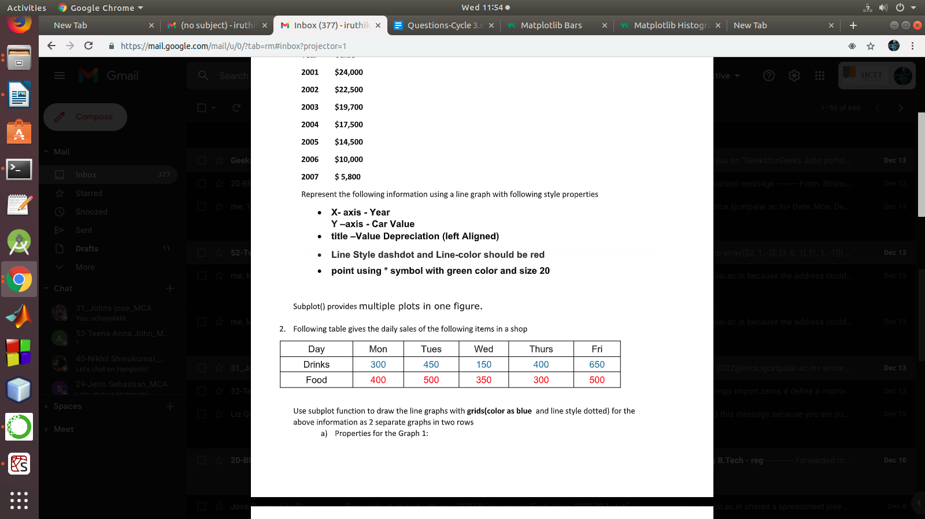
Use subplot function to draw the line graphs with grids(color as blue and line style dotted) for the
above information as 2 separate graphs in two rows
a) Properties for the Graph 1:

• X label- Days of week
• Y label-Sale of Drinks
• Title-Sales Data1 (right aligned)
• Line –dotted with cyan color
• Points- hexagon shape with color magenta and outline black
b) Properties for the Graph 2:
• X label- Days of Week
• Y label-Sale of Food
• Title-Sales Data2 ( center aligned)
• Line –dashed with yellow color
• Points- diamond shape with color green and outline red

PROGRAM

import matplotlib.pyplot as plt
import numpy as np

#plot 1:
x = np.array(["Mon","Tue","Wed","Thu","Fri"])
y = np.array([300,450,150,400,650])

plt.subplot(2, 1, 1)
plt.xlabel("Days of Week")
plt.ylabel("Sales of Drinks")
plt.title("Sales data1",loc="right")
plt.plot(x,y,marker='H',mfc='m',mec='k',ls=':',color='c')
plt.grid(color='b',linestyle='-.')

#plot 2:

x = np.array(["Mon","Tue","Wed","Thu","Fri"])
y = np.array([400, 500, 350, 300,500])

plt.subplot(2, 1, 2)
plt.xlabel("Days of Week")
plt.ylabel("Sales of Food")
plt.title("Sales data2",loc="center")
plt.plot(x,y,marker='d',mfc='g',mec='r',ls='-.',color='y')
plt.grid(color='b',linestyle='-.')
plt.show()

OUTPUT
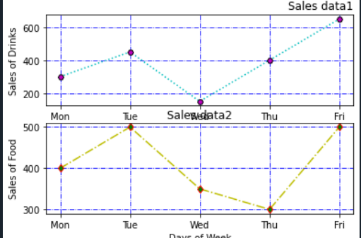

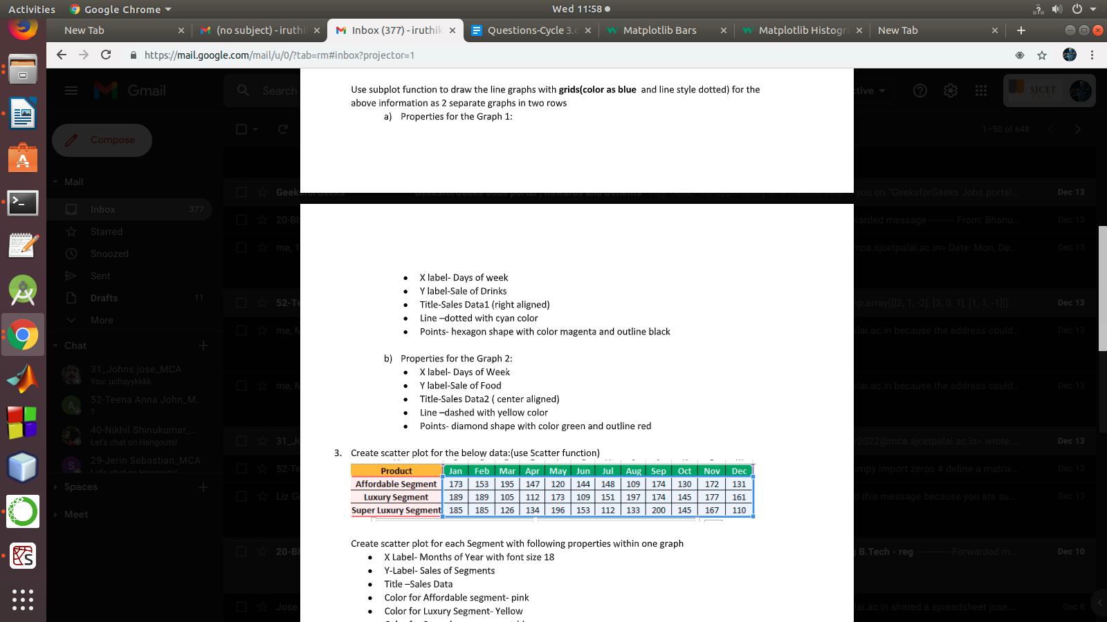
3.Create scatter plot for the below data:(use Scatter function)

Create scatter plot for each Segment with following properties within one graph
• X Label- Months of Year with font size 18
• Y-Label- Sales of Segments
• Title –Sales Data
• Color for Affordable segment- pink
• Color for Luxury Segment- Yellow
• Color for Super luxury segment-blue

PROGRAM

import matplotlib
import matplotlib.pyplot as plt
import numpy as np

x = np.array(["Jan","Feb","Mar","Apr","May","Jun","Jul","Aug","Sep","Oct","Nov","Dec"])
y = np.array([173,153,195,147,120,144,148,109,174,130,172,131])

plt.title("Sales Data")
plt.xlabel('Months of Year', fontsize=18)
plt.ylabel("Sales of Segments")
plt.scatter(x, y,color='pink')

x = np.array(["Jan","Feb","Mar","Apr","May","Jun","Jul","Aug","Sep","Oct","Nov","Dec"])
y = np.array([189,189,105,112,173,109,151,197,174,145,177,161])
plt.scatter(x, y,color='y')

x = np.array(["Jan","Feb","Mar","Apr","May","Jun","Jul","Aug","Sep","Oct","Nov","Dec"])
y = np.array([185,185,126,134,196,153,112,133,200,145,167,110])
plt.scatter(x, y,color='blue')
plt.show()

OUTPUT
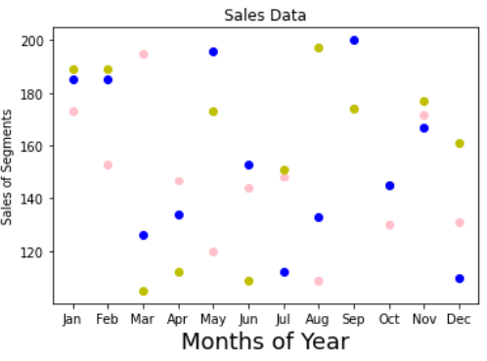

4.Display the above data using multiline plot( 3 different lines in same graph)
• Display the description of the graph in upper right corner(use legend())
• Use different colors and line styles for 3 different lines

PROGRAM

import matplotlib.pyplot as plt
import numpy as np
x = np.array(["Jan","Feb","Mar","Apr","May","Jun","Jul","Aug","Sep","Oct","Nov","Dec"])
y1 = np.array([173,153,195,147,120,144,148,109,174,130,172,131])
y2 = np.array([189,189,105,112,173,109,151,197,174,145,177,161])
y3 = np.array([185,185,126,134,196,153,112,133,200,145,167,110])

fig, ax = plt.subplots()

ax.plot(x, y1,label="affordable segment",ls=":")
ax.plot(x, y2,label="luxuary segment",ls="-.")
ax.plot(x,y3,label = "super segment")
ax.legend()
plt.show()

OUTPUT
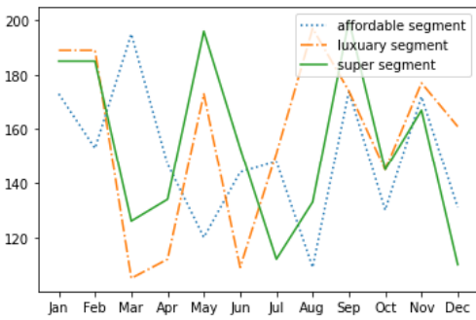

5.100 students were asked what their primary mode of transport for getting to school was. The results of
this survey are recorded in the table below. Construct a bar graph representing this information.
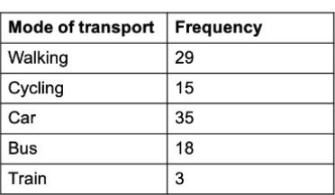

Create a bar graph with
• X axis -mode of Transport and Y axis ‘frequency’

• Provide appropriate labels and title
• Width .1, color green

PROGRAM

import matplotlib.pyplot as plt
import numpy as np

x = np.array(["Walking","Cycling ","Car","Bus","Train"])
y = np.array([25, 15, 35, 18,3])
plt.title("Students Transportation Graph")
plt.xlabel("Mode of Transport")
plt.ylabel("Frequency")
plt.bar(x,y,color='g',width=.1)
plt.show()

OUTPUT

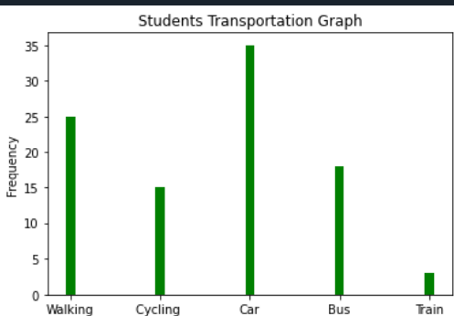

6.We are provided with the height of 30 cherry trees.
The height of the trees (in inches): 61, 63, 64, 66, 68, 69, 71, 71.5, 72, 72.5, 73, 73.5, 74, 74.5, 76, 76.2,
76.5, 77, 77.5, 78, 78.5, 79, 79.2, 80, 81, 82, 83, 84, 85, 87.Create a histogram with a bin size of 5

PROGRAM

import numpy as np
import matplotlib.pyplot as plt
x = [61, 63, 64, 66, 68, 69, 71, 71.5, 72, 72.5, 73, 73.5, 74, 74.5, 76, 76.2,
76.5, 77, 77.5, 78, 78.5, 79, 79.2, 80, 81, 82, 83, 84, 85, 87]
plt.hist(x,bins=5)
plt.show()

OUTPUT
