DATA SCEINCE &MACHINE LEARNING

LAB CYCLE 1

1.Program to Print all non-Prime Numbers in an Interval

CODE

start = int(input("Enter lower bound:"))
end = int(input("Enter upper bound:"))
for i in range(start, end + 1):
if i > 1:
for j in range(2, i):
if (i % j == 0):
break
else:
print(i)

OUTPUT
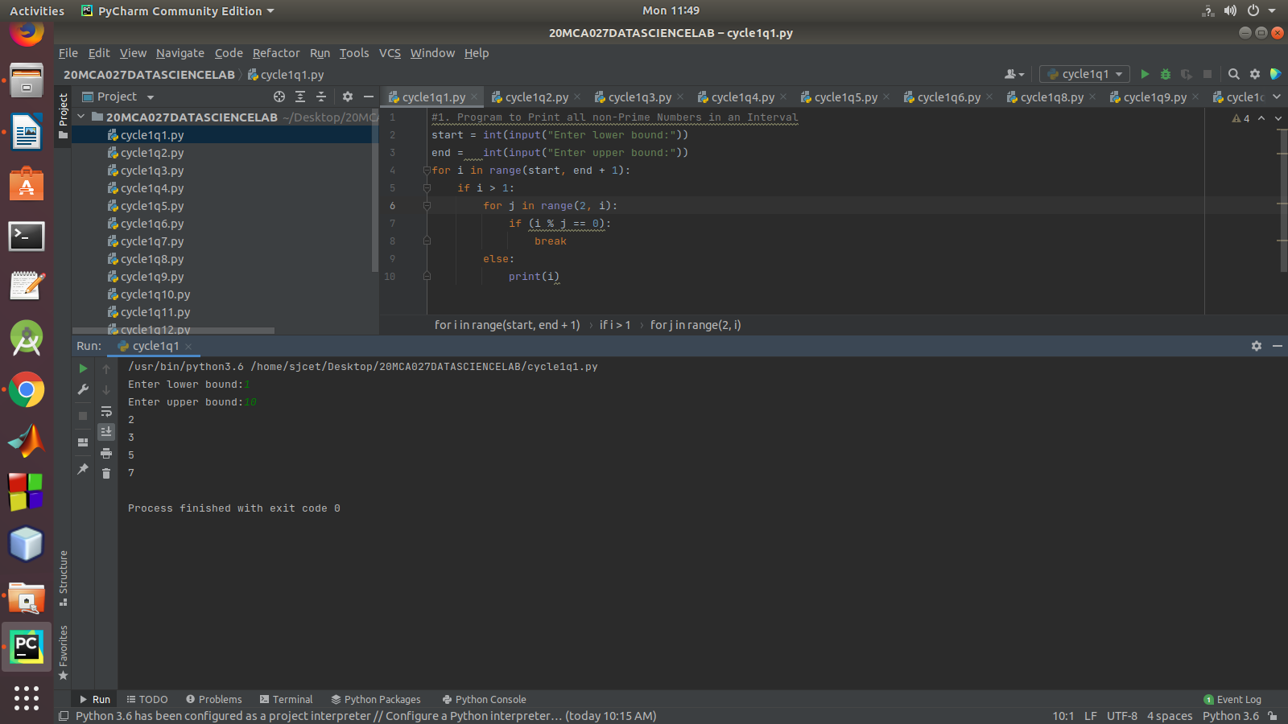

2.Program to print the first N Fibonacci numbers.

CODE

def printFibonacciNumbers(n):
f1 = 0
f2 = 1
if (n < 1):
return
print(f1, end=" ")
for x in range(1, n):
print(f2, end=" ")
next = f1 + f2
f1 = f2
f2 = next
num = int(input("Enter number of tearms:"))
printFibonacciNumbers(num)
OUTPUT
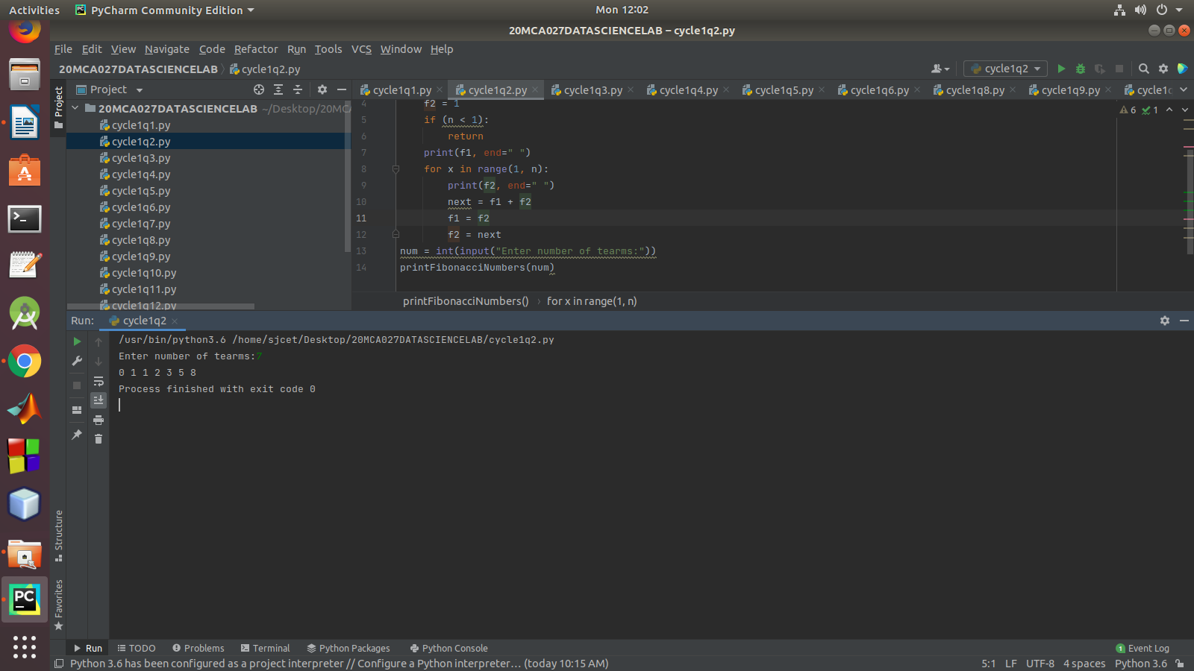

3.Given sides of a triangle, write a program to check whether given triangle is an
isosceles, equilateral or scalene.

CODE

def checkTriangle(x, y, z):
if x == y == z:
print("Equilateral Triangle")
elif x == y or y == z or z == x:
print("Isosceles Triangle")
else:
print("Scalene Triangle")
x = input("enter the first side")
y = input("enter the second variable")
z = input("enter the third variable")
checkTriangle(x, y, z)
OUTPUT

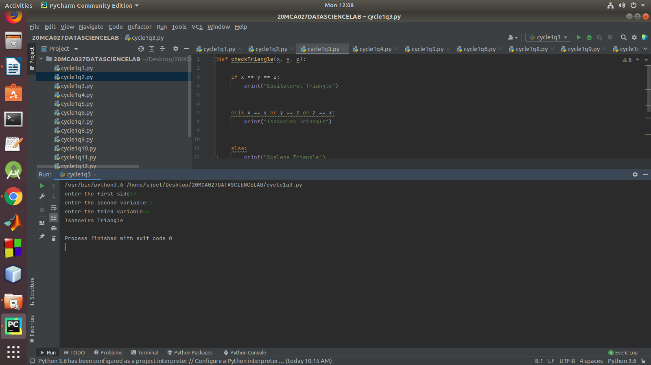

4.Program to check whether given pair of number is coprime

CODE
def __gcd(a, b):
if (a == 0 or b == 0): return 0
if (a == b): return a
if (a > b):
return __gcd(a - b, b)
return __gcd(a, b - a)
def coprime(a, b):
if (__gcd(a, b) == 1):
print("Co-Prime")
else:
print("Not Co-Prime")
a = int(input("Enter first number:"))
b = int(input("enter second number:"))
coprime(a, b)
OUTPUT
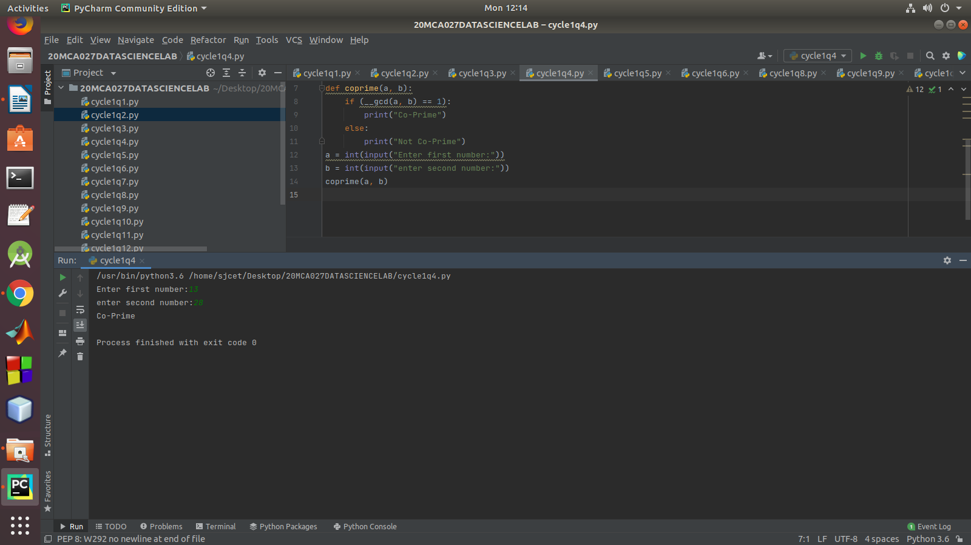

5.Program to find the roots of a quadratic equation(rounded to 2 decimal places)

CODE

from math import sqrt
print("Quadratic function : (a * x^2) + b*x + c")
a = float(input("a: "))
b = float(input("b: "))
c = float(input("c: "))
r = b ** 2 - 4 * a * c
if r > 0:
num_roots = 2
x1 = (((-b) + sqrt(r)) / (2 * a))
x2 = (((-b) - sqrt(r)) / (2 * a))
print("There are 2 roots: %f and %f" % (x1, x2))
elif r == 0:
num_roots = 1
x = (-b) / 2 * a
print("There is one root: ", x)
else:
num_roots = 0
print("No roots, discriminant < 0.")
exit()
OUTPUT

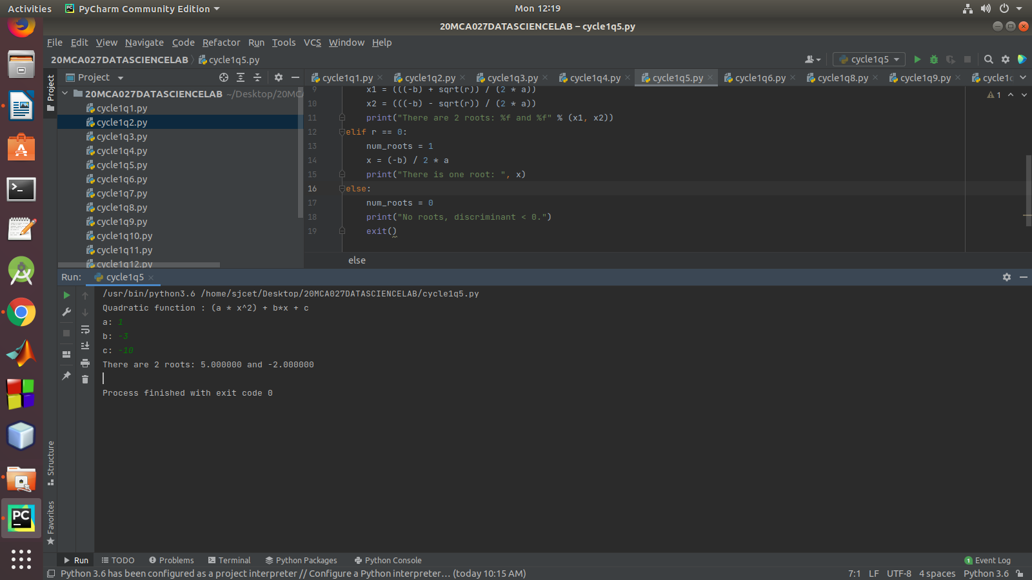

6.Program to check whether a given number is perfect number or not(sum of factors
=number)

CODE

n = int(input("Enter any number: "))
sum1 = 0
for i in range(1, n):
if(n % i == 0):
sum1 = sum1 + i
if (sum1 == n):
print("The number is a Perfect number!")
else:
print("The number is not a Perfect number!")

OUTPUT

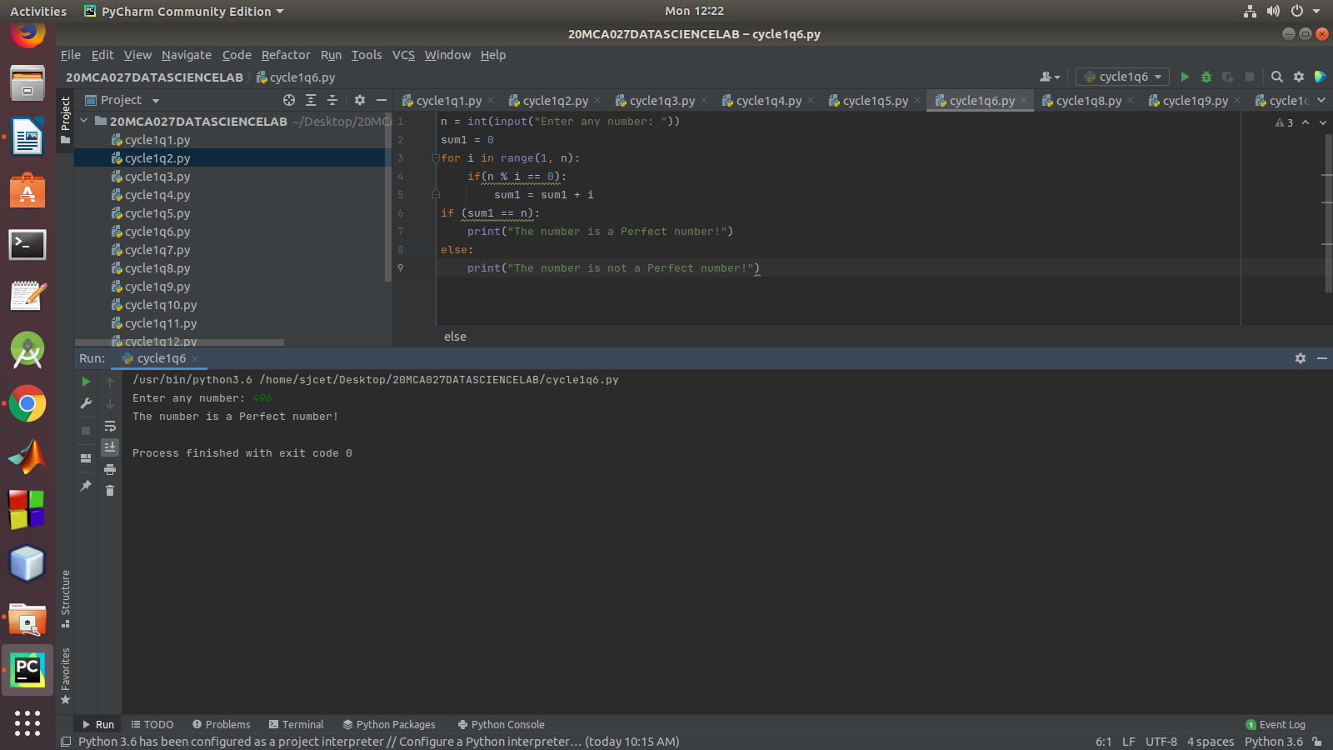

7.Program to display amstrong numbers upto 1000

CODE

for num in range(1,1001):
temp=num
sum=0
while temp>0:
digit=temp%10
sum=sum+digit**3
temp=temp//10
if sum==num:
print (num)
OUTPUT

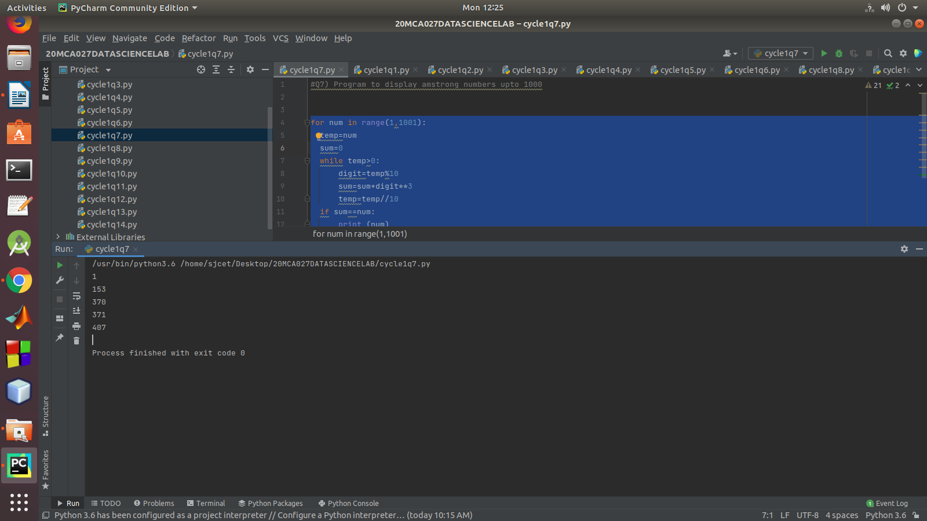
8.Store and display the days of a week as a List, Tuple, Dictionary, Set. Also
demonstrate different ways to store values in each of them. Display its type also.

CODE

# demonstrate different ways to store values in each of them. Display its type also.
list1 = ['Sunday','Monday','Tuesday','Wednesday','Thursday','Friday','Saturday']
tuple1 = ('Sunday','Monday','Tuesday','Wednesday','Thursday','Friday','Saturday')
set1 = {'Sunday','Monday','Tuesday','Wednesday','Thursday','Friday','Saturday'}
dict1 = {1:"Sunday",2:"Monday",3:"Tuesday",4:"Wednesday",5:"Thursday",6:"Friday",7:"Saturday"}
print("LIst:"+str(list1))
print("tuple:"+str(tuple1))
print("Set:"+str(set1))
print("dictionary:"+str(dict1))
print(type(list1))
print(type(tuple1))
print(type(set1))
print(type(dict1))

OUTPUT

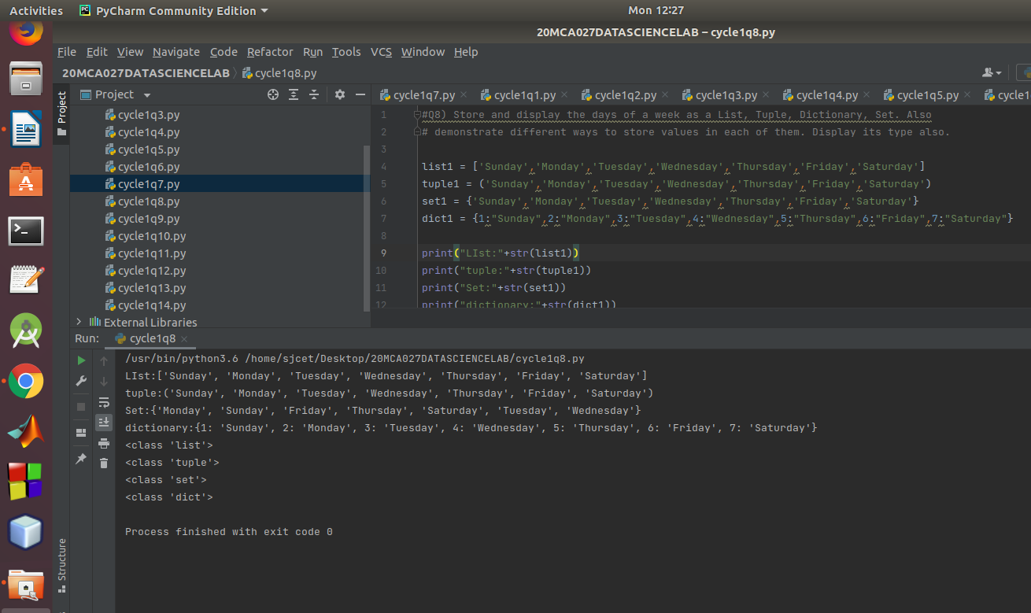
9.Write a program to add elements of given 2 lists

CODE

# Python code to demonstrate
# addition of two list
# naive method
# initializing lists
test_list1 = [1, 3, 4, 6, 8]
test_list2 = [4, 5, 6, 2, 10]
# printing original lists
print ("Original list 1 : " + str(test_list1))
print ("Original list 2 : " + str(test_list2))
# add two list
res_list = []
for i in range(0, len(test_list1)):
res_list.append(test_list1[i] + test_list2[i])
# printing resultant list
print ("Resultant list is : " + str(res_list))

OUTPUT

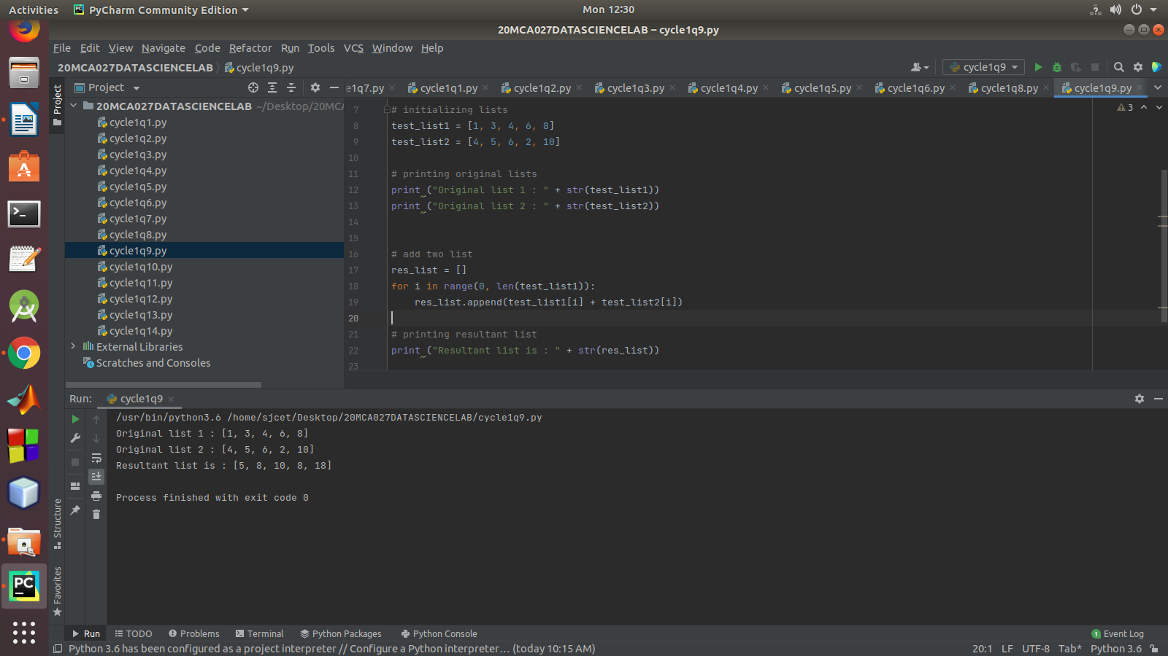

10.Write a program to find the sum of 2 matrices using nested List.

CODE

X = [[1,2,3],
[4 ,5,6],
[7 ,8,9]]
Y = [[9,8,7],
[6,5,4],
[3,2,1]]
result = [[0,0,0],
[0,0,0],
[0,0,0]]
for i in range(len(X)):
for j in range(len(X[0])):
result[i][j] = X[i][j] + Y[i][j]
for r in result:
print(r)

OUTPUT

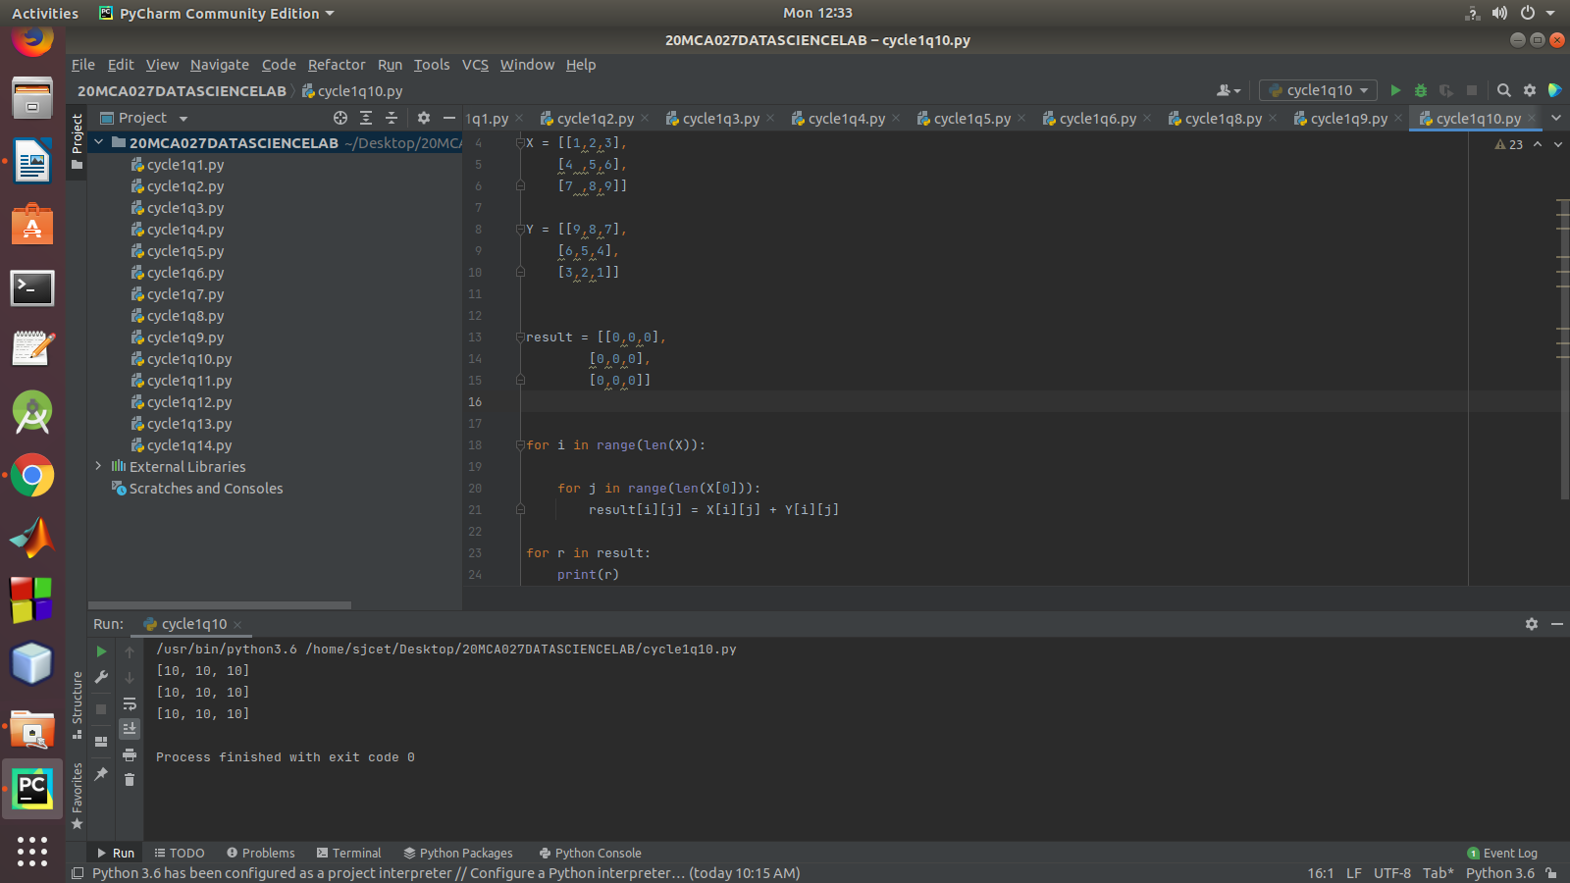

11.Write a program to perform bubble sort on a given set of elements.

CODE

def bubbleSort(arr):
n = len(arr)
for i in range(n-1):
for j in range(0, n-i-1):
if arr[j] > arr[j + 1] :
arr[j], arr[j + 1] = arr[j + 1], arr[j]
arr = [64, 34, 25, 12, 22, 11, 90]
bubbleSort(arr)
print ("Sorted array is:")
for i in range(len(arr)):
print ("% d" % arr[i])

OUTPUT

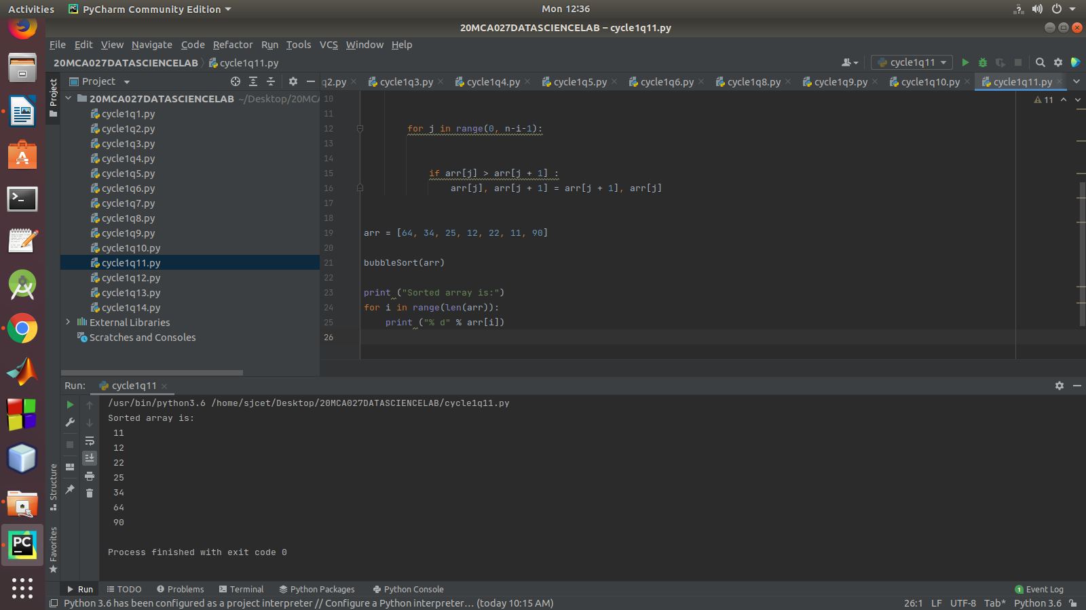
12.Program to find the count of each vowel in a string(use dictionary)

CODE

vowels = 'aeiou'
ip_str = 'Hello, welcome to the magic world of python?'
ip_str = ip_str.casefold()
count = {}.fromkeys(vowels,0)
for char in ip_str:
if char in count:
count[char] += 1
print(count)

OUTPUT
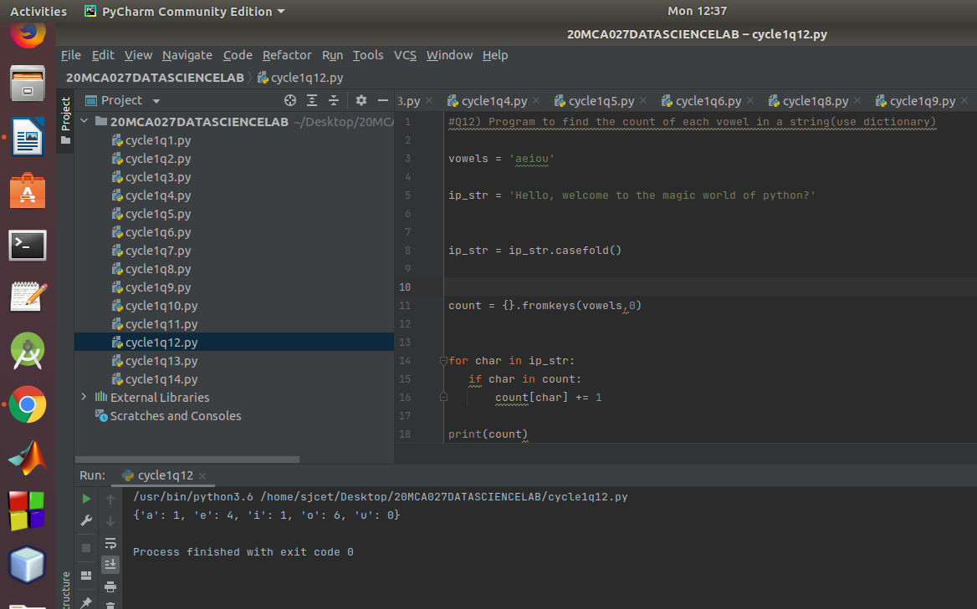

13.Write a Python program that accept a positive number and subtract from this
number the sum of its digits and so on. Continues this operation until the number is positive

CODE

def repeat_times(n):
s = 0
n_str = str(n)
while (n > 0):
n -= sum([int(i) for i in list(n_str)])
n_str = list(str(n))
s += 1
return s
num = int(input("Enter a positive number:"))
print(repeat_times(num))

OUTPUT

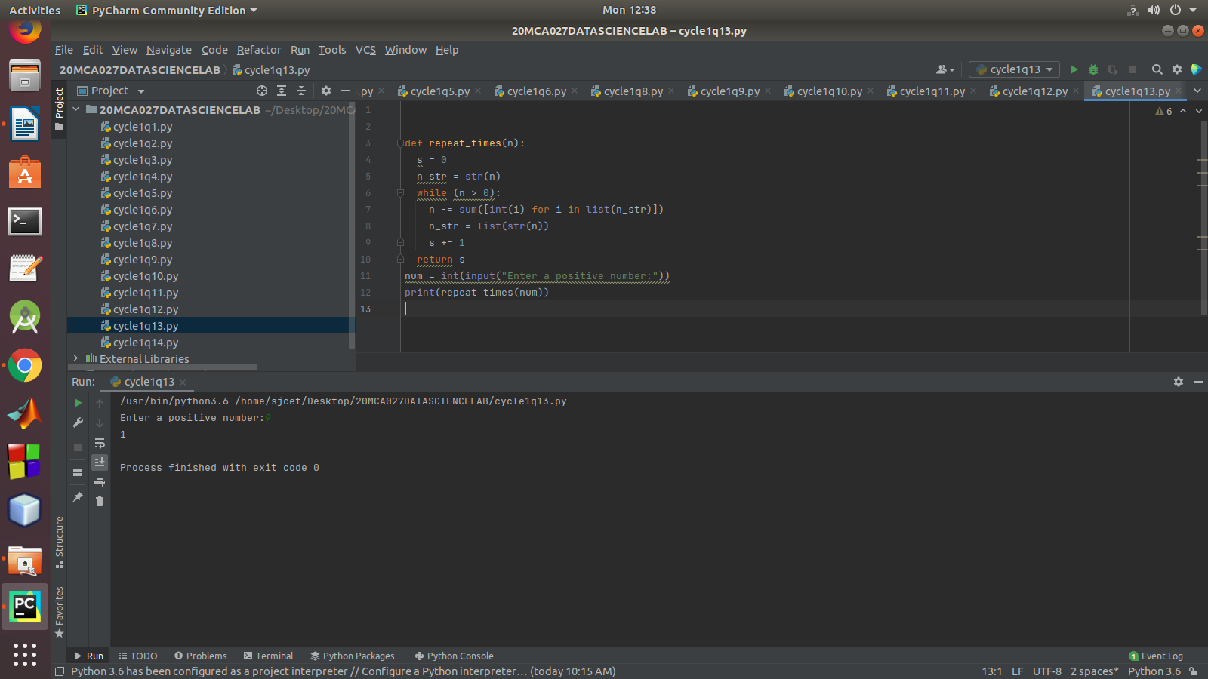

14.Write a Python program that accepts a 10 digit mobile number, and find the digits which are absent in a given mobile number

CODE

def absent_digits(n):
all_nums = set([0,1,2,3,4,5,6,7,8,9])
n = set([int(i) for i in n])
n = n.symmetric_difference(all_nums)
n = sorted(n)
return n
number = input("Enter 10 digit mobile number:")
digit_string = str(number)
digit_map = map(int, digit_string)
digit_list = list(digit_map)
print(absent_digits(digit_list))

OUTPUT

