DATASCIENCE AND MACHINE LEARNING LAB

CYCLE 4

1.Use appropriate functions in pandas to display
- Shape of the data set
- First 5 and last five rows of data set(head and tail)
- Size of dataset
- No:of samples available for each variety
- Description of the data set( use describe
PROGRAM

import numpy as np
import matplotlib.pyplot as plt
import seaborn as sns
import pandas as pd
iris=pd.read_csv("iris.csv")

print("First five rows")
print(iris.head())
print("*********")

print("columns",iris.columns)
print("*********")

print("shape:",iris.shape)
print("*********")

print("Size:",iris.size)
print("*********")

print("no of samples available for each type")
print(iris["variety"].value_counts())
print("*********")

print(iris.describe())

OUTPUT
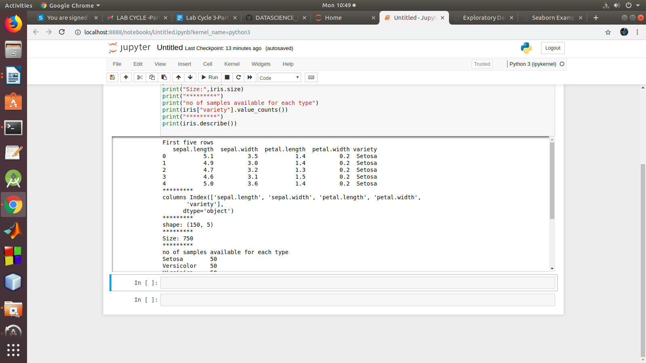

2. Use pairplot() function to display pairwise relationships between attributes. Try different kind of plots {‘scatter’, ‘kde’, ‘hist’, ‘reg’} and different kind of markers

PROGRAM

import numpy as np
import matplotlib.pyplot as plt
import seaborn as sns
import pandas as pd
sns.set_style("whitegrid")
sns.pairplot(iris,hue="variety",height=3,kind = 'scatter');
sns.pairplot(iris,hue="variety",height=3,kind = 'kde');
sns.pairplot(iris,hue="variety",height=3,kind = 'hist');
sns.pairplot(iris,hue="variety",height=3,kind = 'reg');
plt.show()

OUTPUT

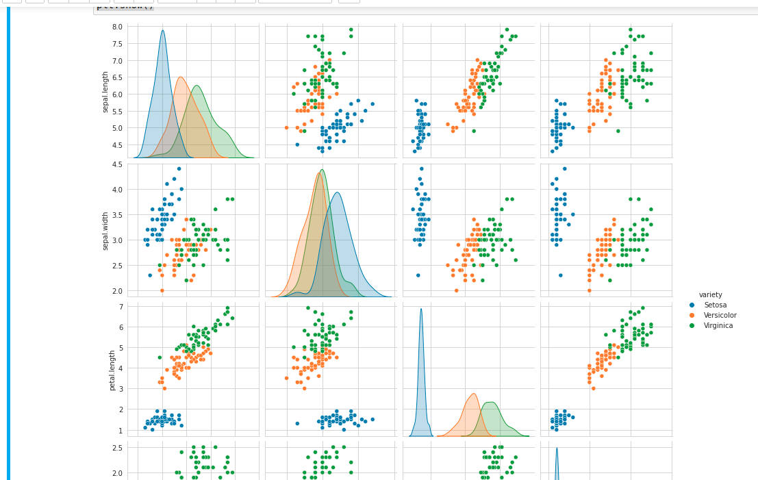
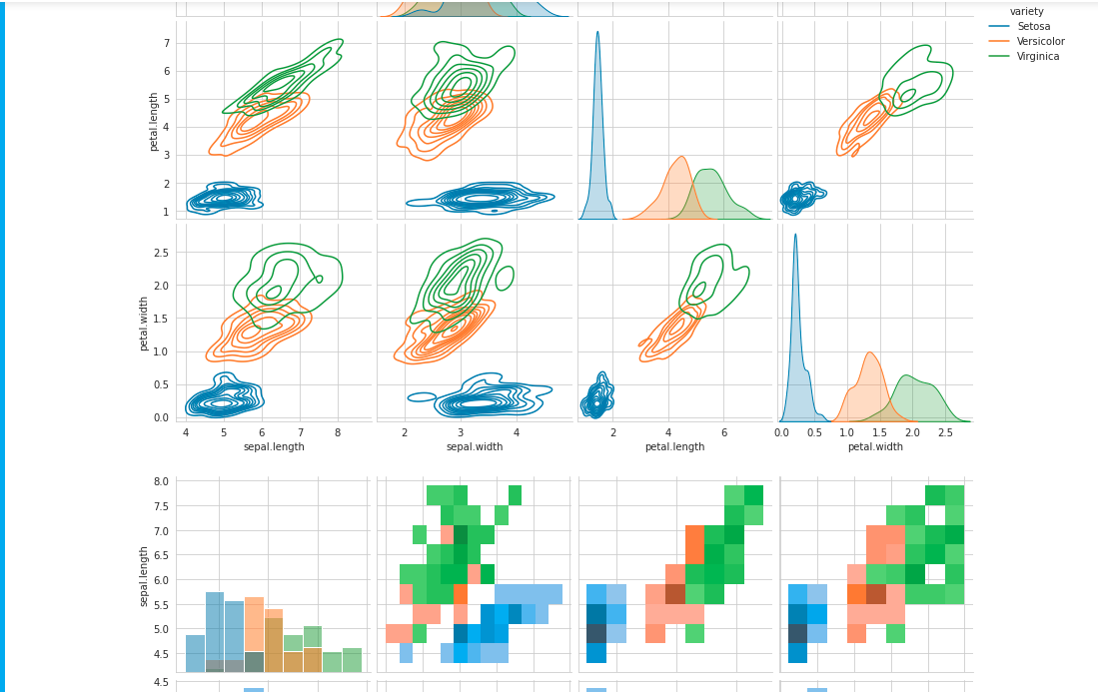
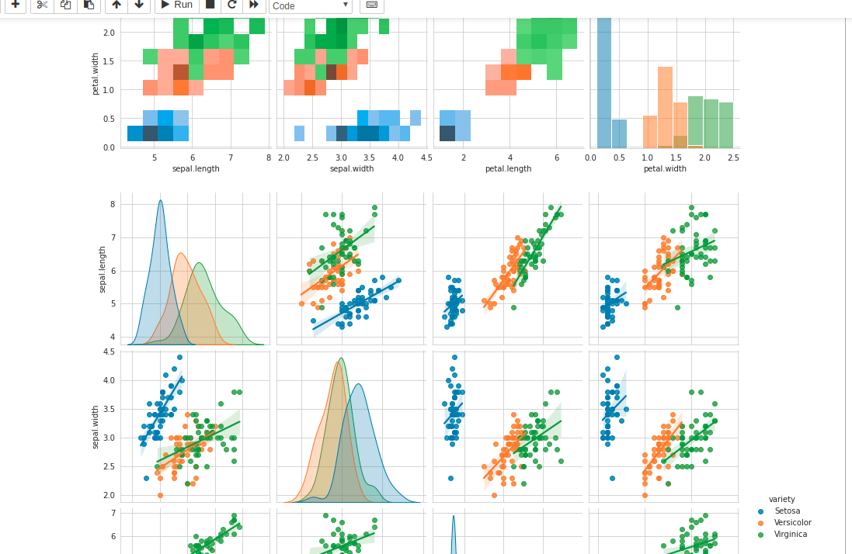

3.using the iris data set,get familiarize with functions:
1)displot()
2) histplot()
3) relplot()
PROGRAM
1)displot()
import numpy as np
import matplotlib.pyplot as plt
import seaborn as sns
import pandas as pd
col=['sepal_length','sepal_width','petal_length','petal_width','variety']
df = sns.load_dataset('iris')
sns.displot(x = 'sepal_length',kde=True,bins = 5 , data =df)

OUTPUT
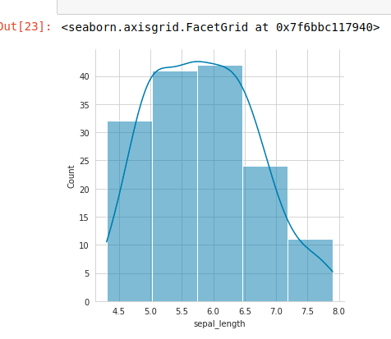

2)histplot()
import numpy as np
import matplotlib.pyplot as plt
import seaborn as sns
import pandas as pd
col=['sepal_length','sepal_width','petal_length','petal_width','variety']
df = sns.load_dataset('iris')
sns.histplot(data =df, x = "sepal_length", kde = True)
OUTPUT
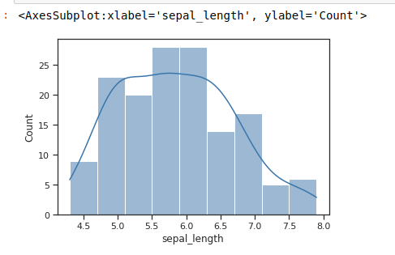

3)RELPLOT()
import seaborn as sns
import numpy as np
import matplotlib.pyplot as plt
import pandas as pd

sns.set(style ="ticks")
tips = sns.load_dataset('iris')

sns.relplot(x ="sepal_length",y ="sepal_width",kind ="scatter",data = tips)

Output
