ANDROID LAB

CYCLE2

1.Create 2 activity from the first the first activity on a button click move to the second activity.

Program
activity_main.xml
<LinearLayout
android:layout_width="match_parent"
android:layout_height="match_parent"
android:orientation="vertical"
android:gravity="center"
xmlns:android="http://schemas.android.com/apk/res/android">
<Button
android:layout_width="wrap_content"
android:layout_height="wrap_content"
android:text="MOVE TO NEXT ACTIVITY"
android:id="@+id/bt"
android:onClick="click"
android:gravity="center"/>
</LinearLayout>
activity_main2.xml
<LinearLayout android:layout_width="match_parent" android:layout_height="match_parent"
android:orientation="vertical"
android:gravity="center"
android:background="@android:color/holo_blue_light"
xmlns:android="http://schemas.android.com/apk/res/android">
<TextView
android:layout_width="wrap_content"
android:layout_height="wrap_content"
android:text="WELCOME TO THE SECOND ACTIVITY"
android:id="@+id/tv" />
</LinearLayout>
MainActivity.java
package com.example.sjcet.switch_to_next_activity;
import android.widget.Button;
import android.content.Intent;
import android.support.v7.app.AppCompatActivity;
import android.os.Bundle;
import android.view.View;

public class MainActivity extends AppCompatActivity {
Button bt;
@Override
protected void onCreate(Bundle savedInstanceState) {
super.onCreate(savedInstanceState);
setContentView(R.layout.activity_main);
bt =findViewById(R.id.bt);
}
public void click(View view) {
OpenNewActivity();
}
public void OpenNewActivity(){
Intent intent=new Intent(this, Main2Activity.class);
startActivity(intent);
}
}
OUTPUT:
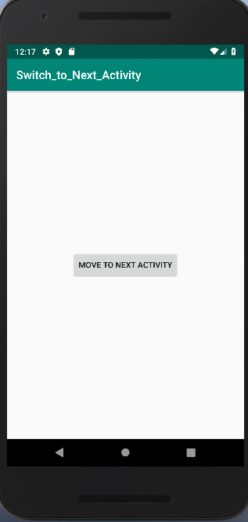
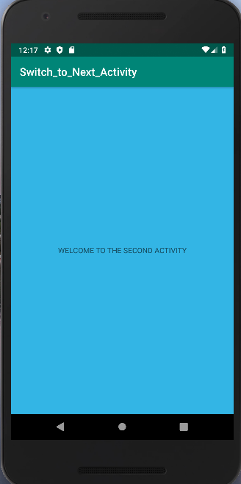

2.Create an activity and move to facebook login page on button click
PROGRAM
activity1.xml
<LinearLayout android:layout_width="match_parent" android:layout_height="match_parent"
android:orientation="vertical"
android:gravity="center"
xmlns:android="http://schemas.android.com/apk/res/android">
<Button
android:layout_width="wrap_content"
android:layout_height="wrap_content"
android:text="MOVE TO FB PAGE"
android:id="@+id/bt"
android:onClick="click"
android:gravity="center"/>
</LinearLayout>
activity1.java
package com.example.sjcet.switch_to_fb;
import android.content.Intent;
import android.net.Uri;
import android.support.v7.app.AppCompatActivity;
import android.os.Bundle;
import android.view.View;
import android.widget.Button;
import java.net.URI;
public class Activity1 extends AppCompatActivity {
protected void onCreate(Bundle savedInstanceState) {
super.onCreate(savedInstanceState);
setContentView(R.layout.activity_1);
Button btn_Explicit = (Button)findViewById(R.id.bt);
btn_Explicit.setOnClickListener(new View.OnClickListener()
{
@Override
public void onClick(View view) {
Intent intent = new Intent(Intent.ACTION_VIEW,Uri.parse("https://www.facebook.com/"));
startActivity(intent);
}
});
}}

OUTPUT
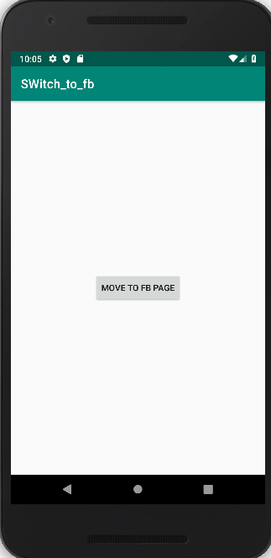
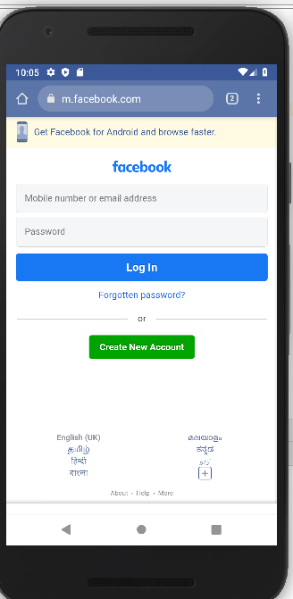

3.Read message in the first activity and pass it to the second activity on a button click
program
activity1.xml
<LinearLayout
android:layout_width="match_parent"
android:layout_height="match_parent"
android:orientation="vertical"
android:gravity="center"
xmlns:android="http://schemas.android.com/apk/res/android">
<EditText
android:id="@+id/send_text_id"
android:layout_width="300dp"
android:layout_height="wrap_content"
android:textSize="25dp"
android:hint="Input"
android:textStyle="bold"
android:layout_marginTop="20dp"
android:layout_marginLeft="40dp"/>
<Button
android:layout_width="wrap_content"
android:layout_height="wrap_content"
android:text="Send"
android:id="@+id/send_button_id"
android:onClick="click"
android:gravity="center"/>
</LinearLayout>
Activit1.java
package com.example.sjcet.message_read_pass;
import android.content.Intent;
import android.support.v7.app.AppCompatActivity;
import android.os.Bundle;
import android.view.View;
import android.widget.Button;
import android.widget.EditText;
public class Activity1 extends AppCompatActivity {
Button send_button;
EditText send_text;
@Override
protected void onCreate(Bundle savedInstanceState) {
super.onCreate(savedInstanceState);
setContentView(R.layout.activity_1);
send_button = (Button)findViewById(R.id.send_button_id);
send_text = (EditText)findViewById(R.id.send_text_id);
send_button.setOnClickListener(new View.OnClickListener() {
@Override
public void onClick(View v)
{
// get the value which input by user in EditText
// and convert it to string
String str = send_text.getText().toString();
// Create the Intent object of this class Context() to Second_activity class
Intent intent = new Intent(getApplicationContext(), Activity2.class);
// now by putExtra method put the value in key, value pair
// key is message_key by this key we will receive the value, and put the string
intent.putExtra("message_key", str);
// start the Intent
startActivity(intent);
}
});
}
}

activity2.xml
<LinearLayout
android:layout_width="match_parent"
android:layout_height="match_parent"
android:orientation="vertical"
android:gravity="center"
xmlns:android="http://schemas.android.com/apk/res/android">
<TextView
android:id="@+id/received_value_id"
android:layout_width="300dp"
android:layout_height="50dp"
android:textStyle="bold"
android:textSize="40dp"
android:layout_marginTop="20dp"
android:layout_marginLeft="40dp"/>
</LinearLayout>

Activity2.java
package com.example.sjcet.message_read_pass;
import android.content.Intent;
import android.support.v7.app.AppCompatActivity;
import android.os.Bundle;
import android.widget.TextView;
public class Activity2 extends AppCompatActivity {
TextView receiver_msg;
@Override
protected void onCreate(Bundle savedInstanceState) {
super.onCreate(savedInstanceState);
setContentView(R.layout.activity_2);
receiver_msg = (TextView)findViewById(R.id.received_value_id);
// create the get Intent object
Intent intent = getIntent();
// receive the value by getStringExtra() method
// and key must be same which is send by first activity
String str = intent.getStringExtra("message_key");
// display the string into textView
receiver_msg.setText(str);
}
}
Output


