**GUNDALA RENTCAR**

**Jl. Raya Cilandak KKO, Jakarta Selatan**

**0812 – 8250 - 3776**

**Nama :…………………………………….**

**Alamat :…………………………………….**

**Dari :…………………………………….**

**Tujuan :…………………………………….**

Hormat Kami,

(……………………………………………………)

**Tanggal berangkat :…………………………………….**

**Jam :…………………………………….**

**No.Polisi :…………………………………….**

**Tarif :……………………….…………….**

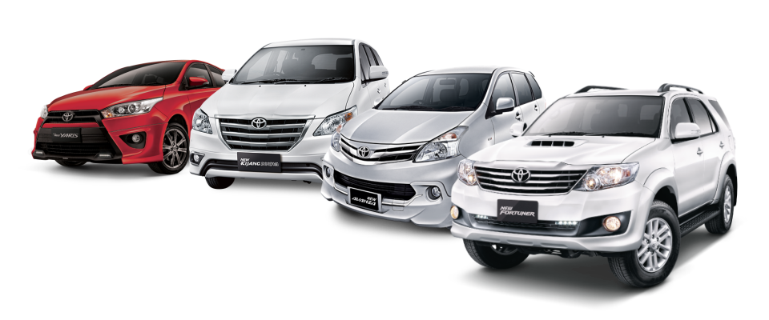

**GUNDALA RENTCAR**

**Jl. Raya Cilandak KKO, Jakarta Selatan**

**0812 – 8250 - 3776**

**Nama :…………………………………….**

**Alamat :…………………………………….**

**Dari :…………………………………….**

**Tujuan :…………………………………….**

Hormat Kami,

(……………………………………………………)

**Tanggal berangkat :…………………………………….**

**Jam :…………………………………….**

**No.Polisi :…………………………………….**

**Tarif :……………………….…………….**

