**Mid-Term Test**

Student: ______________________

**Be sure to read the following general instructions carefully:**

* This lab test must be completed **individually** by all the students.
* You should **demonstrate** the solution and submit it to **eCentennial** when you finish the test. You VS Code project name should be named **“YourFullName_MidTermTest_002_2020”** and should be zipped in a file **“YourFullName_MidTermTest_002_2020.zip”.**

**Exercise #1**

Create an Express.js app that allows users to **create game surveys**. You will have to design an MVC structure. Create a **model** that describes a game survey object. Each survey object should have:

***surveyId*** *- String*

***gameGenre*** - String

***daysPerYear*** - Number

***age*** - Number

Create a **controller** that implements: **add survey**, **list** surveys, **update** **or** **delete** a survey from the database and the list. Implement **update if your first name starts with a letter from A-L**, **otherwise implement delete**. In *development.js* file, name the MongoDB database: *YourFullName-survey-db*.

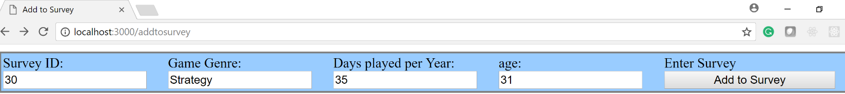

Create the necessary **ejs views** to allow the user to use the application:

* An *ejs* file will be used to **add survey** information (as shown above)
* An *ejs* file will be used to **display a list** of surveys as shown below.
* The same *ejs* file used for displaying the list, can be also used to either **update** **or** **delete** a survey as shown below.

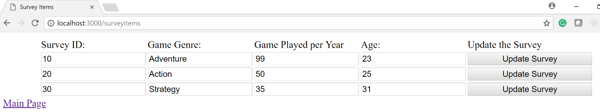

You may use the code from Lab Assignment 2 or SampleTest to implement your solution.

**(100 marks)**

**Evaluation:**

|  |  |
| --- | --- |
| **MongoDB database** (config files, model) | 20% |
| **Express Rest API**: Add  List  Update **or** Delete | 20%  15%  15% |
| **EJS views**:  **Add** survey: ejs view as shown above  **List** surveys: ejs view as shown above (use **forEach** loop) and also update **or** delete. | 10%  10% |
| **Friendliness** (using css to align the HTML elements, etc.) | 10% |
| **Total**: | 100% |