MECH 415 Assignment #2: Review

Question #1

The simulation of a 2nd order differential equation given by 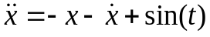 can be approximated using the Euler simulation method given by 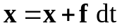, 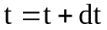 where

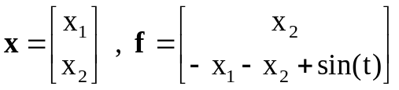

Note 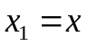 is the position and 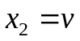 is the velocity. Evaluate the Euler simulation equation indicated above with the initial conditions 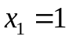, 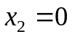 at 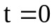 and 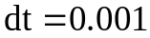 repeatedly using an infinite while loop and suitable arrays to represent the vectors. Print the variables 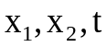 to the screen each time through the loop followed by a new line.

Question #2

Write a function compute_array(M,nz,n7) that initializes (from the keyboard) and computes various statistics for a 5x5 matrix M. The function computes the number of elements equal to zero (nz) and the number of elements greater than 7 (n7). Indicate which function parameters should be call-by-value or call-by-reference. Print out an error message (and return 1) if at least one matrix element is greater than 10 AND at least one element is less than -10.

Question #3

Write a function save_array(M,file_name) that saves a 5x5 matrix (like the one calculated in question #2) to a file, where the name of the file is stored in a string variable file_name. The format of the file has one matrix row on each line of the file.

Question #4

Write a function load_array(M,file_name) that reads a 5x5 matrix from a file with the same format as question #3.

Question #5

Write a function load_table(x,y,n) that reads a table from a file and stores the values in dynamic 1D arrays x and y with a size of n. The format of the file is as follows:

n
x1 y1
x2 y2
… …
xn yn

Hint: The pointers x and y must be call by reference (ie you need to include both * and & in the arguments for the arrays) in order to update/change them with new inside the function.

