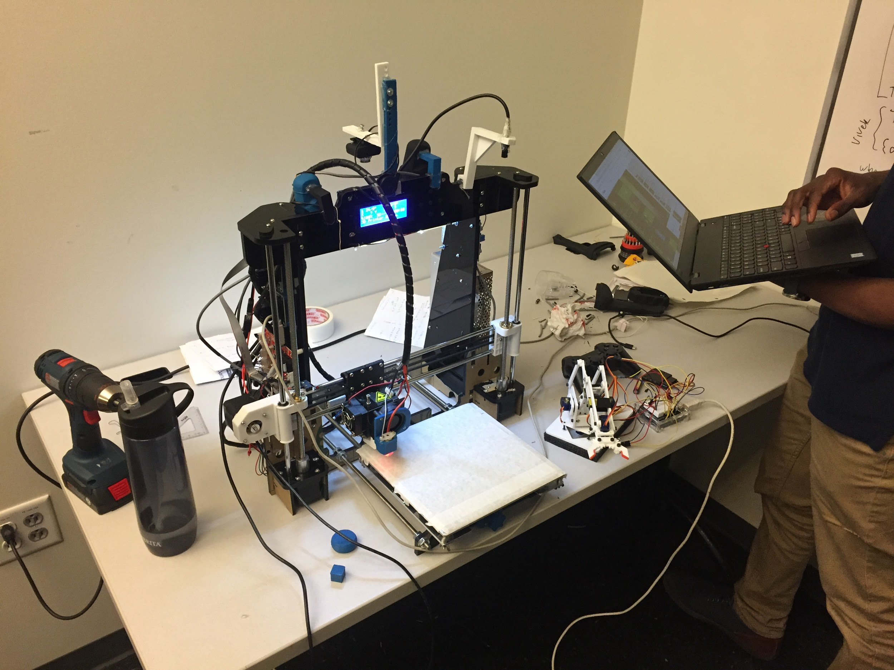
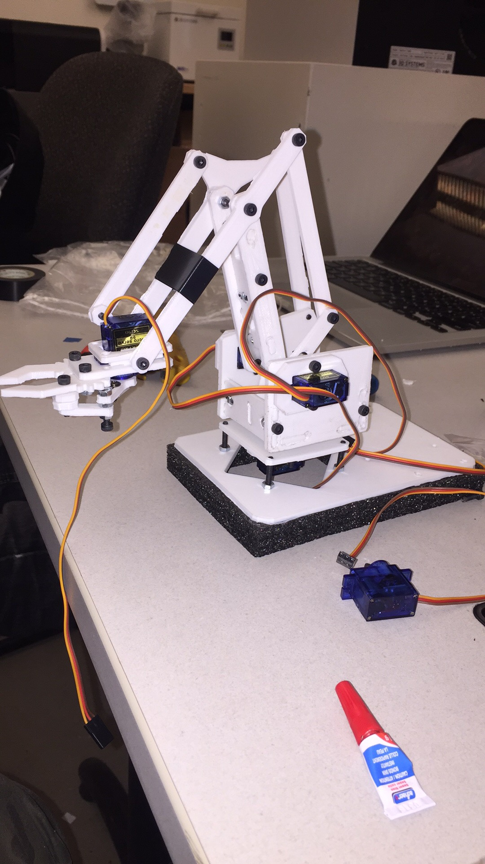
MECH 471 / MECH 6621 Microcontrollers for Mechatronics
Final Report Project

BY
(UNDERGRADUATE)
Astik ………………………………………………
Irwin Lopez……………………………………....................................……….... 29372431
Mina……………………………………...
Tong ………………

INTRODUCTION
This course introduces the fundamentals of computing with microcontrollers using an Atmel Atmega328P. The project consist of design, building, programming an semi-automonous racing/ drifting car using C programming to develop the software of the microcontroller. The car was design using off the shelf and 3D printed parts.
The features that were developed and implemented on the semi-automonous car are the following:

CAPABILITIES AND FEATURES
Compulsory Capabilities

******************************************************************************
*1. motor speed / car speed / cruse control control
-> interrupt based -- other controllers
*2. traction / launch control
3. breaking control
4. steering control
5. traction/breaking + steering control
6. donut radius / angular velocity control
7. collision control -- stop/break car if objects too close

Optional Capabilities
8. move down the hall without hitting walls
- laser range finder
- drifting control

******************************************************************************
Hardware features include; 1 X Servo-motor 996R, 1 arduino uno, fasteners, 1 x wireless PS2 controller, 1 wireless receiver, Front table 3D printed, Front motor holders 3D printed, Rear transmition custom with 3D printed casing, custom build rear passenger axel.
******************************************************************************
Software features include:
RESULTS

Version 1:
The first version of the RC Drift car gave us an inside of what issues we were going to have. The main issue we had was the front parts breaking due to collisions and weak front components, despite the protective foam. The most error was the rc car only turning in donut due to misalignment, we were able to correct it with the code.

Version 2:
For this new version. An old chassis was used to convert it to car within the specifications.
The front axle and fromt motor support and rear transmission were redesign to custom feet our coponents, as shown in the appendix A.
The designed C++ programs were debugged several times

REFERENCES
-https://users.encs.concordia.ca/~bwgordon/mech471.html , Dr. Brandon W. Gordon.

APPENDIX A
1-Front drivetrain 2- Tensioner bracket / tachometer holder

3- New Transmission / motor bracket

4-Front holder barcket + wheel holder
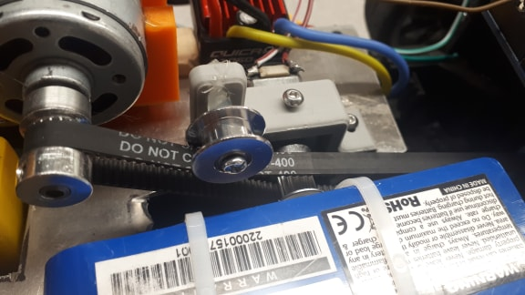
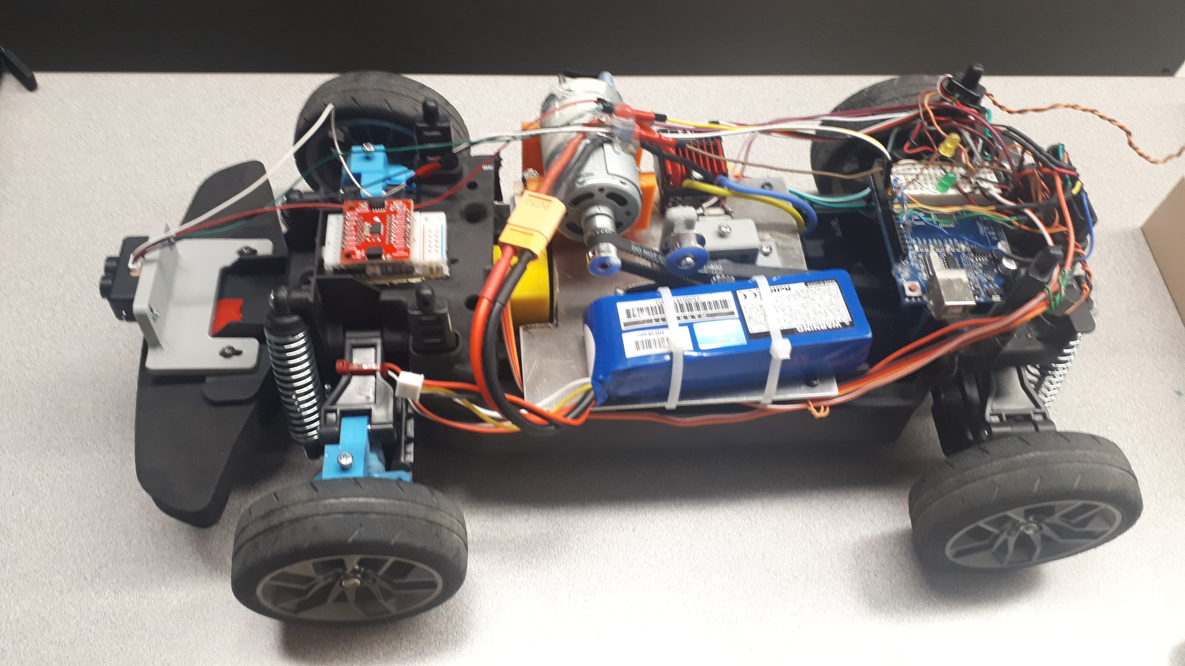

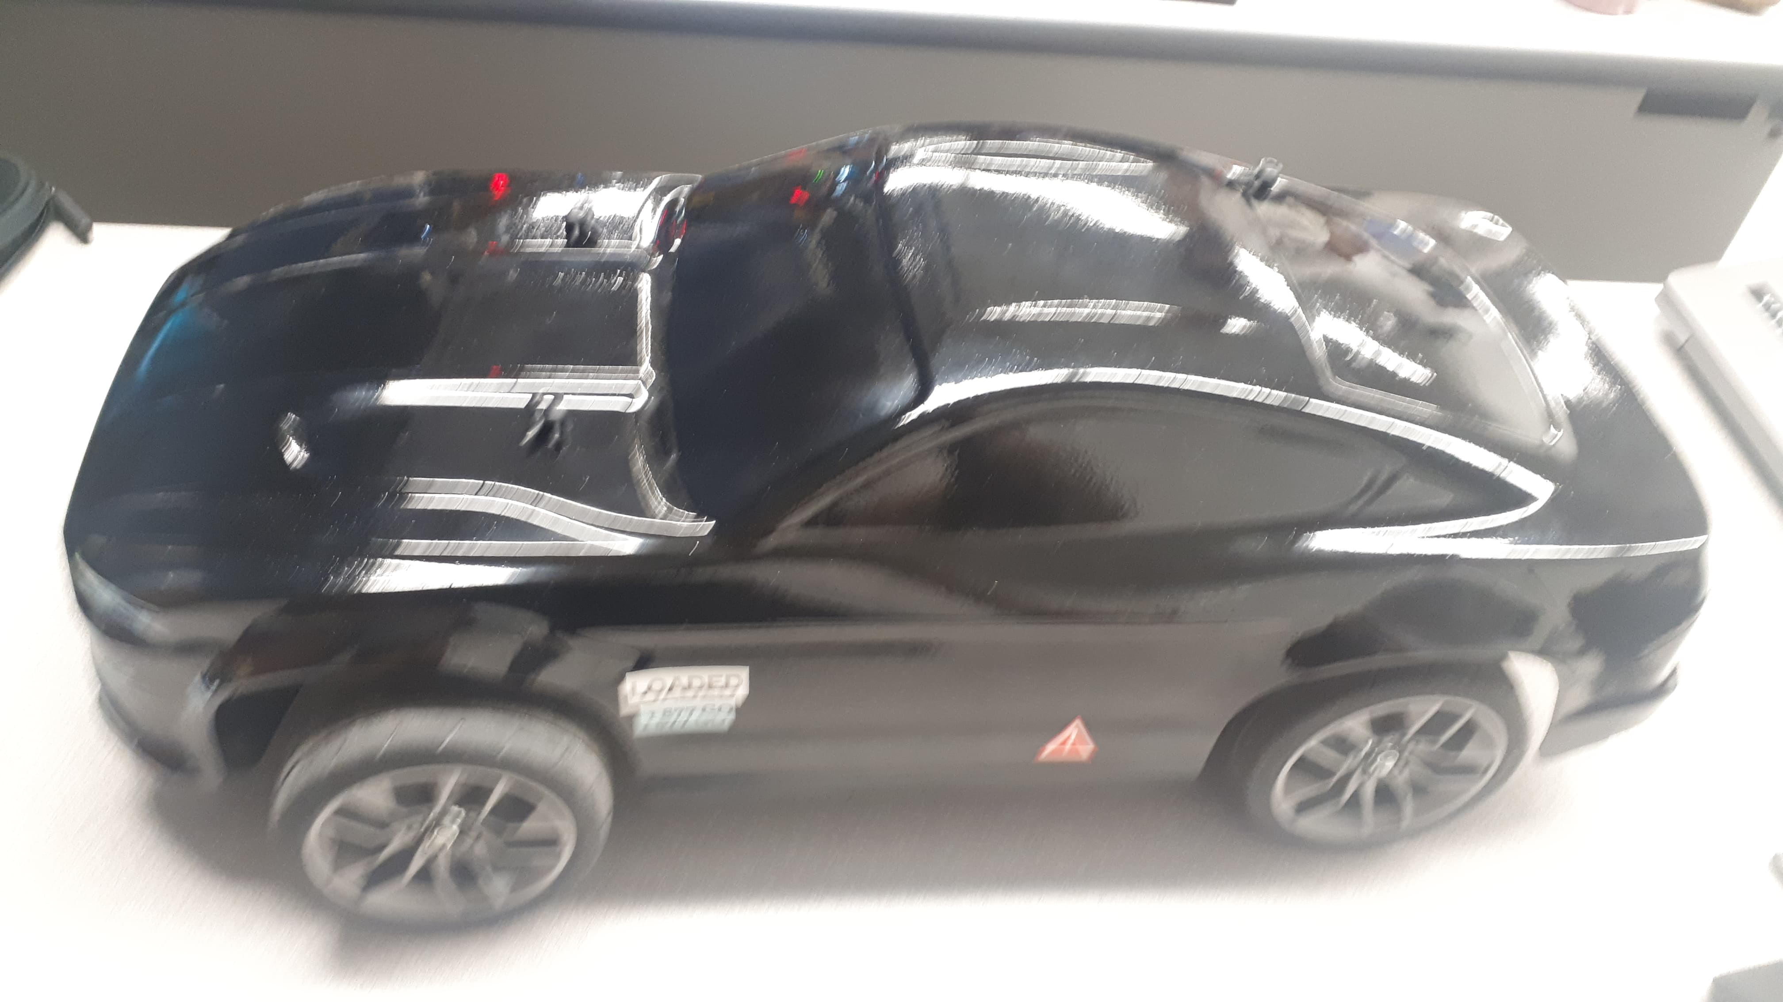
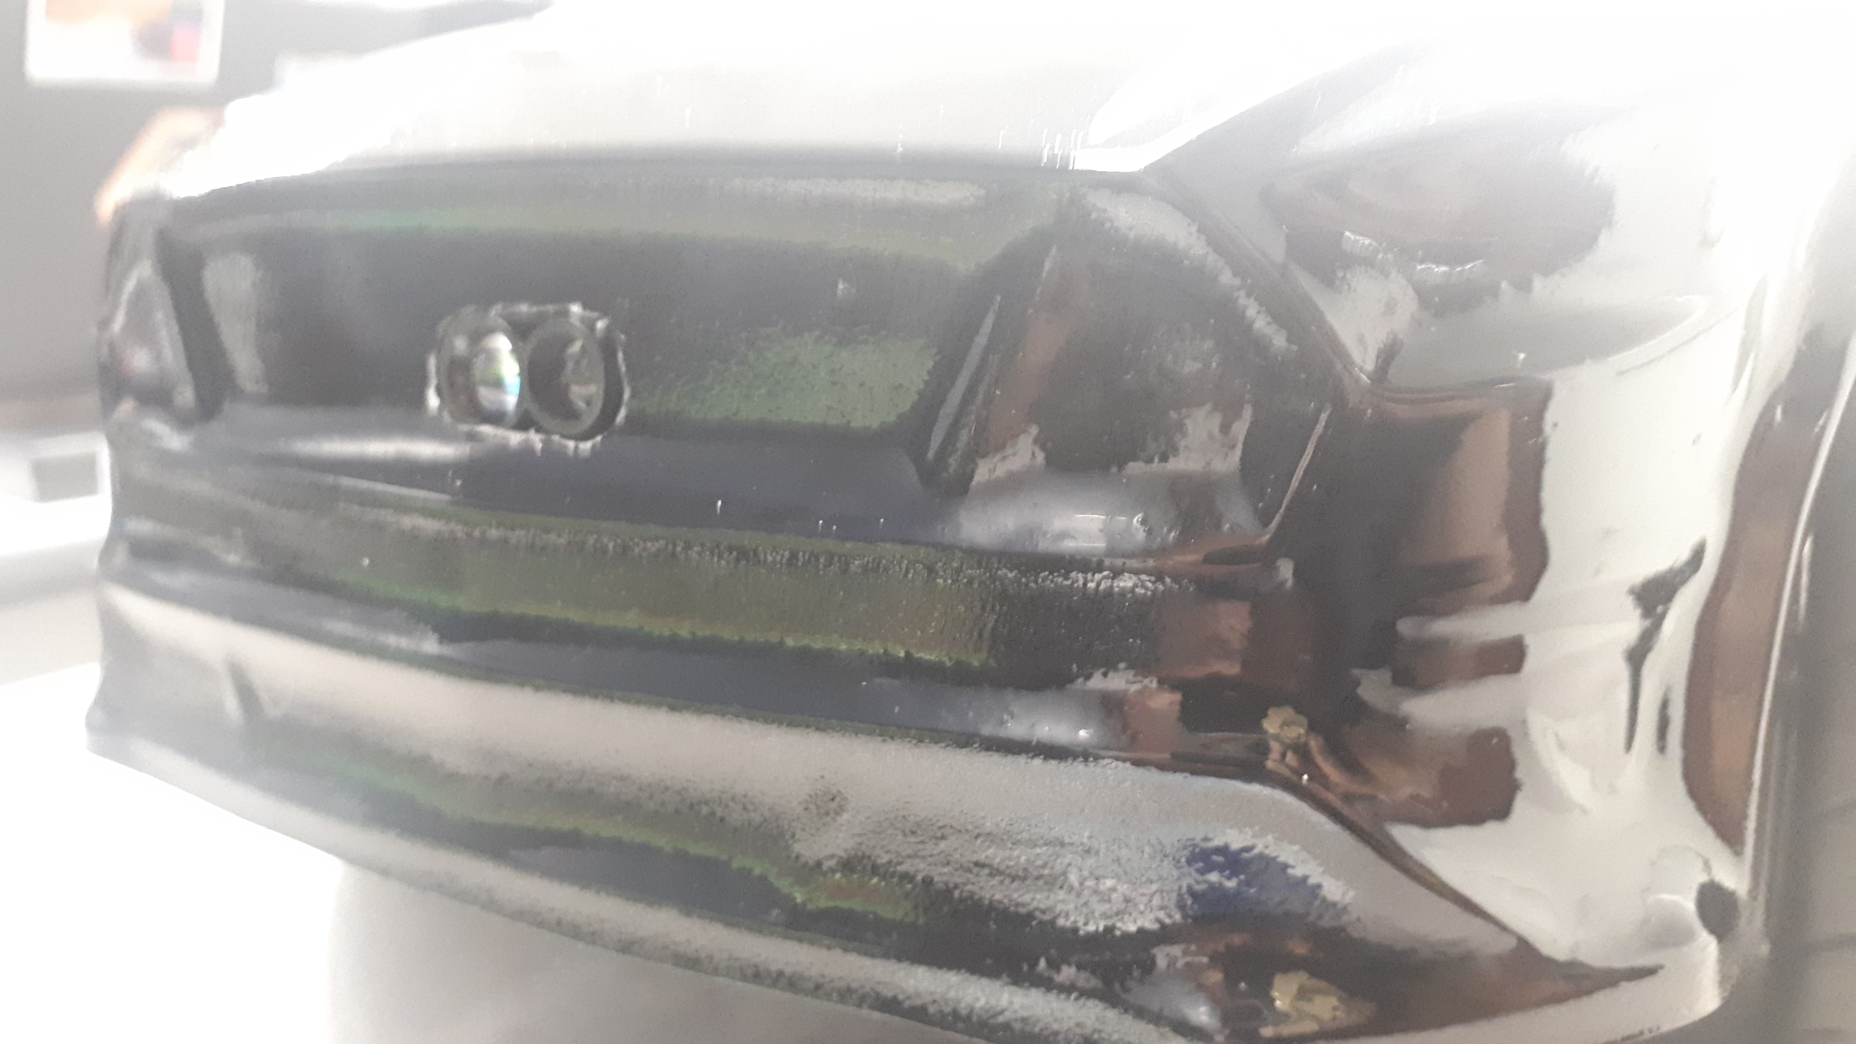

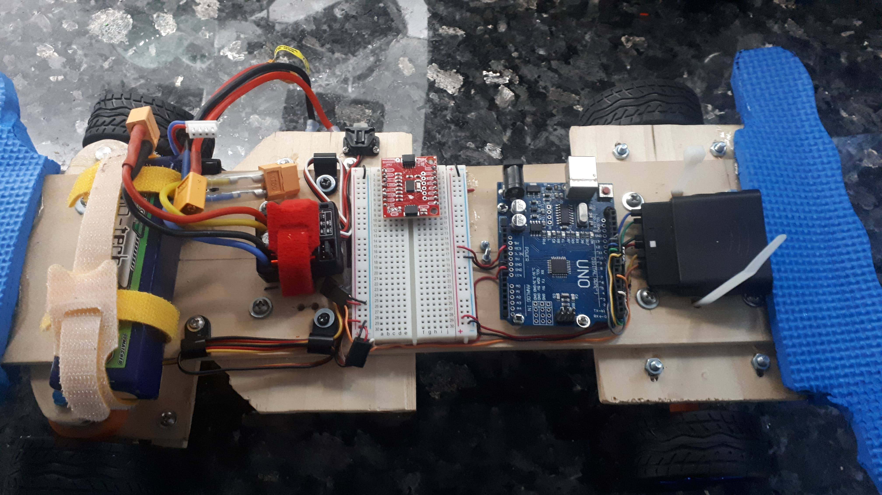
5- Version 1 – prototype 1



