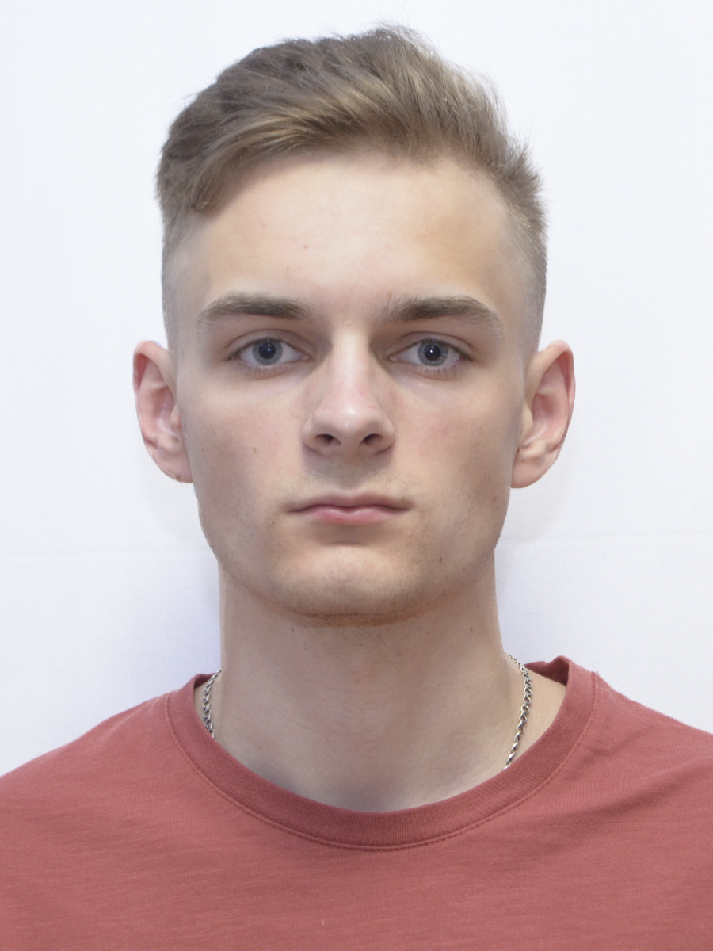Photo

Contact

|  |  |  |  |  |
| --- | --- | --- | --- | --- |
| +380672929584  oleksiichuk_ak16@nuwm.edu.ua  Rivne, Ukraine | | | Bohdan Oleksiichuk | |
|  | | Test Automation Engineer | | |
|  | | | | |
| Summary of Qualifications | Graduate of computer science with experience working across the front-end of software development. I can grow and continue to learn from other experienced team members. Ready to learn automated testing and start a career in this field. | | | |
|  | | | | |
| Skills | **Hard skills**  **Programming languages / technologies:**   * C#/Windows Forms/ASP.NET Core * C++/Win API * JavaScript/ReactJS * HTML, CSS * Python/Django   **Development tools:**   * Visual Studio Community Edition /.NET * Visual Studio Code   **Soft skills**   * Communication * Creativity * Ability to work in a team   **Languages**   * English A2 – pre-intermediate * Ukrainian - native | | |  |
|  |  | | | |
| Experience / IT related educational practice |  | | | |
| Project Name: | **Online System Auction** | | | |
| Project Description: | The project is designed for users who will be able to trade online. | | | |
| Involvement Duration: | 3 months | | | |
| Project Role: | Frontend-development | | | |
| Responsibilities: | • Analysis of analogues  • Website structure development  • Develop a functional part of the site  • Develop a unique website design according to the basic principles of minimalist design | | | |
| Project Team Size: | 4 team members | | | |
| Tools & Technologies: | Django, Python, JavaScript, JQuery, HTML, CSS, Bootstrap | | | |

|  |  |
| --- | --- |
| Certifications | **QATestLab course “Software testing for Universities: Design and testing of software systems”**  2020  Certification No.: 345980 |

|  |  |
| --- | --- |
| Education | **Master's Degree, Applied Mathematics**  National University of Water Management and Environmental Sciences  Automation, Cybernetics and Computer Engineering  September 2020 – until now  **Bachelor degree, Computer Science and Information Technology**  National University of Water Management and Environmental Sciences  Automation, Cybernetics and Computer Engineering  Graduated in 2020 |