1) Update the Employees table, so it contains the HireDate values from 2017 till the current (2019) year.

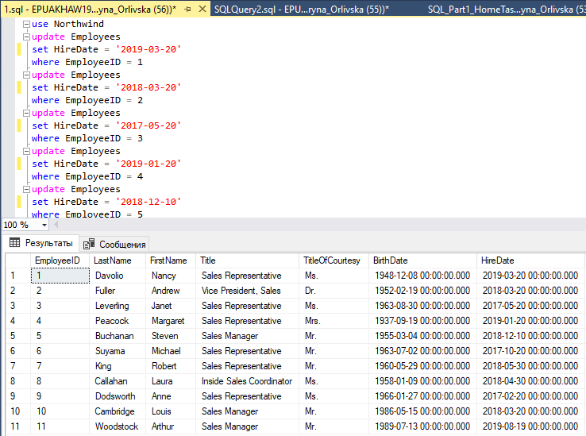

2) Delete records from the Products table which weren't ordered.

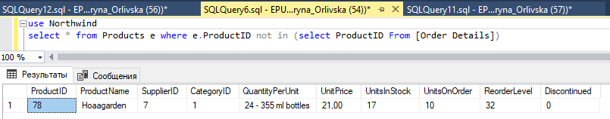

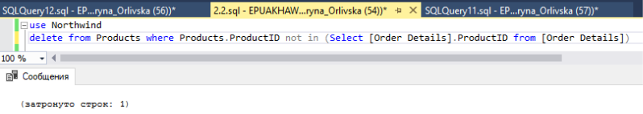

3) Get the list of data about employees: First Name, Last Name, Title, Hire Date who was hired this year (2019).

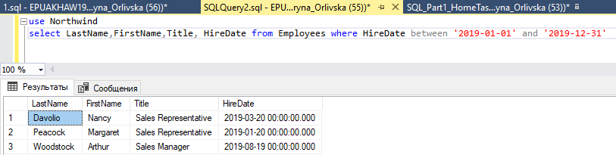

4) Find quantity of employees in each department. Note: Departments is the same as a title in the Employees table

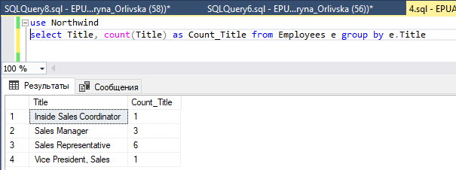

5) Get the list of suppliers, which are in USA and have a specified region.

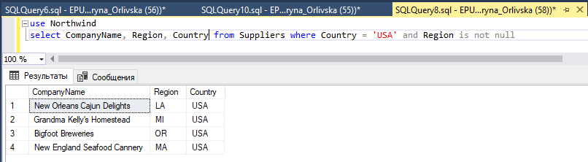

6) Get the number of products that were delivered by each supplier (company), which have a discount from the Unit Price more than 10%. Where record is represented from the biggest to lowest discount.

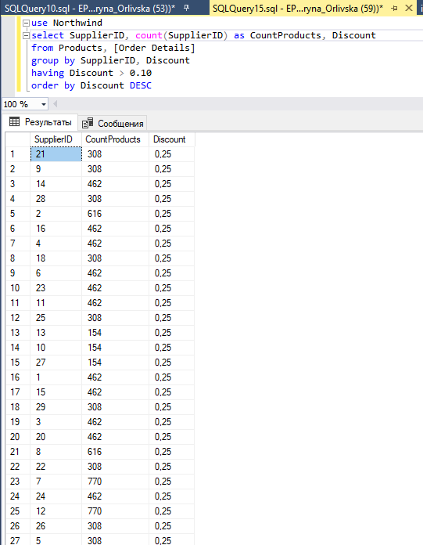

7) Get the top five product categories with the list of the most buyable products in Germany.

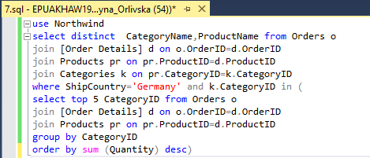

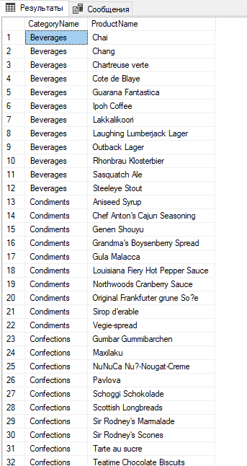

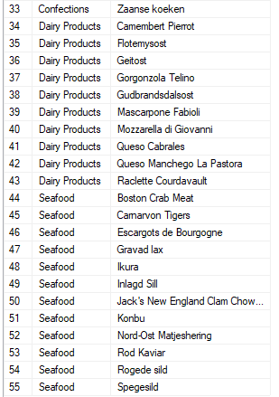

8) Get the First Name, Last Name and Title of Managers and their subordinates.

9) Get the Firts Name, Lastn Name, Title of Sales who has the least amount of orders. (Amount of sold products should be also in the result set).