1) Clone data from the Shippers table to the NewShippers table.

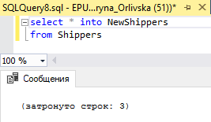

2) Get the list of suppliers which are related to each product name which has price greater than or equal 15$.

(Which information about supplier will be present in result set is optional)

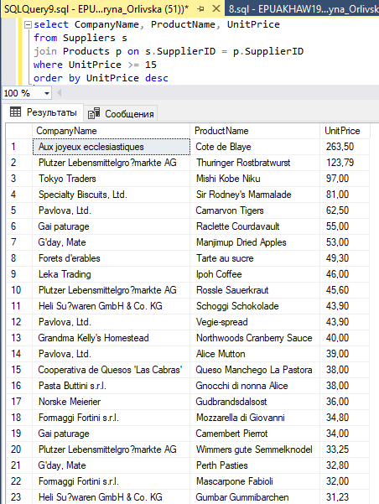

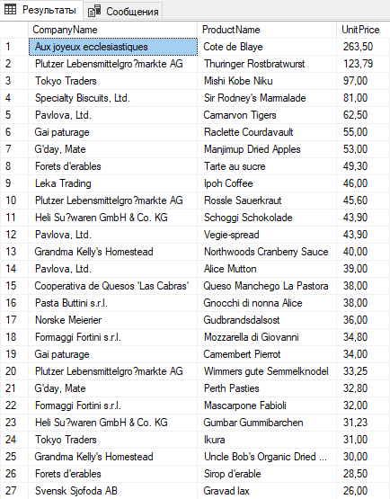 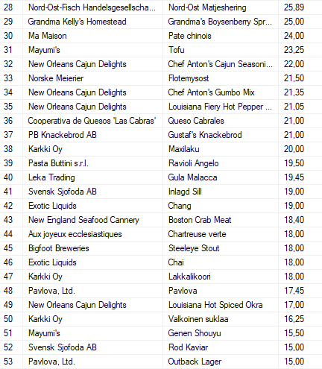

3) Get the list of total quantities of ordered products which consists of:

total quantity ordered in Germany and the total quantity of products ordered in Sweden. (Result should contain 2 rows)

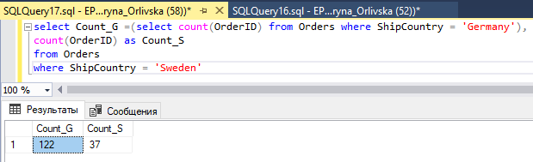

4) Find the list of different countries in Employees and Customers tables.

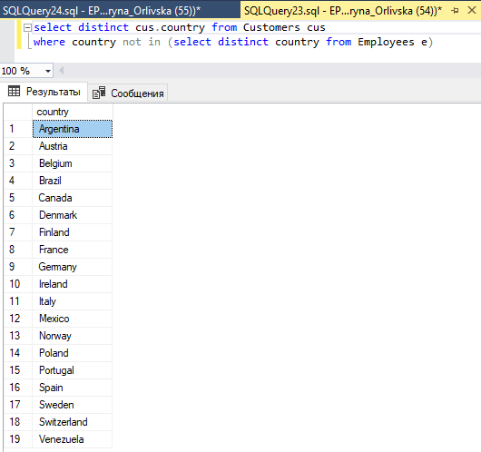

5) Find the list of the same Postal Codes between Suppliers and Customers tables.

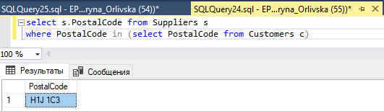

6) Find the top Region, City and Country from which sales specialists were hired (means who sold the biggest quantity of products).

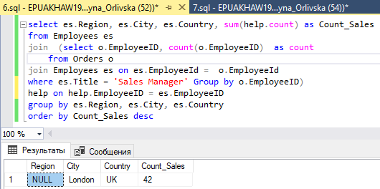

7) Get two lists of products: with a price < 50.00 with a discontinued flag and < 50 without a discontinued flag.

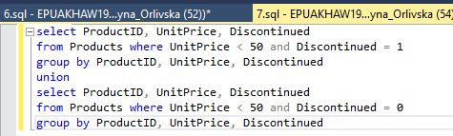

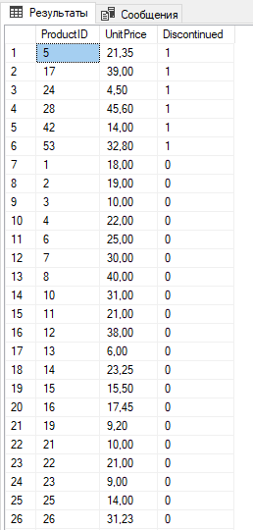

8) Create new table NewProducts based on the Products table with only discontinued products. Compare data sets between Products and NewProducts tables.

(Check that only discontinued products are inserted).

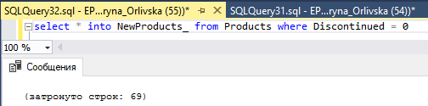



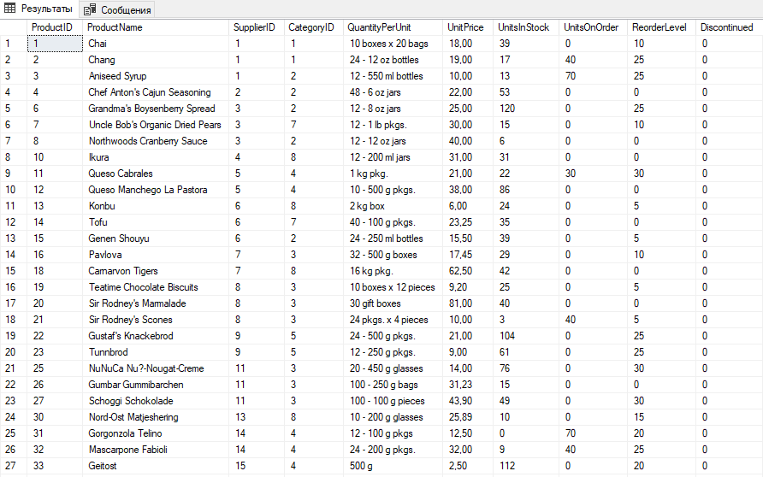

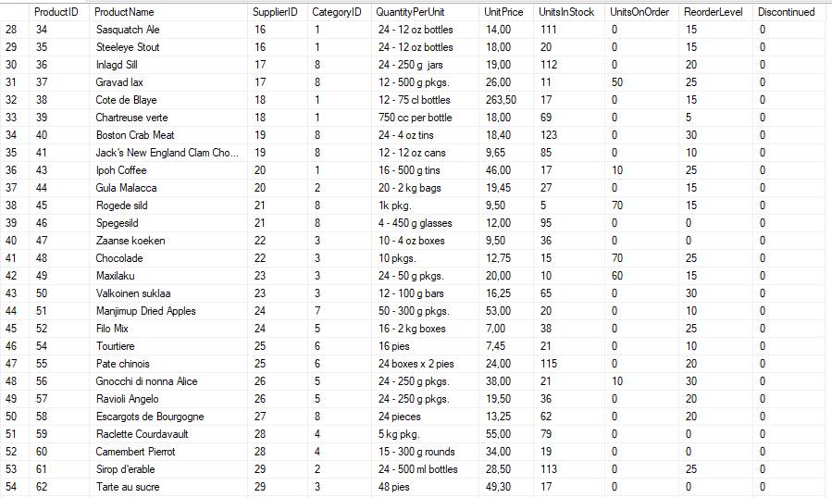

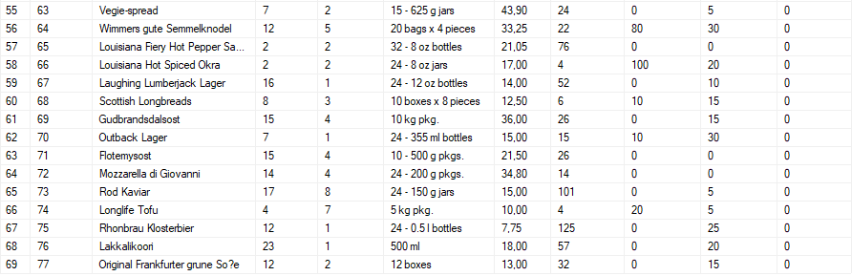

The 9th query is optional

\* Get the list of orders, where a required date is bigger than the Shipped date (compare in days) and Ship Region is not specified.