**CSS Layouts**

**DEADLINE:** 12/08/2018

**FOLDER STRUCTURE**

|  |  |
| --- | --- |
| FE_9_4_homework_css-layouts/*  └─ examples/  └─ task_layout.png     └─ task/      └─ FE_9_4_homework_css-layouts.docx  └─ homework/*     └─ css/*  └─ styles…*  └─ img/*  └─ images…*  └─ index.html* | * ­­­- required |

**TASK**

You need to create a HTML page template according to provided design (see examples/task_layout.png).

Use HTML5 semantic elements.

Minimum size of screen when web page shouldn’t be “broken” is **900px.** For icons use Unicode® character table. All required images can be found in **img** folder.

Colors, used in design:

#B7C8D9 - body

#FFF- wrapper

#F3F3F3 –колір дівки під малюнками

#A4A4A4 – сірий можливо накладні елементи

#F0F0F0 – світло-сірий нижня лінія

#000 – колір рамки, сердечка

#343638 – кнопка Subscribe

#E8E8E8 – 3 год назад

#9E9E9E – текст внизу в чотири колонки

Font, used in design:

Open Sans (<http://fonts.googleapis.com/css?family=Open+Sans>)

/* cyrillic-ext */

@font-face {

font-family: 'Open Sans';

font-style: normal;

font-weight: 400;

src: local('Open Sans Regular'), local('OpenSans-Regular'), url(https://fonts.gstatic.com/s/opensans/v15/mem8YaGs126MiZpBA-UFWJ0bbck.woff2) format('woff2');

unicode-range: U+0460-052F, U+1C80-1C88, U+20B4, U+2DE0-2DFF, U+A640-A69F, U+FE2E-FE2F;

}

/* cyrillic */

@font-face {

font-family: 'Open Sans';

font-style: normal;

font-weight: 400;

src: local('Open Sans Regular'), local('OpenSans-Regular'), url(https://fonts.gstatic.com/s/opensans/v15/mem8YaGs126MiZpBA-UFUZ0bbck.woff2) format('woff2');

unicode-range: U+0400-045F, U+0490-0491, U+04B0-04B1, U+2116;

}

/* greek-ext */

@font-face {

font-family: 'Open Sans';

font-style: normal;

font-weight: 400;

src: local('Open Sans Regular'), local('OpenSans-Regular'), url(https://fonts.gstatic.com/s/opensans/v15/mem8YaGs126MiZpBA-UFWZ0bbck.woff2) format('woff2');

unicode-range: U+1F00-1FFF;

}

/* greek */

@font-face {

font-family: 'Open Sans';

font-style: normal;

font-weight: 400;

src: local('Open Sans Regular'), local('OpenSans-Regular'), url(https://fonts.gstatic.com/s/opensans/v15/mem8YaGs126MiZpBA-UFVp0bbck.woff2) format('woff2');

unicode-range: U+0370-03FF;

}

/* vietnamese */

@font-face {

font-family: 'Open Sans';

font-style: normal;

font-weight: 400;

src: local('Open Sans Regular'), local('OpenSans-Regular'), url(https://fonts.gstatic.com/s/opensans/v15/mem8YaGs126MiZpBA-UFWp0bbck.woff2) format('woff2');

unicode-range: U+0102-0103, U+0110-0111, U+1EA0-1EF9, U+20AB;

}

/* latin-ext */

@font-face {

font-family: 'Open Sans';

font-style: normal;

font-weight: 400;

src: local('Open Sans Regular'), local('OpenSans-Regular'), url(https://fonts.gstatic.com/s/opensans/v15/mem8YaGs126MiZpBA-UFW50bbck.woff2) format('woff2');

unicode-range: U+0100-024F, U+0259, U+1E00-1EFF, U+2020, U+20A0-20AB, U+20AD-20CF, U+2113, U+2C60-2C7F, U+A720-A7FF;

}

/* latin */

@font-face {

font-family: 'Open Sans';

font-style: normal;

font-weight: 400;

src: local('Open Sans Regular'), local('OpenSans-Regular'), url(https://fonts.gstatic.com/s/opensans/v15/mem8YaGs126MiZpBA-UFVZ0b.woff2) format('woff2');

unicode-range: U+0000-00FF, U+0131, U+0152-0153, U+02BB-02BC, U+02C6, U+02DA, U+02DC, U+2000-206F, U+2074, U+20AC, U+2122, U+2191, U+2193, U+2212, U+2215, U+FEFF, U+FFFD;

}

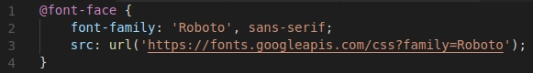

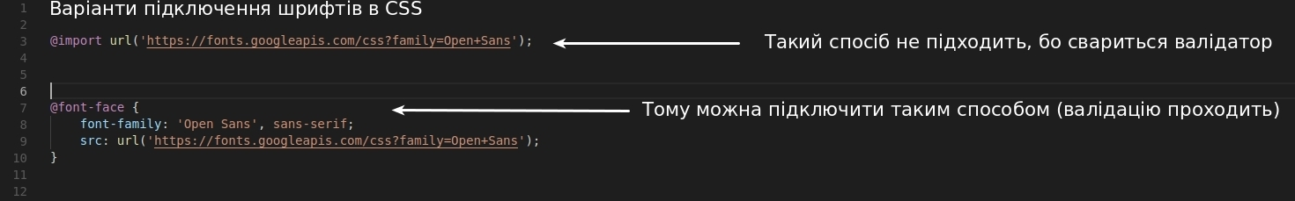

**RESTRICTIONS**

* Do not use any **javascript** or **css framework** for this hometask.
* No requirements for browser support (should correct work in Google Chrome last version).
* All distances between block set by yourself (tips: you can use Pixelperfect browser addon but it isn’t requirement)

**BEFORE SUBMIT**

* Read requirements and compare to your homework result
* Format the code (remove unnecessary lines of code)
* Remove all unnecessary files that you might have included by mistake

**SUBMIT**

* The folder should be uploaded to github repository ‘fl-9’ into master branch

саме забавне шо по результатам 2 домашки видно шо треба використовувати тільки якийсь один колірний режим - HEX, RGB, etc. - в 4 домашці нам дали кольори в HEX, а в прикладі я бачу шо через RGBa треба буде прозорий чорний задавати)))

або mix-blend-mode

