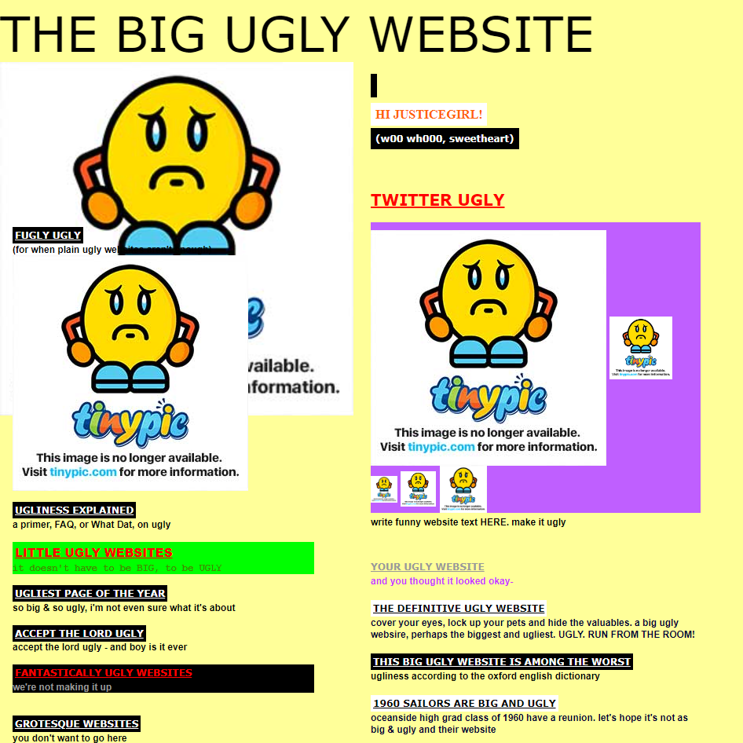

There are no basic elements of the website such as header, footer, logo, navigation, search field

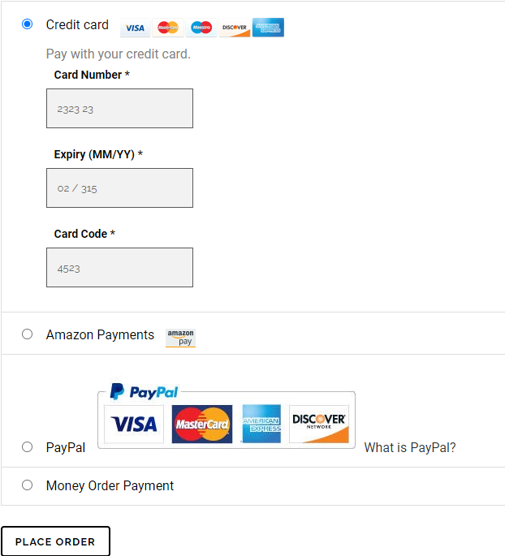

No notification about wrongly filled-in data in the Credit card webfom.



Main Menu button doesn’t work.



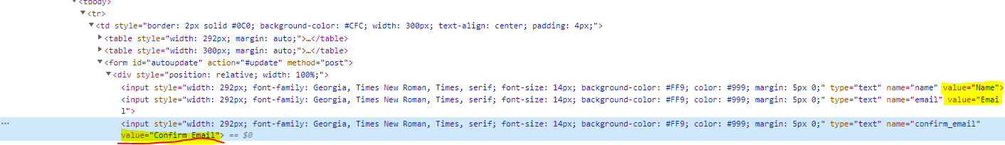

In the web form ‘Name’, ‘Email’, ‘Confirm email’ writings don’t disappear when clicking on their input field.

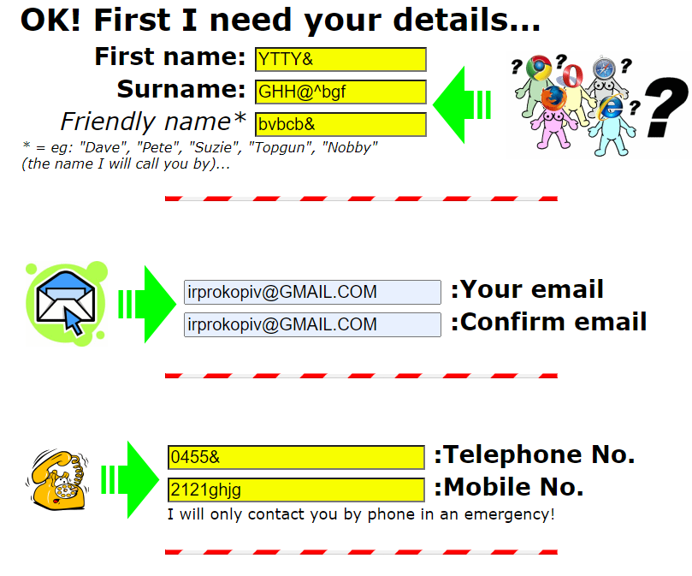

In the web form notification about the wrongly used symbols in the input fields ‘Name’, ‘Surname’, “Telephone No’, ‘Mobile No’ doesn’t appear.



In the scrolled box menu items are not lighted when pointing on them and the scrolled box overlaps the other text