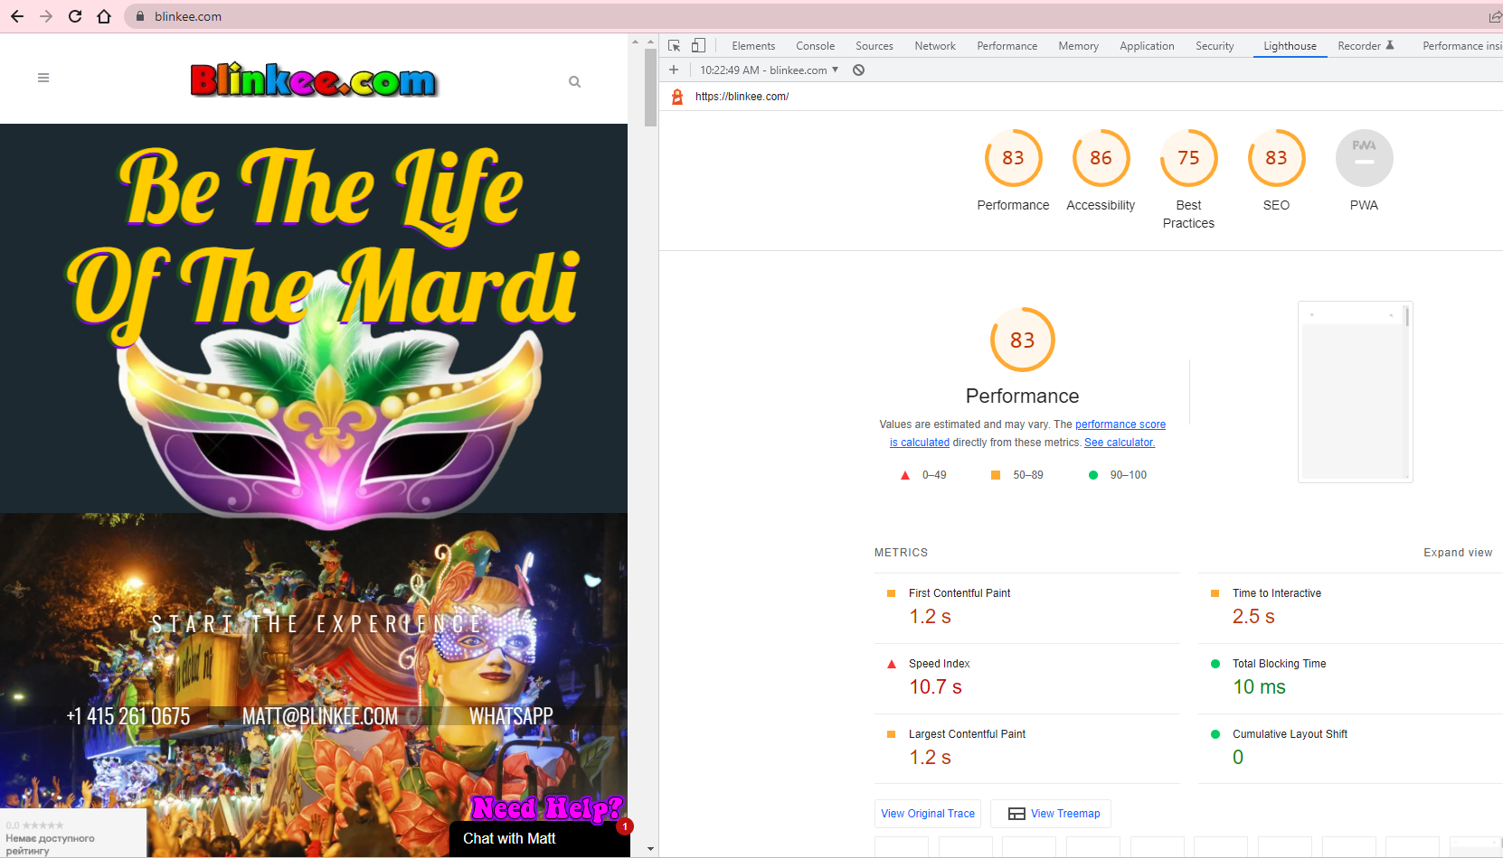

Performance of the site <https://Blinkee.com> is 83%.

Accessibility is 86% and shows how much easy is to navigate throughout the site and how much comfortable it is.

Bets practice is 75% and shows how much the site corresponds to the best practice of the site developing

SEO of 83% corresponds how much our site is available for search