|  |  |
| --- | --- |
| **Soal Tugas Mandiri**  *Assignment Case* |  |
| COMP6183  Secure Web Programming |
| **Teknik Informatika**  *Computer Science* | **E173-COMP6183-YF02** |
| **Periode Berlaku** Semester Genap 2016/2017  ***Valid on*** *Even Semester Year 2016/2017* | **Revisi 00**  *Revision 00* |

## Soal

*Case*

**Smartphone**

**Smartphone** is a web-based company that provides all kinds and types of mobile phones. As a web developer, you are trusted to develop a **PHP**-based website for **Smartphone**, with the following requirements:

1. **Home page (index.php)**

* Everyone can access this page.
* Show the following **navigation menu** for **guest**:
* Welcome message. The **welcome message** has following format: “**Welcome, Guest**”
* Login
* Show the following **navigation menu** for **logged in user**:
* Welcome message. The **welcome message** has following format: “**Welcome, <username>**”
* Logout
* Show **search textbox** to search mobile phone by its **type**
* Show the list of **mobile phones** from the **database** with the following information:
* **Mobile phone brand**
* **Mobile phone image**
* **Mobile phone type**
* **Mobile phone price**
* The **logout menu** will destroy the **user**’**s current session**.
* If user has **logged in**, Show the **update** and **delete button for each product**
* **Update button**, which will be used to **update** the selected product from database
* **Delete button**, which will be used to **delete** the selected product from database

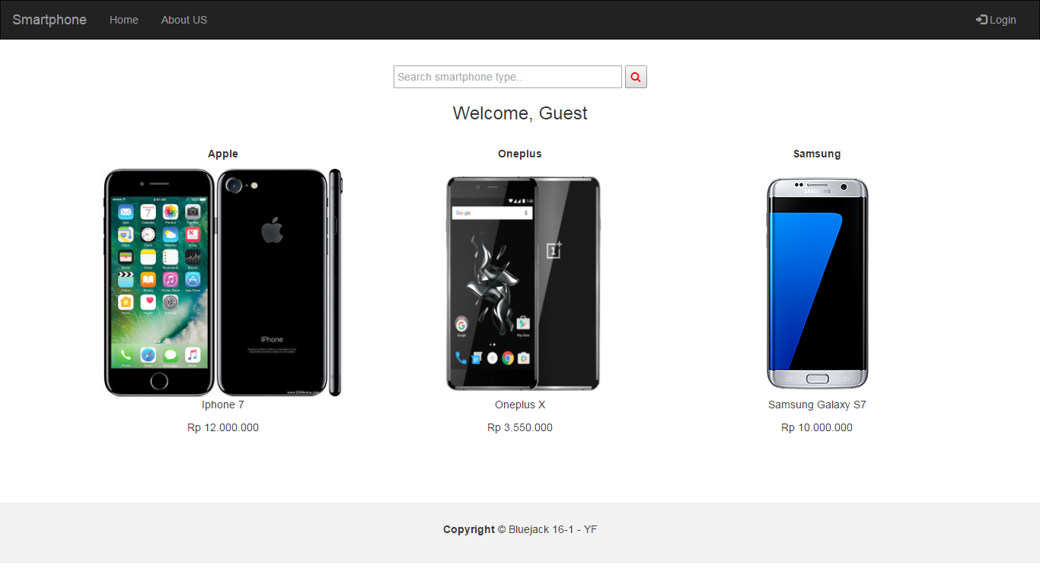

Figure 1. Home page for guest

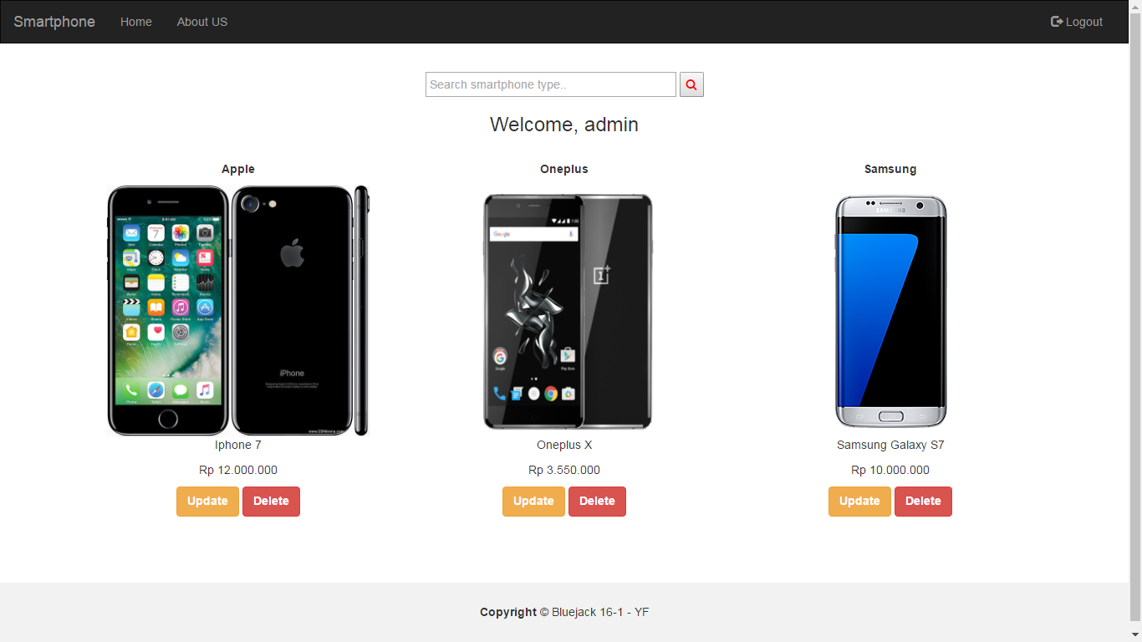

Figure 2. Home page for logged in user (admin)

1. **Login page** (**login.php**)

* This page **can only be accessed** by **guest**. If **logged in user** access this page, then redirect to **Home page** (**index.php**)
* This page consists of a form with the following components:
* **Textbox Username**
* **Textbox Password**
* **Button Login**
* If the user clicks ”**Button** **Login**”, then validate:
* If **username** is **empty**, then show “**Username must be filled**” message
* If **password** is **empty**, then show “**Wrong username or password**” message
* If **username** and **password** doesn’t match with **database**, then show “**Wrong username or password**” message
* The following is the **username** and **password**  which is alreadystored on the database:

|  |  |
| --- | --- |
| Username | Password |
| admin | admin (bcrypt) |
| user | User (sha1) |

* If user successfully **logged in**, then the user will be **stored in a session** and user will be **redirected** to the **Home page (index.php)**
* If there is an **error** during the **login process**, then **display the error message** inthe **Login page as shown** in Figure 3

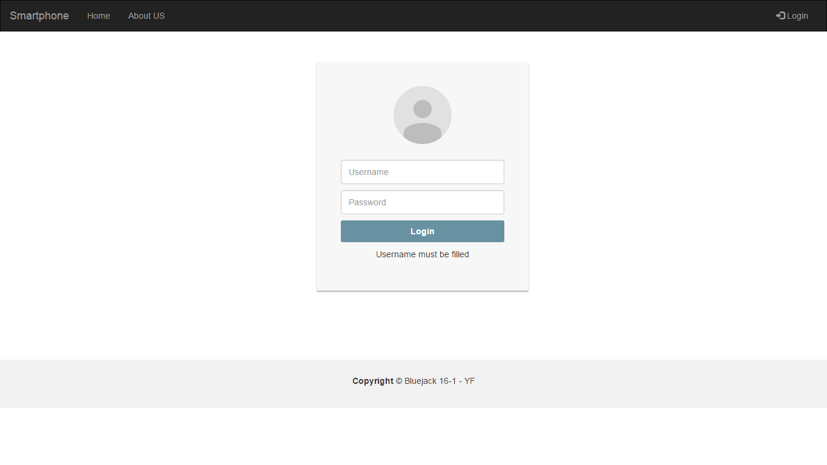

Figure 3. Login page (Username is empty)

1. **Update page** (**update.php**)

* This page **can only accessed** by **logged in user**. If **guest** access this page, then redirect to **Home page (index.php)**.
* This page consists of a form with the following components:
* **Textbox Brand**
* **Textbox Type**
* **Textbox Price**
* **Button Submit**
* If user clicks ”**Submit**” button, then validate:
  + If the **Brand** is **empty**, then show “**Brand must be filled**” message
  + If the **Type** is **empty**, then show “**Type must be filled**” message
  + If the **Price** is **empty**, then show “**Price must be filled**” message
  + If the **Type** is **less than 7 characters**, then show “**Type must be at least 7 characters**”message
  + If the **Type contains** a symbol except **space**(“ ”), then show “**Type must be alphabet or numeric or alphanumeric**” message
  + If the **Price** is **not a number**, then show “**Price must be numeric**” message
  + If the **Price** is **less than 500000**, then show “**Price must be more than 500000**” message
* Make sure the data are **updated** in the **database** based on the chosen **product id**

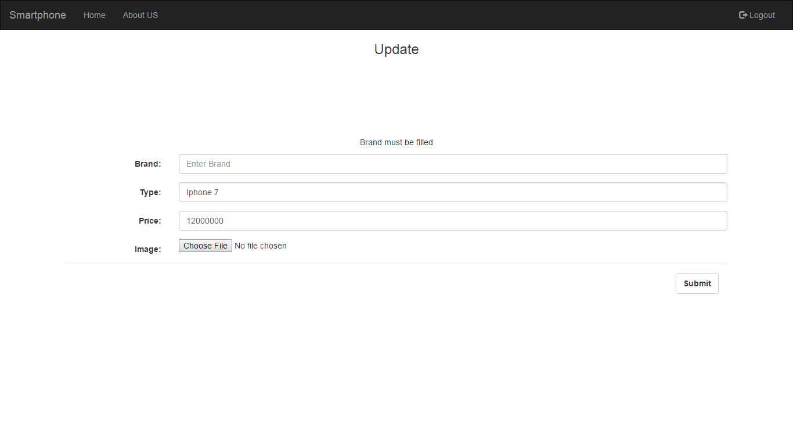

Figure 4. Update page (Brand is empty)

Image reference:

<http://cdn2.gsmarena.com/vv/pics/apple/apple-iphone-7-1.jpg>

<http://phandroid.s3.amazonaws.com/wp-content/uploads/2015/10/OnePlus-X-1.png>

<https://www.mts.ca/file_source/mts/assets/img/wireless_devices/android/Samsung-Galaxy-S7.png>

<https://3.bp.blogspot.com/-DK4cMFCOnkI/VtMC72GakdI/AAAAAAAAA0A/XXsCnVIqDDA/s1600/Xiaomi%2BMi5.png>

<https://upload.wikimedia.org/wikipedia/commons/9/9b/Nokia_3310_blue_R7309170_wp.png>

<http://www.rogerthat.net/wp-content/uploads/2011/12/nokia3310.png>

<http://www.samsung.com/uk/consumer/mobile-devices/smartphones/galaxy-s/galaxy-s7/images/galaxy-s7-edge_gallery_right_gold_s3.png>

<http://s.tmocache.com/content/dam/tmo/en-p/cell-phones/samsung-galaxy-s7/black-onyx/spin/samsung-galaxy-s7-black-spin-0001.png>

<http://s.tmocache.com/content/dam/tmo/en-p/cell-phones/samsung-galaxy-s7/gold-platinum/stills/carousel-samsung-galaxy-s7-gold-platinum-380x380-1.jpg>

<http://xiaomimi5review.com/wp-content/uploads/2015/12/Render-of-the-Xiaomi-Mi-5-shows-a-home-button-confirming-a-rumor-that-the-phone-will-not-employ-an-ultrasonic-fingerprint-scanner.png>

<https://en.wikipedia.org/wiki/Smartphone>

<https://republicwireless.com/static/svg/phone-icon.20390d2d.svg>

**If anyone does not understand, ask your assistant!**