|  |  |
| --- | --- |
| **Practicum Case** |  |
| COMP6183 | COMP6543  Secure Web Programming | Secure Programming |
| **Computer Science** | **E191-COMP6183-RL01-11** |
| ***Valid on*** *Even Semester Year 2019/2020* | **Revision 00** |

## Soal

*Case*

**Topics**

In this session, Apache Hardening will be discussed by utilizing server configuration file, *.htaccess*.

1. **Directory Listing**

**Directory Listing** is a vulnerability that occurs where a user able to fetch files and directories list under a specific directory.

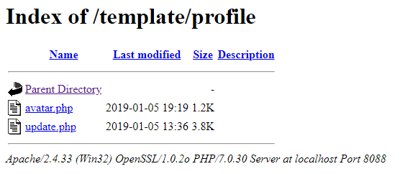

1. **Error Document**

Having a page with 405 error code without any redirection is unclear for the users.

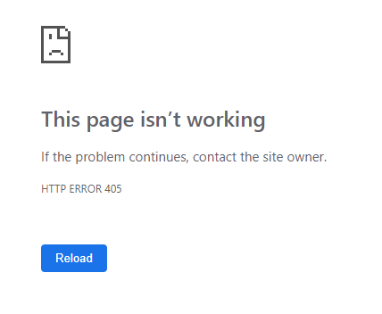

**Countermeasure**

Disabling directory indexing is the prevention for Directory Listing.

1. **Disable Directory Index**

To disable directory indexing, server configuration file *.htaccess* can be used. Create a .htaccess file in the web application root directory if it is not existed and put the following option:

Options All –Indexes

1. **Error Document Handling**

To redirect specific HTTP Error to a file, ErrorDocument configuration on .htaccess can be used. The following option is to redirect 405 error code to errors/405.php file.

ErrorDocument 405 /errors/405.php