实验七：组合模式
个人与组织：个人必定属于每一个组织，组织可以组合成更大的组织。

(1) 安全组合模式

1.1 UML图
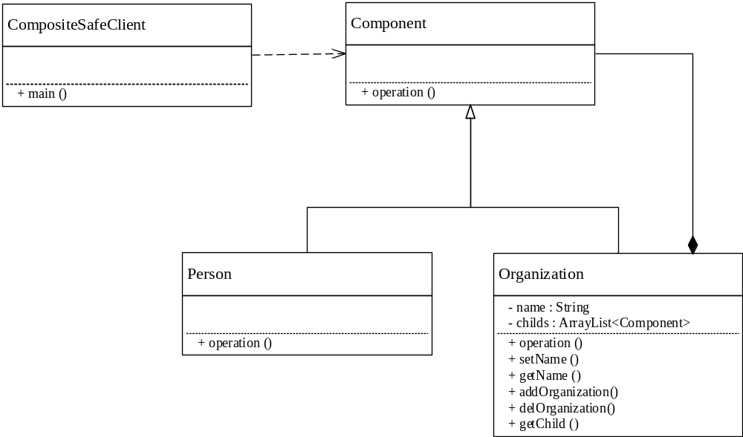

1.2 代码
1.Component
package cn.edu.scau.cmi.zhangjiayi.composite.safe;

public interface Component {
public abstract void operation();
}

2.Organization
package cn.edu.scau.cmi.zhangjiayi.composite.safe;

import java.util.ArrayList;

public class Organization implements Component {
String name;
ArrayList<Component> childs = new ArrayList<Component>();

@Override
public void operation(){
System.out.println("I am organization's operation");
}

public void setName(String name){
this.name=name;
}

public String getName(){
return name;
}

public void addOrganization(Component child){
this.childs.add(child);
}

public void delOrganizaiton(Component child){
this.childs.remove(child);
}

public ArrayList<Component> getChild(){
return childs;
}
}

3.Person
package cn.edu.scau.cmi.zhangjiayi.composite.safe;
public class Person implements Component{
@Override
public void operation() {
// TODO Auto-generated method stub
System.out.println("I am Preson's operation");
}
}

4.Client
package cn.edu.scau.cmi.zhangjiayi.client;

import java.util.ArrayList;

import cn.edu.scau.cmi.zhangjiayi.composite.safe.Component;
import cn.edu.scau.cmi.zhangjiayi.composite.safe.Organization;

public class CompositeSafeClient {

public static void main(String[] args) {
// TODO Auto-generated method stub
System.out.println("组合安全模式：");
Component school = new Organization();
school.operation();
((Organization) school).setName("华南农业大学");
Component union = new Organization();
((Organization) union).setName("学生会");
((Organization) school).addOrganization(union);
Component institute = new Organization();
((Organization) institute).setName("学院");
((Organization) school).addOrganization(institute);
ArrayList<Component> list = new ArrayList<Component>();
list = ((Organization) school).getChild();
System.out.println(((Organization) school).getName()+"的子组织：");
for(int i=0;i<list.size();i++)
{
System.out.println(((Organization)list.get(i)).getName());
}
}

}

实验效果
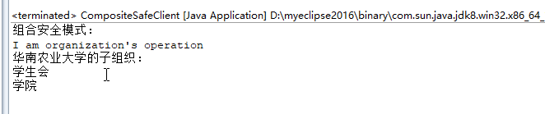

(2) 一致性组合模式

2.1 UML图
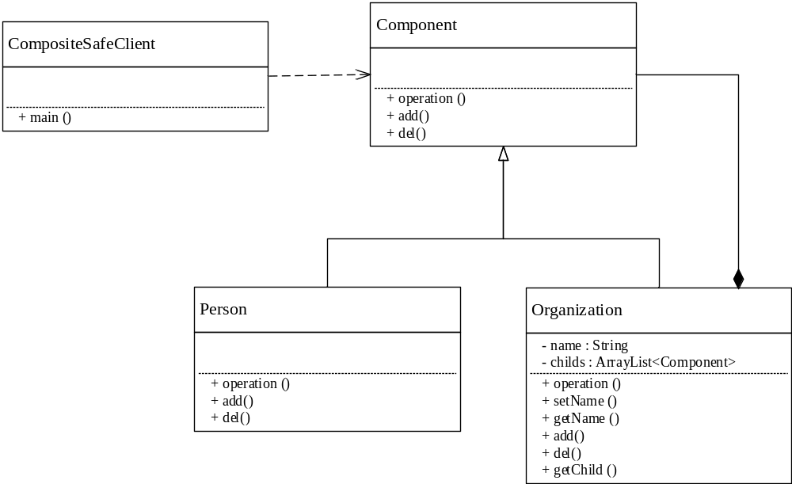

2.2 代码
1.Component
package cn.edu.scau.cmi.zhangjiayi.composite.transparent;

public abstract class Component {
public abstract void operation();
public abstract void add(Component child);
public abstract void del(Component child);
}

2.Organization
package cn.edu.scau.cmi.zhangjiayi.composite.safe;

public abstract class Component {
public abstract void operation();
}

2.Person
package cn.edu.scau.cmi.zhangjiayi.composite.transparent;

public class Person extends Component {

@Override
public void operation() {
// TODO Auto-generated method stub
System.out.println("I am Preson's operation");
}

@Override
public void add(Component child) {
// TODO Auto-generated method stub
System.out.println("sorry，不支持该方法！");
}

@Override
public void del(Component child) {
// TODO Auto-generated method stub
System.out.println("sorry，不支持该方法！");
}

}

- Client
package cn.edu.scau.cmi.zhangjiayi.client;

import java.util.ArrayList;

import cn.edu.scau.cmi.zhangjiayi.composite.transparent.Component;
import cn.edu.scau.cmi.zhangjiayi.composite.transparent.Organization;
import cn.edu.scau.cmi.zhangjiayi.composite.transparent.Person;

public class CompositeTransprentClient {

public static void main(String[] args) {
// TODO Auto-generated method stub
System.out.println("组合透明模式：");
Component school = new Organization();
((Organization) school).setName("华南农业大学");
Component union = new Organization();
((Organization) union).setName("学生会");
((Organization) school).add(union);
Component institute = new Organization();
((Organization) institute).setName("学院");
((Organization) school).add(institute);
ArrayList<Component> list = new ArrayList<Component>();
list = ((Organization) school).getChild();
System.out.println(((Organization) school).getName()+"的子组织：");
for(int i=0;i<list.size();i++)
{
System.out.println(((Organization)list.get(i)).getName());
}
Component student = new Person();
((Person) student).add(institute);
((Person) student).del(institute);
}

}

package cn.edu.scau.cmi.zhangjiayi.composite.transparent;

import java.util.ArrayList;

public class Organization extends Component {

String name;
ArrayList<Component> childs = new ArrayList<Component>();

@Override
public void operation() {
// TODO Auto-generated method stub
System.out.println("I am organization's operation");
}

@Override
public void add(Component child) {
// TODO Auto-generated method stub
this.childs.add(child);
}

@Override
public void del(Component child) {
// TODO Auto-generated method stub
this.childs.remove(child);
}

public void setName(String name){
this.name=name;
}

public String getName(){
return name;
}

public ArrayList<Component> getChild(){
return childs;
}
}

4.Client
package cn.edu.scau.cmi.zhangjiayi.composite.safe;

public abstract class Component {
public abstract void operation();
}

实验效果
