实验五：单工厂模式

(1) 单例模式（必做80分）
建立一个界面，不管创建多少次主席，都只能创建一个“毛泽东”对象，并验证获取的主席都是“毛泽东”。

1.1 UML图
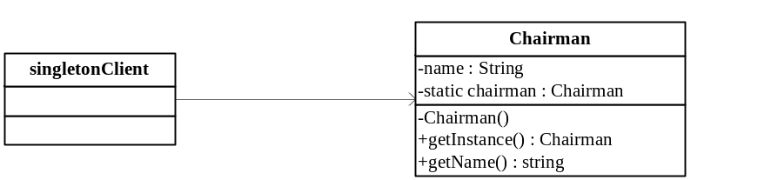

1.2 代码

1.Chairman类
package cn.edu.scau.cmi.zhangjiayi.singleton;
public class Chairman {
private static Chairman chairman;
private String name;
private Chairman() {
this.name = "习近平";
}
public static Chairman getInstance() {
if(chairman == null)
{
chairman = new Chairman();
}
return chairman;
}
public String getName() {
return this.name;
}
}

2.ChairmanClient类
package cn.edu.scau.cmi.zhangjiayi.client;

import cn.edu.scau.cmi.zhangjiayi.singleton.Chairman;

public class singletonClient {

public static void main(String[] args) {
// TODO Auto-generated method stub
Chairman chairman = Chairman.getInstance();
Chairman chairman2 = Chairman.getInstance();
System.out.println(chairman.getName() + chairman);
System.out.println(chairman2.getName()+ chairman2);
}
}

(2) 多例模式（选做20分）
使用单例模式的思想实现多例模式，确保系统中某个类的对象只能存在有限个，如中华人民共和国十大元帅，设计并实现。

2.1 UML图
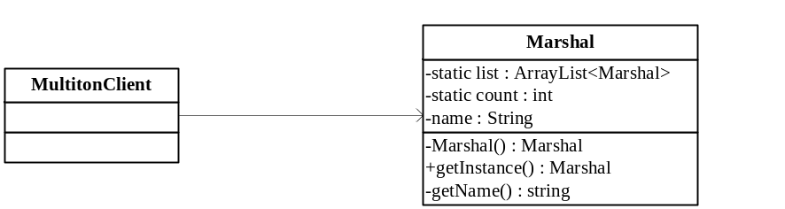

2.2 代码
1.Marshal类
package cn.edu.scau.cmi.zhangjiayi.Multiton;

import java.util.ArrayList;

public class Marshal {
private static ArrayList<Marshal> list = new ArrayList<Marshal>();
private static int count = 0;
private String name;
private Marshal() {

}
public static Marshal getInstance(String name){
if(count < 10)
{
Marshal marchal = new Marshal();
marchal.name = name;
list.add(marchal);
count++;
return marchal;
}
else
{
System.out.println("元帅人数已达10人，不能再任命元帅");
}
return null;
}
public String getName() {
return this.name;
}
}

2.marshalClient类
package cn.edu.scau.cmi.zhangjiayi.client;

import java.util.ArrayList;

import cn.edu.scau.cmi.zhangjiayi.Multiton.Marshal;

public class multitonClient {

public static void main(String[] args) {
// TODO Auto-generated method stub
ArrayList<Marshal> newList = new ArrayList<Marshal>();
for(int i=1;i<=10;i++)
{
newList.add( Marshal.getInstance("元帅"+i) );
System.out.println( newList.get(i-1).getName() );
}
//测试创建第11个元帅能否成功
Marshal marshal = Marshal.getInstance("元帅11");
}
}

