实验八：适配器模式

(1) 类适配器

1.1 UML图
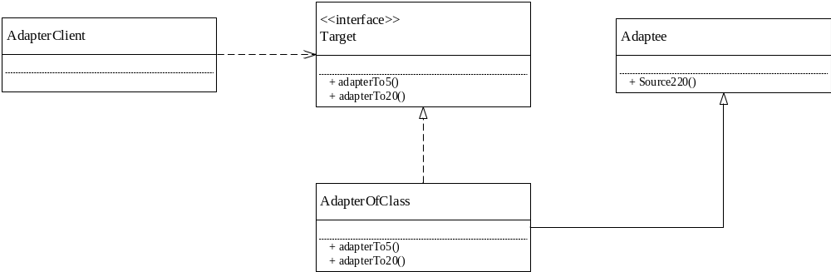

1.2 代码
- Adaptee类
package cn.edu.scau.cmi.zhangjiayi.adapter;

public class Adaptee {
public Adaptee(){

};

public int Source220(){
int voltage = 220;
System.out.println("I am 220V");
return voltage;
}
}

- Target接口

package cn.edu.scau.cmi.zhangjiayi.adapter;

public interface Target{
public int adapterTo5();
public int adapterTo20();
}

3.AdapterOfClass 类

package cn.edu.scau.cmi.zhangjiayi.adapter;

public class AdapterOfClass extends Adaptee implements Target{

@Override
public int adapterTo5(){
int source = Source220();
System.out.println("现在的电源电压是："+source);
int voltage = 5;
System.out.println("使用适配器后,转换为5V");
return voltage;
}

@Override
public int adapterTo20(){
int source = Source220();
System.out.println("现在的电源电压是："+source);
int voltage = 20;
System.out.println("使用适配器后,转换为20V");
return voltage;
}
}

- AdapterOfClassClient客户端类

package cn.edu.scau.cmi.zhangjiayi.client;

import cn.edu.scau.cmi.zhangjiayi.adapter.AdapterOfClass;
import cn.edu.scau.cmi.zhangjiayi.adapter.AdapterOfObject;
import cn.edu.scau.cmi.zhangjiayi.adapter.Target;

public class AdapterClient {

public static void main(String[] args) {
// TODO Auto-generated method stub
//类适配器客户端
System.out.println("****类适配器*****");
Target adapter1 = new AdapterOfClass();
System.out.println(adapter1.adapterTo20());
System.out.println(adapter1.adapterTo5());
}

}

1.3 实现效果
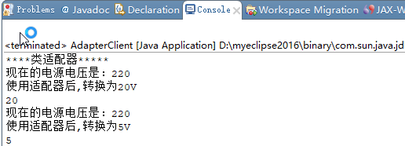

(2) 对象适配器

2.1 UML图
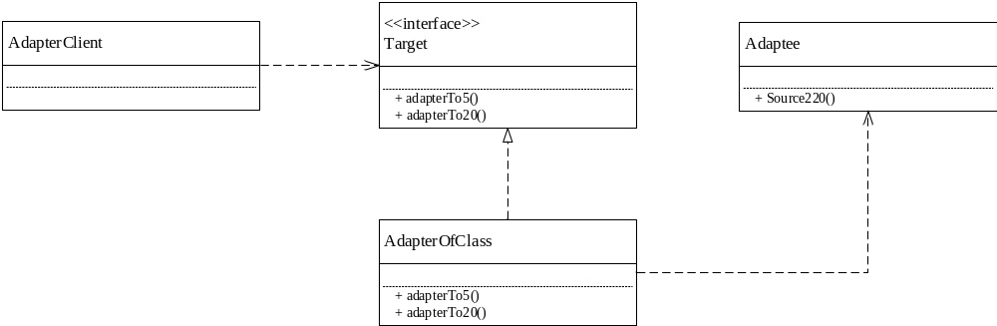

2.2 代码
1.Adaptee类
package cn.edu.scau.cmi.zhangjiayi.adapter;

public class Adaptee {
public Adaptee(){

};

public int Source220(){
int voltage = 220;
System.out.println("I am 220V");
return voltage;
}
}

- AdapterOfObject
package cn.edu.scau.cmi.zhangjiayi.adapter;

public class AdapterOfObject implements Target{
private Adaptee source = new Adaptee();
@Override
public int adapterTo5(){
System.out.println("现在的电源是："+ source.Source220() + "V");
int voltage = 5;
System.out.println("使用适配器后,转换为5V");
return voltage;
}

@Override
public int adapterTo20(){
System.out.println("现在的电源是："+ source.Source220() + "V");
int voltage = 20;
System.out.println("使用适配器后,转换为20V");
return voltage;
}
}

- AdapterClient
package cn.edu.scau.cmi.zhangjiayi.client;

import cn.edu.scau.cmi.zhangjiayi.adapter.AdapterOfClass;
import cn.edu.scau.cmi.zhangjiayi.adapter.AdapterOfObject;
import cn.edu.scau.cmi.zhangjiayi.adapter.Target;

public class AdapterClient {

public static void main(String[] args) {
// TODO Auto-generated method stub
System.out.println("****对象适配器*****");
AdapterOfObject adapter2 = new AdapterOfObject();
adapter2.adapterTo20();
adapter2.adapterTo5();
}

}

2.3 实验效果
