实验四：工厂模式

(1) 简单工厂方法（50分）
肉的种类包括下面几种：牛肉（beef）、猪肉（pork）。使用简单工厂方法模式设计并实现一个可以创建不同肉类对象的应用。具体使用过程如下：
由用户输入所需要的肉的种类，自动创建相应的肉类对象。
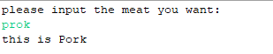

1.1 UML图
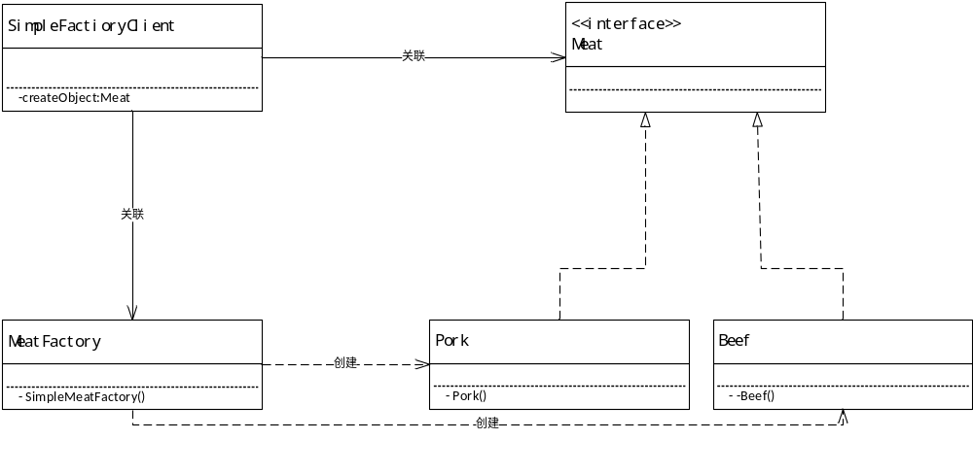

1.2 代码
1）实体类
1. Meat
public interface Meat {

}

- Beef
public class Beef implements Meat {
public Beef()
{
System.out.println("this is Beef!");
}
}

- Pork
public class Pork implements Meat {
public Pork(){
System.out.println("this is Pork");
}
}

2）简单工厂类
public interface MeatFactory {
public static Meat getInstance(String MeatTypeString)
{
switch(MeatTypeString)
{
case("prok"): return new Pork();
case("beef"): return new Beef();
}
return null;
}
}

3）客户端类
public class SimpleFactoryClient {
public static void main(String[] args)
{
Scanner input = new Scanner(System.in);
System.out.println("please input the meat you want:");
String meatTypeString = input.nextLine();
Meat meat = createObject(meatTypeString);
}
public static Meat createObject(String meatType)
{
return MeatFactory.getInstance(meatType);
}
}

(3) 工厂方法模式（30分）
利用工厂方法实现上面的要求。

2.1 UML图
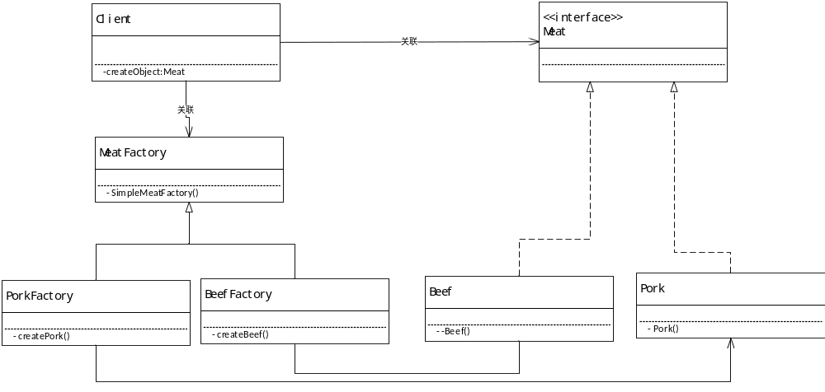

2.2 代码
实体类代码如简单工厂模式
工厂类代码：
1.MeatFactory
public interface MeatFactory {
public static Meat getInstance(String MeatTypeString)
{
switch(MeatTypeString)
{
case("prok"): return new PorkFactory();
case("beef"): return new BeefFactory();
}
return null;
}
}
- PorkFactory
public class PorkFactory implements Meat {
public Pork createPork()
{
return new Pork();
}
}
- BeefFactory
public class BeefFactory implements Meat {
public Beef createBeef(){
return new Beef();
}
}
客户端代码：
public class FactoryClient {
public static void main(String[] args)
{
Scanner input = new Scanner(System.in);
System.out.println("please input the meat you want:");
String meatTypeString = input.nextLine();
Meat meat = createObject(meatTypeString);
}
public static Meat createObject(String meatType)
{
return MeatFactory.getInstance(meatType);
}
}

(3) 抽象工厂模式（20分）
现有苹果、华为、小米三大电子产品公司。每个公司分别有其工厂生产期对应的手机、手表已经平板产品。

3.1 UML图
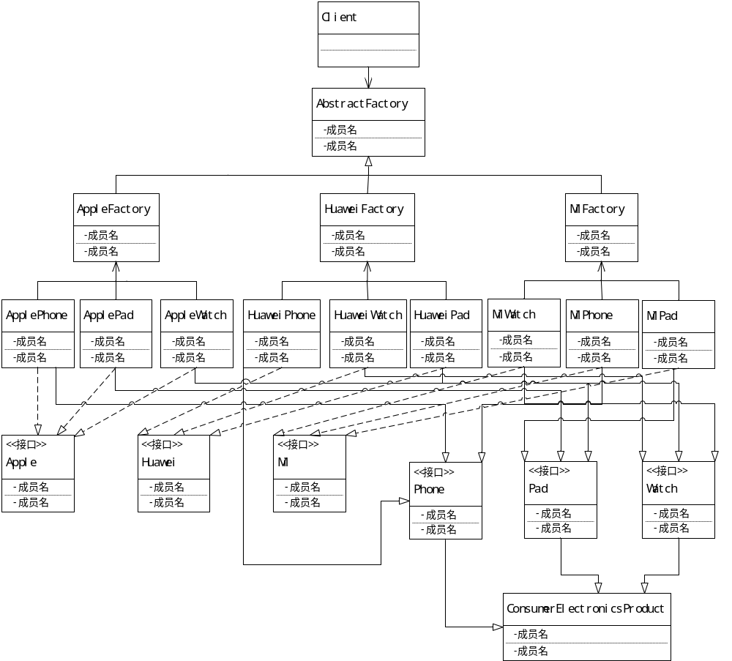

3.2 代码
- 实体
1.ApplePad
public class ApplePad extends Pad implements Apple {
@Override
public void use()
{
System.out.println("苹果平板");
System.out.println("电子产品类型："+super.name+"品牌："+Apple.brand);
}
}
2.ApplePhone
public class ApplePhone extends Phone implements Apple {
@Override
public void use()
{
System.out.println("苹果手机");
System.out.println("电子产品类型："+super.name+"品牌："+Apple.brand);
}
}
3.AppleWatch
public class AppleWatch extends Watch implements Apple {
@Override
public void use()
{
System.out.println("苹果手表");
System.out.println("电子产品类型："+super.name+"品牌："+Apple.brand);
}
}
4.HuaweiPad
public class HuaweiPad extends Pad implements Huawei {
@Override
public void use()
{
System.out.println("华为平板");
System.out.println("电子产品类型："+super.name+"品牌："+Huawei.brand);
}
}
5.HuaweiPhone
public class HuaweiPhone extends Phone implements Huawei {
@Override
public void use()
{
System.out.println("华为手机");
System.out.println("电子产品类型："+super.name+"品牌："+Huawei.brand);
}
}
6.HuaweiWatch
public class HuaweiWatch extends Watch implements Huawei {
@Override
public void use()
{
System.out.println("华为手表");
System.out.println("电子产品类型："+super.name+"品牌："+Huawei.brand);
}
}
7.MiPad
public class MiPad extends Pad implements Mi {
@Override
public void use()
{
System.out.println("小米平板");
System.out.println("电子产品类型："+super.name+"品牌："+Mi.brand);
}
}
8.MiPhone
public class MiPhone extends Phone implements Mi {

@Override
public void use()
{
System.out.println("小米手机");
System.out.println("电子产品类型："+super.name+"品牌："+Mi.brand);
}
}
9.MiWatch
public class MiWatch extends Watch implements Mi {
@Override
public void use()
{
System.out.println("小米手表");
System.out.println("电子产品类型："+super.name+"品牌："+Mi.brand);
}
}
- 实体抽象
1.Pad
public abstract class Pad extends ConsumerElectronicsProduct {
public final String name ="pad";
}
2.Phone
public abstract class Phone extends ConsumerElectronicsProduct {
public final String name ="phone";
}
3.Watch
public abstract class Watch extends ConsumerElectronicsProduct {
public final String name ="name";
}
4.ConsumerElectronicsProduct
public abstract class ConsumerElectronicsProduct {
public abstract void use();
}
- 实体接口
1.Apple
public interface Apple {
String brand="Apple";
}
2.Huawei
public interface Huawei {
String brand="Huawei";
}
3.Mi
public interface Mi {
String brand="Mi";
}

- 工厂
1.AbstractFactory
public abstract class AbstractFactory {
public static AbstractFactory getFactory(String brand) {
switch (brand) {
case("mi"): return new MiFactory();
case("apple"): return new AppleFactroy();
case("huawei"): return new MiFactory();
}
return null;
}
}
public abstract Phone createPhone();
public abstract Pad createPad();
public abstract Watch createWatch();
2.AppleFactroy
public class AppleFactroy extends AbstractFactory {
@Override
public Phone createPhone() {
return new ApplePhone();
}
@Override
public Pad createPad() {
return new ApplePad();
}

@Override
public Watch createWatch() {
return new AppleWatch();
}
}
3.HuaweiFactory
public class HuaweiFactory extends AbstractFactory {
@Override
public Phone createPhone() {
return new HuaweiPhone();
}

@Override
public Pad createPad() {
return new HuaweiPad();
}

@Override
public Watch createWatch() {
return new HuaweiWatch();
}
}
4.MiFactory
public class MiFactory extends AbstractFactory {
@Override
public Phone createPhone() {
return new MiPhone();
}
@Override
public Pad createPad() {
return new MiPad();
}
@Override
public Watch createWatch() {
return new MiWatch();
}
}
- 客户端代码
public class AbstractFactoryClient {

public static void main(String[] args) {
// TODO Auto-generated method stub
AbstractFactory factory = AbstractFactory.getFactory("apple");
Phone phone=factory.createPhone();
Pad pad = factory.createPad();
Watch watch=factory.createWatch();
phone.use();
pad.use();
watch.use();
}
}

