Operating Room Planning

An agent based system analysis and design

By Eric Neher and Pascal Büttiker

Version 1.0

March 2013

**Summary**

Für Interessierte, die sich innerhalb kurzer Zeit einen Überblick über den Inhalt eines Berichts verschaffen wollen, ist das Summary (eine halbe bis anderthalb A4-Seiten das geeignete Mittel. Die Zusammenfassung soll die folgenden fünf Aspekte beleuchten: Problemstellung, Problemlösungen, allenfalls mit Varianten, Hauptergebnisse, Schlussfolgerungen und Vorschläge für das weitere Vorgehen. Die Zusammenfassung entscheidet – zusammen mit dem Inhaltsverzeichnis – ob die Leserin, der Leser den Text eingehend studiert oder gleich beiseitelegt.

**Table of Content**

1 Introduction 4

2 Purpose of Agent System 4

3 Agent Architecture 4

4 Methodologies 4

5 Agent Interaction 4

6 Agent Communication 4

7 Register of Illustrations 5

8 Bibliography 5

9 Appendix 1 – Operating Room Planning 6

9.1 Introduction 6

9.2 Operating Room Planning 6

# Introduction

The aim of this report is to present an analysis and design of an agent based system which is capable of handling the “Operating room planning” problem.

# Purpose of Agent System

# Agent Architecture

## Patient Agent

The Agent has to handle the general patient cases, referred as long term planning, where an optimal schedule is the resulting artifact. Emergency cases, referred as short term planning, must also be handled, and are always in a higher priority than the general patient cases.

Due to the dynamic nature of patient cases (e.g. a general case can always become an emergency case), the Agent needs a reactive part for handling emergency cases yet the overall problem solving must be handled by a pro-active part for long term planning.

Therefore, the approach is to design the Agent as a Hybrid Agent [1; *Wooldridge, An Introduction to Multi Agent Systems* ].

This leads to layered architecture for the Agent, where the layers are organized hierarchically; the most basic reactive behaviors are in the top layers, the long term planning in the bottom ones.

The primary layers are identified as a Reactive Layer for handling environment changes and a Planning Layer for the long term planning. The reactive Layer may affect the planning layer, as the emergency case handling may result in a reprioritization of the overall situation.

# Methodologies

# Agent Interaction

# Agent Communication

# Register of Illustrations

Abbildung 1: Logo FHNW (Quelle) **Fehler Textmarke nicht definiert.**

# Bibliography

# Appendix 1 – Operating Room Planning

## Introduction

Most countries today, try to adjust to increasing demand and cost for healthcare services. One of the most expensive areas in healthcare is surgery, which necessitates many expensive resources in terms of staff, equipment, and medical resources. Generally, these resources have to be managed and divided between several departments within the hospital, e.g., orthopaedics, gynaecology and general surgery, in order to meet the total surgery demand.

## Operating Room Planning

The operating room planning includes both short term planning and long term planning, i.e., emergency cases and non-emergency cases. Non-emergency cases are described as elective cases and are commonly referred from primary care to a specified department within the hospital care. Before surgery is decided, the patient generally meets the surgeon at the outpatient clinic, i.e., the hospital care. Emergency cases commonly enter the Operating room department passing through the Emergency department as illustrated in Figure 2. However, there are exceptions to this rule; for instance, an elective patient admitted to an inpatient ward can suddenly become an emergency surgery case due to unexpected complications

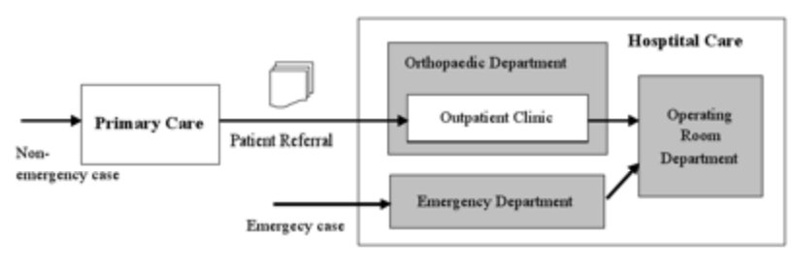

In general, the elective surgery process starts at primary care. The patient is then referred to specialist care for an outpatient appointment. If surgery is decided, the patient is then put on hold for surgery. In reality, the *surgery waiting list* system consists of two waiting lists; one, waiting to meet the surgeon specialist at the outpatient appointment, and one, waiting to be scheduled for surgery after the appointment. Moreover, there is one surgery waiting list system representing each of the operating departments and which are separately managed, i.e., one waiting list system at the Department of Orthopaedics (as depicted in Figure 2), another one at the Department of General Surgery and at the Department of Gynaecology, and so on. Consequently, the allocation of operating room resources affects every surgery' waiting' list' system. In addition, the Operating room department also has to consider a variety of postoperative resources when planning. After surgery, the patients are monitored in a postoperative ward for circulation and respiration, but also for assistance with analgesic before being transferred to the ward or directly discharged. In addition, some patients will need postoperative intensive care and consequently have to be transferred to the Intensive care unit, (ICU) after surgery.