Task 1: Business Snapshot and model

Business Name: It’s a bakery business called Sweet Moments Bakery. It is located in Kampala Uganda. It sells freshly baked products including bread, birthday cakes, doughnuts and cookies. It serves individual customers such as students, workers and families as well as business customers such as schools, offices, cafes, restaurants and events planners.
Customers order through WhatsApp or a website, pay using MTN or Airtel Mobile Money and receive products through delivery riders.
The bakery uses Partial E-commerce because orders and payments are made online but products are physically delivered. It uses B2C, mobile commerce and social commerce.
Value Proposition: Sweet Moments Bakery offers fresh, tasty and affordable baked products with convenient online ordering, mobile money payments.

Support Area Framework
People: They include owners, bakers, delivery riders and customers.
Public policy: Compliance with Uganda’s data protection and adherence to UNBS food safety guidelines.
Marketing and Advertisement: Promoting products through social media.
Support services: Using mobile money, internet and delivery services.
Business partnerships: Working with schools, offices, cafes and restaurants.

Its revenue models include; direct sales, delivery fee model

Item: 1 Custom Chocolate Celebration Cake (1.5 kg)
Selling Price: UGX 85,000
Cost of Goods Sold (COGS): UGX 42,000 (flour, eggs, chocolate, butter, packaging)
Delivery Fee (Subsidized): UGX 5,000
Payment Merchant Fee (MTN Mobile Money / Airtel Money - ~1%): UGX 850
Gross Profit per Order: 85,000-(42,000+5,000+850)=37150

Task 2: Marketing Plan
Objective: To increase online orders by 20% within 2 weeks by promoting bakery products to customers in Kampala.
Customers: These include students, families, schools, workers,offices,cafes, restaurants and event planners in Kampala.
Paid media: The business pays for a facebook or Instagram advert promoting birthday cakes.
Owned media: Post products, photos, prices and offers on the bakery’s WhatsApp business status.
Earned media. Encourage satisfied customers to share Rev and recommend the bakery to friends.
Google Search Phrases
1. Fresh custom cakes Kampala
2. Best birthday cake delivery Uganda
3. Buy fresh bread online Kampala
4. Wholesale bakery suppliers Kampala
5. Artisanal doughnuts delivery Nakasero
6. Custom wedding cakes Makerere
7. Online cake shop Kampala
8. Fresh cookies delivery Ntinda
9. Office snack delivery Kampala
10. Affordable bakery near me Uganda

Week 1- Monday | Post bakery introduction | WhatsApp status
Tuesday | Advertise birthday cakes | Facebook
Wednesday | Post cupcake photos and prices | Instagram
Thursday | Share a customer review | WhatsApp status
Friday | Promote weekend cake orders | Facebook
Saturday | Post a baking and packaging video | Instagram
Sunday | Share a special offer | WhatsApp status
Week 2- Monday | Advertise bread and pastries | Facebook
Tuesday | Promote bulk orders for offices and cafes | WhatsApp status
Wednesday | Share customer testimonials | Instagram
Thursday | Post a birthday cake catalogue | WhatsApp status
Friday | Run a paid weekend promotion | Facebook
Saturday | Share customer photos with permission | Instagram
Sunday | Thank customers and promote future orders | WhatsApp status

Task 3
GOOGLE PROFILE MOCK UP
Business name: Sweet Moments Bakery

Business category: Bakery

Business description:

Sweet Moments Bakery is a proposed bakery business based in Kampala, Uganda, offering fresh, tasty and affordable baked products for individuals, families and businesses. Our products include birthday cakes, bread, cupcakes, doughnuts, cookies and pastries. We also prepare customized cakes for birthdays, weddings and other special occasions. We serve individual customers, schools, offices, cafés, restaurants and event planners. Customers can place orders online through WhatsApp Business and social media. We accept MTN Mobile Money and Airtel Money payments and arrange delivery to homes, offices and event venues within our service area. Our goal is to provide quality baked products, friendly customer service and convenient ordering to make every occasion special.

Opening hours:

* Monday–Saturday: 8:00 a.m.–7:00 p.m.
* Sunday: 9:00 a.m.–4:00 p.m.

Area served: Kampala, Uganda, including nearby areas where delivery is available.

Phone number: To be added when the business contact is available.

Website: To be added. This document is a mock-up, not a live business website.

Products and prices:

Product​Price (UGX)
Loaf of bread​5,000
Birthday cake​60,000
Cupcake​2,000
Doughnuts (2 pieces)​3,000
Cookies (small pack)​5,000
Chocolate cake​50,000
Wedding cake​250,000
Muffins (2 pieces)​5,000
Pastry pack​10,000
Office snack box​25,000

Note: Prices and opening hours are proposed examples for the coursework mock-up.

Ten photos to include in the mock-up

1. Bakery logo.
2. Shopfront or bakery exterior.
3. Freshly baked bread.
4. Birthday cakes.
5. Cupcakes.
6. Doughnuts.
7. Cookies and pastries.
8. Customized celebration cakes.
9. Packaged orders ready for delivery.
10. Bakery products arranged for customers.
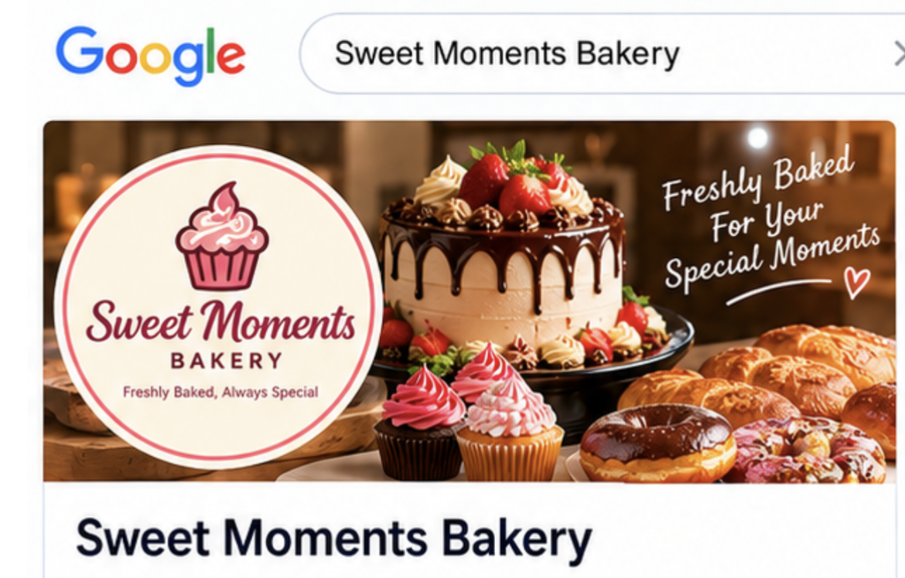
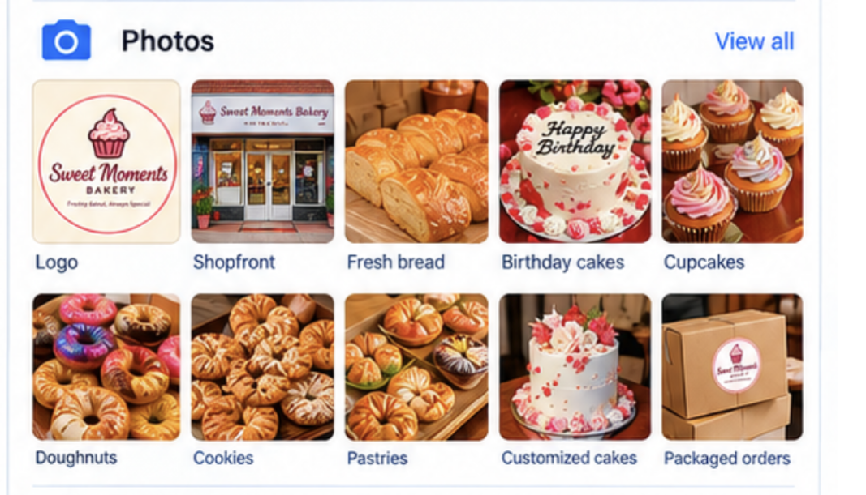
Task 4
External Feedback
Respondent 1 (Cafe Owner): "The LinkedIn B2B proposal looks clean. Clear pricing on daily deliveries is crucial."
Respondent 2 (Student): "The doughnut pics on Instagram look delicious. Make sure the WhatsApp order link is right at the top."
Respondent 3 (Parent): "Good custom cake details. Add a note on lead time (e.g., order 24 hours in advance)."
Respondent 4 (Local Customer): "The color scheme is very inviting. Adding Mobile Money details explicitly helps trust."
Respondent 5 (Courier Driver): "Specify delivery zones clearly so customers know if you reach areas like Gayaza or Entebbe."
Task 5

